

American International University-Bangladesh (AIUB)  
**Department of Computer Science  
Faculty of Science &Technology (FST)  
Fall 21_22**

**Section: L  
Group No: 04**

**Digital Health Care**

A software Engineering project submitted

By

|  |  |  |  |
| --- | --- | --- | --- |
| S/N | Student Name | Student ID | Contribution (%) |
| 37 | NIR, NUSRAT JEVIN | 16-31222-1 | 20% |
| 30 | SINGH, OISHI | 20-43067-1 | 20% |
| 26 | DEBNATH, ANIK | 20-42780-1 | 20% |
| 11 | SEN, ANIK | 20-42138-1 | 20% |
| 09 | NAKIB, MOHAMMAD IMTIAZ | 20-42121-1 | 20% |

The project will be Evaluated for the following Course Outcomes

|  |  |
| --- | --- |
| Your Project will be Evaluated based on the following marking criteria | Total Marks |
|  |
| Requirements Analysis (functional, quality, and project requirements) [5Marks] |  |
| System Design (UI/UX design) [5Marks] |  |
| Test and Project Management Planning [5Marks] |  |
| Submission, Completeness, Spelling, Grammar and Organization [5Marks] |  |

Submission Date: 9th December, 2021

Description of Student’s Contribution in the Project work

|  |
| --- |
| Student Name: NIR, NUSRAT JEVIN  Student ID: 16-31222-1  Contribution in Percentage (%): 20%  Contribution in the Project:   * Contributed in System Quality Attributes * Contributed in System Test Plan * Contributed in UI/UX Design   *________Jevin___________*  Signature of the Student |
| Student Name: SINGH, OISHI  Student ID: 20-43067-1  Contribution in Percentage (%):20%  Contribution in the Project:   * Contributed in System Quality Attributes * Contributed in UI/UX Design * Contributed in Project Scheduling   *_________Oishi__________*  Signature of the Student |
| Student Name: DEBNATH, ANIK  Student ID: 20-42780-1  Contribution in Percentage (%): 20%  Contribution in the Project:   * Contributed in System Quality Attributes * Contributed in UI/UX Design * Contributed in Project Scheduling   *__________Anik Debnath_________*  Signature of the Student |
| Student Name: SEN, ANIK  Student ID: 20-42138-1  Contribution in Percentage (%): 20%  Contribution in the Project:   * Contributed in System Feature * Contributed in UI/UX Design * Contributed in System Test Plan   *________Anik Sen___________*  Signature of the Student |
| Student Name: NAKIB, MOHAMMAD IMTIAZ  Student ID: 20-42121-1  Contribution in Percentage (%): 20%  Contribution in the Project:   * Contributed in System Feature * Contributed in UI/UX Design * Contributed in Risk Analysis   *_______Nakib____________*  Signature of the Student |

# PRODUCT AND PROJECT DESCRIPTION

## System Features

1. **Registration**

**Functional Requirements**

* 1. After opening the app user will get an option for login or signup
  2. If the user has already an account he can put his user name and password and can login
  3. If he doesn’t have any account he can register in the app by providing some basic information
  4. After completing registration user will be allowed to use this app

**Priority level:** High

**Precondition:** N/A

**Cross-reference:** N/A

1. **Profile**

**Functional Requirements**

* 1. After login into the ID user can set his/her age gender location
  2. User can also set any kind of Medical issues if he/she had it before
  3. User can set multiple contact number in case some kind of network issue
  4. System will verify if the number is correct or not and send a message if invalid number.

**Priority level:** Medium

**Precondition:** User must register with Phone No./Gmail.

**Cross-reference**: N/A

1. **Emergency Call:**

**Functional Requirements**

* 1. The software should provide a emergency call button for user
  2. This emergency call button will work as an emergency phone call from where the users can get access to the hospitals easily
  3. User can provide any location to search for the number for the required service.

**Priority level:** High.

**Precondition:** User need to be a registered member first.

**Cross-reference:** N/A

1. **Emergency vehicle:**

**Functional Requirements**

* 1. User can call emergency vehicle for health service
  2. This will allow user to choose different kind of vehicle like ambulance, air ambulance etc
  3. This system will also work under a certain location chosen by user
  4. System will send a message to both consumer and provider when the vehicle is confirmed for the service.

**Priority level:** High

**Precondition:** User need to be registered and within the service location and valid phone number.

**Cross-reference:** N/A

1. **Medicine Delivery**

**Functional Requirements**

* 1. User can directly search for medicine writing the name of it.
  2. All the shop list containing the desired medicine will be shown as list.
  3. Users can select medicine for order.
  4. System will send a message if the medicine is not available in the shop.

**Priority level:** High.

**Precondition:** User need to be registered and within the service location and valid phone number

**Cross-reference:** N/A

1. **Health tips**

**Functional Requirements**

* 1. User can select health tips depending on his health condition
  2. There will be audio and video options user can select between them
  3. Also user will get some contact number of doctors for free advice

**Priority level:** Medium

**Precondition:** N/A

**Cross-reference:** N/A

## System Quality Attributes

There are two types of perspective of quality attributes

First one is user perspective. There are 8 important primarily quality attributes to user perspective.

**QA 1. Availability**: The system shall be at least 98.5 percent available on every seven days a week between 12.00 am to 11.59 pm at local time.

**Priority level:** High

**Precondition:** Must have maintainability attribute

**Cross-reference:** QA-6, QA-7

**QA 2.**  **Efficiency**: There are at least 3.5 percent of the processor capacity, disk space 1.7 MB/S , memory 120MB and communication bandwidth 512kbps shall be available to properly run this system .

**Priority level:** High

**Precondition:** N/A

**Cross-reference:** QA-3, QA-5, QA-8, QA-7

**QA 3.** **Flexibility**: A maintenance programmer who has at least 8 months of experience shall be able to add new feature and function including code, modifications and testing into the system with no more than three hours.

**Priority level:** Medium

**Precondition:** N/A

**Cross-reference:** QA-2, QA-4, QA-8, QA-6

**QA 4.** **Integrity**: When user try to login into the system, there shall have to two step verification. One step is while user try to login into the system, the system will send a verification code to the user via mail and user shall have to use that verification code to login and the second step is user shall have to use their own password while they create the password to sign up this system.

**Priority level:** High

**Precondition:** N/A

**Cross-reference:** QA-2, QA-5, QA-8

**QA 5.** **Interoperability**: When a user sign-up to the system the user has to give some their general information like user name, phone no., email. So, system need to justify the information whether the user given information. For that reason, the system shall be able to import valid information which shall have matched to the user given information. The system shall import the information from local election commission office.

**Priority level:** High

**Precondition:** N/A

**Cross-reference:** QA-2, QA-3, QA-4,

**QA 6 .Reliability**: The system shall no more than three experimental runs out of 800 can be lost.

**Priority level:** High

**Precondition:** N/A

**Cross-reference:** QA-1, QA-2, QA-3, QA-8, QA-7

**QA 7.** **Robustness**: In the system there are two kind of users. One is applicant and another is recruitment. If the recruitment fails to edit their post before the applicant saves the post, the recruitment shall be able to recover all changes made in the post being edited and shall be able to that edited post within 20 seconds.

**Priority level:** High

**Precondition:** N/A

**Cross-reference:** QA-1, QA-2, QA-6

**QA 8. Usability**: When the recruitment do post the system shall able to upload that post within 15 second. When applicant see the recruitment post and if the applicant wants to comment to the post. The system shall able to visible that comment to the recruitment within 2 second.

**Priority level:** High

**Precondition:** N/A

**Cross-reference:** QA-2, QA-7, QA-8

And the last one is developer perspective. There are important primarily quality attributes to developer perspective:

i) **Maintainability**: Suppose there is a problem arise in the system that user can’t upload their post. A maintenance programmer who has at least 8 months of experience can solve this problem within 3hour without any extra helping hand.

**Priority level:** High

**Precondition:** QA-1, QA-2, QA-3, QA-6

**Cross-reference:** N/A

ii) **Portability**: The system must shall able to run any platform or any operating system. Like Windows, Linux, Android, Apple, Unix, Ubuntu, Haiku, Rhapsody etc.

**Priority level:** High

**Precondition :** N/A

**Cross-reference:** QA-2, QA-3, QA-6

iii) **Reusability**: The system functions shall have to be designed in such way that can be reasonable for different any other system.

**Priority level:** Low

**Precondition:** N/A

**Cross-reference:** QA-2, QA-3, QA-4, QA-5

iv) **Testability**: If user want to upload their post, the system shall able to upload that post within 15 second. If the user do comment any post the system shall be able to visible that comment within 2 second. If user communicate with another user via audio or video the system shall able to connect the users within 5 second. If user refresh the page the system will refresh that page within 3 second.

**Priority level:** Medium

**Precondition:** N/A

**Cross-reference:** QA-1, QA-2, QA-3, QA-6

**Besides this two perspective there are also some quality attributes. Like:**

i)**Performance**: If recruitment upload a file, the applicant shall able to download the file in 20 second or less over a 1MBps bandwidth connection. Here a condition that file size must be within 18 MB.

ii) **Learnability**: The system user interface should be structured clearly, simply and be free of all dead weight. It should explain to the user , what the software system should do.

iii) **Readability**: When a programmer will build the system with code. The code shall have to be well structured should be use comment, should be maintain the code alignment. This is that for reason when another programmer will see the system code that the programmer shall able to understand the codes very easily without any hassle.

**iv) Scalability:** The system shall able to handle load increases without decreasing performance or the possibility to rapidly increase the load.

## Project Requirements

1. **Time**: We need four month (15 weeks) to build this software.

2) **Environment**: We need an environment to build this software. So, we create an office space ram.

3) **Resources**: We need total 10 human resources to build this software.

4) **Equipment**: To build this software we need equipment. Like, 5 Computer, 5 Table, 1 Marker board.

5) **Bandwidth**: We need high bandwidth support. Which is around 50 to 60 Mbps.

6) **Tools**: The system developer needs selenium tools in perform testing activities in week

# SYSTEM DESIGN SPECIFICATION

## UI/UX Design

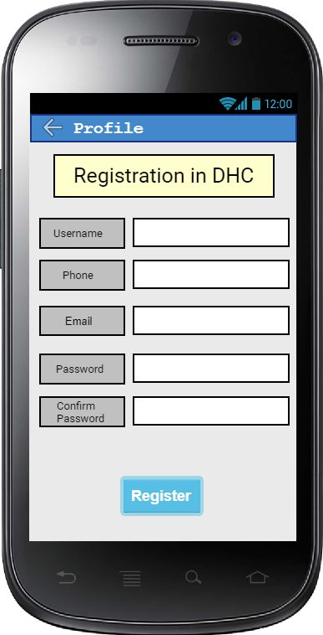

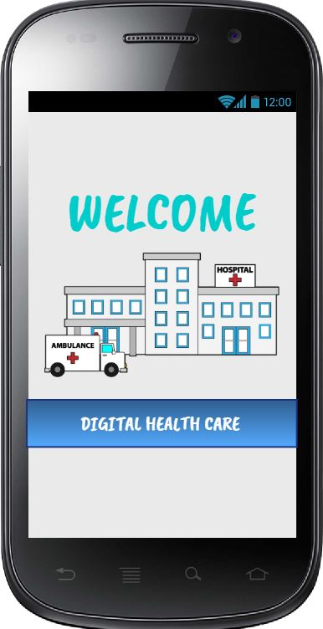

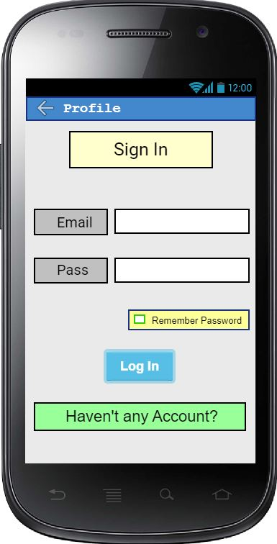

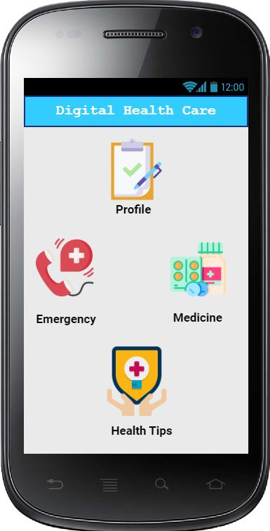 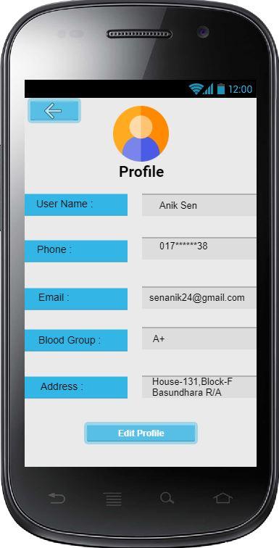 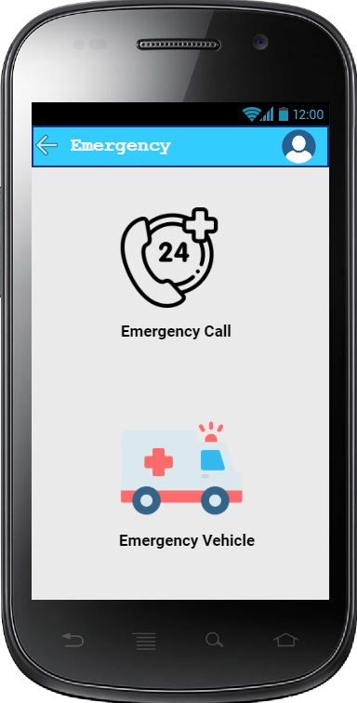

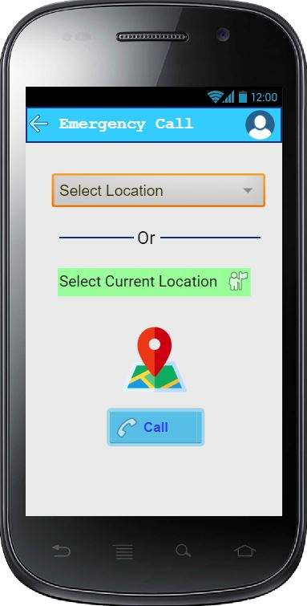 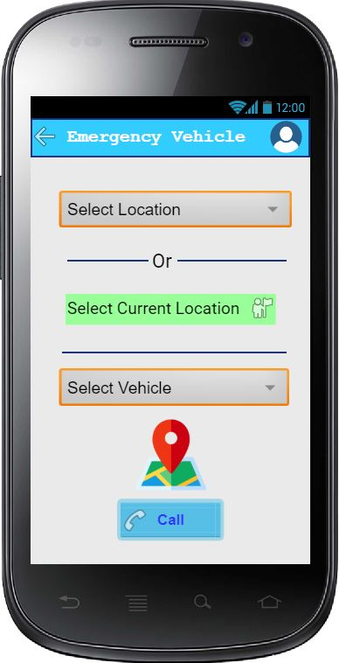 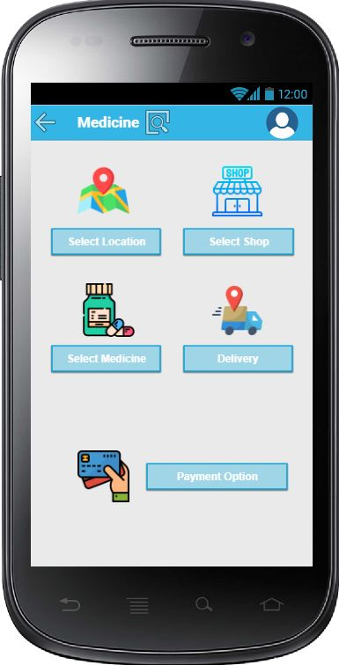

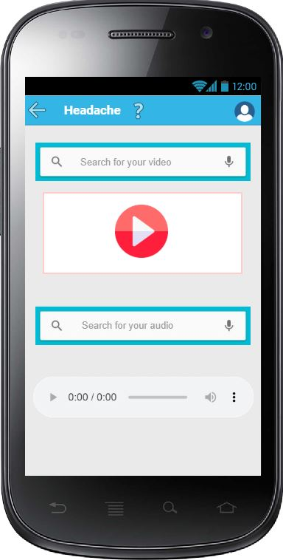

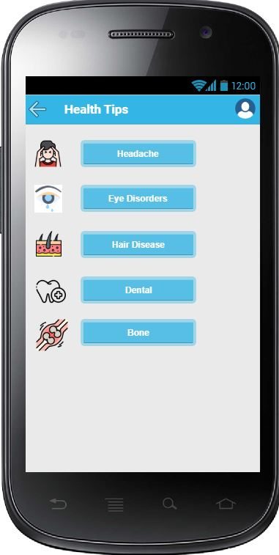

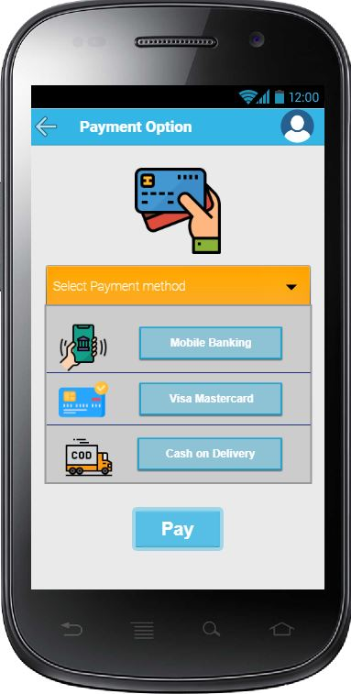

# SYSTEM TEST PLAN

**Table :** Test Case for **Registration**

|  |  |  |  |  |
| --- | --- | --- | --- | --- |
| Project Name: Digital Health Care System | | | Test Designed by: Nusrat | |
| Test Case ID: FR_1 | | | Test Designed date: 02.05.2021 | |
| Test Priority (Low, Medium, High): High | | | Test Executed by: | |
| Module Name: Registration Session | | | Test Execution date: | |
| Test Title: Complete registration with username, phone number, email and password | | | | |
| Description: Test website registration page | | | | |
| Precondition (If any): N/A | | | | |
| Test Steps | Test Data | Expected Results | Actual Results | Status (Pass/Fail) |
| 1. Go to the website 2. Click “Haven’t any Account?” button 3. Enter username 4. Enter Phone number 5. Enter email 6. Enter password 7. Click “Register” button | Username: John  Phone: 01700000000  Email:john@gmail.com  Password: 54321 | User should complete the registration for the application |  |  |
| Post Condition: User is validated with database and successfully login to account. The account session details are logged in the database. | | | | |

**Table** : Test Case for **Emergency Call**

|  |  |  |  |  |
| --- | --- | --- | --- | --- |
| Project Name: Digital Health Care System | | | Test Designed by: Anik Sen | |
| Test Case ID: FR_2 | | | Test Designed date: 02.08.2021 | |
| Test Priority (Low, Medium, High): High | | | Test Executed by: | |
| Module Name: Emergency Call Session | | | Test Execution date: | |
| Test Title: Complete Calling to hospitals by providing user location | | | | |
| Description: Test website Emergency call page | | | | |
| Precondition (If any): User must have registered into the website | | | | |
| Test Steps | Test Data | Expected Results | Actual Results | Status (Pass/Fail) |
| 1. Go to the website 2. Click “Emergency” button 3. Click “Emergency Call” 4. Select location or, provide location 5. Click “Call” button | Location: Bashundhara R/A  Call : Ever Care Hospital, Bashundhara | User should be able to call Ever Care hospital of Bashundhara |  |  |
| Post Condition: The phone number and location will be updated anytime in the database when user select his current location or changes his contact number. | | | | |

**Table** : Test Case for **Medicine**

|  |  |  |  |  |
| --- | --- | --- | --- | --- |
| Project Name: Digital Health Care System | | | Test Designed by: Nakib | |
| Test Case ID: FR_3 | | | Test Designed date: 04.05.2021 | |
| Test Priority (Low, Medium, High): High | | | Test Executed by: | |
| Module Name: Medicine Session | | | Test Execution date : | |
| Test Title: Asking for medicine providing location, shop, medicine name with payment information. | | | | |
| Description: Test website Medicine page | | | | |
| Precondition (If any): User must be registered with valid information. | | | | |
| Test Steps | Test Data | Expected Results | Actual Results | Status (Pass/Fail) |
| 1. Go to the website 2. Click “Medicine” button 3. Select location 4. Select shop name. 5. Select medicine 6. Click “Payment” button 7. Provide payment details. | Location : Bashundhara R/A  Shop Name : Lazz Farma  Medicine name : Maxpro - 20  Payment option : Cash on | User should be able to order Maxpro-20 medicine in Bashundhara R/A. |  |  |
| Post Condition : The medicine shop and payment will be updated anytime in the database when user select his current location. | | | | |

**Table** : Test Case for **Health Tips**

|  |  |  |  |  |
| --- | --- | --- | --- | --- |
| Project Name: Digital Health Care System | | | Test Designed by: Anik Debnath | |
| Test Case ID: FR_4 | | | Test Designed date: 08.05.2021 | |
| Test Priority (Low, Medium, High): High | | | Test Executed by: | |
| Module Name: Health Tips Session | | | Test Execution date: | |
| Test Title: Getting health tips by providing specific disease | | | | |
| Description: Test website Health Tips page | | | | |
| Precondition (If any): User must have registered into the website | | | | |
| Test Steps | Test Data | Expected Results | Actual Results | Status (Pass/Fail) |
| 1. Go to the website 2. Click on heath tips button 3. Select “Headache” option. | Options : “Headache” | User should be able to get some video and audio related to “Headache” |  |  |
| Post Condition: The videos and audios for health tips will be updated continuously after a certain time from better resources. | | | | |

**Table** : Test Case for **Emergency Vehicle**

|  |  |  |  |  |
| --- | --- | --- | --- | --- |
| Project Name: Digital Health Care System | | | Test Designed by: Oishi | |
| Test Case ID: FR_5 | | | Test Designed date: 14.05.2021 | |
| Test Priority (Low, Medium, High): High | | | Test Executed by: | |
| Module Name: Emergency Vehicle Session | | | Test Execution date: | |
| Test Title: Complete Calling for vehicle by providing user location and vehicle name | | | | |
| Description: Test website Emergency Vehicle page | | | | |
| Precondition (If any): User must have registered into the website | | | | |
| Test Steps | Test Data | Expected Results | Actual Results | Status (Pass/Fail) |
| 1. Go to the website 2. Click “Emergency” button 3. Click “Emergency Vehicle” 4. Select location or, provide location 5. Select Vehicle name. 6. Click “Call” button | Location: Bashundhara R/A  Vehicle : Ambulance | User should be able to call Ever Care hospital of Bashundhara for their ambulance. |  |  |
| Post Condition: The phone number and location will be updated anytime in the database when user select his current location or changes his contact number. | | | | |

**Table** : Test Case for **Payment Option**

|  |  |  |  |  |
| --- | --- | --- | --- | --- |
| Project Name: Digital Health Care System | | | Test Designed by: Nusrat | |
| Test Case ID: FR_6 | | | Test Designed date: 18.05.2021 | |
| Test Priority (Low, Medium, High): High | | | Test Executed by: | |
| Module Name: Payment Option | | | Test Execution date: | |
| Test Title: Complete payment with valid account number. | | | | |
| Description: Test website Payment Option page | | | | |
| Precondition (If any): User must have valid mobile banking account. | | | | |
| Test Steps | Test Data | Expected Results | Actual Results | Status (Pass/Fail) |
| 1. Go to the website. 2. Click on “Medicine” 3. Select medicine and related information. 4. Click on “Payment Option” 5. Select Mobile Banking 6. Insert account number. 7. Insert amount 8. Click on “Pay” button. | Account number : 01796986151  Amount : 500 | User should be able to pay properly. |  |  |
| Post Condition: Available payment option will be updated in the database by changing location. | | | | |

# PROJECT MANAGEMENT PLAN

## Project Scheduling

**Table** : Work Breakdown Structure (WBS) of **Digital Health Care**

|  |  |  |
| --- | --- | --- |
| **Project Activity** | **Duration** | **Prerequisite** |
| Preliminary Project/Thesis Plan | 4 weeks | 1. Power Budget. 2. Top Level schedule. 3. Constrains. 4. Resource needs. |
| Requirements Specification | 1 week | 1. Identifying the requirements and purposes. 2. Identifying the necessity and uses of the system. 3. Idea Generation. 4. Budget planning. |
| Analysis [Object model, User interface] | 2 weeks | 1. Improve the data. 2. Interface evaluation. 3. Consider user Expectations. 4. Control Specification. |
| Source Code | 3 weeks | 1. Identifying the appropriate code. |
| Test Plan | 1 week | 1. Unit testing 2. Integration testing and Regression testing 3. Security testing 4. Perform system testing |
| Final Product / Demo | 4 weeks | 1. Pre-construction 2. Construction start date 3. Re-present the Documentation |

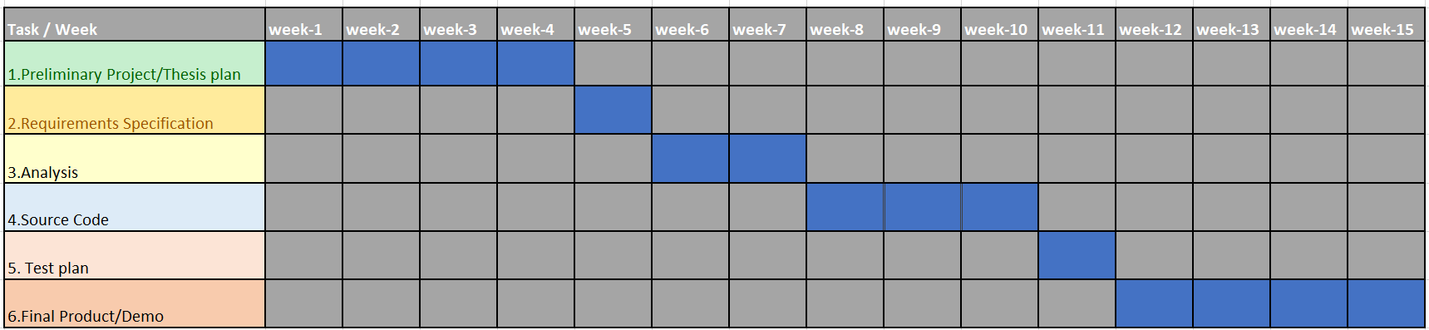

**Figure** : Activity planning of digital health care

## 

**Figure** : Project Contribution

**Activity Key:**

1. overall design
2. Overall design
3. Overall design
4. Overall design
5. Overall design
6. Overall design
7. Overall design
8. Special module 1
9. Special module 2
10. Special module 3
11. Special module 4
12. Special module 5
13. Special module 6
14. Code module 1
15. Code module 2
16. Code module 3
17. Code module 4
18. Integration system
19. Integration system
20. Integration system
21. Integration system
22. System testing
23. System testing
24. System testing
25. System testing

## Risk Analysis

|  |  |  |  |  |
| --- | --- | --- | --- | --- |
| **S/N** | **Risk Description** | **Probability** | **Impact** | **Mitigation Plan** |
| 1 | Unrealistic time estimate | 40% | Significant | Take multiple estimation |
| 2 | Task allocation problem | 20% | Poor code writing and functionality | Make a skill-set chart of the team members and assign tasks according to skill |
| 3 | Maintainability problem | 50% | Poor user experience | We will make a recovery test on our whole project |
| 4 | Excessive Cost | 35% | Project will be more costly | A good pre-estimation and make a good track on budget |
| 5 | Payment Security key | 25% | Customer will lose trust in this app | Make a reliable payment getway and will run an integration testing on payment system. |