ICT726 – Web Development
Assignment 3 Report
Development of "Apex Community Library & Knowledge Hub" Static Website
Student Name: Anika Hossain
Student ID: 20037225
Unit: ICT726 – Web Development
Assignment: Assignment 3 – Static Website
Institution: King's Own Institute (KOI)
Submission Date: 11/08/2026

Contents
1․ Introduction 2
2․ Website Overview 2
3․ Design Decisions 3
4․ Website Structure 3
5․ Technologies Used 7
6․ HTML Implementation 8
7․ CSS Implementation 9
8․ JavaScript Functionality 9
9․ Accessibility and Usability 10
10․ Responsive Design 10
11․ AI Assistance Declaration 11
12․ Ethics and Privacy Considerations 11
13․ Challenges and Solutions 11
14․ Testing and Validation 11
15․ Reflection and Learning 12
16․ Conclusion 13
17. Project Drive Link: 13
18. References (Harvard Style) 13

1․ Introduction

This project aimed to prove proficiency in the following HTML5, CSS3, JavaScript, web forms, media, usability, and responsive web design skills, and to build a working static website featuring web information about the fictional company, Apex Community Library & Knowledge Hub (Mozilla Developer Network, 2025).

In accordance with the requirements of ICT726 Assignment 3, the website is made up of five pages that mimic what a modern digital library may be, with an emphasis on accessibility, interactivity, aesthetic appeal, and ease of navigation. As part of the design process, it was also decided that no website templates and front-end frameworks would be used to create the initial interface (King's Own Institute‚ 2025)․

2․ Website Overview
It is a virtual community library for users to browse books‚ watch multimedia‚ reserve study booths‚ reserve rooms and submit library questions electronically.
The website contains the following pages:
• Home
• Catalog & E-books
• Media Gallery
• About Us
• Contact Us
Each page connects through the same navigation bar‚ allowing the user to navigate between pages․ easily
Major features include:
• Digital book catalogue with search functionality
• User registration and authentication
• Book issuing simulation
• Personal wishlist management
• Interactive commenting system
Online reading seat reservation
• Date and time-based booking system
• Bookings can be made between 30 minutes to 5 hours
• Automatic seat reallocation after the booking expiry
• Contact form with Local Storage
• Frequently Asked Questions
• Image gallery with filter option
• Embedded YouTube videos
• Google Maps integration
• Interactive modal windows
The features were intended for ease of use and the demonstration of client-side web development (W3Schools‚ 2025)․

3․ Design Decisions
The overall design of the site is modern‚ clean, and minimal‚ inspired by other academic sites․
Green was chosen as the colour scheme‚ as it is associated with education‚ growth‚ reading‚ nature‚ and sustainability․ CSS gradients and shadows add depth while maintaining readability (Mozilla Developer Network‚ 2025)․
All pages used the same navigation menus‚ colours, typography‚ spacing, and footer to create consistency‚ ease navigation‚ reduce cognitive load, and help users navigate intuitively (Nielsen‚ 2020)․
Google Fonts (Inter) was chosen due to its readability on both desktop and mobile‚ as well as its professional look and feel․

4․ Website Structure
The project consists of the following files:
• index․html
• catalog․html
• media․html
• about․html
• contact․html
• styles․css
The homepage introduces the library and provides links to most major sections․
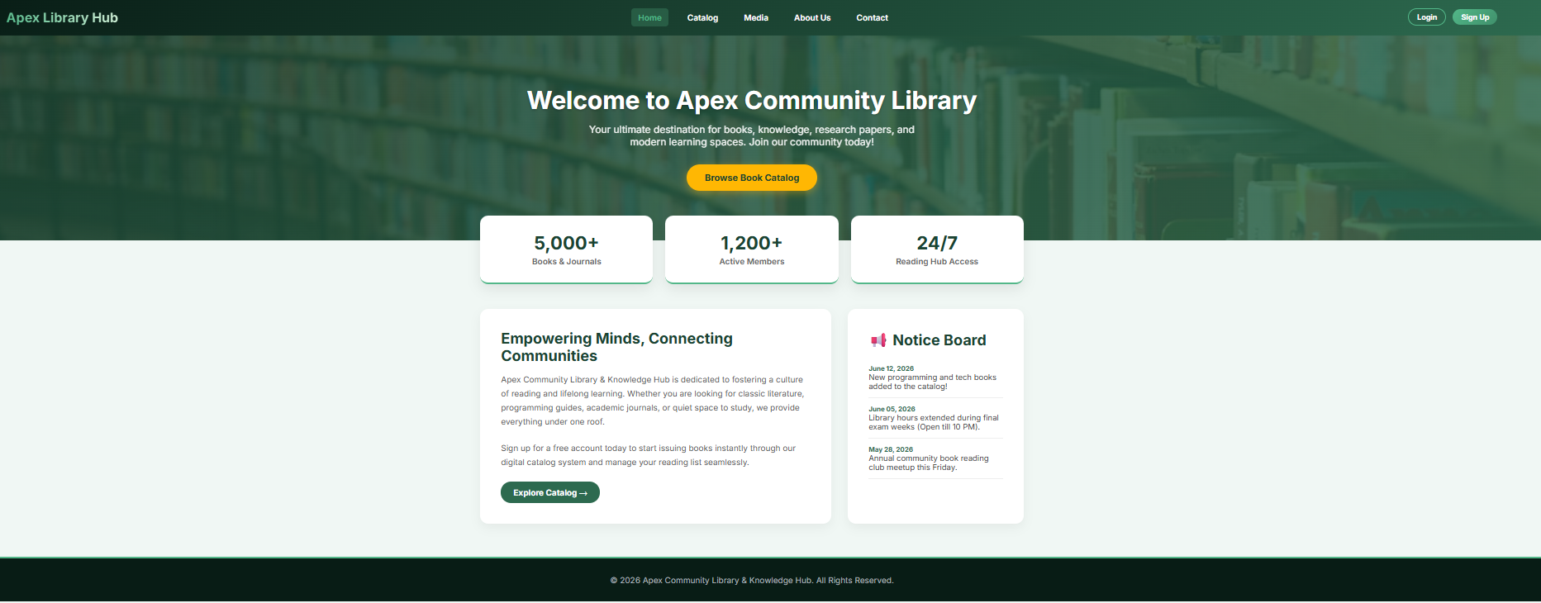
Figure:1 Home Page
The Catalog page contains most of the interactivity found on the website. Users can search for books‚ available issue books ‚ maintain their wishlist‚ comment‚ view online e-books‚ and book study seats․ The seat reservation module requires user sign-in‚ with members also storing the booking date‚ start time, and duration of the booking․ The reservation data are stored locally and released when the booked duration is over․
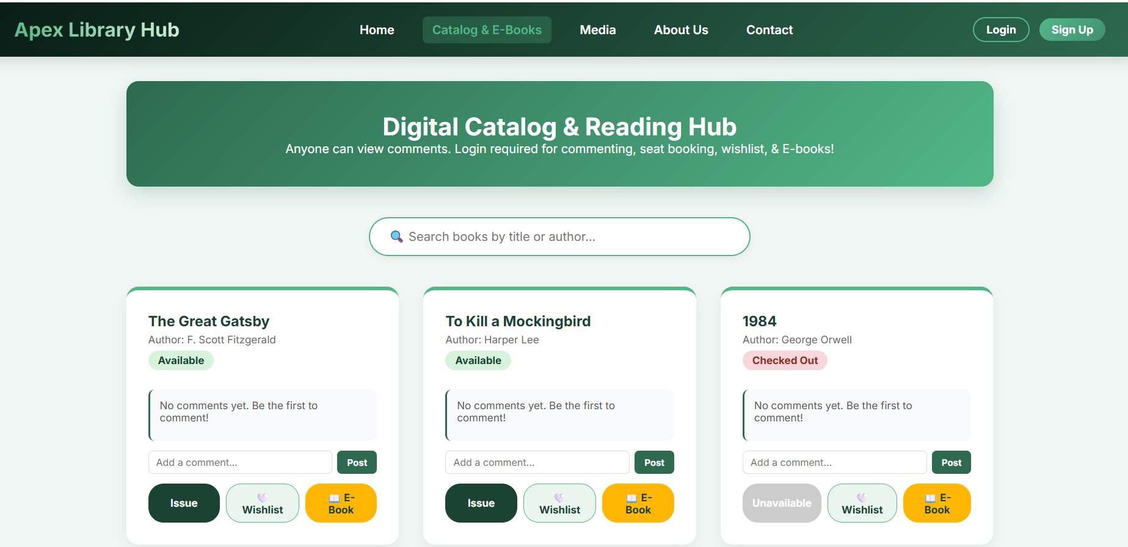
Figure-2: Catalog Page scroll up
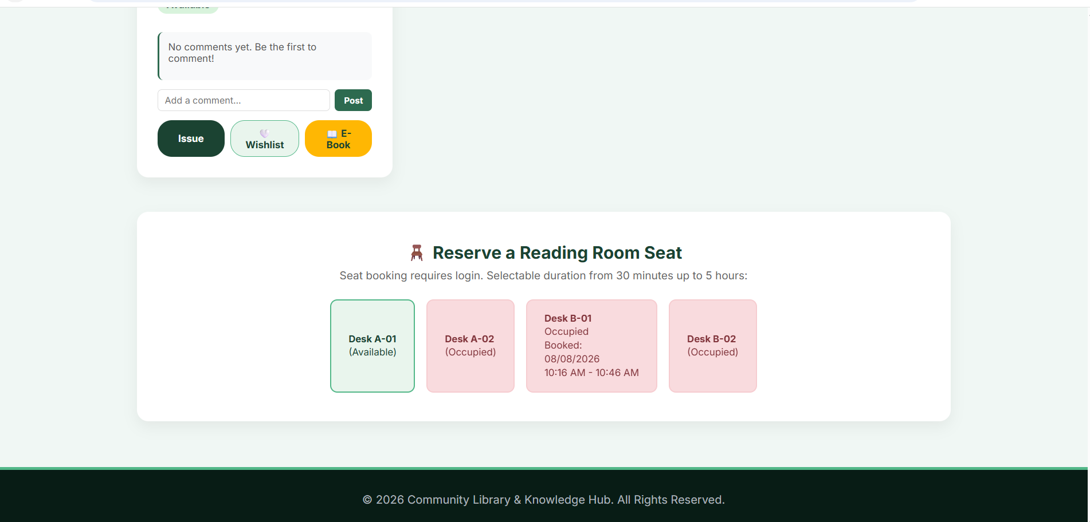
Figure-3: Catalog Page scroll down
The Media page displays images and video links with interactive filtering options․
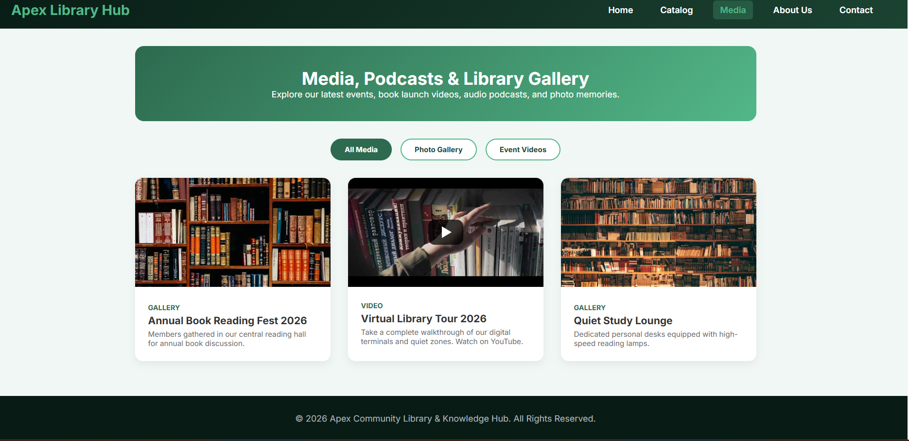
Figure-4: Media page without filter
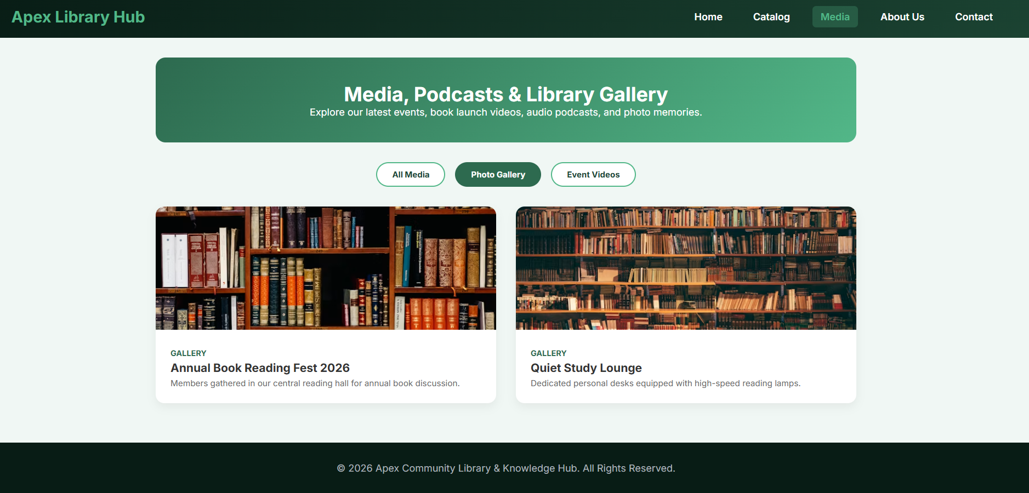
Figure-5: Media Page with filter
The About page details the organisation ‚ management team‚ and frequently asked questions․
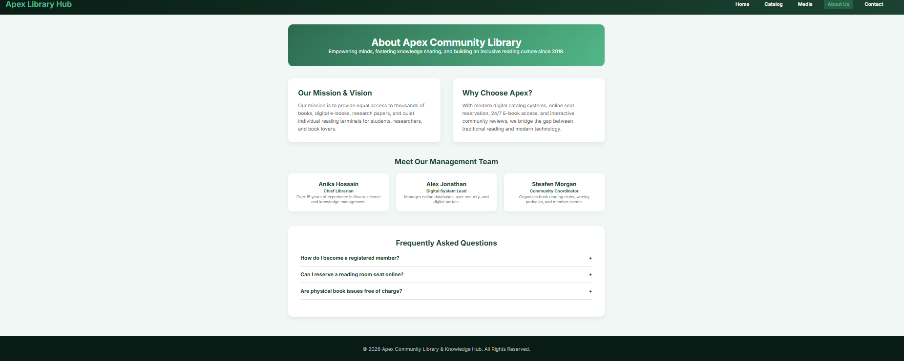
Figure-6: About Us
The Contact page allows users to send an enquiry and shows the library's location using an embedded Google Map․
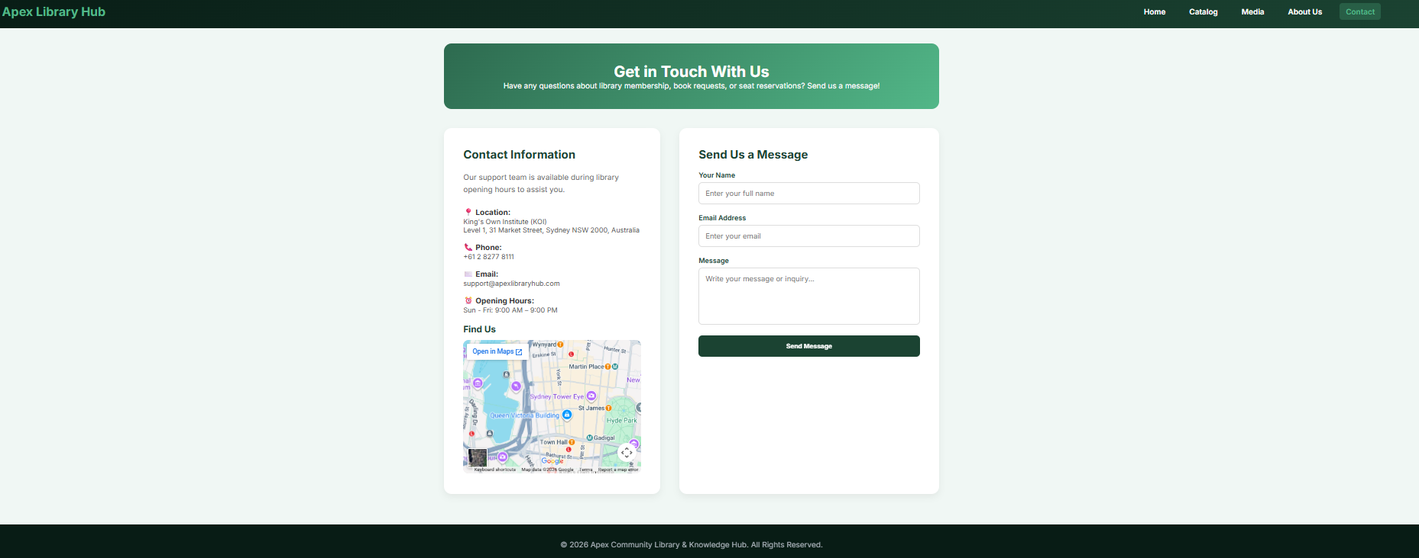
Figure-7: Contact Us

5․ Technologies Used
The site was created using standard front-end web development․
HTML5
HTML5 provides the semantic structure for every web page․ Semantic element such as <header>‚ <nav>‚ <main>‚ <section>‚ <form> and <footer> were used to provide the structure (Mozilla Developer Network‚ 2025)․
CSS3
Every webpage was styled using CSS3․
Modern CSS techniques were used:
• CSS Variables
• CSS Grid
• Flexbox
• Border Radius
• Gradients
• Box Shadows
• Hover Effects
• CSS Transitions
These techniques improve the quality of websites in terms of visual appearance and maintainability (W3Schools‚ 2025)․
JavaScript
All interactive behaviour was implemented using vanilla JavaScript‚ without relying on external libraries․
Implemented functions include:
• Login
• Registration
• User authentication
• Book search
• Wishlist management
• Comment system
• Contact form validation
• Interactive modal windows
• Reading seat reservation
• Date and time selection
• Booking duration selection
• Automatic booking expiry
• Dynamic seat availability
• Storing data in Local Storage
• Contact form validation
• FAQ accordion
• Image gallery
• Media filtering
• Success notifications

Browser Local Storage was used for temporary user data storage‚ including comments‚ messages‚ and wishlists (Mozilla Developer Network‚ 2025)․

6․ HTML Implementation
The website was created entirely in HTML5․
Each page begins with the HTML5 document declaration‚ and semantic elements are used for better readability and maintainability (Mozilla Developer Network‚ 2025)․
Forms are validated using HTML5 for required fields‚ correct email‚ and form control structure to decrease the number of invalid submissions and improve user experience (W3Schools‚ 2025)․
These navigation links are present on each page of the site‚ allowing easy access to almost all parts of the website․

7․ CSS Implementation
There was wide-ranging use of CSS to create the professional look․
Key styling techniques include:
• Responsive layouts using Flexbox and the CSS Grid
• Linear gradients
• Rounded corners
• Shadows
• Colour variables
• Smooth transitions
• Hover animations
Thus‚ these styles help improve a website's aesthetics and ensure uniformity throughout the website (Mozilla Developer Network‚ 2025)․

8․ JavaScript Functionality
All interactive features of the website are scripted in JavaScript․ Restricted access functions are authenticated for users through pop-up windows for registration and login on the Home page․ Among the most complex JavaScript application‚ the Catalog page allows searching the digital catalogue‚ issuing books‚ creating the favourite book wishlist‚ posting comments‚ and reading books online‚ after the user has logged in․ A custom seat reservation system was implemented to mimic the actual library reservation process which has a login step before booking any study desk․ Existing members can select the date and starting time of the booking‚ and the duration of the booking (from 30 minutes to 5 hours) in a booking modal dialog․ The booking modal stores the user's details‚ date‚ duration‚ start‚ and expiry times in Local Storage․ After the hotelier reserves the seat‚ the booked seat automatically appears as reserved and the booking schedule is displayed․ After the booking duration period‚ JavaScript automatically removes the booking from Local storage and automatically restores the seat status as an available seat without any action by the administrator․ Other JavaScript features in the site include an FAQ accordion‚ media filter‚ image preview modals‚ the contact form validation‚ and Local Storage‚ a method of synchronized‚ browser-side storage․ Together‚ these features show some of the ways JavaScript can be used to develop modern web applications (Mozilla Developer Network‚ 2025; W3Schools‚ 2025)․

9․ Accessibility and Usability
Accessibility and usability were continuously accounted for․
The website includes:
• Clear navigation
• Readable typography
• High colour contrast
• Descriptive headings
• Consistent layouts
• HTML5 form validation
It can be said to follow established usability guidelines on consistency‚ simplicity‚ and intuitiveness (Nielsen‚ 2020)․
Future development might involve adding ARIA attributes or more complete descriptions in the alternative text (Google Developers‚ 2025)․

10․ Responsive Design
The website was built using responsive design․
Responsive layouts were implemented with:
• Flexible containers
• CSS Grid
• Flexbox
• Relative spacing
• Responsive images
These methods create responsive websites that respond to the user browsing the website on a desktop‚ tablet or smartphone (Mozilla Developer Network‚ 2025)․

11․ AI Assistance Declaration
Various other Artificial Intelligence tools were used at different points to provide interface suggestions‚ refine JavaScript logic‚ improve code readability, and proofread text․
All AI-generated suggestions were reviewed‚ refined‚ and adapted to finalise the output․ This was seen as consistent with the view of AI as a tool that supported (and did not replace) knowledge and development work‚ in keeping with the ethical application of AI for the assignment (King's Own Institute‚ 2025)․

12․ Ethics and Privacy Considerations
Ethical considerations were considered․
Additionally, as the project is client-side only‚ no personal user data is sent to external servers․
User data such as comments‚ contact enquiries, and Wishlist is stored in the user's web browser using Local Storage․
Media files are either in the public domain or available through educational projects․ Links to websites such as Project Gutenberg‚ Internet Archive‚ Google Maps‚ and YouTube make up the external links․

13․ Challenges and Solutions
Development faced several challenges․
Creating similar navigation patterns across different webpages required a great deal of planning and coordination․
The seat reservation feature was one of the hardest‚ because the whole site is client-side and there is no database․ Local Storage in the web browser is used to emulate seat reservation․ Afterward‚ JavaScript was added to capture the reservation date‚ start time‚ duration‚ user profile‚ and automatic expiration time‚ allowing the website to simulate booking a library seat without needing additional server-side technology․
Responsive design required multiple iterations and testing at various screen sizes․
Problems of this kind led to a growing understanding of front-end development and client-side programming․

14․ Testing and Validation
The website was tested for consistent behaviour among various web browsers․
Testing included:
• Navigation links
• Forms
• Search functionality
• Wishlist
• Book issuing
• Seat reservation
• Login validation
• Booking date validation
• Booking time validation
• Booking duration selection
• Automatic booking expiry
• Seat availability restorationFAQ
• Contact form
• Media gallery
• Google Maps
All main functions passed the tests without issue․

15․ Reflection and Learning
Helping to put together the website for Apex Community Library helped strengthen my front-end web development skills as well as my knowledge of semantic HTML5‚ CSS3 layout‚ JavaScript‚ responsive design‚ and browser Local Storage․
The project reinforced the importance of planning website architecture ‚ writing well-organised code‚ and testing features during website development․
Using AI responsibly helped me with brainstorming ideas and problem-solving․ All output was reviewed‚ repurposed, and integrated with greater understanding․ From this project‚ I improved technical skills and confidence to build professional static websites․
Designing the dynamic seat reservation system gave me experience in working with events with JavaScript‚ using date and time objects‚ manipulating and extracting objects from the Document Object Model (DOM)‚ and using Local Storage to simulate a realistic seat reservation system․ I also learned to expire seat reservations after a period of time chosen by the user․

16․ Conclusion
The Apex Community Library & Knowledge Hub website proudly presents the completion of ICT726 Assignment as per requirements‚ with multiple features achieved through HTML5‚ CSS3‚ and Vanilla JavaScript․ The developed digital library website is modern‚ responsive‚ and user-interactive‚ containing features like user sign-in‚ books search‚ comments‚ wishlist‚ contact form‚ images‚ videos‚ and google maps‚ as well as a web-based reading seat reservation system․ The booking feature shows my experience at using analysis skills and advanced client-side programming skills‚ as it allows the user to pick a date‚ time‚ and duration for a booking‚ and restores available seats when not booked․ I also learnt more about responsive web design‚ JavaScript programming‚ browser storage‚ and user-cantered interface design․ This project meets the requirements of the ICT726 assignment (King's Own Institute‚ 2025; Mozilla Developer Network‚ 2025; Nielsen‚ 2020)․

17. Project Drive Link:
https://drive.google.com/drive/folders/1MSPdr9liQ56qMYwBVhvzD07uFdksboDy?usp=sharing

18. References (Harvard Style)
Google Developers (2025) Learn Accessibility: ARIA and HTML. Available at: https://web.dev/learn/accessibility/aria-html (Accessed: 7 August 2026).
King's Own Institute (2025) ICT726 Web Development Assignment 3 Specification. Internal course document.
Mozilla Developer Network (2025) Learn Web Development. Available at: https://developer.mozilla.org/en-US/docs/Learn (Accessed: 7 August 2026).
Mozilla Developer Network (2025) HTML: HyperText Markup Language. Available at: https://developer.mozilla.org/en-US/docs/Web/HTML (Accessed: 7 August 2026).
Mozilla Developer Network (2025) CSS: Cascading Style Sheets. Available at: https://developer.mozilla.org/en-US/docs/Web/CSS (Accessed: 7 August 2026).
Mozilla Developer Network (2025) JavaScript Guide. Available at: https://developer.mozilla.org/en-US/docs/Web/JavaScript/Guide (Accessed: 7 August 2026).
Nielsen, J. (2020) 10 Usability Heuristics for User Interface Design. Nielsen Norman Group. Available at: https://www.nngroup.com/articles/ten-usability-heuristics/ (Accessed: 7 August 2026).
Project Gutenberg (2025) Project Gutenberg. Available at: https://www.gutenberg.org/ (Accessed: 7 August 2026).
Unsplash (2025) Unsplash. Available at: https://unsplash.com/ (Accessed: 7 August 2026).
W3Schools (2025) HTML, CSS and JavaScript Tutorials. Available at: https://www.w3schools.com/ (Accessed: 7 August 2026).

