

Boxing Analyser

Project Engineering

Year 4

Oisin Concannon

Bachelor of Engineering (Honours) in Software and Electronic Engineering

Galway-Mayo Institute of Technology

2020/2021

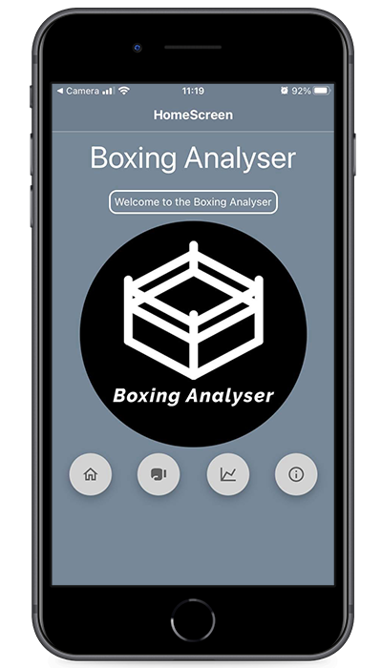

**Declaration**

This project is presented in partial fulfilment of the requirements for the degree of Bachelor of Engineering (Honours) in Software and Electronic Engineering at Galway-Mayo Institute of Technology.

This project is my own work, except where otherwise accredited. Where the work of others has been used or incorporated during this project, this is acknowledged and referenced.

____________________________________________

**Acknowledgements**

I would like to thank all the lecturers for helping me achieve this project and guide me on the correct path to completing this project successfully. A special thankyou to Paul Lennon and Brian O Shea as these two played a big part in the guidance of this project. Without them this would not have been achieved and I would like to send my sincerest thankyou to everyone who played a part.

**Table of Contents**

1 Summary 6

2 Poster 7

3 Introduction 8

4 Project Background 9

4.1 Martial Arts 9

4.2 Front End Development 10

5 Project Architecture 11

6 Project Plan 12

7 React Native 13

7.1 React Navigation 13

7.2 Picker 15

8 Accelerometer 16

9 Charts 17

10 Ethics 18

11 Conclusion 19

12 Appendix 20

13 References 21

# Summary

As part of my final year studying BEng Software and Electronic Engineering, I was required to complete a project engineering module. For this project I came up with “Boxing Analyser”. The goal of this project was to attempt to solve and ongoing issue for amateur fighters. As a fighter myself I find it difficult to monitor statistics and analyse previous bouts. This was the inspiration behind the project as I am passionate about combat sports and have a fascination with the constant improvement aspect.

This module took place over both semesters and this project came to fruition in the very first week of the first semester. The aim of “Boxing Analyser” was to provide users with real-time statistics as well as the ability to study previous bouts. It was planned to generate charts based on the punch output each round. This would give the fighters or coaches’ real-time statistics visually in a practical way. The approach was simple, I researched similar products on the market and I found very little. After this I was forced into a lot of trial and error. I had a very clear image of what I wanted to achieve and once the vision was clear I just had to figure out the path to get to the result.

I originally planned to make a full stack web application using the framework “Express” however I was guided away from this route by my supervisor. I settled on creating a cross platform application using React Native. This would give my application versatility and would be compatible with all operating systems. React Native was a key part in the completion of this project as I was able to gather a strong knowledge on the framework quickly.

As planned I completed the project and my application is gathering real time statistics and pushing them to my database. I also have a feature which allows fighters to search previous bouts and view the charts of that specific bout.

In conclusion, I was very satisfied with how this project transpired. If I could plan my next step for this particular project I would working on the accelerometer side and start to detect specific punches and chart these punches whether it’s a straight punch, hook or uppercut.

# Poster

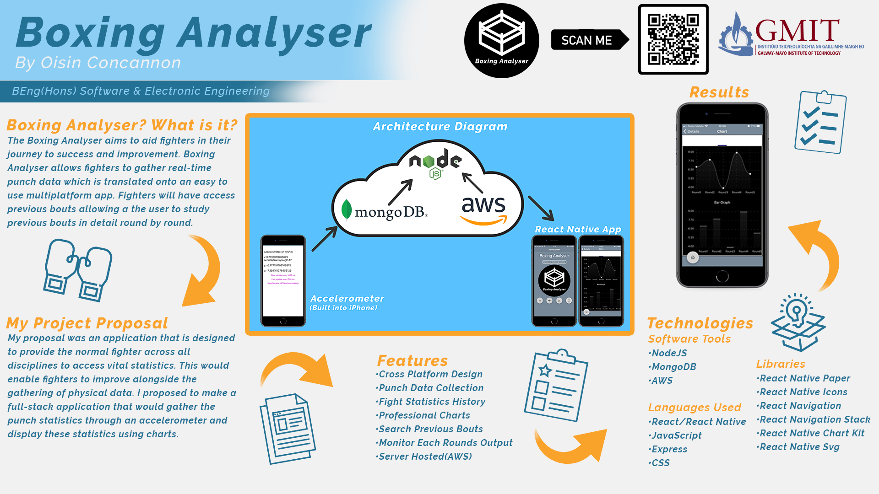

# Introduction

Firstly as an introduction to this report I would like to introduce myself. My name is Oisin Concannon and I am a final year student studying Software and Electronic engineering. As part of this final year we are tasked with the design of a final year project. Due to my immense interest in martial arts I decided to base my project on this topic as I feel I have the knowledge and the passion to design something useful.

This was a yearlong module and it was over the duration of seven months. Over the course of two semesters I have put together the “Boxing Analyser”, this project is very close to what I had envisioned at the beginning of the year. With some more time I would make some useful additions to make the application even more feature based and user friendly.

The aim of this project was to provide a simple but professional user interface that would allow martial artists to gather real tine data with the ability to retrieve previous bouts and study them in greater detail. Boxing Analyser solves these issues and provides physical data to fighters.

Its ease of use is vital as this application does not require the bells and whistles of much more complex projects. Using react native I created a very practical user interface. React Native was the backbone for the application. MongoDB provides the database aspect of the project allowing fighters to store data into columns and retrieve them at a later date if they wish. Lastly, the project is hosted using Amazon Web Services (AWS). Using AWS allows me to share the application with others and give them access to the client side of the application. This entire project was planned using Microsoft Project and was regularly used as a reference.

In this report I will discuss in greater detail, the scope of this project and the timeline as well as my approach and problem solving.

# Project Background

## Martial Arts

Martial arts is not as popular as some mainstream sports and people can often be misinformed on the subjects. Hopefully in this section I can give more of an insight into the inspiration and the background for this project.



Figure 4‑1 My First Bout

I have been training in the discipline of kickboxing for four years and I have become obsessed with learning and improving constantly. Due to this passion for improvement and the opportunity to complete a final year project, it granted me the chance address this topic. I was presented with the opportunity to assist fighters in terms of their personal improvement and development as a fighter.

## Front End Development

As I have developed over the duration of this course, I have slowly gravitated towards the front end aspect of software development. I feel there is a more visual and interactive characteristics. Due to this I chose to design a full stack application using MERN stack (Mongo, Express, React, Node).

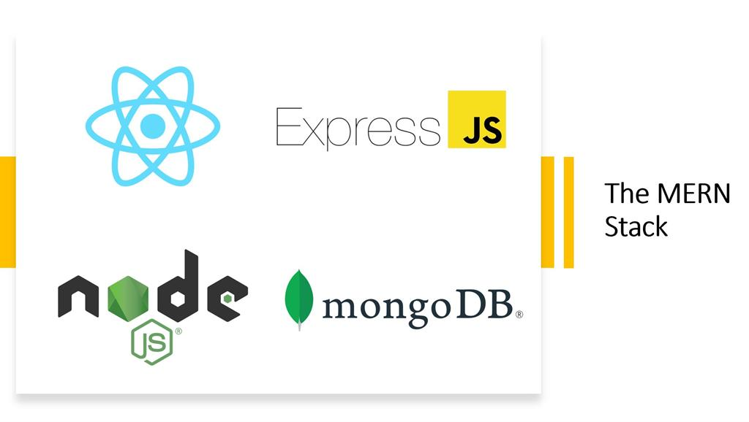

[1] Figure 4‑2 MERN Stack

React Native provided a professional framework that had a smooth learning curve. It enabled me to develop a cross platform application. This is a massive advantage as my application can appeal to users across all platforms. A major advantage also in the selection of React Native is the ability to only create one project that can function across all platforms. This is highly efficient and aids developers in the creation of such applications.

# Project Architecture

Below is my architecture diagram. As can be seen, an accelerometer sends data to the cloud. This data is handled by NodeJS which is hosted on AWS. NodeJS then sends this data to my React Native application. The data across the five rounds is gathered and stored in MongoDB alongside some user details such as name, opponent name and date. These bout details can be retrieved at any point using the search feature. The punch data across five rounds is then used to spin up charts as can be seen on the right hand side.

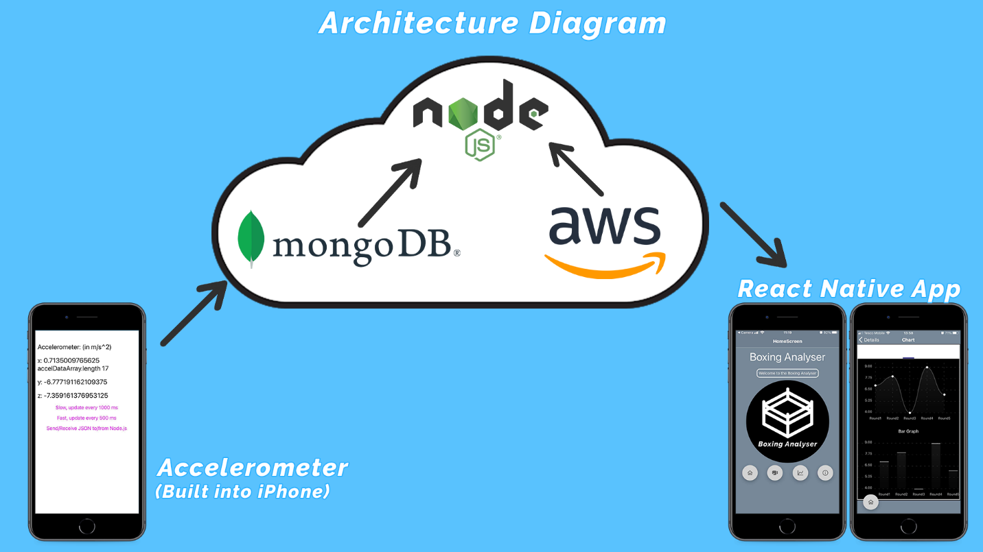

Figure 5‑1 Architecture Diagram

# Project Plan

# React Native

In this section I will discuss in detail the use of React Native and the reasoning about using this approach. I will break down some of the key features that were used with regards React Native.

“React Native combines the best parts of native development with React, a best-in-class JavaScript library for building user interfaces” [2]. This was one of the driving forces behind this viewpoint. The ability to create native applications is a massive advantage that suited the style of project I was creating.

## React Navigation

React Navigation is a very functional way of moving between screens in an application. “React Navigation provides a straightforward navigation solution, with the ability to present a common stack navigation and tabbed navigation patterns on both Android and iOS” [3]. Firstly I was required to make a stack, this is a common container for all the screens required. As can be seen below, we have created a navigation container and then inside this we declare our screen. I have only used one screen in this example called “HomeScreen”.

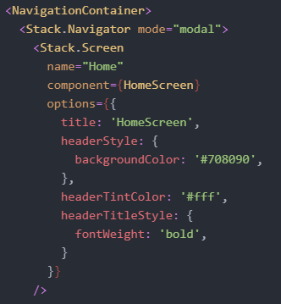

Figure 7‑1 Stack Navigation Container

The component name needs to be identical to the import component name to allow me to use a multi file structure. As can be seen in “Figure 7-2”, the component that is being imported is identical in name to the component in the stack navigator and this allows me to import functions/screens from separate files keeping my “App.js” (or main file) clean and clutter free.



Figure 7‑2 Component Import

I also provide a route to the screen. This route is used when I require to move to another screen. Below I will provide an example and explain how this functions.

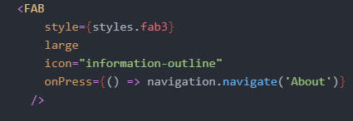

Figure 7‑3 Navigation Route

When an action is performed, in this case its “onPress” we call the function “navigation.navigate()” and we pass it the route and in this example the route is “About”. This “FAB”[4] when pressed will navigate to the route “About”. It’s a very simple yet effective method of moving throughout various screens in react native applications.

## Picker

Photographs are not technical diagrams and are not a good substitute for professional technical diagrams. Use photographs to enhance a report, but not as a replacement for diagrams.

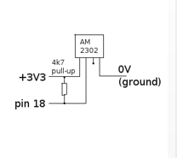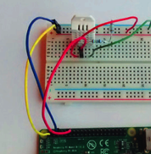

V

Figure 6‑2 A photograph is not a replacement for a circuit diagram

In describing software, you need diagrams and/or summaries of software design & layout. It is not sufficient to just paste some code. You should describe what your code is designed to do, in English. If you decided to put your code in functions or libraries or objects, describe this architecture. One good layout is to include a snippet(s) of code alongside an explanation. You do not have to explain every part of your code, pick the important parts.

Write out any mathematical equations or calculations that are important in your project and explain them.

Include details of any major problems or challenges you encountered in an area, and how you solved them.

# Accelerometer

# Charts

# Ethics

Include a short section on ethical considerations in your project or in the field of study of your project.

# Conclusion

Write a short conclusion. What is the outcome of the project? Perhaps you have a product prototype, or some results, or a demonstratable system.

Do not use your conclusion to tell the reader what you might have done if you had more time, but keep it focussed on what you actually have done. You can mention future opportunities for further development of the work, but keep this part short.

# Appendix

AWS – Amazon Web Services

FAB – Floating Action Button

# References

[1] MERN Stack Image: https://csharpcorner.azureedge.net/article/what-is-mern-stack/Images/The%20MERN%20Stack.jpg

[2] React Native: <https://reactnative.dev/>

[3]React Navigation: https://reactnative.dev/docs/navigation#:~:text=If%20you%20are%20getting%20started,on%20both%20Android%20and%20iOS.

[4] React Native FAB: https://callstack.github.io/react-native-paper/fab.html