Advanced Forest Fire Prediction System
From School Project to Systems Engineering
STUDENT  330861 | WORD COUNT  776 words | SUBMISSION  ISE Route A — 200pts

SECTION 1
Overview of Work
This project began as a standard Leaving Certificate coursework assignment but I have completely re-engineered it into an advanced environmental monitoring system. My goal was to move beyond a simple idea into real world monitoring and prediction systems.

My system consists of 2 separate components, the Python file and my Micro:bit. My Micro:bit gathers data such as light, temperature and soil moisture and then sends it via USB Serial to the Python file. The Python file handles all of the calculations, GUI and graphing,

Technical Deep Dive: The McArthur Index
The core of the system's intelligence is the implementation of the McArthur Forest Fire Danger Index (FFDI).This is the official equation used by Australian fire services. Unlike my original project, which used a simple weighted formula, this one implements the actual differential equation:

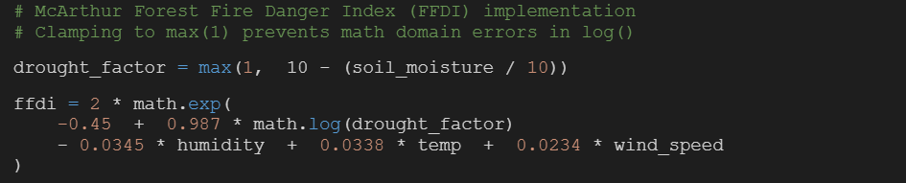

In the beginning the app would crash with a ValueError: math domain error.When debugging it I found out that the soil moisture was quite high, the drought_factor could drop to zero or even in the negatives. Since you cannot get the log of 0 or negative numbers it would produce an error. I solved this with clamping logic (max(1, ...)), this ensures that the inputs remain valid.
Machine Learning Integration
My second major addition was a Machine Learning Predictor. Using Gemini AI as my tutor, I researched time series forecasting with scikit-learn. My first attempt failed miserably as it treated days as independent numbers. To fix this I tried a 7-day sliding window approach by training the model on the previous 7 days in order to predict the 8th. My system learns to recognise patterns rather than just looking at raw values, making it far more accurate.

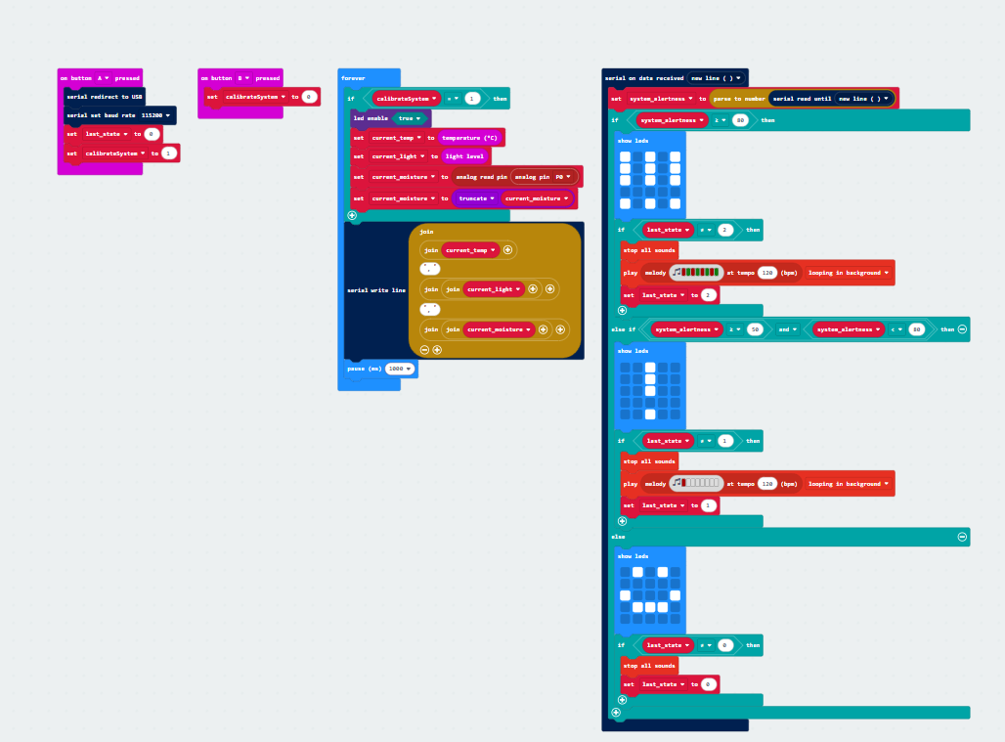

SECTION 2
Project Impact
My motivation for this project comes from the 2019-2020 Australian Forestfire season. Watching the sheer scale of that issue allowed me to realise the importance of this issue. I realised that knowledge of all variables allows us to perfectly predict outcomes in almost all cases, so this is what I set out to do.

Climate Change Simulation
The most impactful feature is the Climate Change Simulation. I build a set of adjustable environmental variables that allow for a wide range of simulations and scenarios to be run and tested (e.g. +2°C temperature). When I ran this on my seasonally generated data set which I generated by implementing a seasonal curve through the use of a sine wave, the results were apparent. This transforms my project from a simple school experiment to a real, scalable tool.
Adaptive Alertness Algorithm
To make the system practical in a real monitoring context, I developed an Adaptive Alertness Algorithm. Raw sensor data is annoying and useless to the untrained eye. I designed a smoothing approach.
- Slow increase (0.1 factor) — prevents false positives from momentary spikes.
- Fast decrease (0.5 factor) — ensures the "All Clear" is given quickly once danger passes.
This makes the system practical by preventing false alarms and ensuring the alertness falls realistically.

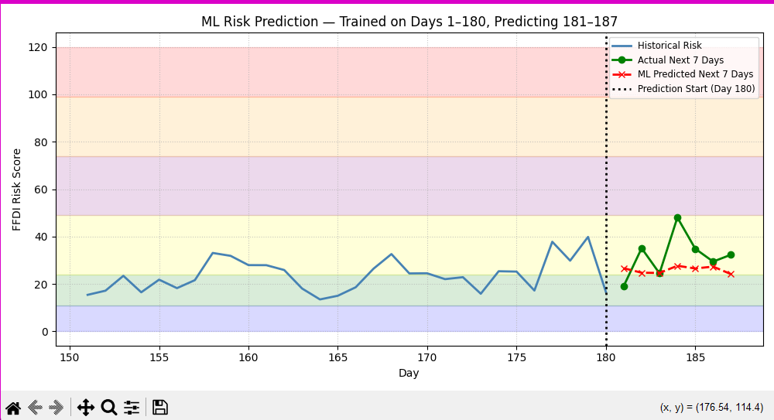

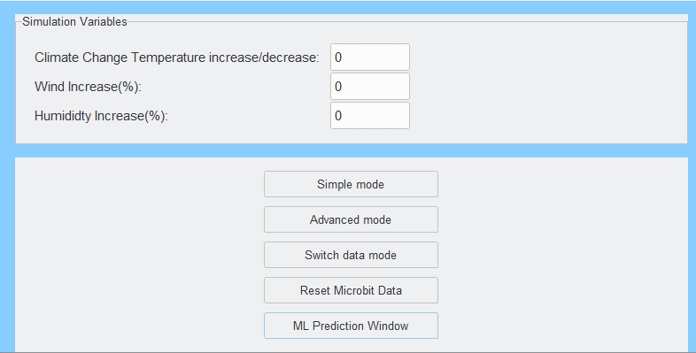

SECTION 3
Reflection and Improvements
User-Centric Iteration
User testing was extremely important to this project's success. Feedback I received from peers stated that my GUI looked outdated and that the graphs were hard to understand due to just raw risk numbers being shown. In response to this, I upgraded the GUI using ttkthemes "breeze" theme for a much more modern look, and also added colour coded Danger Zones to all of the graphs, making the data far more readable.

Data Lessons
One of the hardest hidden bugs involved data. The Python serial reader kept crashing with UnicodeDecodeError. I discovered that my Micro:bit kept on sending the ° symbol as extended ASCII, which python's UTF-8 decoder was not a fan of in the slightest. I wrote a filter in order to clean data before processing.
Future Vision
If I were to have a little more time with this project, I would try to make use of LoRa radio modules to allow multiple separate Micro:bits to communicate with one centralised hub, and visualise this sensor network on a Folium map. I think this could actually help people rather than just keeping this as a passion project.
In conclusion, this project changed my outlook on writing programs. It opened my eyes to the real world implementation of Software Engineering rather than just messing around with loops and if statements that just print things to terminal. It really opened my eyes to the practicality of Software Engineering.

Full Source Code Here

