目录
一、基于深度学期基础的深度学习曲线回归项目 2
1.1.项目简介 2
1.2项目原理 3
1.2.1深度学习输入 3
1.2.2网络层 3
1.2.3输出层 4
1.2.4定义损失函数与优化器 5
1.2.5开始迭代 5
1.2.6显示频率设置 5
1.2.7深度学习输出 6
1.3编程实例与步骤 7
1.3.1启动服务 7
1.3.2拖出组件并连线 7
1.3.3验证 8
1.3.4运行 9
1.4运行代码与结果 9

一、基于深度学期基础的深度学习曲线回归项目

1.1.项目简介
本项目基于深度学习基础理论，搭建单隐藏层全连接神经网络，完成非线性曲线回归任务。项目以离散样本散点数据集作为输入，通过神经网络自动学习数据之间的非线性映射关系，拟合出数据背后的曲线规律。
项目完整复现深度学习训练全流程：数据加载、网络前向传播计算、网络参数初始化、损失函数计算、反向传播链式求导、梯度下降参数迭代更新。训练过程中实时绘制损失变化曲线与样本拟合效果，直观观察损失随迭代不断下降、模型逐步逼近真实数据分布的全过程。
本项目不依赖复杂深度学习框架封装，聚焦神经网络底层原理，重点理解前向计算、链式求导、梯度下降核心机制。通过可视化训练过程，验证神经网络具备拟合非线性曲线的能力，帮助理解深度学习回归任务的基本思想，掌握从数据输入到模型收敛的完整训练链路。

1.2项目原理

1.2.1深度学习输入
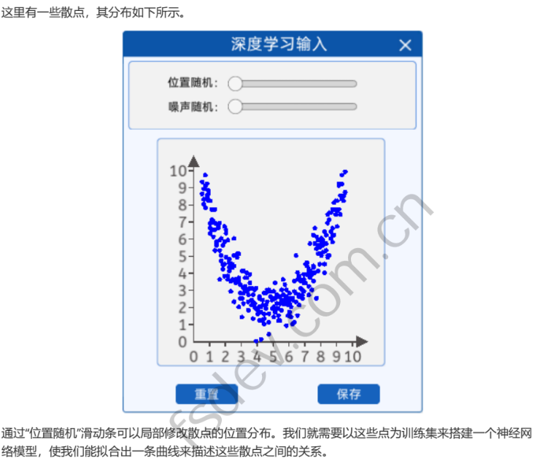

1.2.2网络层
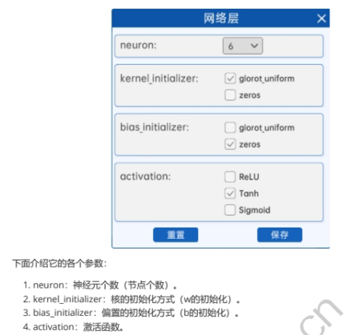

1.2.3输出层


1.2.4定义损失函数与优化器


1.2.5开始迭代


1.2.6显示频率设置


1.2.7深度学习输出
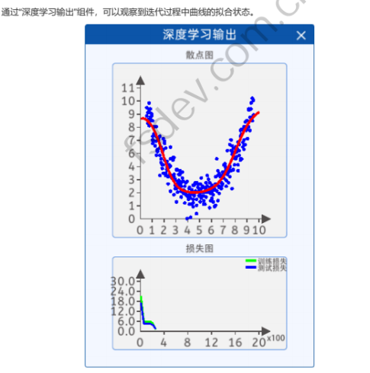

1.3编程实例与步骤

1.3.1启动服务


1.3.2拖出组件并连线
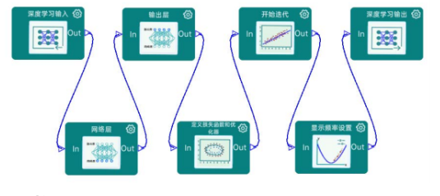

1.3.3验证


1.3.4运行
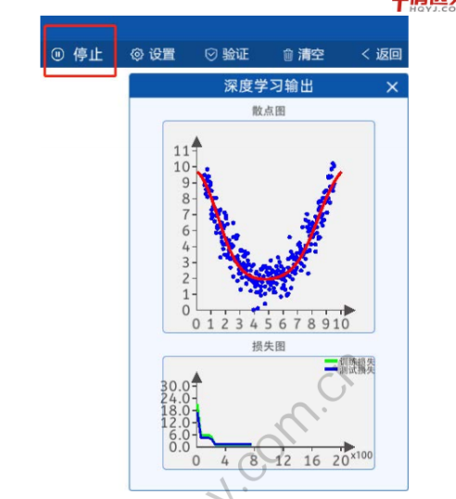

1.4运行代码与结果
import numpy as np
import torch
import random
import torch.nn as nn
import matplotlib.pyplot as plt
from IPython import display
import torch.nn.init as init

# 创造数据，数据集
point = [[0.5, 8.6], [0.5, 9.3], [0.6, 8.9], [0.6, 8.3], [0.6, 8.0], [0.7, 7.8], [0.7, 8.9], [0.7, 9.7],
[0.7, 9.1], [0.8, 9.2],
[0.8, 8.5], [0.8, 8.4], [0.9, 8.8], [0.9, 8.6], [0.9, 8.2], [1.0, 8.2], [1.0, 6.6], [1.0, 6.3],
[1.0, 6.9], [1.1, 7.1],
[1.1, 7.7], [1.1, 6.5], [1.2, 7.0], [1.2, 7.7], [1.2, 6.1], [1.3, 7.7], [1.3, 6.5], [1.3, 6.9],
[1.3, 5.3], [1.4, 5.7],
[1.4, 5.8], [1.4, 5.6], [1.5, 6.8], [1.5, 6.7], [1.5, 6.6], [1.6, 3.6], [1.6, 5.3], [1.6, 6.9],
[1.6, 5.9], [1.7, 6.0],
[1.7, 4.7], [1.7, 5.0], [1.8, 4.5], [1.8, 5.6], [1.8, 4.2], [1.9, 3.8], [1.9, 4.5], [1.9, 5.8],
[1.9, 6.7], [2.0, 6.5],
[2.0, 6.3], [2.0, 4.9], [2.1, 5.9], [2.1, 3.6], [2.1, 3.8], [2.2, 4.8], [2.2, 4.3], [2.2, 4.6],
[2.2, 4.1], [2.3, 3.5],
[2.3, 2.9], [2.3, 4.4], [2.4, 4.5], [2.4, 3.6], [2.4, 4.3], [2.5, 5.0], [2.5, 2.3], [2.5, 4.4],
[2.5, 6.0], [2.6, 3.4],
[2.6, 3.6], [2.6, 3.6], [2.7, 4.9], [2.7, 3.6], [2.7, 5.1], [2.8, 5.1], [2.8, 3.5], [2.8, 2.0],
[2.8, 3.7], [2.9, 2.5],
[2.9, 3.3], [2.9, 2.8], [3.0, 2.5], [3.0, 1.4], [3.0, 4.1], [3.1, 2.8], [3.1, 4.1], [3.1, 2.2],
[3.1, 3.1], [3.2, 3.2],
[3.2, 3.0], [3.2, 3.7], [3.3, 3.7], [3.3, 2.9], [3.3, 4.0], [3.4, 2.7], [3.4, 3.0], [3.4, 2.3],
[3.4, 1.8], [3.5, 3.4],
[3.5, 3.9], [3.5, 3.1], [3.6, 3.1], [3.6, 2.4], [3.6, 2.1], [3.7, 2.3], [3.7, 1.3], [3.7, 2.7],
[3.8, 2.0], [3.8, 2.2],
[3.8, 3.0], [3.8, 2.0], [3.9, 3.1], [3.9, 1.9], [3.9, 0.0], [4.0, 1.6], [4.0, 1.9], [4.0, 1.8],
[4.1, 2.6], [4.1, 2.0],
[4.1, 1.2], [4.1, 2.5], [4.2, 2.0], [4.2, 0.1], [4.2, 1.7], [4.3, 1.2], [4.3, 2.4], [4.3, 2.1],
[4.4, 1.3], [4.4, 1.0],
[4.4, 1.6], [4.4, 2.8], [4.5, 2.8], [4.5, 2.1], [4.5, 1.9], [4.6, 3.0], [4.6, 2.3], [4.6, 2.3],
[4.7, 3.0], [4.7, 0.4],
[4.7, 1.6], [4.7, 1.1], [4.8, 2.6], [4.8, 2.9], [4.8, 2.9], [4.9, 2.5], [4.9, 2.4], [4.9, 1.9],
[5.0, 1.9], [5.0, 2.9],
[5.0, 1.4], [5.0, 2.0], [5.1, 3.4], [5.1, 2.5], [5.1, 1.7], [5.2, 2.7], [5.2, 2.2], [5.2, 1.9],
[5.3, 1.5], [5.3, 2.6],
[5.3, 1.9], [5.3, 1.2], [5.4, 2.2], [5.4, 2.6], [5.4, 1.2], [5.5, 1.8], [5.5, 2.4], [5.5, 3.0],
[5.6, 2.7], [5.6, 3.6],
[5.6, 2.2], [5.6, 2.4], [5.7, 2.2], [5.7, 3.3], [5.7, 2.2], [5.8, 3.0], [5.8, 0.9], [5.8, 2.6],
[5.9, 2.5], [5.9, 1.5],
[5.9, 2.4], [5.9, 2.1], [6.0, 2.2], [6.0, 1.7], [6.0, 2.8], [6.1, 1.4], [6.1, 2.5], [6.1, 2.0],
[6.2, 2.5], [6.2, 2.5],
[6.2, 1.0], [6.2, 2.4], [6.3, 1.1], [6.3, 2.9], [6.3, 3.5], [6.4, 2.3], [6.4, 5.0], [6.4, 2.8],
[6.5, 1.5], [6.5, 4.0],
[6.5, 3.6], [6.6, 3.8], [6.6, 2.7], [6.6, 2.6], [6.6, 2.1], [6.7, 3.1], [6.7, 3.6], [6.7, 3.5],
[6.8, 2.7], [6.8, 3.0],
[6.8, 2.5], [6.9, 2.9], [6.9, 3.9], [6.9, 3.6], [6.9, 3.4], [7.0, 3.4], [7.0, 3.4], [7.0, 4.5],
[7.1, 3.9], [7.1, 4.6],
[7.1, 4.4], [7.2, 4.1], [7.2, 3.2], [7.2, 2.7], [7.2, 4.2], [7.3, 4.1], [7.3, 5.7], [7.3, 3.7],
[7.4, 3.0], [7.4, 4.0],
[7.4, 3.9], [7.5, 4.3], [7.5, 3.5], [7.5, 4.4], [7.5, 6.2], [7.6, 4.0], [7.6, 5.7], [7.6, 6.6],
[7.7, 6.1], [7.7, 5.4],
[7.7, 2.5], [7.8, 5.6], [7.8, 4.1], [7.8, 5.9], [7.8, 5.1], [7.9, 4.5], [7.9, 5.1], [7.9, 5.5],
[8.0, 5.8], [8.0, 5.0],
[8.0, 6.0], [8.1, 5.8], [8.1, 5.9], [8.1, 5.6], [8.1, 5.2], [8.2, 4.0], [8.2, 6.4], [8.2, 4.5],
[8.3, 6.2], [8.3, 5.7],
[8.3, 5.3], [8.4, 4.9], [8.4, 6.9], [8.4, 5.0], [8.4, 7.4], [8.5, 5.0], [8.5, 7.5], [8.5, 7.1],
[8.6, 6.4], [8.6, 6.0],
[8.6, 7.5], [8.7, 5.8], [8.7, 7.7], [8.7, 6.2], [8.7, 6.6], [8.8, 6.2], [8.8, 8.1], [8.8, 7.7],
[8.9, 7.4], [8.9, 8.2],
[8.9, 7.4], [9.0, 7.6], [9.0, 6.7], [9.0, 7.7], [9.0, 8.2], [9.1, 7.7], [9.1, 9.2], [9.1, 9.1],
[9.2, 8.5], [9.2, 7.4],
[9.2, 8.5], [9.3, 9.2], [9.3, 8.3], [9.3, 9.7], [9.3, 8.5], [9.4, 8.2], [9.4, 9.9], [9.4, 8.5],
[9.5, 9.9], [9.5, 8.7]]

# 将 point1 分割为训练集和测试集
random.shuffle(point) # 随机打乱数据
split_index = int(0.1 * len(point)) # 取前 10% 的数据作为测试集

train_point = point[split_index:]
test_point = point[:split_index]

x_train = np.array([point[0] for point in train_point])
y_train = np.array([point[1] for point in train_point])

x_test = np.array([point[0] for point in test_point])
y_test = np.array([point[1] for point in test_point])

# 转换为PyTorch的张量
x_train = torch.from_numpy(x_train).float()
y_train = torch.from_numpy(y_train).float()

def normal(bias):
return init.normal_(bias, mean=0, std=0.01)

# 2.定义前向模型
class YourModelClass(nn.Module):
def __init__(self):
super(YourModelClass, self).__init__()
self.layer1 = nn.Linear(1, 6)
self.layer2 = nn.Linear(6, 1)

# 初始化方式
init.xavier_uniform_(self.layer1.weight)
init.zeros_(self.layer1.bias)

def forward(self, x):
x = torch.tanh(self.layer1(x))
x = self.layer2(x)
return x

model = YourModelClass()

# 3、定义损失函数和优化器
criterion = nn.MSELoss()
optimizer = torch.optim.Adam(model.parameters(), lr=0.01, weight_decay=0.01)

# 初始化绘图
fig, (ax1, ax2) = plt.subplots(1, 2, figsize=(12, 6))

# 4、开始迭代
num_iterations = 2000
step_list = []
loss_list = []
test_step_list = []
test_loss_list = []

for n in range(1, num_iterations + 1):
# 前向传播
y_pred = model(x_train.unsqueeze(1))
# 计算损失
loss = criterion(y_pred.squeeze(1), y_train)

# 反向传播和优化
optimizer.zero_grad()
loss.backward()
optimizer.step()

# 更新右侧的损失图数据并绘制
step_list.append(n)
loss_list.append(loss.detach())

# 5、显示频率设置
frequence_display = 50
if n % frequence_display == 0 or n == 1:
# 清空Jupyter输出
display.clear_output(wait=True)

# 绘制左侧的拟合图
ax1.clear()
ax1.set_xlim(0, 10)
ax1.set_ylim(0, 10)
ax1.set_xlabel("x axis label")
ax1.set_ylabel("y axis label")
ax1.scatter(x_train, y_train)
x_range = torch.tensor(np.arange(0, 10, 0.1)).unsqueeze(1).float()
y_range = model(x_range).detach().numpy()
ax1.plot(x_range, y_range, 'r') # 绘制拟合线

# 计算测试集损失
y_pred_test = model(torch.tensor(x_test).unsqueeze(1).float())
loss_test = criterion(y_pred_test.squeeze(1), torch.from_numpy(y_test).float())
test_step_list.append(n)
test_loss_list.append(loss_test.detach())

ax2.clear()
ax2.plot(step_list, loss_list, 'r-', label='Train Loss')
ax2.plot(test_step_list, test_loss_list, 'b-', label='Test Loss') # 绘制测试集损失
ax2.set_xlabel("Step")
ax2.set_ylabel("Loss")
ax2.legend()
# 显示图形
display.display(plt.gcf())
# 清空Jupyter输出
display.clear_output(wait=True)

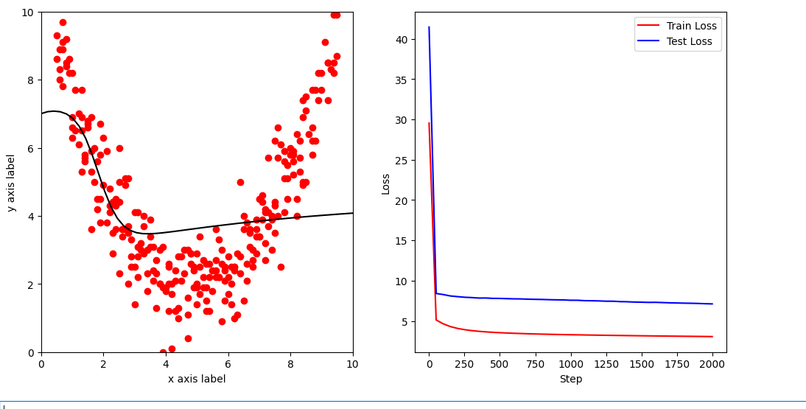
图1.4.1 数据分布结果
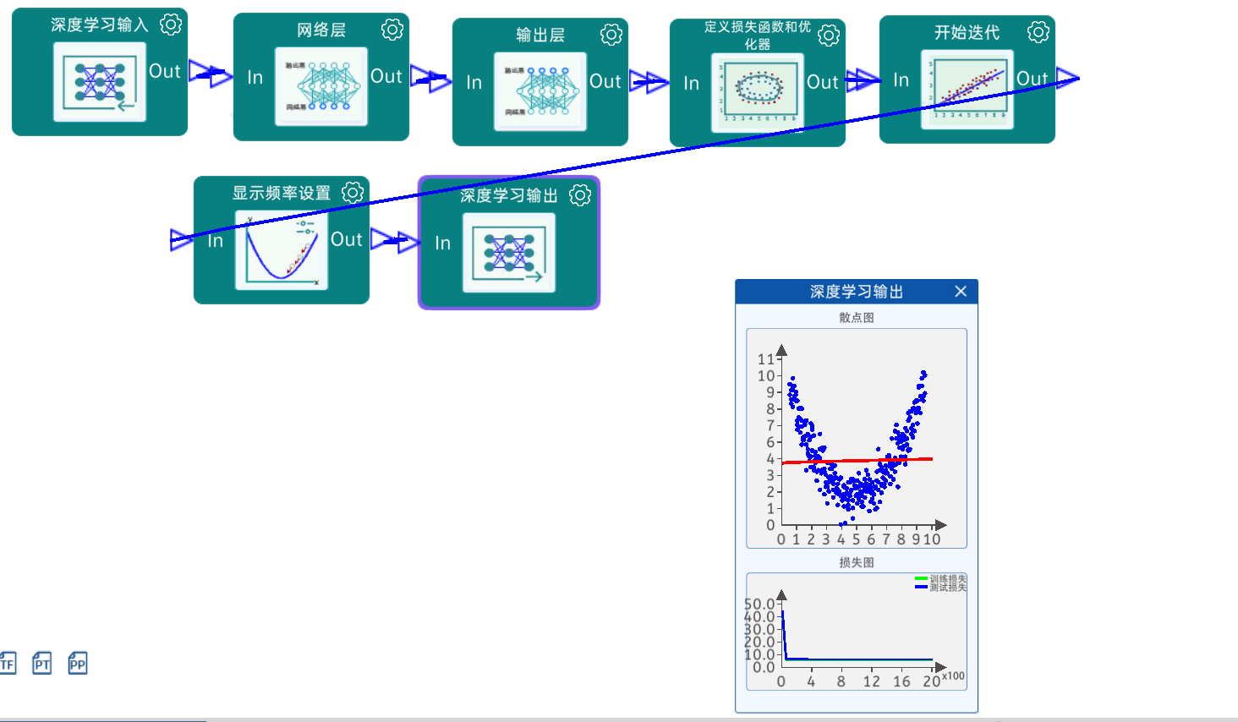
图1.4.2预测结果

