Oya İlayda Yalçın
60692
ENGR 421 Homework #3
23/11/2020
Naive bayes classifier
In this homework we were asked to implement A naive bias Classifier to classify the labels that were given to us as pictures. In order to do this implementation, the first step was to divide the test data and training data. Do data given to us had 195 pictures with 20 * 16 pixels. For training data, I have took 125 data and put them in an array called training set. For the test data I took the remaining 70 data and put them in an array called test set. In order to achieve this I have used some loops which are given at the beginning part of my code. In the end of this first part, the arrays that I had were two sets having the training and test data and two sets having the corresponding labels for these data. In addition the labels giving to us being A,B,C,D and E I made hot encoding in order to generate these labels as ones and zeros . The purpose was to be able to create the confusion matrix more easily.
After the step I estimated the parameters needed. The needed parameters to implement the classification were the class priors and prior class densities. The class priors are calculated via dividing the number of data associated with the labels with the number of total data in that corresponding set. In addition, the needed prior class densities are calculated by taking the average of all of the bits given in a label. In the end what I achieved was a set with 320 bits. These 320 bits were the average of bits of the data in a label. With this average that I have found I was able to create a heatmap that will show how a label looks by the data given to us. So in the end I was able to create a heatmap for every label and the heat maps are given below:
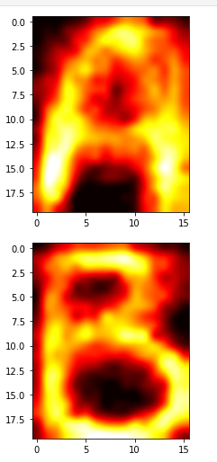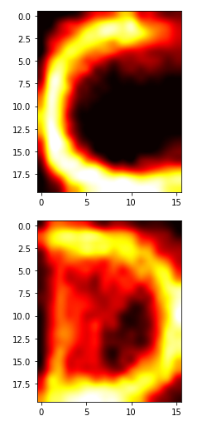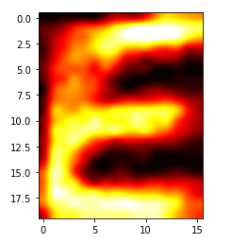
In addition the formula that I used in order to find the prior class densities is given below:
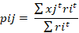
After calculating these prior densities I calculated the following score function for each data:
Using this score function I found the score of labels for each data. Later, finding the maximum score I was able to append the corresponding estimated label to every data in the test set and training set. Calculating the estimated labels for each sets the found confusion matrix for the training data and the test set data are also given below :

For training set:
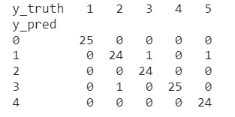
For test set:
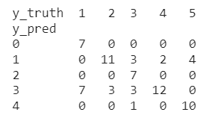
The reason why I use this score function was, the given data and the case made me understand that, we had to create a naive bias classifier where the distribution was Bernoulli. Xj’s being independent binary variables, taking the logarithm of class prior and the class prior density function the ending result was the formula given above. In the end since this is a naïve bias classifier the error function the error percentage is pretty high compared to other methods.

