Oya İlayda Yalçın
60692
ENGR 421 HW#4
In this homework we were asked to implement three nonparametric regression algorithms in code. To start this process first we had to divide data set given to us it which have contained 133 data points. We divided these data points into two parts 1st part was the training set which had 100 data points and the remaining 33 data points were given to test set.
The first part was to learn regressogram by setting the bin width parameter to three and origin parameter to 0. To achieve the desired graph the equation used is given below:
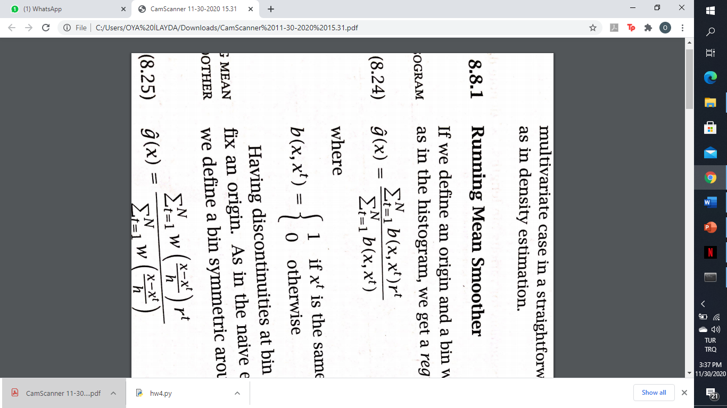
In addition to the equation that I give above the logic of this graph is to create left borders and rights borders for every space that I will be taking in my regressogram. I found the data interval for the left borders by taking the minimum value and maximum value minus the bin width with the step of the bin width. To find the right border I took points between minimum value plus bin width and maximum value with step value of bin width. Then I ran the algorithm given according to the borders that I have found.
The graph that I found for the regressogram with the bin width three is given below:
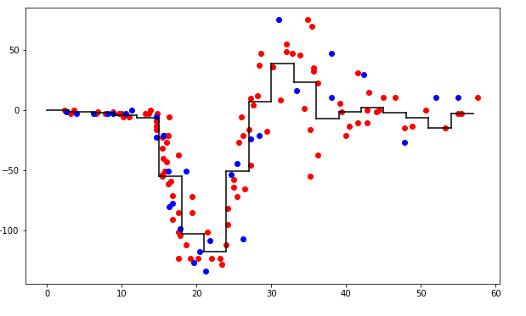
After this part we calculated the root mean squared error of our regressogram for test data data points. The equation used in order to find this root mean squared error is also given below:
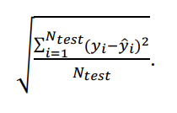
Using this equation the root mean square value that I found for the regressogram is given below:
Regressogram => RMSE is 24.725997719599928 when h is 3

The second part was to learn a running mean smoother by setting the bin width parameter to three. The reason to do this was that discontinuities at bin boundaries is disturbing as is the need to fix an origin as in the naive estimator in the running means smoother. We define a bin symmetric around x and average in there. I draw the training set data points, test set data points and my running mean smoother in the same figure. The figure and I end up with is given below:
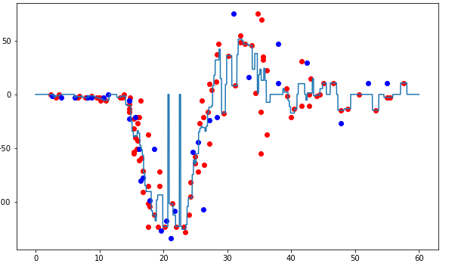
In order to come up with the graph given above I used the equation given below:
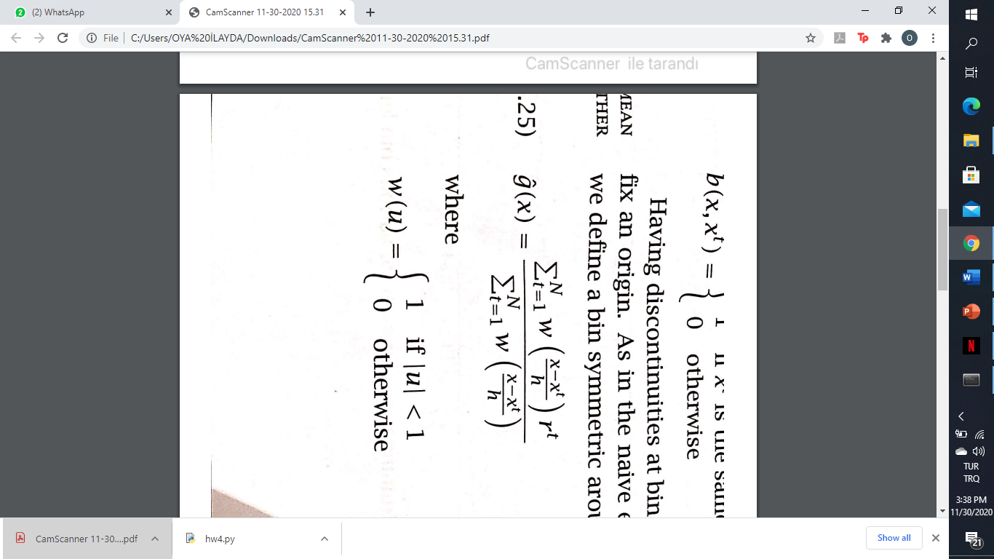
Next step was to find the root mean squared error off my running mean smoother. in order to find this value I again use the equation I have given above for the root mean squared error algorithm. In the end the value that I found for running mean smoother is given below:
Regressogram => RMSE is 28.650049130654672 when h is 3

In the third part of this homework we were asked to learn a kernel smoother by setting the bin with parameter to one. I draw the training data points test data points in my kernel smoother in the same figure in the end the figure that I came up with is given below:
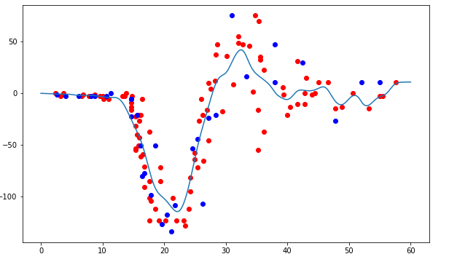
In order to find the graph given above I use the formula given below :
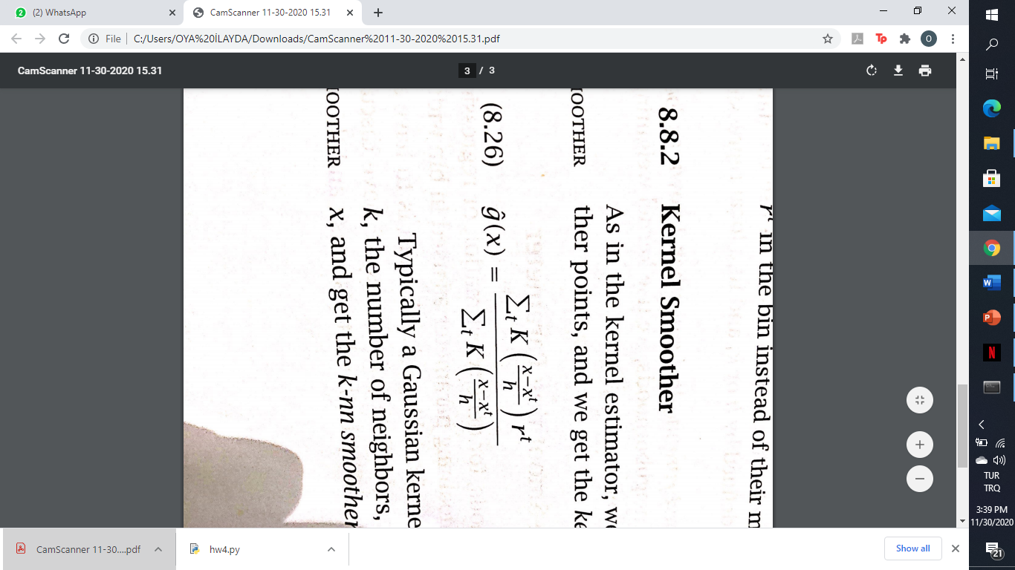
For the formula given above, I have used a Gaussian Kernel, which has the formula:
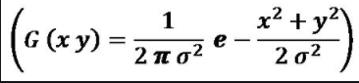
After finding the graph I had to find the root mean squared error of my kernel smoother in order to find this I again used the root mean squared error formula that I have given above in the end the value that I found for my kernel smoother is given below:
Regressogram => RMSE is 24.175338186742685 when h is 1

