- All students’ undergoing Practicum/OJT is required to submit a soft bounded written report after completing the
program. The contents of the bounded report are as follows:

  - Title Page
  - Table of Contents
  - Chapter I Introduction
  - Chapter II Company Profile
Brief History/Background of the Company/Agency
(Include Contact Details)/Company Profile (Mission, Vision, Objectives, Organizational charts, etc.)
  - Chapter III Daily and Weekly Progress Reports Compilation
  - Chapter IV Pertinent Documents Letter of Application Acceptance Letter Waiver Form
Certificate of Completion (photo copy) Practicum Form
  - Chapter V Assessment of Practicum Program
Reaction Paper by the student with the following suggested content
    - What have I learned from the program? (Technical)
    - My experiences with the people around me during Practicum
    - The most memorable event during my Practicum
    - What can I recommend for the improvement of the Practicum program?
    - My advice to those who will take their practicum in the near future.
  - Annexes
Annex A Pictorials
(pictures during the Practicum with proper label)
Sample 1. During at work
Sample 2. Colleagues at the department/unit Sample 3. Picture with the superior
Annex B Sample document work
(can include sample documents done during Practicum with permission from the department/unit)


Annex C Daily Time Record Sheet

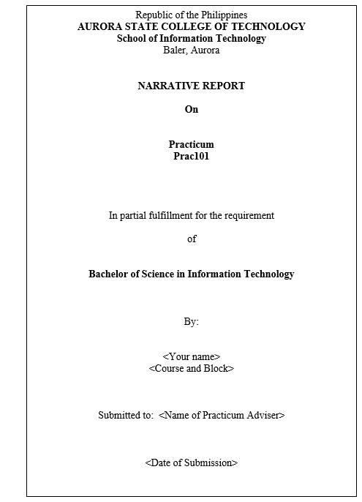
Title Format

Document Specifications:
- Short bond paper (8 ½ x 11)
- Margin: 0.75 inch on all margin with 0.7-inch gutter at left side
- Font: Default font (Time New Roman Size 12)
- With proper paging (using footer)
- Orientation: Portrait



Annex E

STUDENT DAILY ACTIVITY SHEET

STUDENT TRAINEE : AREA OF SPECIALIZATION : SUPERVISOR : DEPARTMENT/SECTION :

DATE | STUDENT ACTIVITIES | SUPERVISORS SIGNATURE

REMARKS:






PRACTICUM
SUPERVISED WEEKLY PERFORMANCE RATING SHEET

DAILY ACTIVITIES | INCLUSIVE DATES | RATING | SUPERVISOR’S  SIGNATURE

RATING GUIDE:
9-10 Outstanding
7-8 Above Satisfactory
5-6 Satisfactory
3-4 Need Improvement
1-2 Poor

