***I535 ASSIGNMENT 2: DATA TYPES AND STRUCTURES***

**OJAAS HAMPIHOLI – 03/02/2020**

The Project Summary page has been updated as follows:

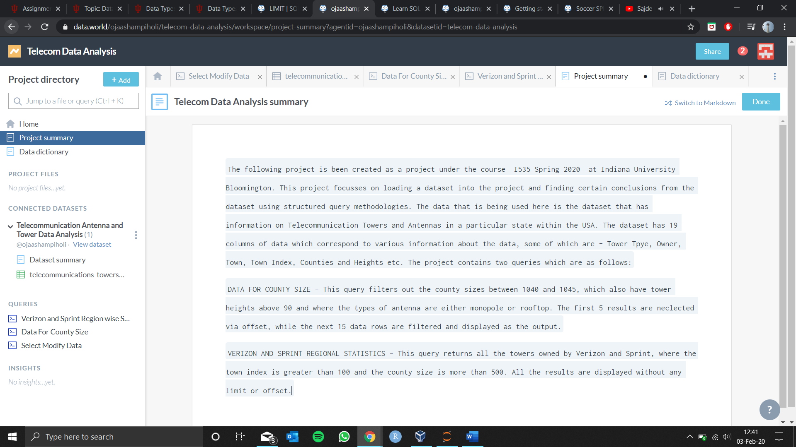

The Data Dictionary page contains the brief description of the data stored in each column:

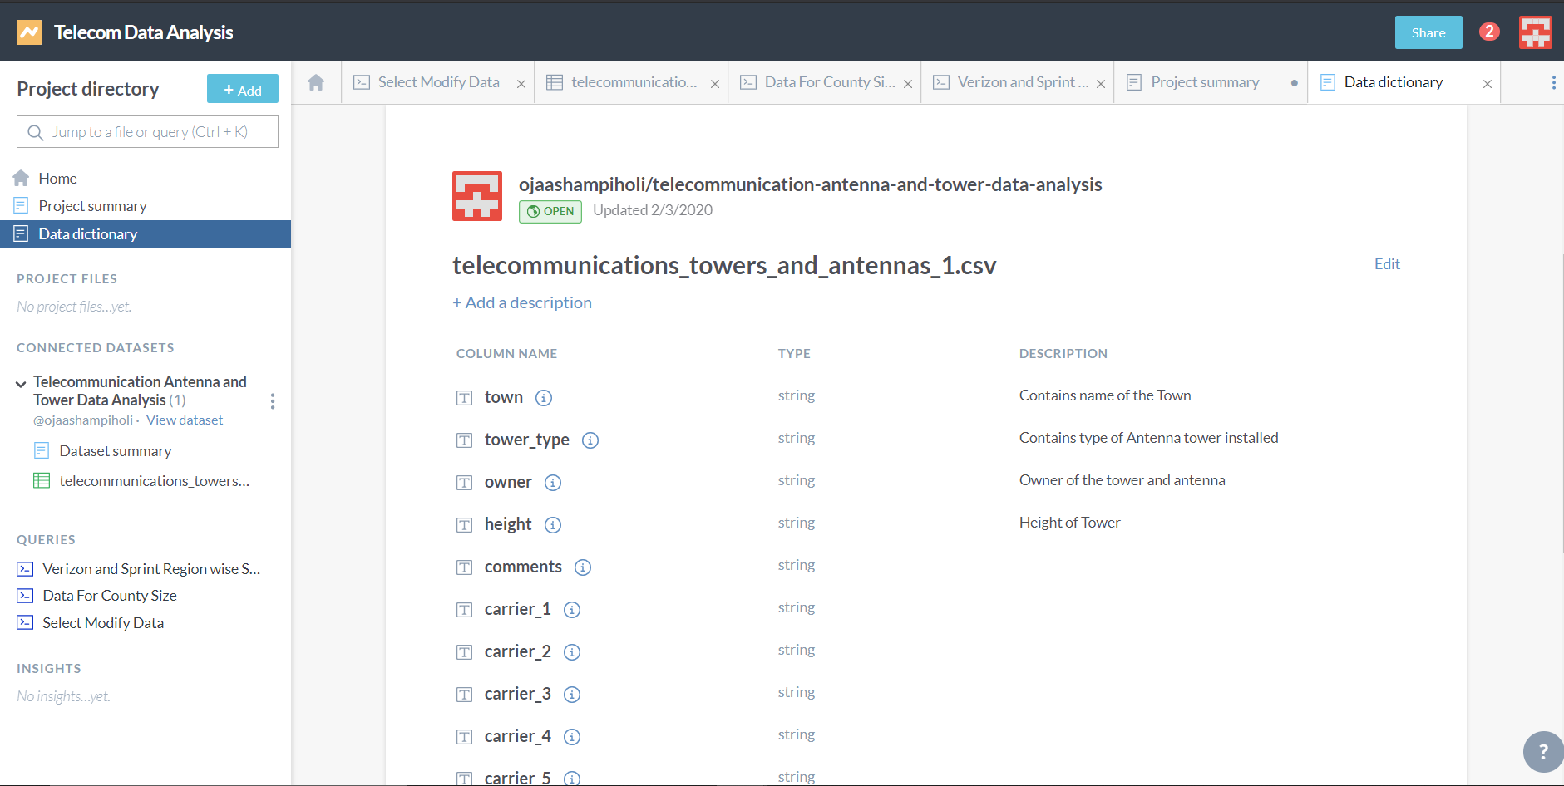

The first query mentioned in the Project Summary titled “Data for County Size” has been implemented as follows:

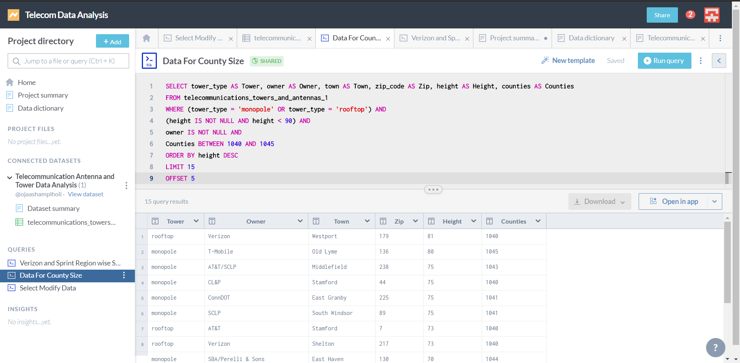

The second query mentioned in the project summary titled “Verizon and Sprint Region wise Statistics” has been implemented as follows:

