BigDataProjectB

Ojaas Hampiholi

4/25/2020

## Warning: package 'tidyverse' was built under R version 3.6.2

## -- Attaching packages ---------------------------------------------------------------------------------------- tidyverse 1.3.0 --

## v ggplot2 3.2.1 v purrr 0.3.3  
## v tibble 2.1.3 v dplyr 0.8.3  
## v tidyr 1.0.0 v stringr 1.4.0  
## v readr 1.3.1 v forcats 0.4.0

## Warning: package 'tidyr' was built under R version 3.6.2

## Warning: package 'readr' was built under R version 3.6.2

## Warning: package 'purrr' was built under R version 3.6.2

## Warning: package 'dplyr' was built under R version 3.6.2

## Warning: package 'forcats' was built under R version 3.6.2

## -- Conflicts ------------------------------------------------------------------------------------------- tidyverse_conflicts() --  
## x dplyr::filter() masks stats::filter()  
## x dplyr::lag() masks stats::lag()

## Warning: funs() is soft deprecated as of dplyr 0.8.0  
## Please use a list of either functions or lambdas:   
##   
## # Simple named list:   
## list(mean = mean, median = median)  
##   
## # Auto named with `tibble::lst()`:   
## tibble::lst(mean, median)  
##   
## # Using lambdas  
## list(~ mean(., trim = .2), ~ median(., na.rm = TRUE))  
## This warning is displayed once per session.

## `geom_smooth()` using method = 'loess' and formula 'y ~ x'

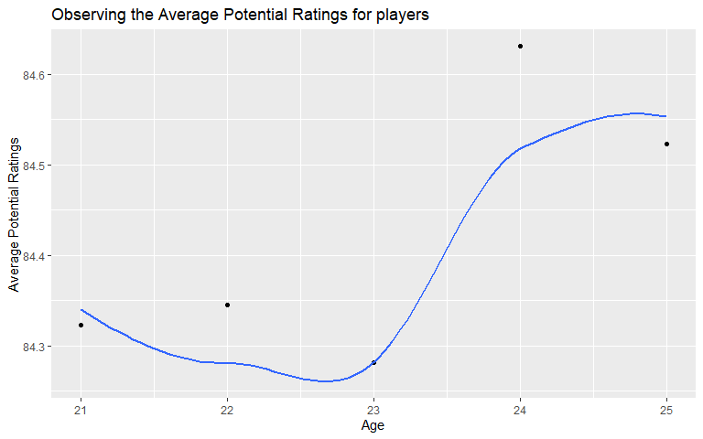

## `geom_smooth()` using method = 'loess' and formula 'y ~ x'

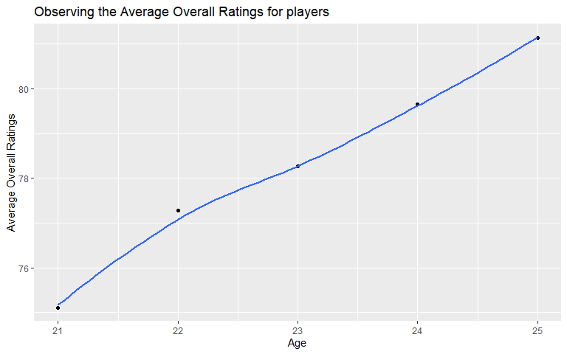

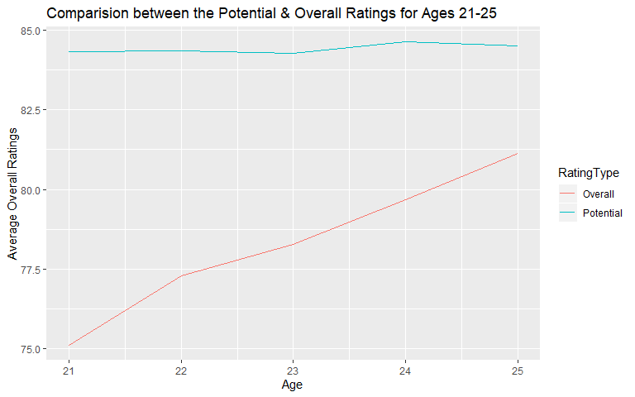

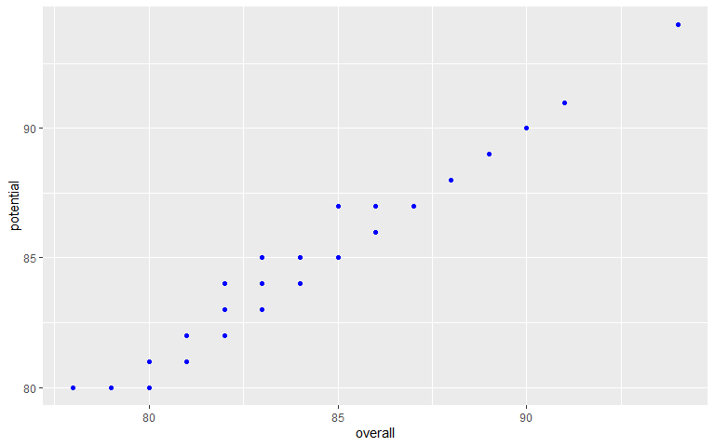

## `geom_smooth()` using method = 'gam' and formula 'y ~ s(x, bs = "cs")'

