Test Report Template

Name | Oraldo Jacinto Simón | Date | 6-03-2017
Project/Task | Programa 2

Test Name/# 1 | Amount of LOC Program1
Test Objective | Count the code lines of the Program 1
Test Description | Count each physical line as one LOC.  Do not count blank lines, imports, comment and docstring only lines.
Test Conditions | Go to the countloc.py file and put the directory address in the rootDir and path variable.
Expected Results
  Part Name | Number of item | Part size | Total size
  Calculate | 3 | 48
  ListaSE | 13 | 85
  main | 1 | 33
  Node | ​2 | 6
   |  |  | 172
Actual Results | 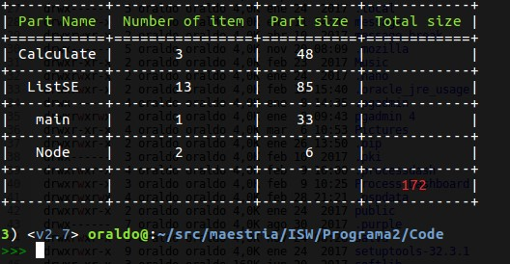

Test Name/# 2 | Amount of LOC Program2
Test Objective | Count the code lines of the Program 2
Test Description | Count each physical line as one LOC.  Do not count blank lines, imports, comment and docstring only lines.
Test Conditions | Go to the countloc.py file and put the directory address in the rootDir and path variable.
Expected Results
  Part Name | Number of item | Part size | Total size
  main | 1 | 35
  CountLine | 6 | 39
   |  |  | 74
Actual Results | 