Test Report Template

Name | Oraldo Jacinto Simón | Date | 12-04-2017
Project/Task | Programa 3

Test Name/# 1 | Amount of LOC Program3
Test Objective | Count the code lines of the Program3
Test Description | Count each physical line as one LOC.  Do not count blank lines, imports, comment and docstring only lines.
Test Conditions | Go to the countloc.py file in Program2 and place the address in the root directory and the path variable of the Program3 access.
Expected Results
  Part Name | Number of item | Part size | Total size
  CalculateRegression | 8 | 116
  main | 1 | 24
   |  |  | 140
Actual Results | 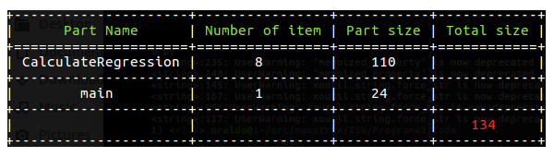

Test Name/# 2 | Verify that the linear regression parameters and the correlation coefficients.
Test Objective | Compare that the linear regression parameters and the correlation coefficients are correct.
Test Description | Calculate the linear regression parameters and the correlation coefficients and compare with the test case verifying that the values are correct. In this test case, the tests of the four test cases that come in the orientation of the exercise will be executed.  Test1 (col2, col4)  Test2 (col2, col5)  Test3 (col3, col4)  Test4 (col3, col5)
Test Conditions | The history.txt file must have data to be able to execute the general test case:
  Program  Number | Estimated  Proxy Size | Plan A & M Size | Actual A & M Size | Actual Develop  Hours
  1 | 130 | 163 | 186 | 15.0
  2 | 650 | 765 | 699 | 69.9
  3 | 99 | 141 | 132 | 6.5
  4 | 150 | 166 | 292 | 22.4
  5 | 128 | 137 | 271 | 28.4
  6 | 302 | 355 | 331 | 65.9
  7 | 95 | 136 | 199 | 19.4
  8 | 945 | 1206 | 1890 | 198.7
  9 | 368 | 433 | 788 | 38.8
  10 | 961 | 1130 | 1601 | 138.2
Expected Results
  Test | Expected Values
  Test1 | -22.5 | 1.7279 | 0.9545 | 0.9111 | 644.429
  Test2 | -4.039 | 0.1681 | 0.9333 | .8711 | 60.858
  Test3 | -23.92 | 1.4307 | .9631 | .9276 | 528.4294
  Test4 | -4.604 | 0.140164 | .9480 | .8988 | 49.4994
Actual Results | Since the expected results are rounded to 1, 2, 3, 4 and 6 places after the comma, it was decided to have uniformity in the values rounded to 3 places after the comma. If we observe well the results are the same except with this small detail.  