Test Report Template

Name | Oraldo Jacinto Simón | Date | 19-04-2018
Project/Task | Programa 4

Test Name/# 1 | Amount of LOC Program4
Test Objective | Count the code lines of the Program4
Test Description | Count each physical line as one LOC.  Do not count blank lines, imports, comment and docstring only lines.
Test Conditions | Go to the countloc.py file in Program2 and place the address in the root directory and the path variable of the Program4 access.
Expected Results
  Part Name | Number of item | Part size | Total size
  CalculateRelativeSize | 5 | 105
  main | 1 | 21
   |  |  | 126
Actual Results | 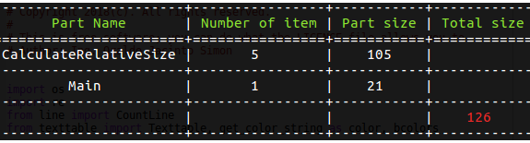

Test Name/# 2 | Verify that the relative size ranges are correct.
Test Objective | Compare that the linear regression parameters and the correlation coefficients are correct.
Test Description | Compare the values ​​of the output table of the exercise coincide with the current values ​​found by the execution of the Program 4
Test Conditions | The history.txt file must have data to be able to execute the general test case:  Table 1:  Tabla 2:
  Class name | Class LOC | Number of Methods
  each_char | 18 | 3
  string_read | 18 | 3
  single_character | 25 | 3
  each_line | 31 | 3
  single_line | 37 | 3
  string_builder | 82 | 5
  strind_manager | 82 | 4
  list_clump | 87 | 4
  list_clip | 89 | 4
  string_decrementer | 230 | 10
  Char | 85 | 3
  Character | 87 | 3
  Converter | 558 | 10
  Chapter | Pages
  Preface | 7
  Chapter1 | 12
  Chapter2 | 10
  Chapter3 | 12
  Chapter4 | 10
  Chapter5 | 12
  Chapter6 | 12
  Chapter7 | 12
  Chapter8 | 12
  Chapter9 | 8
  Appendix A | 8
  Appendix B | 8
  Appendix C | 20
  Appendix D | 14
  Appendix E | 18
  Appendix F | 12
Expected Results
   | VS | S | L | M | VL
  LOC/Method | 4.3953 | 8.5081 | 16.4696 | 31.8811 | 61.7137
  Pgs/Chapter | 6.3375 | 8.4393 | 11.2381 | 14.9650 | 19.9280
Actual Results | 