Test Report Template

Name | Oraldo Jacinto Simón | Date | 29-04-2018
Project/Task | Programa 5

Test Name/# 1 | Amount of LOC Program5
Test Objective | Count the code lines of the Program5
Test Description | Count each physical line as one LOC.  Do not count blank lines, imports, comment and docstring only lines.
Test Conditions | Go to the countloc.py file in Program2 and place the address in the root directory and the path variable of the Program5 access.
Expected Results
  Part Name | Number of item | Part size | Total size
  CalculateIntegrateSimpsonRule | 7 | 85
  Main | 1 | 22
   |  |  | 107
Actual Results | 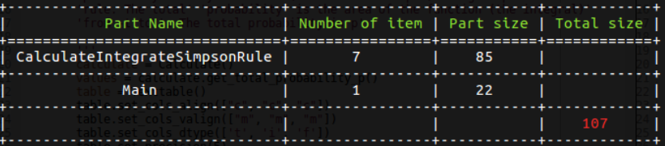

Test Name/# 2 | Verify that the total probability represents the area of ​​the function for each value from 0 to t is correct.
Test Objective | Compare that the total probability for each value of the test data table is correct.
Test Description | Compare the values ​​of the output table of the exercise coincide with the current values ​​found by the execution of the Program 5
Test Conditions | The history.txt file must have data to be able to execute the general test case:  Table 1:
  Test
  t | dof
  0 to 1.1 | 9
  0 to 1.1812 | 10
  0 to 2.750 | 30
Expected Results
  Test |  | Expected Values
  t | dof | p
  0 to 1.1 | 9 | 0.35006
  0 to 1.1812 | 10 | 0.36757
  0 to 2.750 | 30 | 0.49500
Actual Results | 