Test Report Template

Name | Oraldo Jacinto Simón | Date | 5-05-2018
Project/Task | Programa 6

Test Name/# 1 | Amount of LOC Program6
Test Objective | Count the code lines of the Program6
Test Description | Count each physical line as one LOC.  Do not count blank lines, imports, comment and docstring only lines.
Test Conditions | Go to the countloc.py file in Program2 and place the address in the root directory and the path variable of the Program6 access.
Expected Results
  Part Name | Number of item | Part size | Total size
  Searchtdistribution | 3 | 50
  Main | 1 | 22
   |  |  | 72
Actual Results | 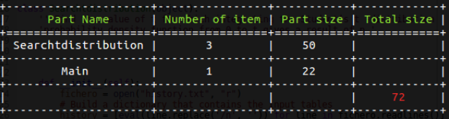

Test Name/# 2 | Verify that each value t is correct.
Test Objective | Compare the value´s t for each value of the test data table is correct.
Test Description | Compare the values ​​of the output table of the exercise coincide with the current values ​​found by the execution of the Program 6
Test Conditions | The history.txt file must have data to be able to execute the general test case:  Table 1:
  Test
  p | dof
  0.2 | 6
  0.45 | 15
  0.495 | 4
Expected Results
  Test |  | Expected Values
  p | dof | t
  0.2 | 6 | 0.553381
  0.45 | 15 | 1.753050
  0.495 | 4 | 4.604095
Actual Results | 