Test Report Template

Name | Oraldo Jacinto Simón | Date | 13-05-2018
Project/Task | Programa 7

Test Name/# 1 | Amount of LOC Program7
Test Objective | Count the code lines of the Program6
Test Description | Count each physical line as one LOC.  Do not count blank lines, imports, comment and docstring only lines.
Test Conditions | Go to the countloc.py file in Program2 and place the address in the root directory and the path variable of the Program6 access.
Expected Results
  Part Name | Number of item | Part size | Total size
  CalculateRequeriments | 8 | 86
  Main | 1 | 25
   |  |  | 111
Actual Results | 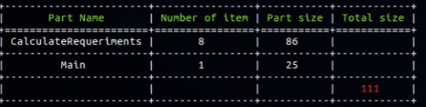

Test Name/# 2 | Verify that each value t is correct.
Test Objective | Compare the value´s t for each value of the test data table is correct.
Test Description | Compare the values ​​of the output table of the exercise coincide with the current values ​​found by the execution of the Program 7
Test Conditions | The history.txt file must have data to be able to execute the general test case:  Table 1:  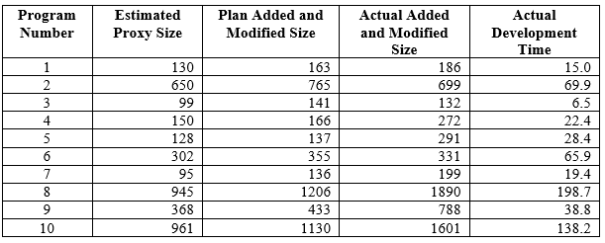
Expected Results | 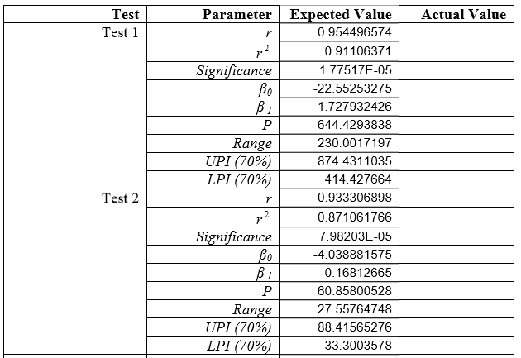
Actual Results | 