
CS4104 – COMPUTER GRAPHICS AND VIRTUAL REALITY
PROJECT / CASE STUDY REPORT
TITLE OF THE SELECTED CASE STUDY

Metro Station Crowd Evacuation Simulation Using Unity and Virtual Reality
Submitted by
Ojas B A
USN: 1RVU23CSE321
Under the guidance of
Dr. Shyam Mohan J S
School of Computer Science and Engineering
RV University, Bengaluru
Academic Year: 2026 - 27
RV UNIVERSITY
School of Computer Science and Engineering
CERTIFICATE
This is to certify that the CS4104 – Computer Graphics and Virtual Reality case study report titled “Metro Station Crowd Evacuation Simulation Using Unity and Virtual Reality” has been prepared and submitted by Ojas B A (USN: 1RVU23CSE321) of the School of Computer Science and Engineering, RV University, Bengaluru, during the academic year 2026 - 27. The report has been completed in accordance with the course requirements and the instructions provided.

Dr. Shyam Mohan J S
Faculty Guide

Abstract
This case study proposes a three dimensional crowd evacuation simulation for a busy metro station using Unity, with a possible virtual reality extension for training. The main problem is to represent many passengers who can notice an alarm, choose an exit and respond when their route becomes unavailable. A shared agent design combines simple behavioural states, individual walking characteristics, navigation over walkable surfaces and local collision avoidance. This approach reduces the need to script each passenger separately while allowing different actions to emerge from the same rules.
The report explains a conceptual station layout, the decision process for a blocked exit, and the visual, auditory and haptic channels needed for an immersive drill. It also addresses rendering, collision detection, frame time and the limits of crowd realism. An existing Unity evacuation demonstration is used as an external illustration, supported by a published crowd simulation and VR study. The proposed metro layout and VR features are design recommendations rather than features verified in that demonstration. Worked calculations illustrate route selection, frame budget and crowd density. A repeatable evaluation plan is provided for future implementation. The central conclusion is that a small set of understandable agent rules can support a useful classroom explanation of industrial crowd simulation, while practical evacuation assessment still requires calibration and validation.
Keywords: crowd simulation, metro evacuation, Unity, intelligent agents, NavMesh, virtual reality.
Selected topic: Case Study 4, Behavioral Simulation and Crowd Dynamics. This report presents a proposed solution and analysis of existing work. No new Unity execution, headset experiment or measured performance results are claimed. The classroom demonstration is credited to its original creator.

Contents
Section | Topic | Page
 | Abstract | 3
1 | Introduction and objectives | 5
2 | Metro station scenario and requirements | 6
3 | Computer graphics concepts | 7
4 | Agent modelling and autonomous behaviour | 8
5 | Exit choice and blocked route handling | 9
6 | Local movement and crowd behaviour | 10
7 | VR hardware and immersion | 11
8 | Sensory design and user interaction | 12
9 | System architecture and workflow | 13
10 | Unity project and demonstration | 14
11 | Performance and optimization | 15
12 | Evaluation plan and metrics | 16
13 | Applications and limitations | 17
14 | Conclusion and presentation guide | 18
 | References | 19–20
Assignment coverage: Sections 4 to 6 answer the agent modelling question. Sections 7 and 8 answer the hardware and immersion question. Sections 9 to 12 explain the proposed design, demonstration, optimization and evaluation. The report concerns Case Study 4, Behavioral Simulation and Crowd Dynamics.

1 Introduction and objectives
A metro station brings passengers into shared corridors, gates and stairs. During an evacuation, a route that appears close may become crowded or unavailable. A transport agency therefore needs to examine how passengers make decisions and where queues form before testing a procedure in a live station. A 3D simulation can make those interactions visible and allow the same scenario to be repeated with controlled changes.
Published work by Zhao et al. uses Unity and virtual reality to examine crowd management in the 2010 Love Parade setting [1]. It provides a relevant example of combining crowd modelling with an immersive view. Its findings concern a festival environment; the station design in this report is a separate proposed application.
The assignment asks how hundreds of virtual passengers can act autonomously, including reacting to a blocked exit or an emergency, and which VR devices and sensory cues support an authentic drill. The proposed solution uses reusable agents that perceive local conditions, select a goal and move through a simplified station. An instructor can change exit availability and review the resulting movement.
• Represent a station with recognisable platforms, stairs, gates and exits.
• Explain passenger decisions using a small, reusable set of behavioural rules.
• Show how route planning and local avoidance solve different movement problems.
• Specify practical VR equipment and consistent sensory feedback.
• Define performance budgets and evaluation metrics without inventing results.
The external example is the Generic Crowd Simulation Engine by Cain Ashmore, developed with Ricardo Goncalves [2]. Ashmore’s short video, “Evacutation Simulation,” provides a visual illustration of an evacuation scenario [3]. The report adapts the underlying idea to the metro assignment; it does not present the external work as a newly built student project.

2 Metro station scenario and requirements
The proposed station has a platform connected by two stairs to a concourse and two exits. Passengers begin in different locations. After an alarm, they move towards an available exit. A blocked Exit A forces affected passengers to consider Exit B. Figure 1 shows the intended arrangement, rather than a drawing of a particular real station.
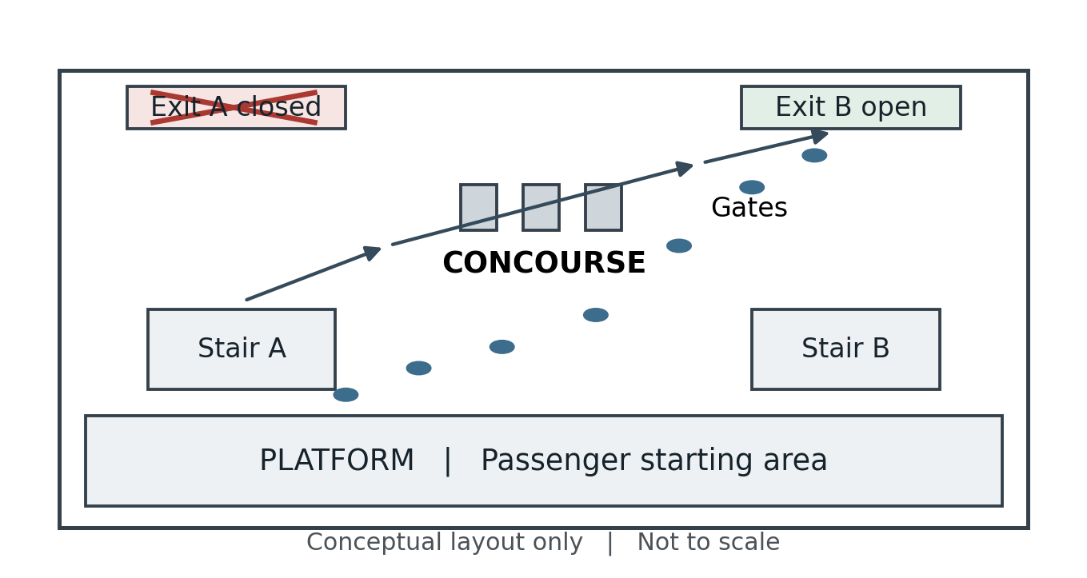
Figure 1 Proposed station layout and rerouting towards an available exit
Table 1 Main requirements of the proposed station model
Requirement | Behaviour to represent
Walkable space | Platforms, corridors and stairs connected by valid routes
Autonomous passengers | Different response delays, goals and preferred speeds
Changing conditions | An exit can close and trigger a new decision
Instructor review | Count arrivals, queues, stalled agents and elapsed time
For the first implementation, 100 to 300 passengers would be a useful test range, subject to profiling. These are proposed test sizes, not a demonstrated capacity. Walkable areas can be represented by a NavMesh [4]. Station dimensions and passenger distributions must be measured before the model is used to assess a real facility.

3 Computer graphics concepts
The station can begin with simple 3D meshes: boxes for walls and gates, planes for floors, and a ramp or stair mesh for vertical connections. Each passenger has a position and orientation in the station coordinate system. A shared passenger prefab provides a consistent visual form, while changes in scale and colour can help distinguish groups during analysis.
The rendering pipeline transforms vertices from each object’s local space into world space, then into the camera view and a projected image. A desktop demonstration uses a perspective camera; an immersive extension supplies a tracked view for each eye. Figure 2 summarises the relationship between the station model and the displayed image.
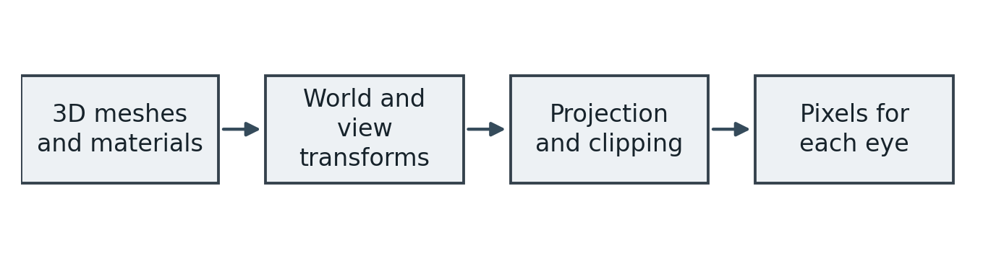
Figure 2 Simplified graphics pipeline for the station scene
Exit signs, door states and walking directions must be readable from the participant’s viewpoint. Simple materials and stable lighting are sufficient for the conceptual model. Decorative reflections and detailed textures add less explanatory value than a clearly visible bottleneck. The camera should show an overview first, then a passenger level view when discussing VR.
Near and far clipping planes define the visible depth range of a camera [5]. An unsuitable near plane can cut through a nearby passenger or a hand, while an unnecessarily distant far plane can waste depth precision. These settings must be checked at the station’s actual scale and with the headset’s supported camera configuration.
Walking animation should follow the agent’s movement speed so that feet do not visibly slide. A simplified capsule can represent personal space for movement and collision queries. The visible mesh, navigation radius and physical collider serve different purposes; matching their scale avoids agents appearing to pass through walls or overlap at narrow doors.

4 Agent modelling and autonomous behaviour
For Question 1, each passenger is an intelligent agent: a simulated individual that observes conditions and selects an action. Hundreds of agents can share one behaviour program and differ through parameters. Their routes are generated during the simulation rather than drawn manually for every person.
Each agent stores its state, position, selected exit, preferred speed and response delay. It senses nearby people and obstacles and receives scenario information. An uninformed passenger should not automatically know a closure, so visibility, signs and announcements can affect decisions.
A sensor can combine a local distance query with a line of sight test, so walls hide blocked doors. Announcements inform agents within an assigned area. Individual reaction delays prevent every passenger responding on the same frame.
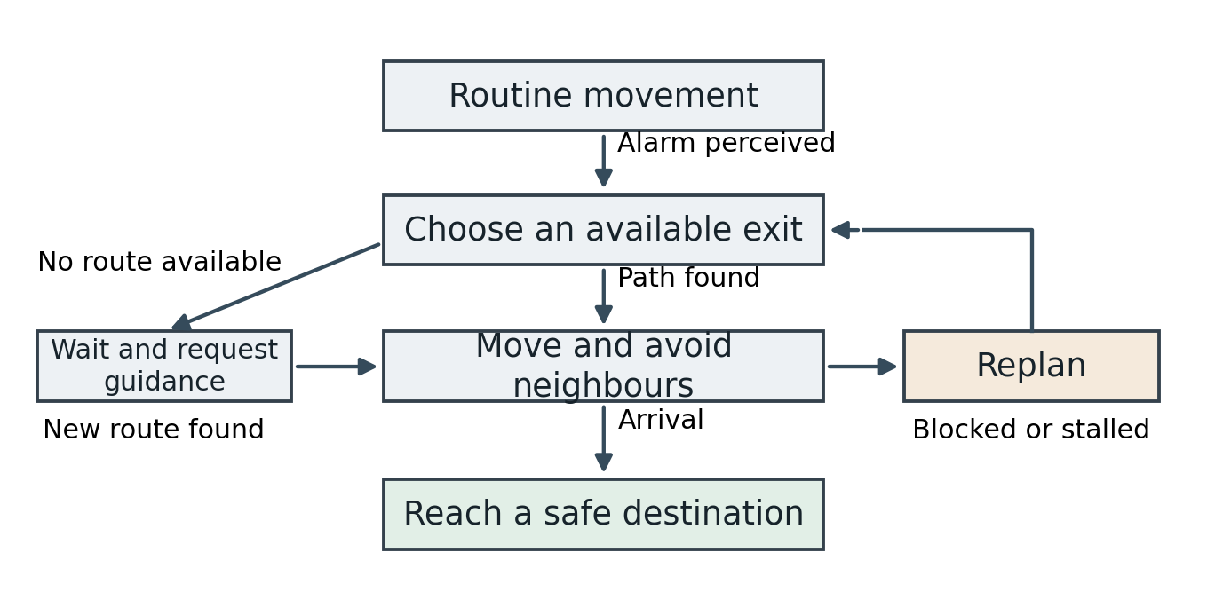
Figure 3 Proposed passenger state model including replanning and waiting
Different positions, response delays and walking profiles create varied interactions at the stairs. A state machine is suitable because its decisions can be inspected and explained. Unity distinguishes global navigation from local movement [6]: behaviour chooses the goal, navigation finds the route and movement follows it.
An agent without a valid route must enter a waiting or guidance state. It should remain visible to the instructor as unresolved rather than being removed or counted as evacuated. This makes failures in the procedure observable.

5 Exit choice and blocked route handling
A short path can still lead to a long queue. The proposed agent therefore compares reachable exits using estimated walking time, queue delay and a penalty for known undesirable conditions. Equation 1 is a simple design rule for this report, rather than a calibrated prediction of human exit choice.
$$C_{e} = \frac{L_{e}}{v_{i}} + T_{q,e} + λH_{e}$$
Equation 1 Illustrative exit cost with time measured in seconds
Here L is route length in metres, v is preferred speed in metres per second, T with subscript q is estimated queue delay, H is a dimensionless penalty and λ converts that penalty into seconds. Closed or unreachable exits are excluded before costs are compared. An exit must remain preferable for a short interval before an agent switches, to avoid repeated changes caused by small queue fluctuations.
The route length should come from a complete navigable path, rather than a straight line across walls. A queue delay can be estimated from recent exit flow and the number waiting. These estimates need smoothing; otherwise small changes can make passengers repeatedly switch exits. The estimates must also reflect what the agent is assumed to know.
Worked example: let v = 1.2 m/s and H = 0 for both exits. Exit A has L = 24 m and Tq = 12 s, so its cost is 24 ÷ 1.2 + 12 = 32 s. Exit B has L = 36 m and Tq = 0 s, so its cost is 36 ÷ 1.2 = 30 s. The agent selects B. These assumed numbers illustrate the rule; they are not measurements from the video.
1. Mark the exit unavailable and update the affected walkable connection.
2. Let informed agents invalidate the closed destination and request a new route.
3. Find reachable open exits, compare their costs and select an alternative.
4. Move along the new route while avoiding nearby passengers.
5. If no route exists, wait for guidance and log the unresolved agent.
A collider alone may produce local avoidance without changing the planned route. NavMesh obstacle carving can update the traversable surface; its update timing and stationary settings must be respected [7]. Replanning should use the updated navigation data, with requests spread across frames to avoid a sudden CPU spike.

6 Local movement and crowd behaviour
Route planning answers which corridors lead to an exit. Local avoidance answers how to move past the next person without an immediate collision. The proposed baseline uses NavMesh routing and the navigation agent’s movement and avoidance system [6]. Unity uses A* search over connected walkable polygons to find a route. A high level state machine supplies destinations, keeping the first implementation understandable.
The social force model treats changes in walking velocity as the combined effect of a desired motion and responses to neighbours and boundaries [8]. Equation 2 gives a simplified acceleration form for discussion. Attraction, random variation and contact forces are omitted.
$$\frac{dv_{i}}{dt} = \frac{v_{i}^{0}e_{i} − v_{i}}{τ_{i}} + \sum_{j ≠ i}{a_{ij}} + \sum_{B}{a_{iB}}$$
Equation 2 Simplified social force formulation expressed as acceleration
The first term turns the current velocity towards the desired velocity over a response time τ. The two sums describe responses to other pedestrians and boundaries. These social terms describe modelled motivations; they do not mean that ordinary avoidance is a literal physical push. For one unobstructed direction, if desired speed is 1.2 m/s, current speed is 0.6 m/s and τ = 0.5 s, the driving acceleration is (1.2 − 0.6) ÷ 0.5 = 1.2 m/s².
A future implementation could use this model instead of built in local avoidance, while retaining a global route. Both systems should not independently overwrite agent motion. Such an extension needs its own integration, parameter calibration and tests.
Navigation and physical collision handling also need a single authority over movement. A dynamic rigid body should not compete with the navigation controller to move the same passenger. Simple colliders can support contact queries, while the steering layer controls intended motion. At a narrow gate, failed avoidance and persistent overlap should be logged for inspection.
An emergency can be represented through varied response delays, stronger preference for familiar routes, changes in desired speed and increased following of nearby groups. These are proposed behavioural assumptions to test. Faster desired motion alone does not establish realistic panic. Queueing, hesitation, information and reduced mobility should remain visible; the model does not predict injury or certify an evacuation procedure.

7 VR hardware and immersion
For Question 2, the core proposed setup is a headset with positional and rotational tracking, a supported controller input method, spatial audio and a computer or standalone headset able to sustain its display rate. Presence depends on consistent feedback when the participant looks, moves and interacts. Table 2 separates the core equipment from optional additions.
Table 2 Proposed equipment and its contribution to the drill
Component | Role in the metro drill | Priority
Tracked VR headset | Shows a stereo view that follows head position and rotation | Core
Controllers or hand input | Selects controls, points at signs and supports interaction | Core input
Headphones or spatial speakers | Locates alarms, announcements and nearby crowd sounds | Core audio
Controller vibration | Confirms an action or signals a proximity cue | Basic haptic cue
Suitable compute device | Runs the scene, navigation and tracked rendering | Core
Haptic vest or body trackers | Adds body cues or more detailed avatar motion | Optional
Instructor display | Mirrors the scene and shows participant progress | Useful for review
Unity’s XR Interaction Toolkit supports controller input, interaction, locomotion and controller haptic feedback [9]. These are possible building blocks for the proposed extension; the external demo is not evidence that this integration has already been completed.
An expensive haptic suit is not essential to explain the scenario. Controller vibration can act as a symbolic cue, but it cannot reproduce the force or pressure of a physical crowd. In a classroom video, the audience sees the 3D behaviour on a normal screen rather than experiencing headset immersion.

8 Sensory design and user interaction
The participant should recognise the platform edge, stairs and exit signs from a normal eye height. Exit status must be conveyed by symbols and text as well as colour. For an instructor view, simple labels may identify agents or show congested zones. These overlays should be optional in the participant view so that the exercise still tests attention to station cues.
Head movement should change the view immediately and consistently. A correct scale helps a passenger judge the width of a doorway or distance to a sign. The drill should avoid unexpected camera shaking and forced camera turns, which add discomfort without explaining route decisions.
Audio can communicate both urgency and direction. A platform alarm attracts attention, while a public address message identifies an available route. Spatial crowd sounds help the participant locate nearby activity. Unity Audio Sources provide distance and spatial settings [10]; clear announcements should remain intelligible over background noise. A headset session can change the perceived sound direction as the user turns their head.
Announcements should have matching captions or text instructions. The scenario can also test whether people receive guidance at the right time, instead of making every agent react to an event simultaneously.
A short vibration can confirm pressing a virtual emergency control or approaching a restricted area. Its meaning should match a visible or audible event. Continuous vibration for every nearby passenger would create noise and could make the participant ignore useful signals. Haptics should be adjustable and should not be presented as a measure of real crowd pressure.
Sensory events should agree. If a door closes, its visual state, announcement and any interaction feedback should refer to the same exit. Conflicting cues can change the participant’s decision for reasons unrelated to the evacuation procedure. User controls should allow the audio level and vibration strength to be adjusted.
A proposed session starts with a brief explanation of controls, a route familiarisation stage and then the alarm scenario. The user can stop at any time. Room boundaries and a supervised play area support physical movement. If teleportation is offered for comfort, the session should be labelled an orientation exercise: teleportation bypasses walking constraints and cannot provide a valid measurement of pedestrian evacuation time.

9 System architecture and workflow
Figure 4 separates scenario control, agent decisions, movement and presentation. This makes it possible to explain the same crowd through a lightweight desktop overview first and a proposed VR participant view later. A logger records events independently of the camera so that changing the viewpoint does not change how arrivals are counted.
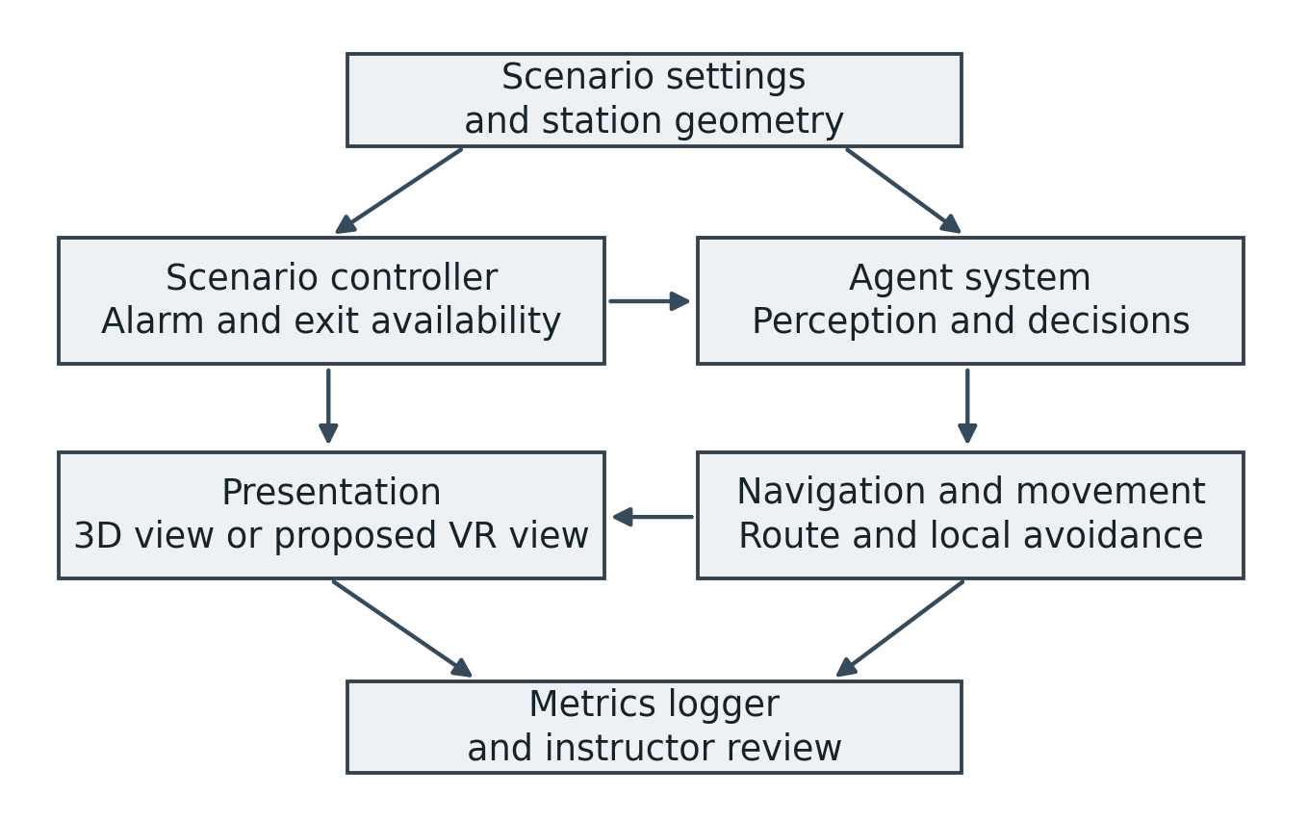
Figure 4 Proposed system architecture for simulation and instructor review
At startup, the controller loads the station, creates passengers on valid positions and assigns their parameters. Each simulation update advances perception and behaviour, then movement. Exit events update destination availability. Rendering reads the resulting positions and the user’s tracked viewpoint. The logger records an agent’s first arrival at a defined safe destination, preventing repeated counts when the agent crosses a trigger again.
A saved scenario should include starting positions, exit states, response delays and a random seed. Simulation time and playback time should be distinguished. A fixed movement step can improve repeatability, but floating point operations and different platforms can still affect exact trajectories. Repeated runs are therefore required for comparisons.
Each run should also save the model version, update interval, passenger count and time of each exit event. These records make an unexpected queue traceable to a particular configuration. The passenger view and instructor view should read the same simulation state rather than running separate crowds.

10 Unity project and demonstration
The selected repository documents Unity 2020.3.30f1 as its confirmed editor version and includes an Evacuation scene. Its design uses an agent prefab with movement, core behaviour, behaviour management and sensing components; agent attributes are loaded from JSON [2]. This supports a concise explanation of reusable agents.
Table 3 Relationship between the external example and the proposed design
Existing example | Proposed metro adaptation
Evacuation scene | Replace the generic setting with the station layout
Reusable agent prefab | Assign passenger profiles and varied starting positions
Movement and behaviour modules | Add explicit exit selection and closure states
Environment obstacles and NavMesh | Represent walls, gates, stairs and available routes
Desktop demonstration | Add a tracked VR view as a separate development task
A practical development sequence would start by opening the documented editor version and verifying the supplied scene. A separate copy would then receive the station geometry, two exit destinations and a closure control. After checking a single passenger, the scene could be tested with increasing crowd sizes. Metrics and a VR view would follow only after the movement behaviour is stable. This sequence is a development plan, not a record of completed execution.
Video: Cain Ashmore, “Evacutation Simulation,” approximately 52 seconds [3]. The link and source repository are included in the references. Introduce it as an external Unity crowd example, show the movement, then use Figure 1 to explain how the same concept would apply to a blocked metro exit. Describe only behaviour visible in the recording; it does not verify the proposed station, VR layer or performance.

11 Performance and optimization
Using 90 Hz as an illustrative headset target, Equation 3 gives about 11.11 milliseconds between display frames. The actual target depends on the headset. This is a planning budget, not a measured result.
$$T_{frame} = \frac{1000}{f} ms = \frac{1000}{90} ms ≈ 11.11 ms$$
Equation 3 Example frame budget for a 90 Hz display
Both eye views must meet this frame schedule. CPU and GPU work can overlap, so inspect their timings separately. Single pass instanced rendering can reduce repeated stereo work on supported systems [11]. A normal video does not establish live headset frame rate or latency.
Table 4 Proposed performance controls for the station scene
Likely cost | Proposed optimization
Agent decisions and path requests | Update distant decisions less often and stagger replanning
Neighbour and collision queries | Use a spatial grid for neighbours and simple capsule colliders
Crowd meshes and animation | Use levels of detail and reduce distant animation work [12]
Hidden station geometry | Cull areas concealed by substantial static walls [13]
Lighting and stereo rendering | Use simple lighting, restrained shadows and compatible shaders
Hidden passengers must remain in the simulation because they can still affect queues. Check clipping and intersections in both eyes. Profile frame time, pathfinding spikes and memory on the target hardware. Tracking, scheduling and display scanout also contribute to latency.
For 300 passengers, comparing every unordered pair means 300 × 299 ÷ 2 = 44,850 checks per update. A spatial grid limits neighbour searches to nearby cells, although dense bottlenecks can still be expensive. This is an illustrative computation, not a benchmark.

12 Evaluation plan and metrics
No experimental results are reported here. Table 5 defines future tests that would examine the proposed implementation. For a fair comparison, keep the station geometry, initial passenger set and parameter distribution fixed, repeat each scenario with several seeds, and record failures as well as successful arrivals.
Table 5 Proposed evaluation scenarios
Test condition | What to examine
Both exits open | Reference movement pattern, queues and time to clear
Exit A closes after the alarm | Replanning delay, use of Exit B and unresolved agents
Larger passenger set | Queue growth and CPU and GPU frame time
Mixed walking profiles | Behaviour of slower passengers and group separation
Guidance reaches agents later | Time lost before agents change route
No reachable exit | Waiting state and accurate reporting of incomplete evacuation
Useful measures include the number reaching safety, the fraction cleared by a stated time, total clearance time, queue delay and route changes. If anyone remains unresolved, total clearance time should be recorded as incomplete. Local density is the number of passengers in a defined area divided by that area.
$$ρ = \frac{N}{A} = \frac{50}{40} = 1.25 persons/m²$$
Equation 4 Illustrative density calculation for a concourse observation zone
The example assumes 50 passengers within a 40 m² zone: 50 ÷ 40 = 1.25 persons/m². The area and time window must be reported with the value. This is an average over the chosen zone; a small doorway can have a higher local concentration. It is not a safety threshold or a measurement from the selected video.
Validation would compare simulated routes, walking times and queues with suitable station observations or drill data. Parameters should be calibrated on one dataset and checked against separate observations before drawing practical conclusions.

13 Applications and limitations
Zhao et al. reconstructed the Love Parade area in Unity, combined navigation with the social force model and compared crowd management interventions. They also used a VR experiment to examine participant responses. In their simulated setting, opening another exit and removing police cordons reduced the estimated consequences of crowding [1]. This supports studying layout and operational changes together, although it does not establish how the proposed metro station would perform.
For a metro agency, the proposed model could help communicate why a closed route changes the use of stairs or how delayed guidance affects queues. Staff could compare the distribution of passengers across available routes and discuss where instructions should be placed. A 3D overview would help explain a bottleneck to a class, while a validated immersive version could support route familiarisation.
The useful comparison is between clearly specified scenarios. If one run changes exit availability, passenger count and walking speeds together, any difference becomes difficult to explain. Controlled changes and recorded assumptions make a simulation useful even when the geometry is simple.
Simplified agents do not capture every human response. Familiarity, language, mobility needs, companions and trust in instructions may affect decisions. A navigation system can generate plausible motion while still producing an unrealistic queue. Dense contact, falling and injury require specialised modelling beyond this report. Density alone does not establish those outcomes.
The conceptual layout omits a real station’s dimensions and operational constraints. The external video supplies visual context but no validated metro data or performance benchmark. The proposed VR features require implementation and user evaluation. Headset discomfort and the difference between virtual and physical movement may also affect observations. Practical use would require station specific data, domain review and evidence that the model reproduces relevant behaviour.

14 Conclusion and presentation guide
The proposed solution uses shared passenger rules to explain autonomous crowd movement in a metro evacuation. Each agent notices information, selects an available exit, follows a route and avoids local obstacles. An explicit replanning state handles a closure, and a waiting state makes an unavailable route visible to the instructor. Different passenger parameters create varied responses without manually scripting each person.
A proposed immersive drill adds tracked stereo viewing, clear audio and meaningful interaction feedback. Basic controller vibration can provide a cue; more elaborate body hardware is optional. Stable rendering and understandable signs matter directly to the participant’s experience. The existing Unity video provides an accessible illustration, while the metro and VR features remain the report’s proposed design.
The next development steps are a measured station model, reliable closure handling and logs that expose queues and unresolved agents. Later work can calibrate passenger profiles, compare movement models and evaluate a tracked VR version. These steps would turn the classroom concept into a system whose behaviour can be tested against evidence.
“My case study is about metro station evacuation. Each virtual passenger follows a few rules: notice the alarm, select an exit and avoid people nearby. If an exit is blocked, informed passengers choose another valid route. The video is an existing Unity example by Cain Ashmore. My report explains its relevance to a proposed metro scenario and describes how VR could support an immersive drill.”
If asked why Unity is useful, explain that it combines 3D geometry, animation, navigation and interaction. If asked whether the model proves a real station is safe, explain that the report provides a conceptual design and evaluation plan; a practical assessment needs measured data and validation.

References
[1] H. Zhao, T. Thrash, M. Kapadia, K. Wolff, C. Hölscher, D. Helbing, and V. R. Schinazi, “Assessing crowd management strategies for the 2010 Love Parade disaster using computer simulations and virtual reality,” Journal of the Royal Society Interface, vol. 17, no. 167, Art. no. 20200116, 2020, doi: 10.1098/rsif.2020.0116. https:/​/​doi.org/​10.1098/​rsif.2020.0116
[2] C. Ashmore, “Generic Crowd Simulation Engine,” GitHub repository. Developed with R. Goncalves. Accessed: Nov. 6, 2026. [Online]. Available: https:/​/​github.com/​ashmoreinc/​Generic-​Crowd-​Simulation-​Engine
[3] C. Ashmore, “Evacutation Simulation,” YouTube, video, approximately 52 s. Accessed: Nov. 6, 2026. [Online]. Available: https:/​/​www.youtube.com/​watch?v=XhD6wtgHV4I
[4] Unity Technologies, “Navigation Overview,” Unity User Manual 2020.3. Accessed: Nov. 6, 2026. [Online]. Available: https:/​/​docs.unity3d.com/​2020.3/​Documentation/​Manual/​nav-​Overview.html
[5] Unity Technologies, “Camera component,” Unity User Manual 2020.3. Accessed: Nov. 6, 2026. [Online]. Available: https:/​/​docs.unity3d.com/​2020.3/​Documentation/​Manual/​class-​Camera.html
[6] Unity Technologies, “Inner Workings of the Navigation System,” Unity User Manual 2020.3. Accessed: Nov. 6, 2026. [Online]. Available: https:/​/​docs.unity3d.com/​2020.3/​Documentation/​Manual/​nav-​InnerWorkings.html

References continued
[7] Unity Technologies, “Nav Mesh Obstacle,” Unity User Manual 2020.3. Accessed: Nov. 6, 2026. [Online]. Available: https:/​/​docs.unity3d.com/​2020.3/​Documentation/​Manual/​class-​NavMeshObstacle.html
[8] D. Helbing and P. Molnár, “Social force model for pedestrian dynamics,” Physical Review E, vol. 51, no. 5, pp. 4282–4286, 1995, doi: 10.1103/PhysRevE.51.4282. https:/​/​doi.org/​10.1103/​PhysRevE.51.4282
[9] Unity Technologies, “XR Interaction Toolkit,” package documentation, ver. 2.0.4. Accessed: Nov. 6, 2026. [Online]. Available: https:/​/​docs.unity3d.com/​Packages/​com.unity.xr.interaction.toolkit​@2.0/​manual/​index.html
[10] Unity Technologies, “Audio Source,” Unity User Manual 2020.3. Accessed: Nov. 6, 2026. [Online]. Available: https:/​/​docs.unity3d.com/​2020.3/​Documentation/​Manual/​class-​AudioSource.html
[11] Microsoft, “Recommended settings for Unity,” Microsoft Learn. Accessed: Nov. 6, 2026. [Online]. Available: https:/​/​learn.microsoft.com/​en-​us/​windows/​mixed-​reality/​develop/​unity/​recommended-​settings-​for-​unity
[12] Unity Technologies, “Level of Detail for meshes,” Unity User Manual 2020.3. Accessed: Nov. 6, 2026. [Online]. Available: https:/​/​docs.unity3d.com/​2020.3/​Documentation/​Manual/​LevelOfDetail.html
[13] Unity Technologies, “Occlusion culling,” Unity User Manual 2020.3. Accessed: Nov. 6, 2026. [Online]. Available: https:/​/​docs.unity3d.com/​2020.3/​Documentation/​Manual/​OcclusionCulling.html

