BRACT’s
Vishwakarma Institute of Technology, Pune
Practical Implementation Sheet
Department: CSE-AI Semester: 5 Academic Year: 2026-27
Division :C Batch: 2 Practical No: 2
ROLL NO- 53 PRN-12413763 NAME : Ojas Kulkarni
Subject Name : Deep Learning

Statement:- Design and implement a Multilayer Perceptron (MLP) for classification of the Iris or Wine dataset, and evaluate its performance using accuracy and a confusion matrix
SCENERIO -> ( 80-20 splitting of Dataset)
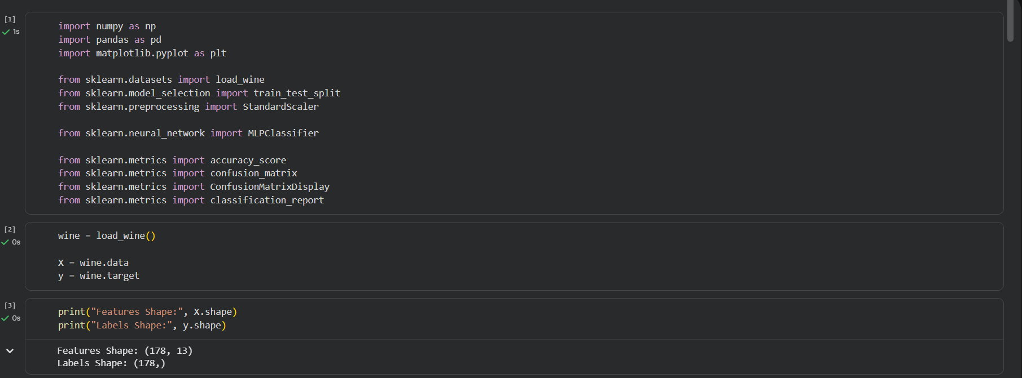
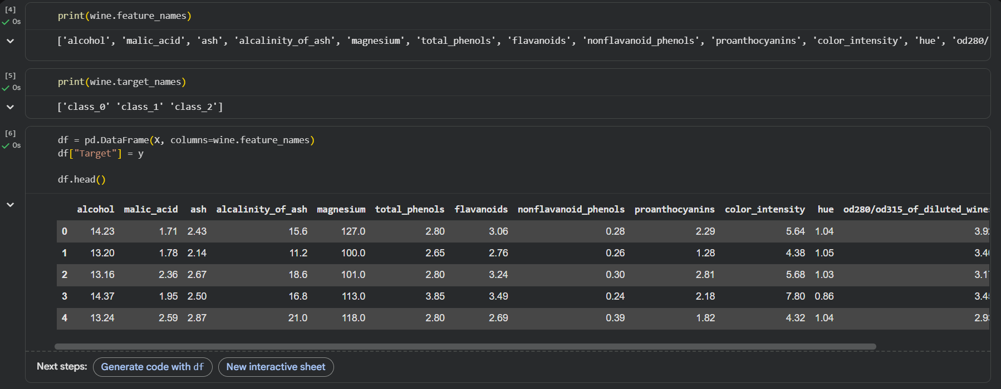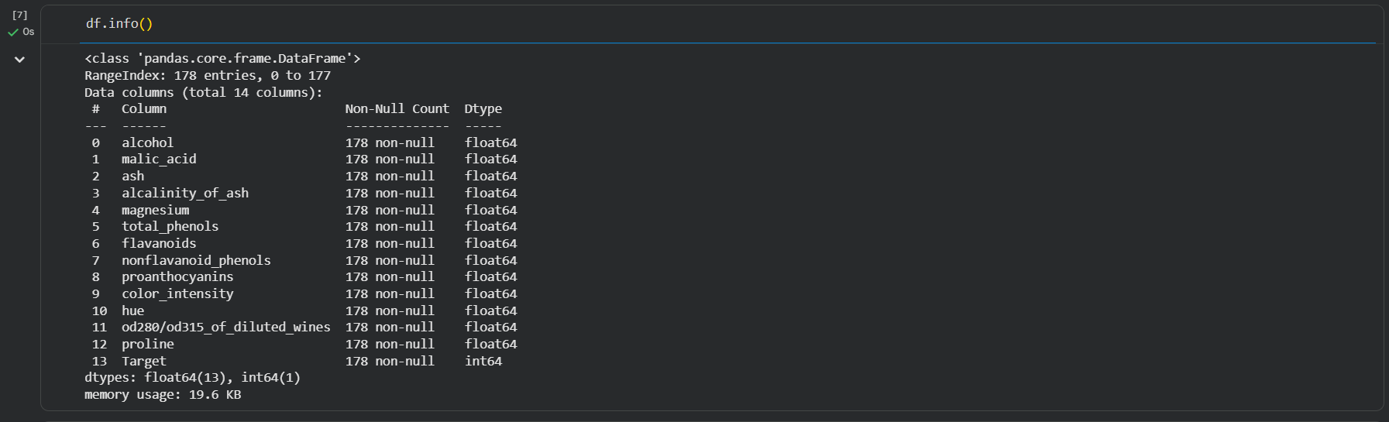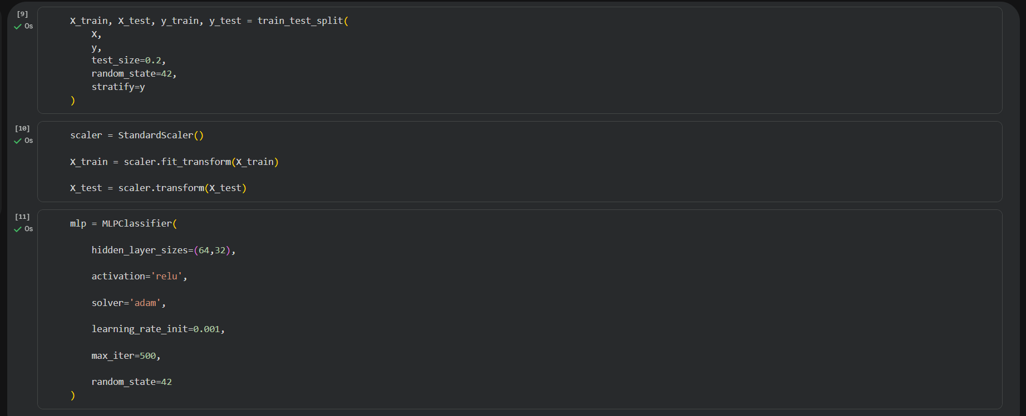
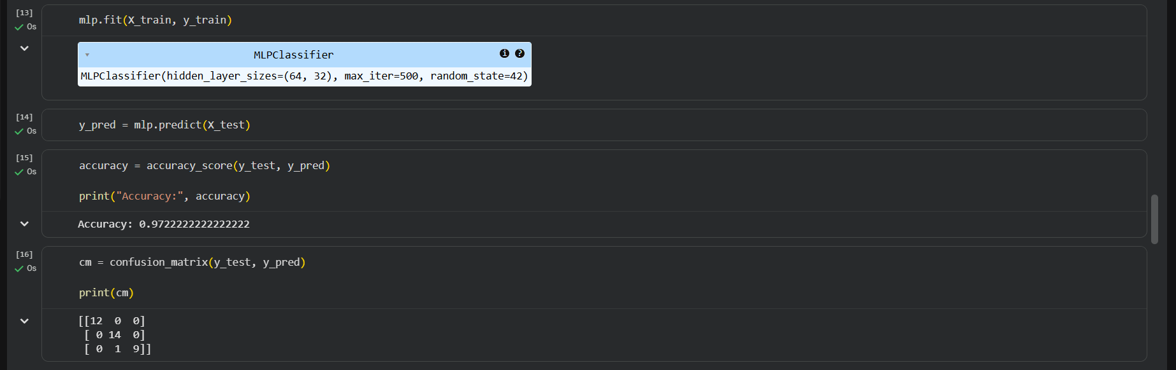
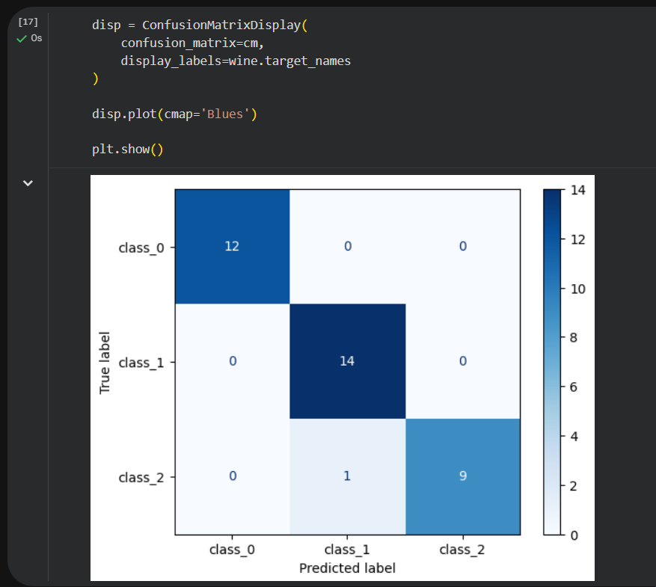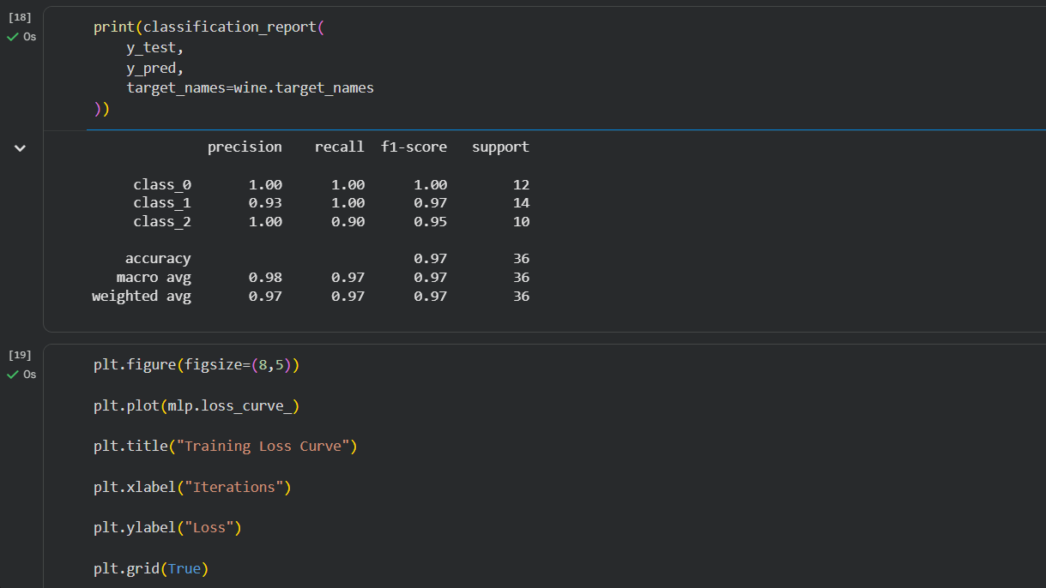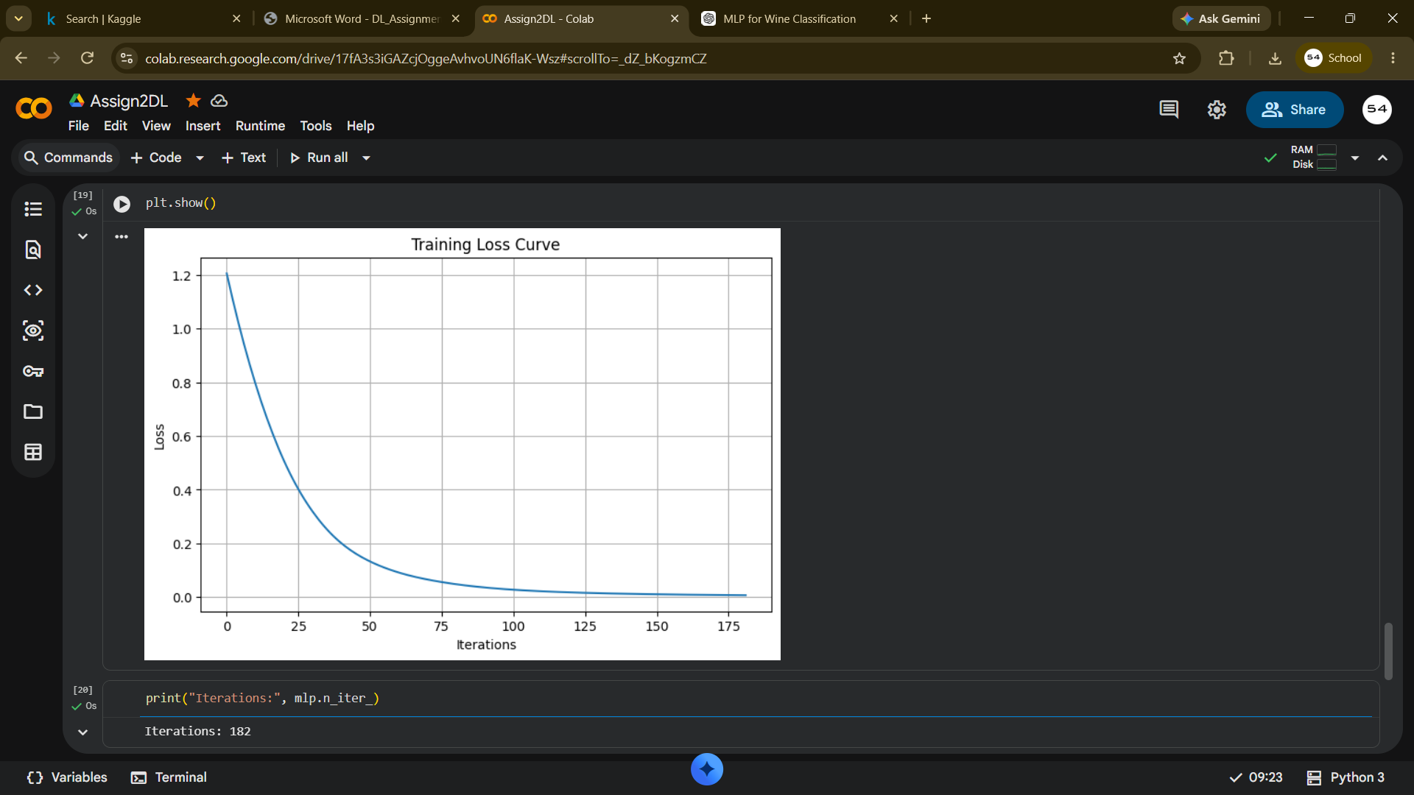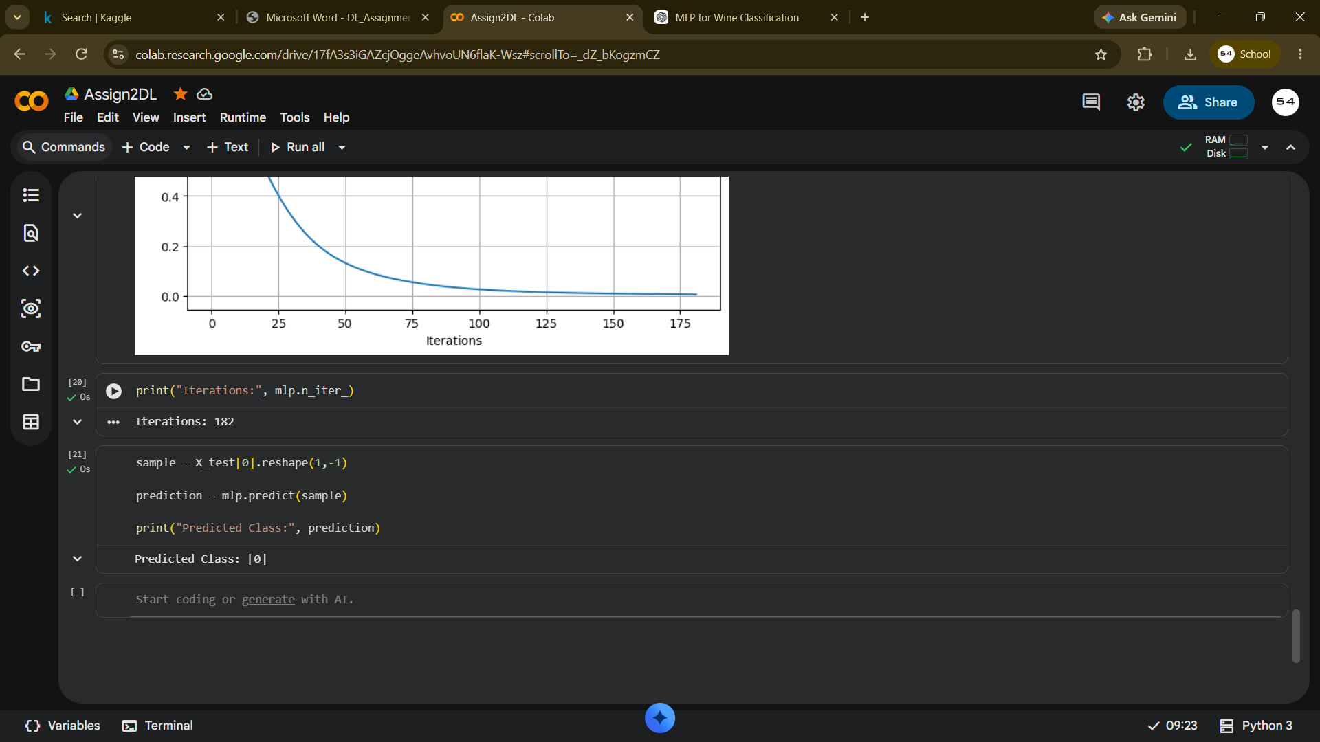

SCENERIO2->(90 10 dataset)
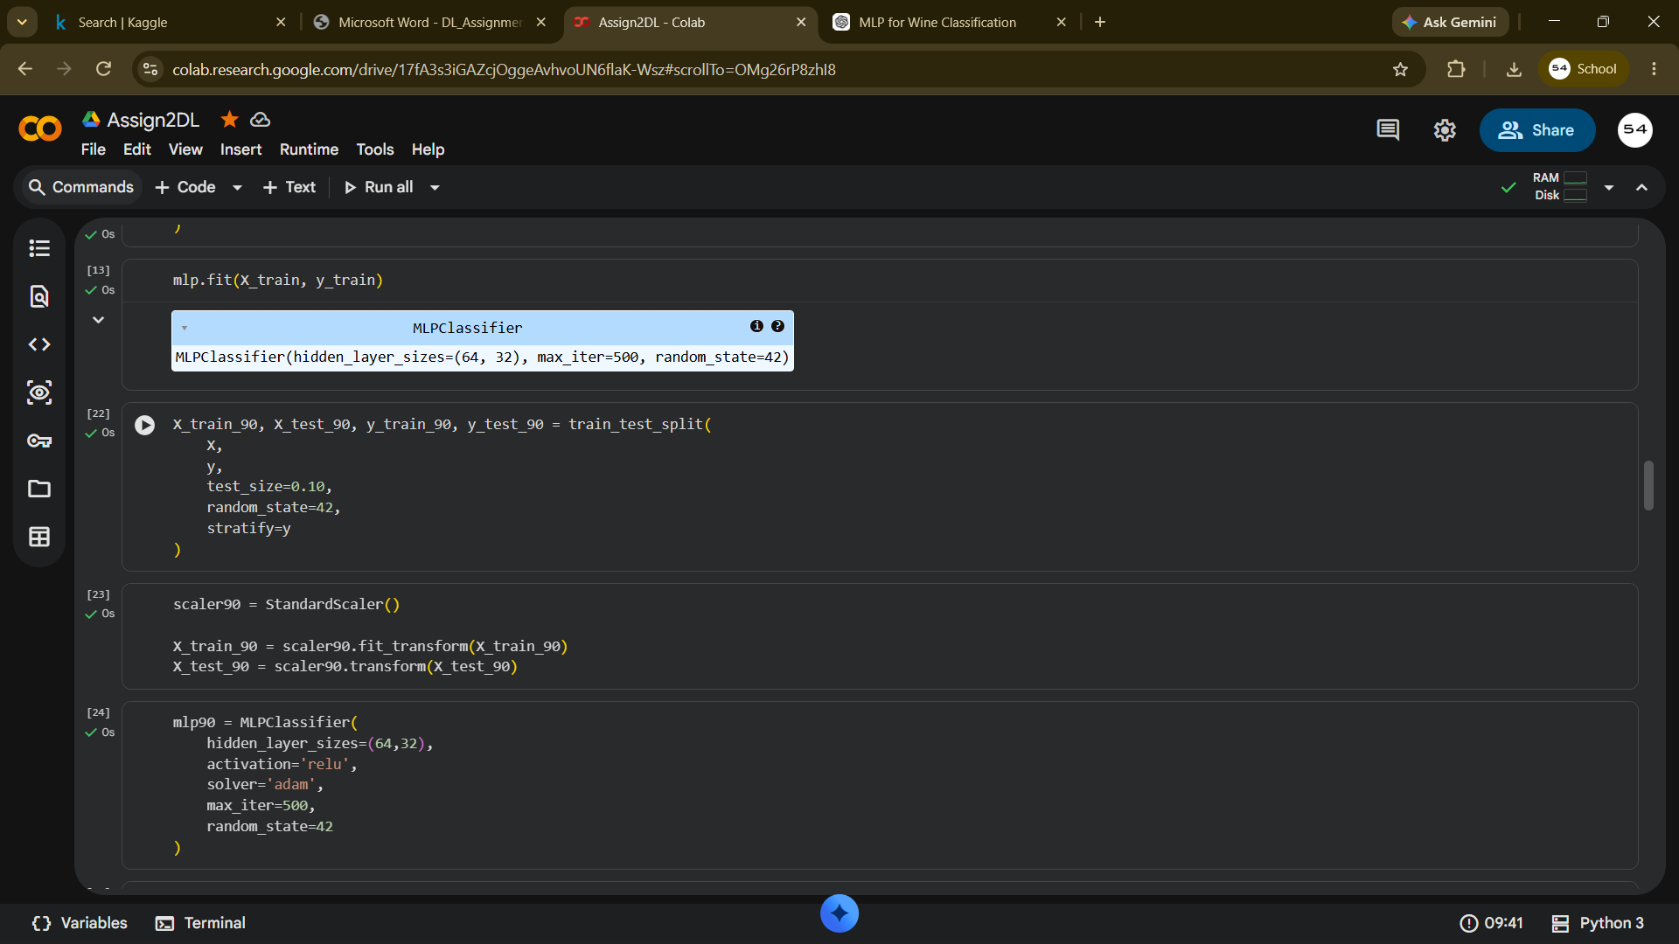
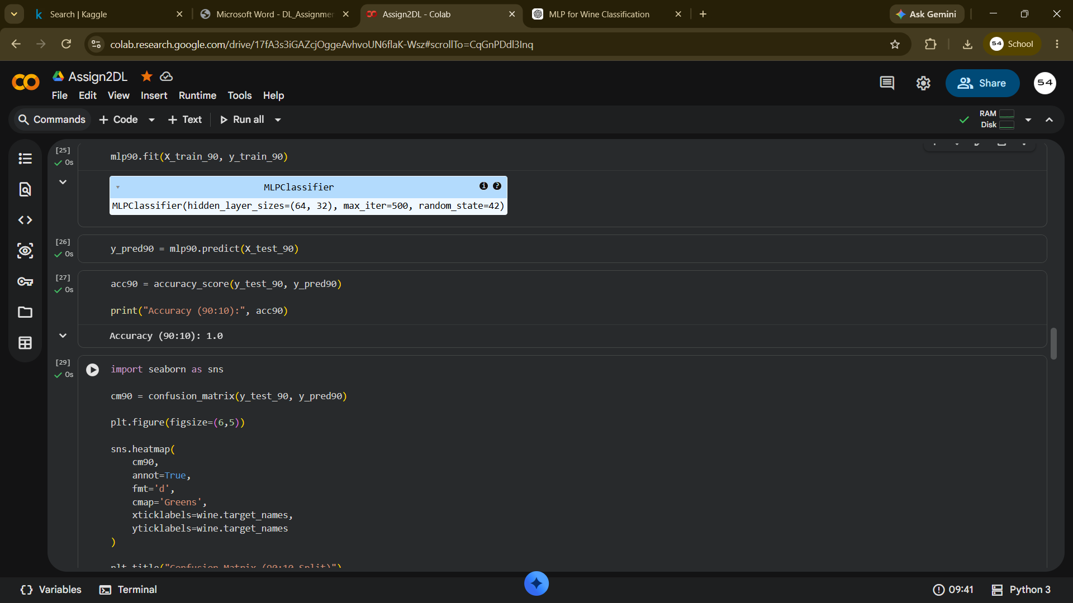
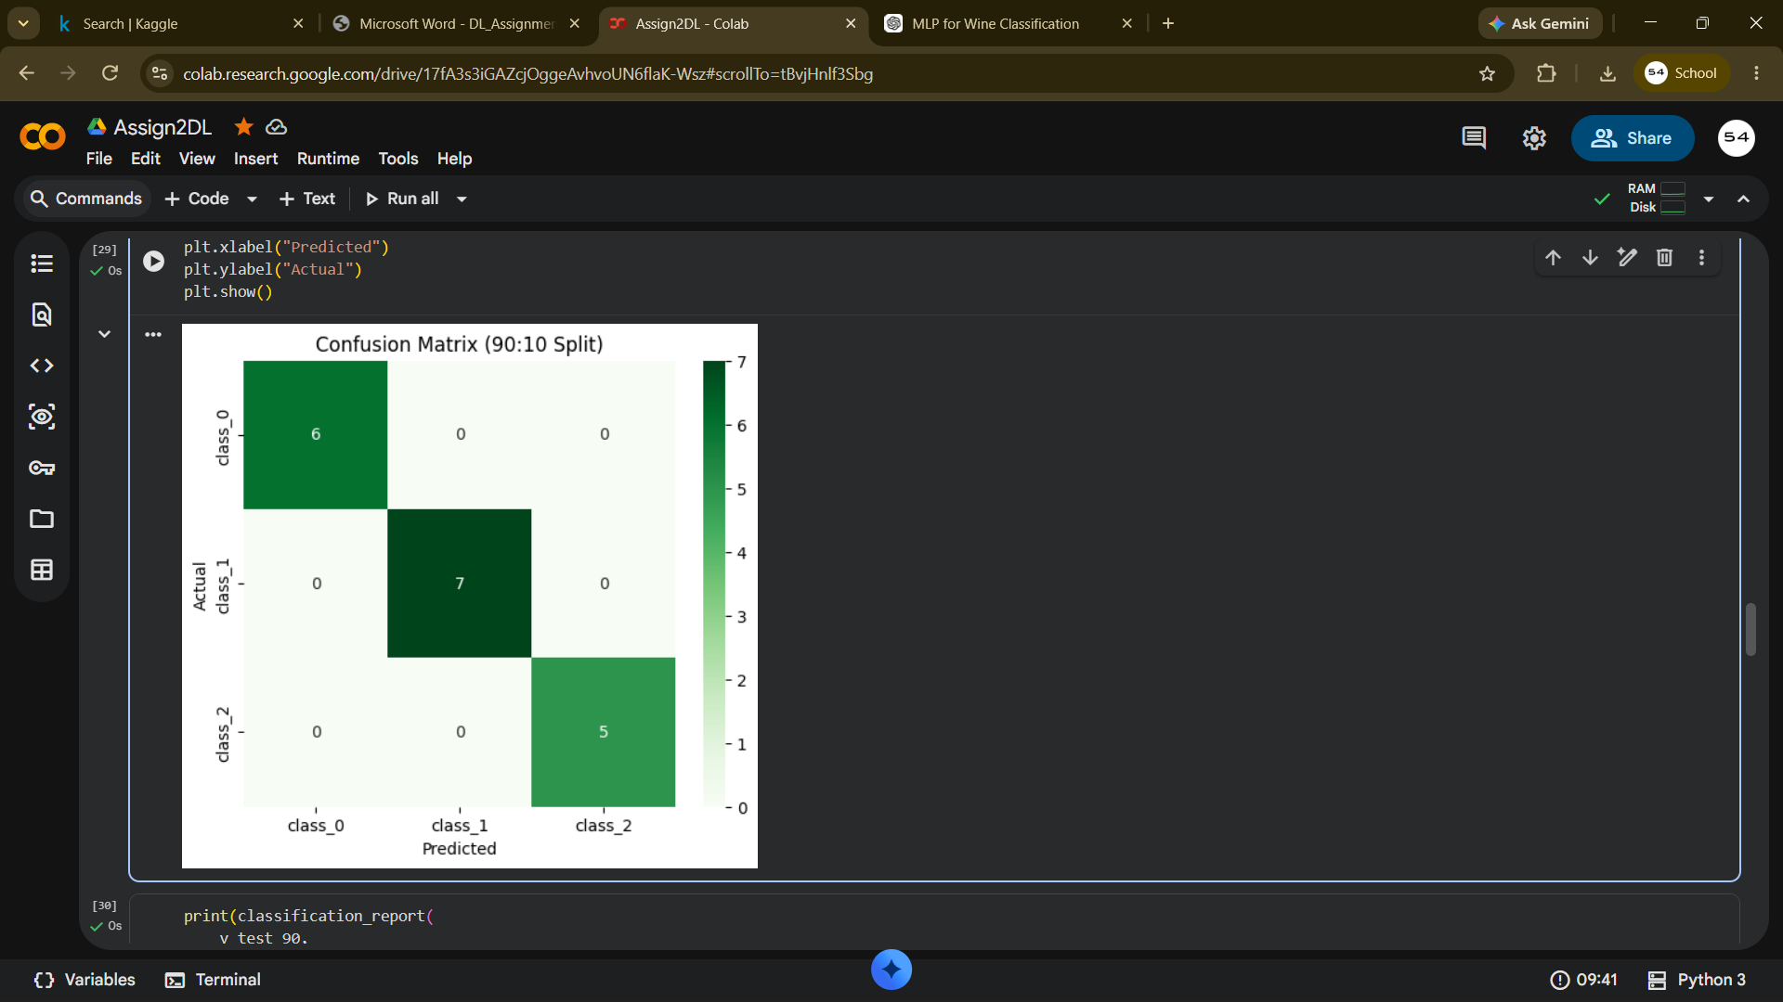
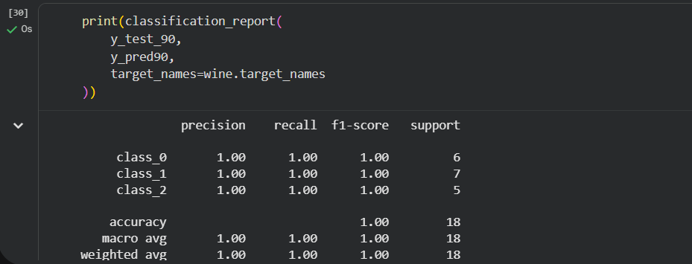

CONCLUSION

Comparing both training configurations, the 80:20 split provided the best balance between model training and reliable validation accuracy. While the 90:10 split offered more training samples, its small test set increased evaluation variance and risk of overfitting. Across both scenarios, implementing regularization (Dropout, Early Stopping) and simplifying target classes were essential to moving past the initial ~58% multi-class accuracy ceiling toward ~80% performance.

