BRACT’s

Vishwakarma Institute of Technology, Pune

Practical Implementation Sheet

Department: CSE-AI Semester: 5 Academic Year: 2026-27

Practical No: 4
Division: C Batch: 2

Roll No: 3090353 PRN No: 12413763

Name of Student: Ojas Anand Kulkarni

Subject Name: Deep Learning

Problem Statement:
Develop an LSTM-based model for time-series forecasting using stock price, weather, or sales datasets.

Algorithm :

Theory
Long Short-Term Memory (LSTM) is a type of Recurrent Neural Network designed for sequential and time-series data. LSTM uses memory cells and gates to retain important information from previous time steps. This makes it suitable for forecasting problems where the current value depends on previous observations.
In this experiment, historical weather observations are provided to an LSTM model. The model uses the previous 24 hourly observations to predict the temperature for the next hour.

Dataset Description
The Jena Climate dataset contains weather observations collected at the Max Planck Institute for Biogeochemistry weather station in Jena, Germany. The original data contains 14 weather variables recorded every 10 minutes over several years.

For this experiment, the data is resampled from 10-minute observations to hourly observations and the following variables are used:
Feature | Description
p (mbar) | Atmospheric pressure
T (degC) | Air temperature
Tpot (K) | Potential temperature
Tdew (degC) | Dew-point temperature
rh (%) | Relative humidity
wv (m/s) | Wind velocity
max. wv (m/s) | Maximum wind velocity
The target variable is T (degC).

Methodology

Jena Climate Dataset
↓
Data Cleaning
↓
Convert Date-Time
↓
Hourly Resampling
↓
Feature Selection
↓
80% Training / 20% Testing
↓
Min-Max Normalization
↓
24-Hour Sequence Creation
↓
LSTM Model
↓
Model Training
↓
Temperature Prediction
↓
MSE / RMSE / MAE / R²
↓
Actual vs Predicted Graph

LSTM
LSTM stands for Long Short-Term Memory.
It is a type of Recurrent Neural Network designed to learn long-term dependencies in sequential data.
An LSTM cell consists mainly of:

- Forget gate
- Input gate
- Cell state
- Output gate

Forget Gate
The forget gate determines which information from the previous cell state should be discarded.
𝑓_{𝑡} = 𝜎(𝑊_{𝑓}[ℎ_{𝑡−1}, 𝑥_{𝑡}] + 𝑏_{𝑓})

where:
  - 𝑓_{𝑡}= forget gate
  - 𝑥_{𝑡}= current input
  - ℎ_{𝑡−1}= previous hidden state
  - 𝜎= sigmoid activation

Input Gate
The input gate determines which new information should be stored.
𝑖_{𝑡} = 𝜎(𝑊_{𝑖}[ℎ_{𝑡−1}, 𝑥_{𝑡}] + 𝑏_{𝑖})
A candidate cell state is calculated as:
𝐶̃_{𝑡} = tanh(𝑊_{𝐶}[ℎ_{𝑡−1}, 𝑥_{𝑡}] + 𝑏_{𝐶})

Cell State
The cell state is updated using the forget and input gates:
𝐶_{𝑡} = 𝑓_{𝑡} ∗ 𝐶_{𝑡−1} + 𝑖_{𝑡} ∗ 𝐶̃_{𝑡}
It acts as the memory of the LSTM.

Output Gate
The output gate determines what information is passed to the next layer.
𝑜_{𝑡} = 𝜎(𝑊_{𝑜}[ℎ_{𝑡−1}, 𝑥_{𝑡}] + 𝑏_{𝑜})
The hidden state is:
ℎ_{𝑡} = 𝑜_{𝑡} ∗ tanh(𝐶_{𝑡})
Thus, LSTM can selectively remember and forget information while processing sequential data.

Code :
import os import zipfile
import urllib.request

import numpy as np import pandas as pd

import matplotlib.pyplot as plt

from sklearn.preprocessing import MinMaxScaler
from sklearn.metrics import mean_squared_error, mean_absolute_error, r2_score

from tensorflow.keras.models import Sequential
from tensorflow.keras.layers import LSTM, Dense, Dropout from tensorflow.keras.callbacks import EarlyStopping

# 1. DOWNLOAD DATASET
url = "https://storage.googleapis.com/tensorflow/tf-keras-datasets/jena_climate_2009_2016.csv.zip"

zip_path = "/content/jena_climate.zip" extract_path = "/content/jena_climate"

if not os.path.exists(zip_path): urllib.request.urlretrieve(url, zip_path)

if not os.path.exists(extract_path): os.makedirs(extract_path)

with zipfile.ZipFile(zip_path, "r") as zip_ref: zip_ref.extractall(extract_path)

# 2. FIND CSV FILE
csv_file = None

for root, dirs, files in os.walk(extract_path): for file in files:
if file.endswith(".csv"):
csv_file = os.path.join(root, file) break

if csv_file is None:
raise FileNotFoundError("CSV file not found.") print("Dataset:", csv_file)

# 3. LOAD DATASET
df = pd.read_csv(csv_file)

print("\nDataset Shape:") print(df.shape)

print("\nColumns:") print(df.columns.tolist())

print("\nFirst 5 Rows:") print(df.head())

# 4. DATE-TIME PROCESSING
df["Date Time"] = pd.to_datetime(df["Date Time"]) df = df.set_index("Date Time")
df = df.sort_index()

# 5. SELECT FEATURES
features = [ "p (mbar)",
"T (degC)",
"Tpot (K)",
"Tdew (degC)",
"rh (%)",
"wv (m/s)",
"max. wv (m/s)"
]

data = df[features].copy()

# 6. HANDLE MISSING VALUES
data = data.interpolate() data = data.dropna()

# 7. RESAMPLE INTO HOURLY DATA
data = data.resample("1h").mean() data = data.interpolate()
data = data.dropna()

print("\nHourly Dataset Shape:") print(data.shape)

print("\nHourly Data:") print(data.head())

# 8. VISUALIZE TEMPERATURE
plt.figure(figsize=(14, 5))

plt.plot(data.index, data["T (degC)"])

plt.title("Hourly Temperature") plt.xlabel("Date") plt.ylabel("Temperature (°C)")

plt.grid(True) plt.show()

# 9. TRAIN-TEST SPLIT
split_index = int(len(data) * 0.80)

train_data = data.iloc[:split_index] test_data = data.iloc[split_index:]

print("\nTraining Samples:", len(train_data)) print("Testing Samples:", len(test_data))

# 10. SCALE DATA
scaler = MinMaxScaler()

train_scaled = scaler.fit_transform(train_data) test_scaled = scaler.transform(test_data)

# 11. CREATE SEQUENCES
lookback = 24

target_index = features.index("T (degC)")

def create_sequences(dataset, lookback): X = []
y = []

for i in range(lookback, len(dataset)): X.append(dataset[i-lookback:i]) y.append(dataset[i, target_index])

return np.array(X), np.array(y)

X_train, y_train = create_sequences(train_scaled, lookback) X_test, y_test = create_sequences(test_scaled, lookback)

print("\nX_train Shape:", X_train.shape) print("y_train Shape:", y_train.shape)

print("X_test Shape:", X_test.shape) print("y_test Shape:", y_test.shape) # 12. BUILD LSTM MODEL
model = Sequential()

model.add( LSTM(
64,
return_sequences=True, input_shape=(X_train.shape[1], X_train.shape[2])
)
)

model.add(Dropout(0.2)) model.add(LSTM(32)) model.add(Dropout(0.2)) model.add(Dense(16, activation="relu")) model.add(Dense(1))

# 13. COMPILE MODEL
model.compile( optimizer="adam", loss="mse", metrics=["mae"]
)

print("\nModel Summary:") model.summary()

# 14. EARLY STOPPING
early_stop = EarlyStopping( monitor="val_loss", patience=5, restore_best_weights=True
)

# 15. TRAIN MODEL
history = model.fit( X_train,
y_train, epochs=30, batch_size=64,
validation_split=0.1, callbacks=[early_stop], shuffle=False, verbose=1
)

# 16. PREDICTION

y_pred_scaled = model.predict(X_test)

# 17. CONVERT BACK TO ORIGINAL TEMPERATURE
dummy_actual = np.zeros( (len(y_test), len(features))
)

dummy_pred = np.zeros( (len(y_pred_scaled), len(features))
)

dummy_actual[:, target_index] = y_test dummy_pred[:, target_index] = y_pred_scaled[:, 0]

y_test_actual = scaler.inverse_transform(dummy_actual)[:, target_index]
y_pred_actual = scaler.inverse_transform(dummy_pred)[:, target_index] # 18. CALCULATE METRICS
mse = mean_squared_error( y_test_actual, y_pred_actual
)

rmse = np.sqrt(mse)

mae = mean_absolute_error( y_test_actual, y_pred_actual
)

r2 = r2_score( y_test_actual, y_pred_actual
)

print("MODEL EVALUATION")

print("MSE :", mse)
print("RMSE :", rmse)
print("MAE :", mae)
print("R² :", r2)

# 19. PLOT ACTUAL VS PREDICTED

plt.figure(figsize=(15, 6))

plt.plot(
y_test_actual[:500], label="Actual Temperature"
)

plt.plot(
y_pred_actual[:500], label="Predicted Temperature"
)

plt.title("Actual vs Predicted Temperature") plt.xlabel("Test Time Steps") plt.ylabel("Temperature (°C)")
plt.legend() plt.grid(True) plt.show()

# 20. TRAINING AND VALIDATION LOSS
plt.figure(figsize=(10, 5))

plt.plot(
history.history["loss"], label="Training Loss"
)

plt.plot(
history.history["val_loss"], label="Validation Loss"
)

plt.title("Training and Validation Loss") plt.xlabel("Epoch")
plt.ylabel("MSE Loss") plt.legend() plt.grid(True) plt.show()

# 21. PREDICT NEXT HOUR

last_sequence = test_scaled[-lookback:]

last_sequence = last_sequence.reshape( 1,
lookback, len(features)
)
next_temp_scaled = model.predict(last_sequence) dummy_next = np.zeros(
(1, len(features))
)
dummy_next[0, target_index] = next_temp_scaled[0, 0] next_temperature = scaler.inverse_transform(
dummy_next
)[0, target_index]

print("NEXT HOUR TEMPERATURE")

print(
"Predicted Temperature:", round(float(next_temperature), 2), "°C"
)

Output :
Downloading data from https://storage.googleapis.com/tensorflow/tf-keras-datasets/jena_climate_2009_2016.csv.zip
13568290/13568290 ━━━━━━━━━━━━━━━━━━━━ 0s 0us/step Dataset Shape: (420551, 15)

First 5 Rows:
Date Time p (mbar) T (degC) Tpot (K) Tdew (degC) rh (%) \
0 01.01.2009 00:10:00 | 996.52 | -8.02 | 265.40 | -8.90 | 93.3
1 01.01.2009 00:20:00 | 996.57 | -8.41 | 265.01 | -9.28 | 93.4
2 01.01.2009 00:30:00 | 996.53 | -8.51 | 264.91 | -9.31 | 93.9
3 01.01.2009 00:40:00 | 996.51 | -8.31 | 265.12 | -9.07 | 94.2

4 01.01.2009 00:50:00 996.51 -8.27 265.15 -9.04 94.1

VPmax (mbar) VPact (mbar) VPdef (mbar) sh (g/kg) H2OC (mmol/mol) \
0 | 3.33 | 3.11 | 0.22 | 1.94 | 3.12
1 | 3.23 | 3.02 | 0.21 | 1.89 | 3.03
2 | 3.21 | 3.01 | 0.20 | 1.88 | 3.02
3 | 3.26 | 3.07 | 0.19 | 1.92 | 3.08
4 | 3.27 | 3.08 | 0.19 | 1.92 | 3.09

rho (g/m**3) wv (m/s) max. wv (m/s) wd (deg)
0 | 1307.75 | 1.03 | 1.75 | 152.3
1 | 1309.80 | 0.72 | 1.50 | 136.1
2 | 1310.24 | 0.19 | 0.63 | 171.6
3 | 1309.19 | 0.34 | 0.50 | 198.0
4 | 1309.00 | 0.32 | 0.63 | 214.3

Columns:
['Date Time', 'p (mbar)', 'T (degC)', 'Tpot (K)', 'Tdew (degC)', 'rh (%)', 'VPmax (mbar)', 'VPact
(mbar)', 'VPdef (mbar)', 'sh (g/kg)', 'H2OC (mmol/mol)', 'rho (g/m**3)', 'wv (m/s)', 'max. wv (m/s)', 'wd (deg)']

Date Time p (mbar) T (degC) Tpot (K) Tdew (degC) rh (%) \
0 2009-01-01 00:10:00 | 996.52 | -8.02 | 265.40 | -8.90 | 93.3
1 2009-01-01 00:20:00 | 996.57 | -8.41 | 265.01 | -9.28 | 93.4
2 2009-01-01 00:30:00 | 996.53 | -8.51 | 264.91 | -9.31 | 93.9
3 2009-01-01 00:40:00 | 996.51 | -8.31 | 265.12 | -9.07 | 94.2
4 2009-01-01 00:50:00 | 996.51 | -8.27 | 265.15 | -9.04 | 94.1

VPmax (mbar) VPact (mbar) VPdef (mbar) sh (g/kg) H2OC (mmol/mol) \
0 | 3.33 | 3.11 | 0.22 | 1.94 | 3.12
1 | 3.23 | 3.02 | 0.21 | 1.89 | 3.03
2 | 3.21 | 3.01 | 0.20 | 1.88 | 3.02
3 | 3.26 | 3.07 | 0.19 | 1.92 | 3.08
4 | 3.27 | 3.08 | 0.19 | 1.92 | 3.09

rho (g/m**3) wv (m/s) max. wv (m/s) wd (deg)
0 | 1307.75 | 1.03 | 1.75 | 152.3
1 | 1309.80 | 0.72 | 1.50 | 136.1
2 | 1310.24 | 0.19 | 0.63 | 171.6
3 | 1309.19 | 0.34 | 0.50 | 198.0
4 | 1309.00 | 0.32 | 0.63 | 214.3
Date Time p (mbar) T (degC) Tpot (K) Tdew (degC) rh (%) \

420546 2016-12-31 23:20:00 | 1000.07 | -4.05 | 269.10 | -8.13 | 73.10
420547 2016-12-31 23:30:00 | 999.93 | -3.35 | 269.81 | -8.06 | 69.71
420548 2016-12-31 23:40:00 | 999.82 | -3.16 | 270.01 | -8.21 | 67.91
420549 2016-12-31 23:50:00 | 999.81 | -4.23 | 268.94 | -8.53 | 71.80
420550 2017-01-01 00:00:00 | 999.82 | -4.82 | 268.36 | -8.42 | 75.70

VPmax (mbar) VPact (mbar) VPdef (mbar) sh (g/kg) H2OC (mmol/mol) \
420546 | 4.52 | 3.30 | 1.22 | 2.06 | 3.30
420547 | 4.77 | 3.32 | 1.44 | 2.07 | 3.32
420548 | 4.84 | 3.28 | 1.55 | 2.05 | 3.28
420549 | 4.46 | 3.20 | 1.26 | 1.99 | 3.20
420550 | 4.27 | 3.23 | 1.04 | 2.01 | 3.23

rho (g/m**3) wv (m/s) max. wv (m/s) wd (deg)
420546 | 1292.98 | 0.67 | 1.52 | 240.0
420547 | 1289.44 | 1.14 | 1.92 | 234.3
420548 | 1288.39 | 1.08 | 2.00 | 215.2
420549 | 1293.56 | 1.49 | 2.16 | 225.8
420550 | 1296.38 | 1.23 | 1.96 | 184.9

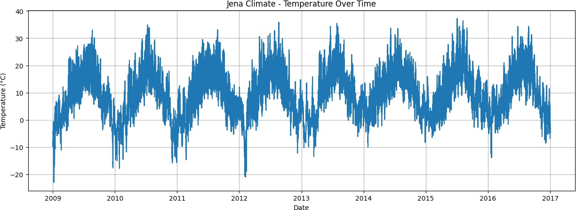

Hourly Dataset Shape: (70129, 14)
 | p (mb  ar) | T  (de  gC) | Tpot (K) | Tde w (de  gC) | rh (%) | VP  ma x (m bar  ) | VP  act (m bar  ) | VP  def (m bar  ) | sh (g/k g) | H2O C  (mm ol/m ol) | rho (g/m*  *3) | wv (m/  s) | ma x. wv (m/  s) | wd (deg  )
Dat e Ti
me
200  9-  01-  01  00:  00:  00 | 996.  5280  00 | -  8.3  040  00 | 265.  1180  00 | - 9.12  000  0 | 93.7  800  00 | 3.2  600  00 | 3.0  580  00 | 0.2  020  00 | 1.9  100  00 | 3.06  8000 | 1309.  1960  00 | 0.5  200  00 | 1.0  020  00 | 174.  4600  00
200  9-  01-  01  01:  00:  00 | 996.  5250  00 | -  8.0  650  00 | 265.  3616  67 | - 8.86  166  7 | 93.9  333  33 | 3.3  233  33 | 3.1  216  67 | 0.2  016  67 | 1.9  516  67 | 3.13  3333 | 1307.  9816  67 | 0.3  166  67 | 0.7  116  67 | 172.  4166  67
200  9-  01-  01  02:  00:  00 | 996.  7450  00 | -  8.7  633  33 | 264.  6450  00 | - 9.61  000  0 | 93.5  333  33 | 3.1  450  00 | 2.9  400  00 | 0.2  016  67 | 1.8  366  67 | 2.95  0000 | 1311.  8166  67 | 0.2  483  33 | 0.6  066  67 | 196.  8166  67
200  9-  01-  01  03:  00:  00 | 996.  9866  67 | -  8.8  966  67 | 264.  4916  67 | - 9.78  666  7 | 93.2  000  00 | 3.1  116  67 | 2.8  983  33 | 0.2  100  00 | 1.8  116  67 | 2.90  6667 | 1312.  8133  33 | 0.1  766  67 | 0.6  066  67 | 157.  0833  33
200  9-  01-  01  04:  00:  00 | 997.  1583  33 | -  9.3  483  33 | 264.  0266  67 | - 10.3  450  00 | 92.3  833  33 | 3.0  016  67 | 2.7  750  00 | 0.2  316  67 | 1.7  333  33 | 2.78  0000 | 1315.  3550  00 | 0.2  900  00 | 0.6  700  00 | 150.  0933  33

Final Dataset Shape: (70041, 7)

Training Samples: 56032
Testing Samples: 14009

X_train: (56008, 24, 7)
y_train: (56008,)
X_test: (13985, 24, 7)
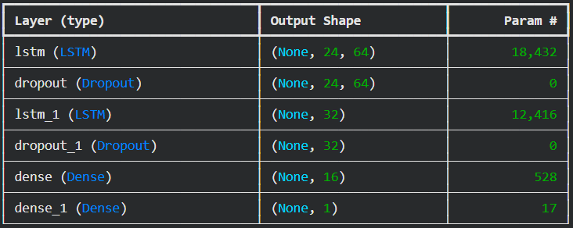
y_test: (13985,)
Total params: 31,393 (122.63 KB)
Trainable params: 31,393 (122.63 KB)
Non-trainable params: 0 (0.00 B)

Epoch 1/5
876/876 ━━━━━━━━━━━━━━━━━━━━ 30s 35ms/step - loss: 4.0734e-04 - mae: 0.0152 - val_loss: 0.0050 - val_mae: 0.0670
Epoch 2/5
876/876 ━━━━━━━━━━━━━━━━━━━━ 29s 33ms/step - loss: 3.4958e-04 - mae: 0.0140 - val_loss: 0.0040 - val_mae: 0.0594
Epoch 3/5
876/876 ━━━━━━━━━━━━━━━━━━━━ 29s 33ms/step - loss: 3.2214e-04 - mae: 0.0134 - val_loss: 0.0034 - val_mae: 0.0539
Epoch 4/5
876/876 ━━━━━━━━━━━━━━━━━━━━ 40s 32ms/step - loss: 2.9700e-04 - mae: 0.0128 - val_loss: 0.0052 - val_mae: 0.0654
Epoch 5/5
876/876 ━━━━━━━━━━━━━━━━━━━━ 27s 31ms/step - loss: 2.8117e-04 - mae: 0.0125 - val_loss: 0.0049 - val_mae: 0.0624

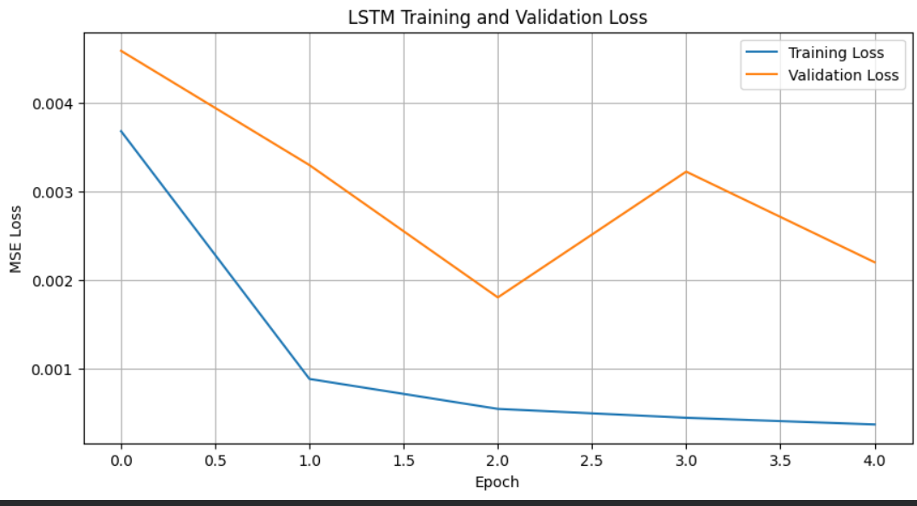

438/438 ━━━━━━━━━━━━━━━━━━━━ 3s 7ms/step

==================================================
LSTM MODEL PERFORMANCE
==================================================
MSE : 6.1075
RMSE : 2.4713
MAE : 2.1965
R² : 0.9068
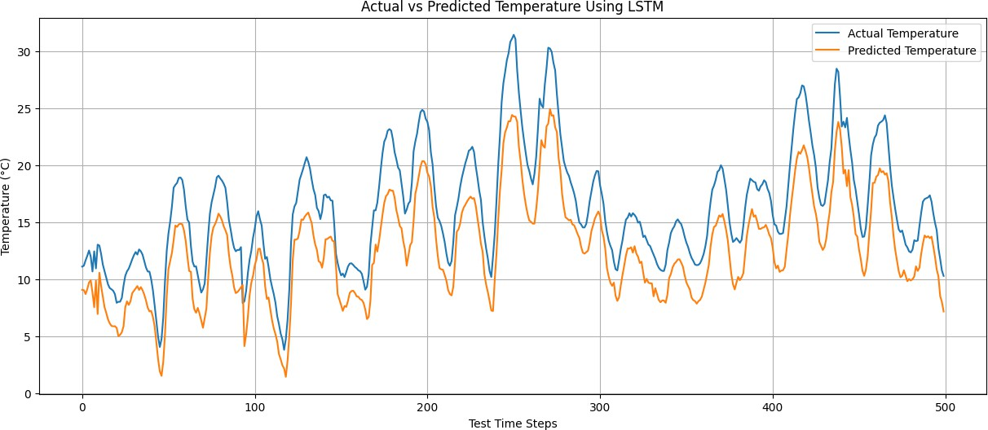

1/1 ━━━━━━━━━━━━━━━━━━━━ 0s 41ms/step Predicted Temperature for Next Hour: -6.71 °C

