Lab Report
Deep Learning & Data Analysis Experiments
Experiment 3: ANN, CNN & Wholesale Customer Data Analysis

Part 1: Artificial Neural Network (ANN) — Breast Cancer Classification

1.1 Objective
The objective of this experiment is to build an Artificial Neural Network (ANN) using TensorFlow/Keras to classify tumours in the Wisconsin Breast Cancer dataset as malignant (0) or benign (1). The experiment covers data loading, preprocessing, model construction, training, and performance evaluation.

1.2 Dataset Overview
The Wisconsin Breast Cancer dataset was loaded from sklearn.datasets. It contains 569 samples, each described by 30 numerical features computed from digitized images of fine needle aspirate (FNA) of breast masses. The target variable is binary: 0 = Malignant, 1 = Benign.

Property | Value
Dataset | Wisconsin Breast Cancer (sklearn)
Total Samples | 569
Features | 30 (mean, SE, worst measurements)
Target Classes | 2 (Malignant = 0, Benign = 1)
Train Size (80%) | 455
Test Size (20%) | 114

1.3 Data Preprocessing
The dataset was split 80/20 into training and testing sets using train_test_split with random_state=42. StandardScaler was applied to normalize all 30 features to zero mean and unit variance. This step is critical for neural networks, which are sensitive to the scale of inputs. The first five rows of scaled training data were printed to verify correct transformation.

1.4 Model Architecture
A Sequential ANN was built with the following layers:

Layer | Type | Units | Activation | Parameters
Input / Hidden 1 | Dense | 16 | ReLU | 496
Hidden 2 | Dense | 8 | ReLU | 136
Output | Dense | 1 | Sigmoid | 9

Total trainable parameters: 641 (2.50 KB). The sigmoid output function produces a probability score; values > 0.5 are classified as Benign.

1.5 Model Compilation & Training
The model was compiled with the Adam optimizer and Binary Cross-Entropy loss function, which is standard for binary classification. It was trained for 20 epochs with a batch size of 32 and a 20% validation split.

Training progression (selected epochs):

Epoch | Train Accuracy | Train Loss | Val Accuracy | Val Loss
1 | 59.89% | 0.8177 | 62.64% | 0.7154
5 | 90.11% | 0.3453 | 89.01% | 0.2961
10 | 94.78% | 0.1703 | 93.41% | 0.1712
15 | 97.53% | 0.1098 | 94.51% | 0.1333
20 | 98.08% | 0.0806 | 96.70% | 0.1170

The model shows consistent improvement across all 20 epochs. Train and validation accuracy closely track each other, indicating no significant overfitting.

1.6 Evaluation Results
Test Set Performance:

Metric | Value
Test Accuracy | 95.61%
Test Loss | 0.0886
True Negatives (Malignant correctly classified) | 40
False Positives | 3
False Negatives | 2
True Positives (Benign correctly classified) | 69

Confusion Matrix: [[40, 3], [2, 69]]

Per-class classification report:

Class | Precision | Recall | F1-Score | Support
Malignant (0) | 0.95 | 0.93 | 0.94 | 43
Benign (1) | 0.96 | 0.97 | 0.97 | 71
Macro Avg | 0.96 | 0.95 | 0.95 | 114
Weighted Avg | 0.96 | 0.96 | 0.96 | 114

1.7 Conclusion — ANN
The ANN achieved a test accuracy of 95.61% on the Breast Cancer classification task. The model performed well across both classes, with especially strong recall (97%) for Benign cases. The network converged steadily without overfitting over 20 epochs. The high precision and recall scores validate the model's clinical utility for preliminary tumour classification.

Part 2: Convolutional Neural Network (CNN) — MNIST Digit Classification

2.1 Objective
This experiment applies a Convolutional Neural Network (CNN) to classify handwritten digits (0–9) from the MNIST dataset using TensorFlow/Keras. The experiment covers image loading, reshaping, normalization, CNN construction, training, and performance evaluation.

2.2 Dataset Overview
The MNIST dataset contains 70,000 grayscale images (28x28 pixels) of handwritten digits. It is split into 60,000 training samples and 10,000 test samples with 10 classes (digits 0 through 9). Images were reshaped from (28, 28) to (28, 28, 1) to add a channel dimension for CNN compatibility, and normalized by dividing by 255.0 to scale pixel values to [0, 1].

Property | Value
Dataset | MNIST (TensorFlow/Keras)
Training Samples | 60,000
Test Samples | 10,000
Image Size | 28 x 28 x 1 (grayscale)
Number of Classes | 10 (digits 0–9)

2.3 Model Architecture
A Sequential CNN was constructed with two convolutional blocks followed by fully-connected layers. Dropout (50%) was applied after the Dense layer to reduce overfitting.

Layer | Type | Output Shape | Parameters
Conv2D (32 filters, 3x3) | Convolutional | (None, 26, 26, 32) | 320
MaxPooling2D (2x2) | Pooling | (None, 13, 13, 32) | 0
Conv2D (64 filters, 3x3) | Convolutional | (None, 11, 11, 64) | 18,496
MaxPooling2D (2x2) | Pooling | (None, 5, 5, 64) | 0
Flatten | Flatten | (None, 1600) | 0
Dense (128 units, ReLU) | Fully Connected | (None, 128) | 204,928
Dropout (0.5) | Regularization | (None, 128) | 0
Dense (10 units, Softmax) | Output | (None, 10) | 1,290

Total trainable parameters: 225,034 (879.04 KB). The softmax output layer produces probabilities across 10 digit classes; np.argmax selects the predicted class.

2.4 Model Compilation & Training
The model was compiled using the Adam optimizer with Sparse Categorical Cross-Entropy loss (suitable for integer-encoded labels). Training was run for 5 epochs with a batch size of 64 and a 20% validation split.

Epoch-by-epoch training results:

Epoch | Train Accuracy | Train Loss | Val Accuracy | Val Loss
1 | 91.35% | 0.2830 | 97.81% | 0.0728
2 | 97.24% | 0.0951 | 98.48% | 0.0530
3 | 97.86% | 0.0716 | 98.71% | 0.0431
4 | 98.40% | 0.0548 | 98.93% | 0.0392
5 | 98.58% | 0.0472 | 98.97% | 0.0385

The CNN converged rapidly — achieving 97.81% validation accuracy by the very first epoch. Training continued to improve steadily through epoch 5.

2.5 Evaluation Results
Test Set Performance:

Metric | Value
Test Accuracy | 99.07%
Test Loss | 0.0275

Per-class classification report (10,000 test samples):

Digit | Precision | Recall | F1-Score | Support
0 | 0.99 | 1.00 | 0.99 | 980
1 | 0.99 | 1.00 | 1.00 | 1135
2 | 0.99 | 0.99 | 0.99 | 1032
3 | 0.99 | 0.99 | 0.99 | 1010
4 | 0.99 | 1.00 | 0.99 | 982
5 | 0.99 | 0.98 | 0.99 | 892
6 | 0.99 | 0.99 | 0.99 | 958
7 | 0.99 | 0.99 | 0.99 | 1028
8 | 0.99 | 0.99 | 0.99 | 974
9 | 0.99 | 0.98 | 0.99 | 1009
Macro Avg | 0.99 | 0.99 | 0.99 | 10,000

The CNN achieved near-perfect performance on all 10 digit classes, with no single class showing notable weakness.

2.6 Conclusion — CNN
The CNN achieved an exceptional test accuracy of 99.07% on MNIST digit classification. Convolutional layers effectively learned spatial patterns in handwritten digit images, far outperforming a fully-connected ANN for this image task. The Dropout layer successfully prevented overfitting, as evidenced by the close match between training and validation accuracy. All 10 digit classes achieved precision, recall, and F1-score of 0.99 or higher.

Part 3: Wholesale Customers Data — Exploratory Data Analysis

3.1 Objective
This section presents an exploratory data analysis (EDA) of the Wholesale Customers dataset. The goal is to understand the spending behaviour of wholesale customers across six product categories (Fresh, Milk, Grocery, Frozen, Detergents_Paper, Delicassen) and examine differences between customer channels and regions.

3.2 Dataset Overview
The Wholesale Customers dataset from the UCI Machine Learning Repository captures the annual spending (in monetary units) of clients of a wholesale distributor in Portugal across six product categories.

Property | Value
Total Records | 440
Features | 8 (Channel, Region + 6 product categories)
Missing Values | None
Channel 1 (HoReCa) | 298 customers (67.7%)
Channel 2 (Retail) | 142 customers (32.3%)
Region 1 (Lisbon) | 77 customers (17.5%)
Region 2 (Oporto) | 47 customers (10.7%)
Region 3 (Other) | 316 customers (71.8%)

3.3 Descriptive Statistics
Mean annual spending across all 440 customers by product category:

Product Category | Mean Spending | Std Dev | Min | Max
Fresh | 12,000 | 12,647 | 3 | 112,151
Milk | 5,796 | 7,380 | 55 | 73,498
Grocery | 7,951 | 9,503 | 3 | 92,780
Frozen | 3,072 | 4,855 | 25 | 60,869
Detergents_Paper | 2,881 | 4,768 | 3 | 40,827
Delicassen | 1,525 | 2,820 | 3 | 47,943

All product spending distributions are heavily right-skewed — the mean is significantly higher than the median, indicating that a small number of high-spending customers inflate the average.

3.4 Distribution Analysis
Figure 1 shows the frequency distributions of annual spending across the six product categories. All distributions are positively skewed (right-tailed), with most customers spending at lower levels and a few extreme high-spenders. Fresh products exhibit the widest spread, while Delicassen has the most concentrated distribution around low spending values.

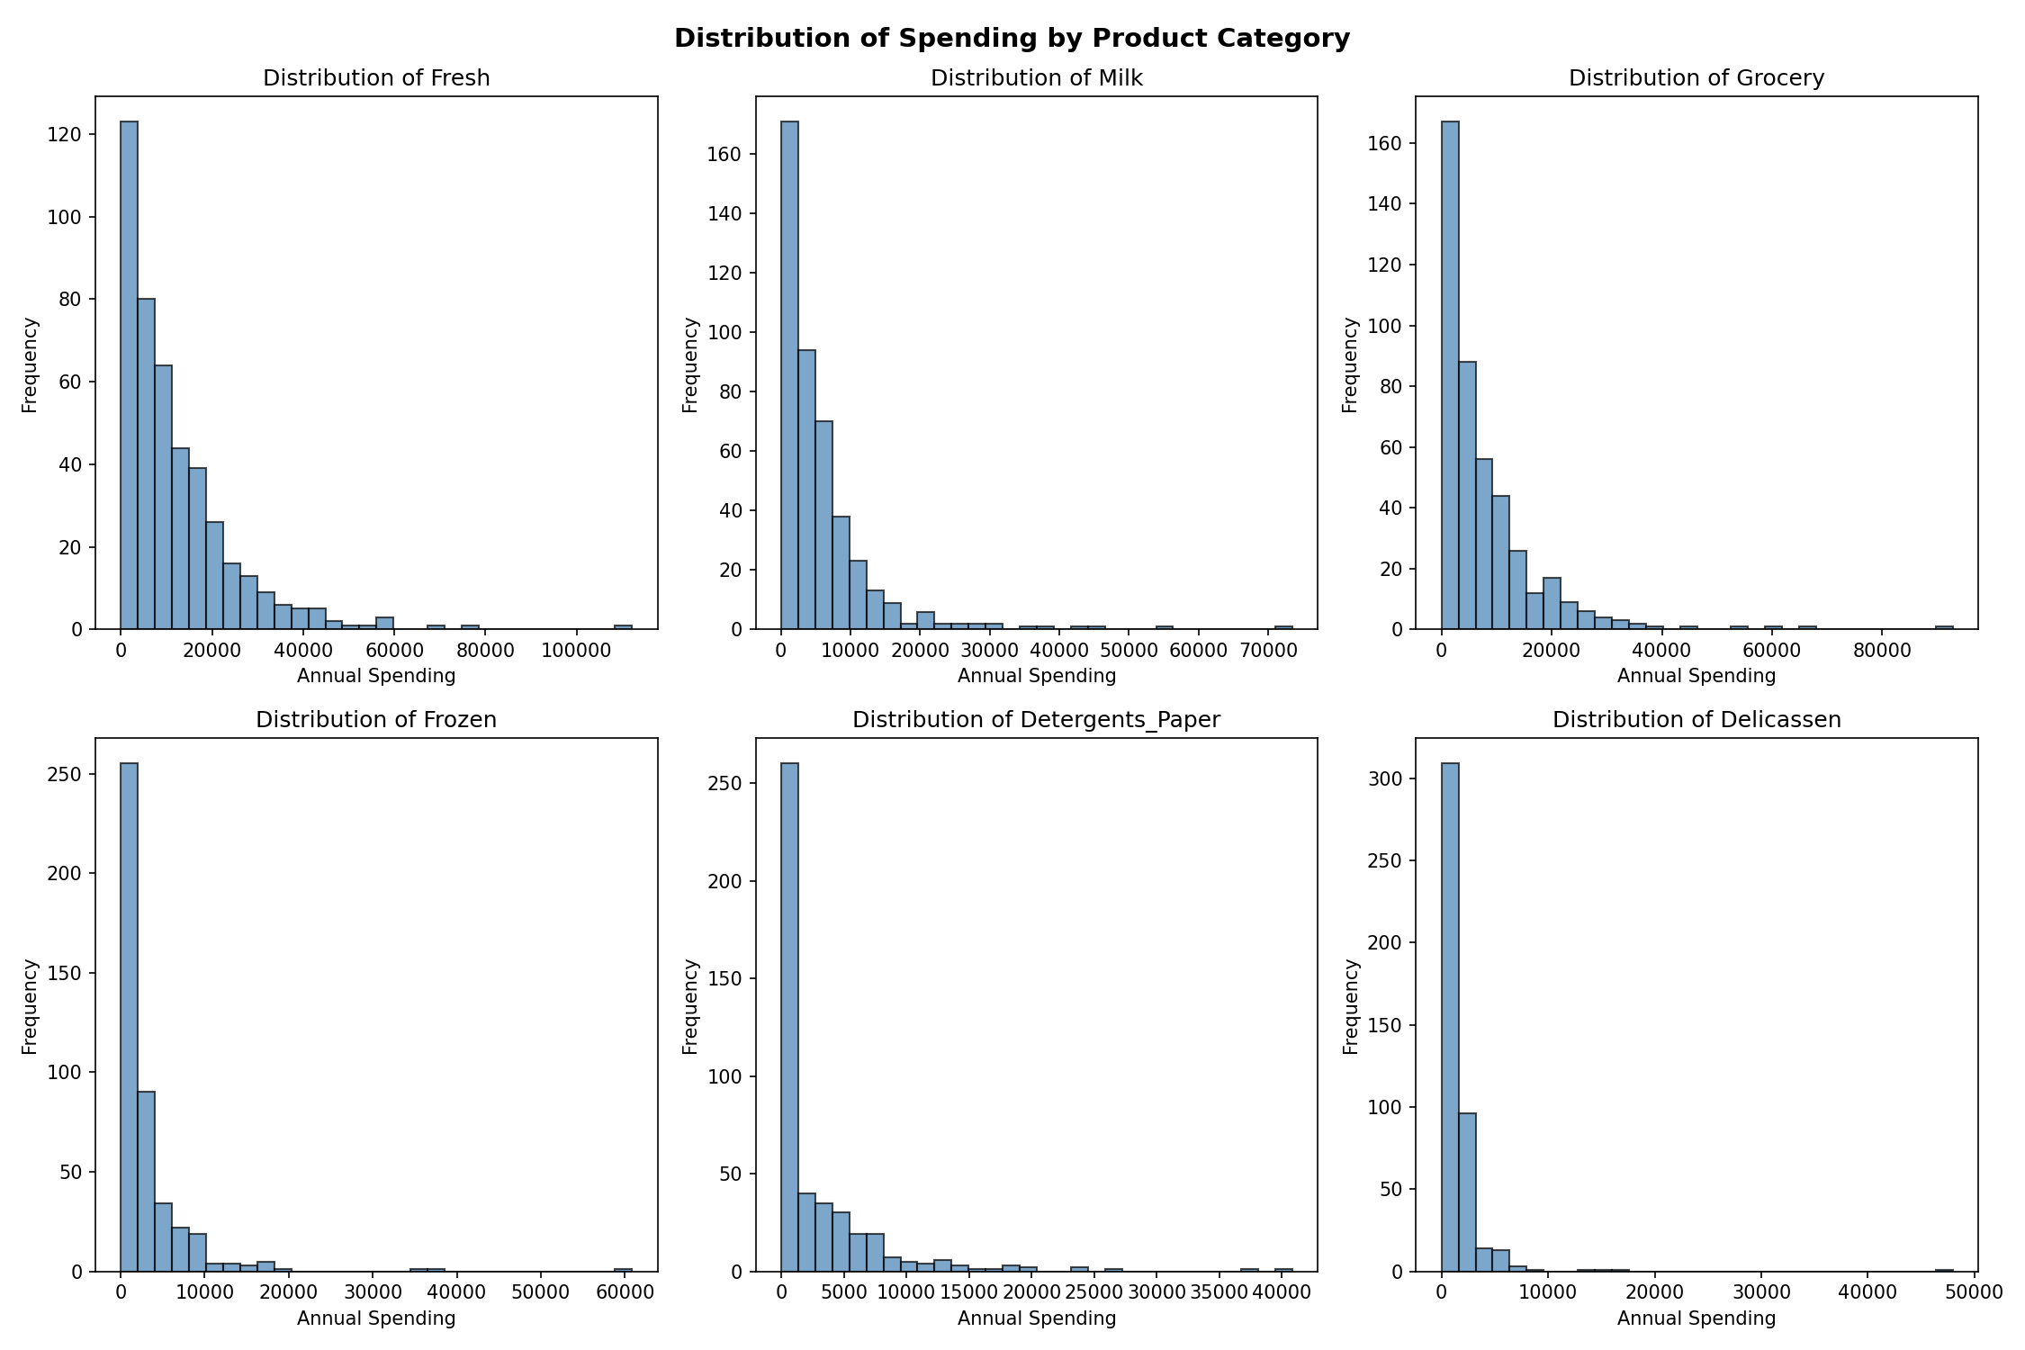

Figure 1: Frequency distributions of annual spending per product category

3.5 Correlation Analysis
Figure 2 shows the Pearson correlation matrix between product categories. Grocery and Detergents_Paper exhibit the strongest positive correlation (r ≈ 0.92), suggesting that customers who purchase large amounts of Grocery also tend to purchase large amounts of Detergents_Paper — both typical of retail customers. Milk also correlates moderately with both Grocery (r ≈ 0.73) and Detergents_Paper (r ≈ 0.66). Fresh spending shows weak or near-zero correlation with most other categories, indicating it is driven by different customer types (HoReCa).

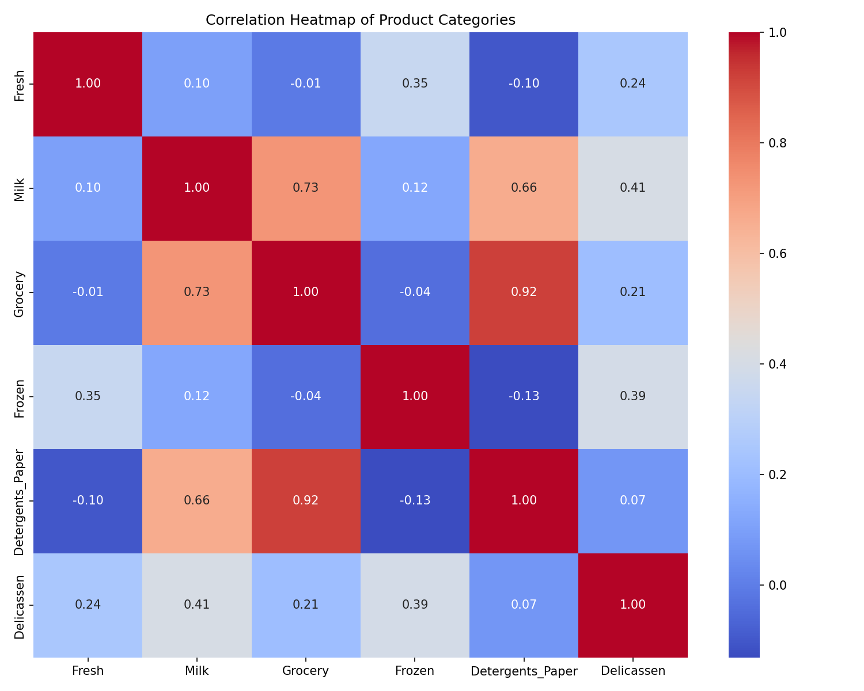

Figure 2: Pearson correlation heatmap of product categories

3.6 Channel Comparison
Channel 1 (HoReCa — Hotel/Restaurant/Café) and Channel 2 (Retail) serve very different business types. Figure 3 compares mean annual spending by product category across both channels.

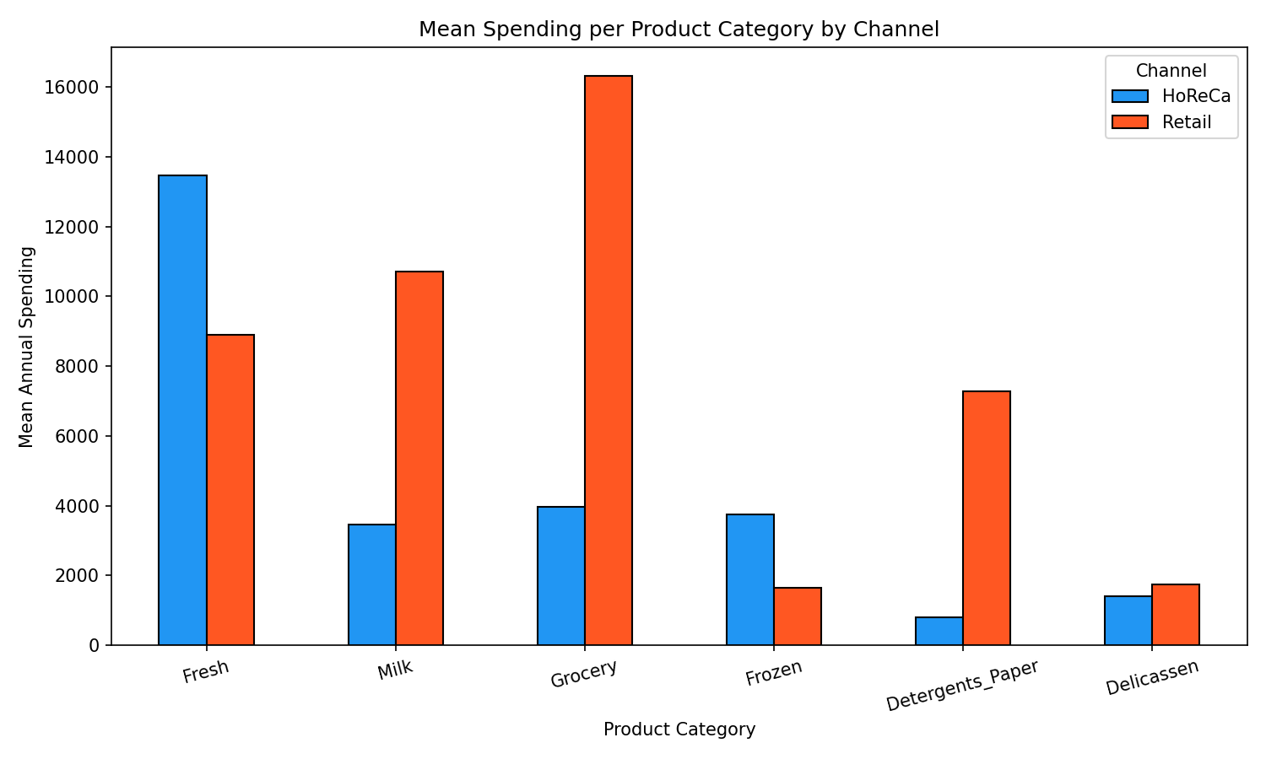

Figure 3: Mean spending per product category by channel

Product | HoReCa Mean | Retail Mean | Notable Difference
Fresh | 13,476 | 8,904 | HoReCa spends 51% more
Milk | 3,452 | 10,716 | Retail spends 210% more
Grocery | 3,962 | 16,323 | Retail spends 312% more
Frozen | 3,748 | 1,653 | HoReCa spends 127% more
Detergents_Paper | 791 | 7,270 | Retail spends 819% more
Delicassen | 1,416 | 1,753 | Similar

HoReCa customers spend significantly more on Fresh and Frozen products, while Retail customers dominate in Grocery, Milk, and Detergents_Paper. This reflects the operational differences between food service establishments and retail stores.

Figure 4 shows boxplots of spending distributions by channel, revealing the spread and outliers within each channel group.

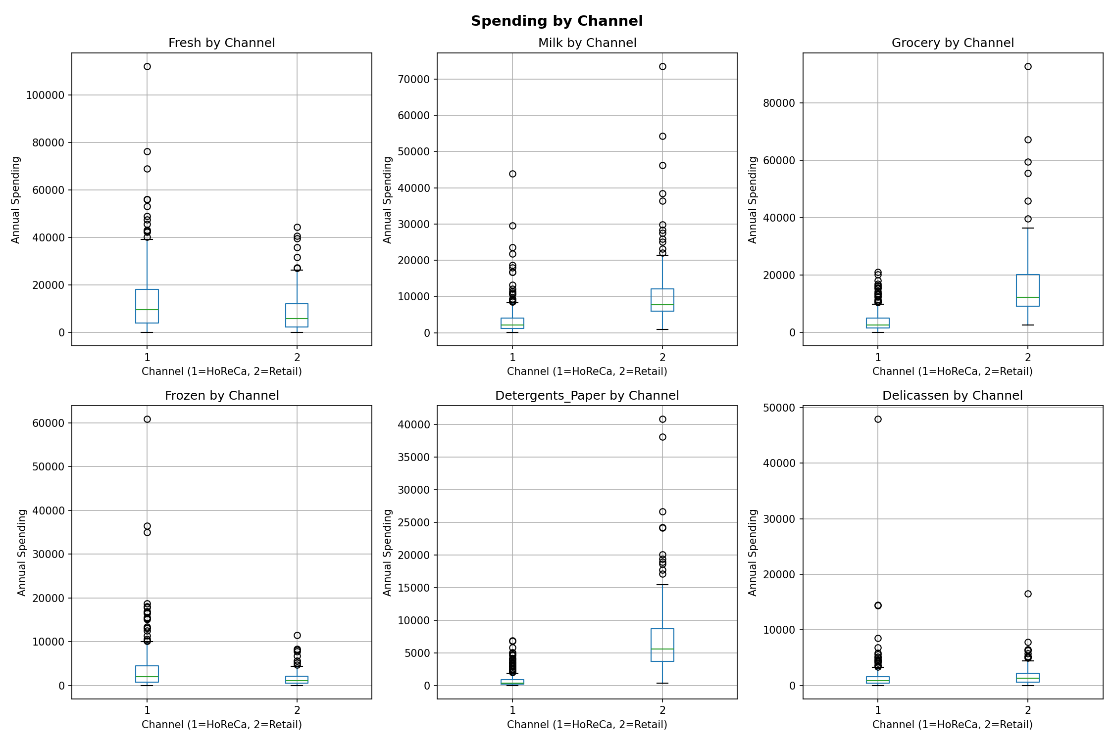

Figure 4: Boxplots of spending by channel for each product category

3.7 Regional Comparison
Figure 5 compares mean annual spending across three regions: Lisbon (Region 1), Oporto (Region 2), and Other (Region 3). Region 3 (Other) dominates numerically (71.8% of all customers), so region-level averages are heavily influenced by this group.

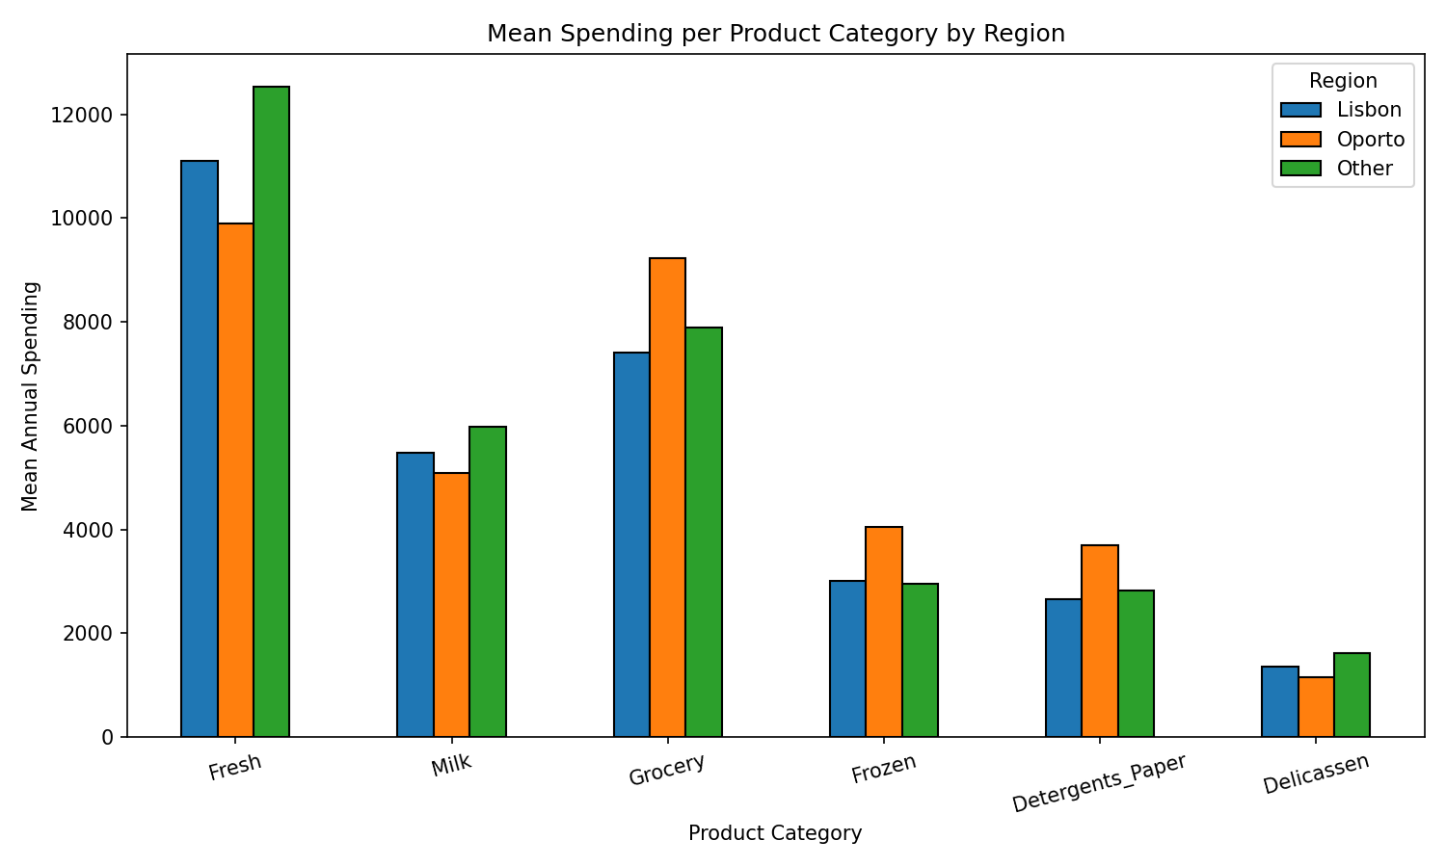

Figure 5: Mean spending per product category by region

3.8 Scatter Analysis: Fresh vs Grocery
Figure 6 plots Fresh spending against Grocery spending, colour-coded by Channel. A clear separation is visible — HoReCa customers (blue) cluster towards high Fresh and low Grocery, while Retail customers (orange) cluster toward high Grocery and lower Fresh. This visual separation suggests that Fresh and Grocery spending alone can serve as useful discriminating features for customer segmentation.

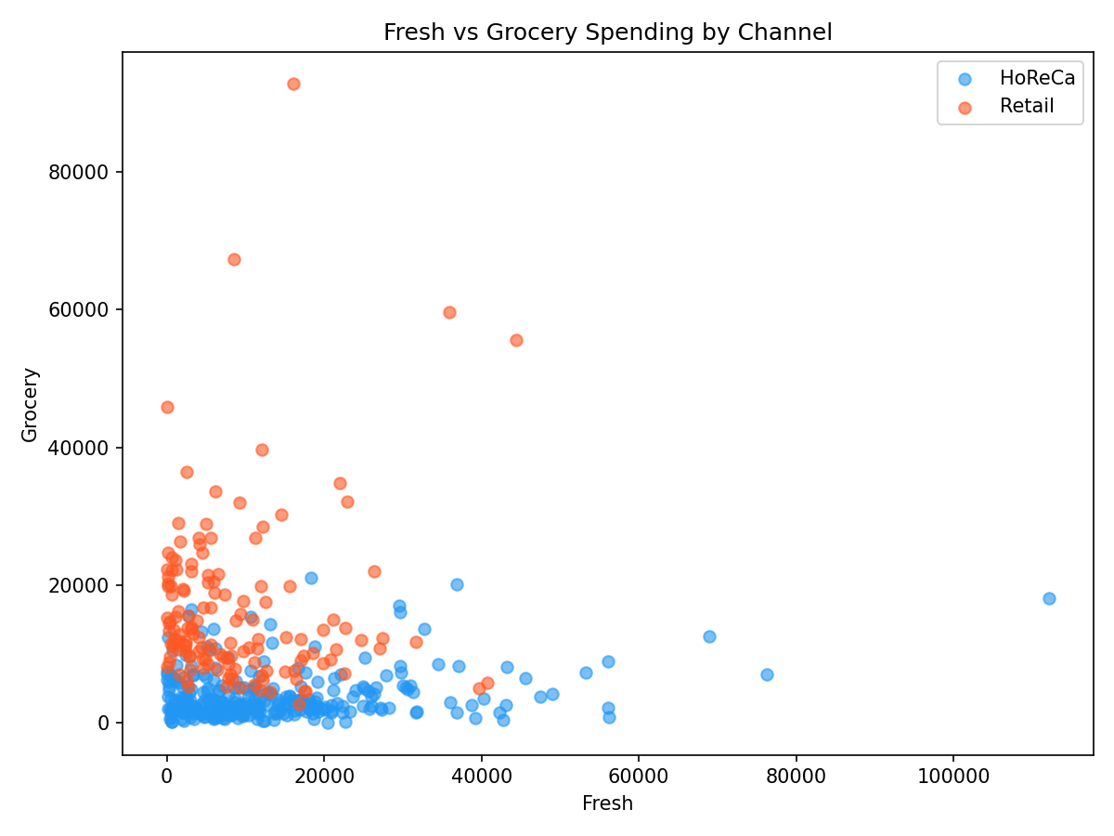

Figure 6: Scatter plot of Fresh vs Grocery spending, coloured by Channel

3.9 Key Findings & Conclusion
The EDA of the Wholesale Customers dataset reveals several clear patterns:

1. All spending distributions are right-skewed, indicating that a small number of customers account for the majority of purchases in each category.
2. Grocery, Milk, and Detergents_Paper are strongly correlated, characteristic of Retail channel customers.
3. HoReCa customers prioritise Fresh and Frozen products, while Retail customers are the dominant buyers of Grocery and Detergents_Paper.
4. The scatter analysis of Fresh vs Grocery demonstrates that these two features alone provide reasonable channel separability, making them strong candidate features for machine learning-based customer segmentation.
5. Region 3 (Other cities) constitutes nearly 72% of all customers, with Lisbon and Oporto representing smaller fractions.

These findings support the use of clustering algorithms (e.g., K-Means) or supervised classification on this dataset to segment customers and optimize wholesale distribution strategies.

Summary

Experiment | Model | Dataset | Test Accuracy
Part 1 — Binary Classification | ANN (3 Dense layers) | Breast Cancer (569 samples, 30 features) | 95.61%
Part 2 — Multi-class Classification | CNN (2 Conv + Pooling + Dense) | MNIST (70,000 images, 10 classes) | 99.07%
Part 3 — EDA | Statistical Analysis + Visualization | Wholesale Customers (440 records) | N/A

All three experiments demonstrate the practical power of deep learning and data analysis in extracting meaningful patterns from real-world datasets. The ANN and CNN models achieved high accuracy with minimal hyperparameter tuning, while the EDA revealed actionable customer behaviour insights from the Wholesale dataset.

