Title : Comparative Performance Evaluation of Sparse, Dense and Hybrid (RRF) Retrieval for Evidence Retrieval on Natural Questions
Students Name | Registration No. | Email-id
Ojas Raghav | 23FE10CSE00709 | ojasraghav48@gmail.com
Keshav Kumar | 23FE10CSE00589 | KESHAV.23FE10CSE00589@muj.manipal.edu
Krishna Goyal | 23FE10CSE00446 | KRISHNA.23FE10CSE00446@muj.manipal.edu

Abstract — Evidence retrieval is the first stage of open-domain question answering, and the ranking model chosen at this stage limits what any downstream reader can use. This paper compares four retrieval strategies — TF-IDF, Okapi BM25, a Sentence-Transformer dense retriever, and a Hybrid pipeline built on Reciprocal Rank Fusion (RRF) — on the Natural Questions (NQ) retrieval benchmark, where real Google queries are matched against Wikipedia passages. All systems are scored on 800 test queries with Precision@10, Recall, MAP, nDCG@10 and MRR@10. The dense retriever is the strongest single system (nDCG@10 = 0.825, MAP = 0.784), ahead of BM25 (0.681, 0.633) and TF-IDF (0.490, 0.435). Three-way RRF fusion improves on both lexical baselines (nDCG@10 = 0.749) but does not surpass the dense retriever, and a significance test on per-query nDCG@10 shows the gap is not due to chance (p < 0.001). A fusion ablation shows that BM25 + dense RRF stays close to the dense model (nDCG@10 = 0.804) and marginally exceeds its Recall@50 and Recall@100, whereas adding the weaker TF-IDF ranking dilutes the fused list. Fusion is therefore not automatically beneficial: its value depends on the quality of the rankings being combined.
Keywords: Information Retrieval · Reciprocal Rank Fusion · BM25 · Sentence Transformers · Hybrid Search · Natural Questions Dataset

1. Introduction
Information Retrieval (IR) underpins web search, question-answering systems and Retrieval-Augmented Generation (RAG). In open-domain question answering a reader model can only answer from the passages it is given, so the quality of the retrieval stage sets an upper bound on the whole system. Classical retrieval is lexical: each passage is scored by the query terms it shares, using term frequencies and an inverted index. Term Frequency–Inverse Document Frequency (TF-IDF) and the probabilistic Okapi BM25 function [1] are the standard examples, and both remain fast, cheap and surprisingly hard to beat.
Lexical scoring fails, however, when a question and its answer-bearing passage describe the same fact in different words. Dense retrievers address this vocabulary mismatch by mapping queries and passages into a shared embedding space, for instance with Sentence-BERT style encoders [2], and ranking by vector similarity. They capture paraphrase and intent, but can underperform on rare names, numbers and exact strings. Reciprocal Rank Fusion (RRF) [3] was proposed to merge several rankings using only rank positions, which avoids having to calibrate BM25 scores against cosine similarities. It is widely used to build hybrid search engines on the assumption that lexical and semantic evidence complement each other.
This report tests that assumption empirically on Natural Questions (NQ) [4], a benchmark of genuine user questions asked on Google Search. We compare TF-IDF, BM25, a Sentence-Transformer dense retriever and a three-way RRF hybrid under identical preprocessing, corpus and evaluation conditions. The contributions are:
- Implementation: lexical retrieval is built on an inverted index written from scratch, with TF-IDF and BM25 (tuned on a held-out development split) scoring directly from its postings.
- Comparison: all four models, plus three RRF variants, are evaluated on 800 test queries using Precision, Recall, MAP, nDCG@10 and MRR@10, with latency measurements.
- Analysis: a significance test, a Precision–Recall curve, per-query score distributions and a BM25-versus-dense win/loss breakdown explain when each paradigm succeeds and why fusion did not help here.
The rest of the report is organised as follows: Section 2 describes the dataset, Section 3 the methodology, Section 4 the experiments and results, and Section 5 concludes.
2. About Dataset
2.1 Visualization of dataset in form of graphs or tables and explanation of dataset using an example
Natural Questions [4] consists of real, anonymised queries issued to Google Search, each paired with a Wikipedia page that annotators examined for an answer. We use the retrieval formulation of NQ distributed with the BEIR benchmark [5], which has three parts: a corpus of Wikipedia passages (a title plus body text), a set of short natural-language questions, and relevance judgements (qrels) linking each question to the passage(s) that contain its answer.
The complete corpus holds roughly 2.68 million passages, too large for repeated indexing and encoding on a laptop, so we built a reproducible subset (random seed 42) that keeps the passages judged relevant to the evaluation queries and fills the rest of the collection with randomly sampled distractor passages. Every relevant passage is retained, so recall stays meaningful, but absolute scores are higher than on the full corpus. Table 1 summarises the subset and its index.
Table 1. Statistics of the NQ retrieval subset and its inverted index.
Property | Value
Source benchmark | Natural Questions (BEIR retrieval form)
Test queries | 800
Passages in indexed corpus | [fill from dataset_stats.json]
Mean passage length (after preprocessing) | 48.9 tokens
Vocabulary size / total postings | 176,623 terms / 3,856,444
Subset sampling seed | 42

Example record (constructed to show the format; not taken from the evaluation set):
Query: who wrote the declaration of independence
Relevant passage (title: United States Declaration of Independence): The document was drafted principally by Thomas Jefferson, working with a committee of five, and adopted by the Second Continental Congress in July 1776. Qrel: (query, passage) → 1

The question says “wrote” while the passage says “drafted”, so after stemming the two never match: a lexical model must rely on the other shared terms, whereas a dense encoder can link the verbs semantically. NQ has very few relevant passages per query (about 1.2 on average, implied by the dense model's P@10/R@10 ratio), so Precision@10 cannot exceed roughly 0.1 and is best read alongside Recall, MAP and nDCG.
3. Methodology
Our pipeline applies the same document processing, indexing, ranking and evaluation steps to every model. The complete workflow, from the raw query to the final fused ranking, is shown in Figure 1.
[ User Input Query ]
│
▼
[ Query Preprocessing & Tokenization ]
│
┌───────┴──────────────────────────────┐
│ │
▼ ▼
[ Sparse Retrieval Path ] [ Dense Retrieval Path ]
├── Inverted Index Lookup └── Sentence Transformer Encoder
├── TF-IDF & Okapi BM25 Score └── Dense Vector Cosine Similarity
└── Top-K Sparse Ranked List └── Top-K Dense Ranked List
│ │
└───────┬──────────────────────────────┘
│
▼
[ Reciprocal Rank Fusion (RRF) Aggregator ]
│
▼
[ Final Aggregated Ranking & Top-K Results ]
Figure 1: Architectural Flowchart of the Hybrid Reciprocal Rank Fusion (RRF) Retrieval Pipeline.
3.1 Preprocessing and Indexing
For the lexical models, passage text is lowercased, stripped of markup, URLs and punctuation, tokenised with NLTK, filtered with an English stop-word list and reduced to stems with the Snowball stemmer; the passage title is prepended to its text. From the resulting tokens we built an inverted index from scratch that maps each term to its postings (document identifier and term frequency) and stores document lengths and document frequencies. The index contains 176,623 terms and 3,856,444 postings, with a mean passage length of 48.9 tokens. The dense path skips stemming and stop-word removal and encodes lightly cleaned raw text, because transformer encoders depend on function words and exact word forms.
3.2 Ranking Models
We evaluate four ranking models:
- TF-IDF Vector Space Model: scores passages with a log-scaled term frequency multiplied by the inverse document frequency log(Nf), and ranks them by cosine similarity with length normalisation, computed directly from the inverted index.
- Okapi BM25: a probabilistic function [1] with term-frequency saturation (k1) and length normalisation (b). Both parameters were tuned on a held-out development split by grid search over k1 ∈ {0.9, 1.2, 1.5, 2.0} and b ∈ {0.4, 0.6, 0.75, 0.9}; the best setting was k1 = 0.9, b = 0.4 (dev nDCG@10 = 0.663, Figure 3).
- Sentence Transformer (Dense Search): a MiniLM-based encoder [2, 6] (all-MiniLM-L6-v2) embeds queries and passages into the same vector space; passage embeddings are computed once offline and passages are ranked by cosine similarity to the query embedding.
- Hybrid Reciprocal Rank Fusion (RRF): merges the TF-IDF, BM25 and dense ranked lists into one list using only rank positions (Section 3.3). Two-way variants are also evaluated as an ablation.
3.3 Reciprocal Rank Fusion Formulation
RRF combines the positions that a document occupies in several ranked lists. Given a set of rankers M and a smoothing constant k (set to 60,\\\ following [3]), the fused score of a document d is:
RRF_Score(d ∈ D) = ∑ (m ∈ M) 1 / (k + r_m(d))
where r_m(d) is the 1-based rank of d in the list produced by ranker m (documents missing from a list contribute nothing). The top 100 results of each ranker are fused with equal weights. Because only ranks are used, no score normalisation between BM25 values and cosine similarities is needed. The same property has a cost: a document ranked moderately well by several weak rankers can outscore one ranked first by a single strong ranker, which becomes relevant in Section 4.
4. Experimental Setup and Performance Analysis
All models are evaluated on the same 800 NQ test queries and the same relevance judgements. We report Precision@10 (P@10), Recall@10/50/100, Mean Average Precision (MAP), nDCG@10 with binary gains, and MRR@10, together with mean per-query latency. Significance is assessed with a test on per-query nDCG@10 differences at α = 0.05. Table 2 gives the main comparison, using the four models in the specification.
Table 2. Performance comparison of sear models on the Natural Questions (NQ) retrieval subset.
Ranking Model | Precision@10 | Recall@100 | MAP | nDCG@10
TF-IDF | 0.0816 | 0.9223 | 0.4352 | 0.4903
BM25 | 0.0989 | 0.9490 | 0.6332 | 0.6806
Sentence Transformer (Dense) | 0.1135 | 0.9921 | 0.7838 | 0.8249
Hybrid RRF (BM25 + TF-IDF + Dense) | 0.1075 | 0.9910 | 0.7000 | 0.7488

As reported in Table 2, the dense retriever is the best model on every metric. Relative to BM25 it improves MAP by about 23.8% (0.783 vs 0.633) and nDCG@10 by about 21.2%; relative to TF-IDF the gains are 80.1% and 68.2%. BM25 itself a large step above TF-IDF (+38.8% nDCG@10), which shows the benefit of term saturation and lengthnormalisation on short passages. Recall@100 exceeds 0.92 for all four systems, so the models differ mainly in how high they place the relevant passage, not in whether they retrieve it at all.
The three-way hybrid lands between BM25 and the dense model. It improves on BM25 by about 10.0% in nDCG@10 and 10.5% in MAP, but it trais te dense retriever by about 9.2% in nDCG@10 and 10.7% in MAP. The difference between hybrid and dense nDCG@10 is statistically significant (p < 0.001), so on this benchmark fusion reduces ranking qualitycompared with the best single model. The only metric where it effectively ties dense is Recall@100 (0.9910 vs 0.9921). Table 3 adds deeper recall, MRR, latency and the RRF ablation.
Table 3. Extended metrics, latency and RRF ablation on the NQ retrieval subset.
Model | R@10 | R@50 | MRR@10 | MAP | nDCG@10 | Latency (ms/query)
TF-IDF | 0.6771 | 0.8712 | 0.4416 | 0.4352 | 0.4903 | 24.8
BM25 | 0.8244 | 0.9262 | 0.6462 | 0.6332 | 0.6806 | 20.5
Dense | 0.9412 | 0.9842 | 0.7946 | 0.7838 | 0.8249 | 21.3
Hybrid-RRF (all three) | 0.8923 | 0.9725 | 0.7141 | 0.7000 | 0.7488 | 69.6
RRF (BM25 + Dense) | 0.9404 | 0.9890 | 0.7707 | 0.7572 | 0.8044 | —
RRF (TF-IDF + BM25) | 0.7971 | 0.9206 | 0.5933 | 0.5839 | 0.6351 | —
RRF (TF-IDF + Dense) | 0.8948 | 0.9835 | 0.6545 | 0.6433 | 0.7051 | —

Ablation. Fusing BM25 with the dense retriever gives the best hybrid (nDCG@10 = 0.804). It is still below dense alone, but it reaches the highest Recall@50 (0.9890) and Recall@100 (0.9929) of any confiuration, so fusion helps slightly at greater depth, which would matter if the list feeds a re-ranker. Adding TF-IDF consistently hurts: it lowers the BM25 + dense result from 0.804 to 0.749, and fusing the two lexical rankers (TF-IDF + BM25, nDCG@10 = 0.635) is worsethan BM25 alone (0.681). Fusing a weak ranking with equal weight lets its errors outvote the stronger ranking. Latency. TF-IDF, BM25 and dense search each take 20–25 ms per query. The hybrid takes 69.6 ms, close to the sum of its three components (66.6 ms) plus a small fusion cost, so it is about three times slower than dense alone while being less accurate. Latency was recorded for the primary configurations only.
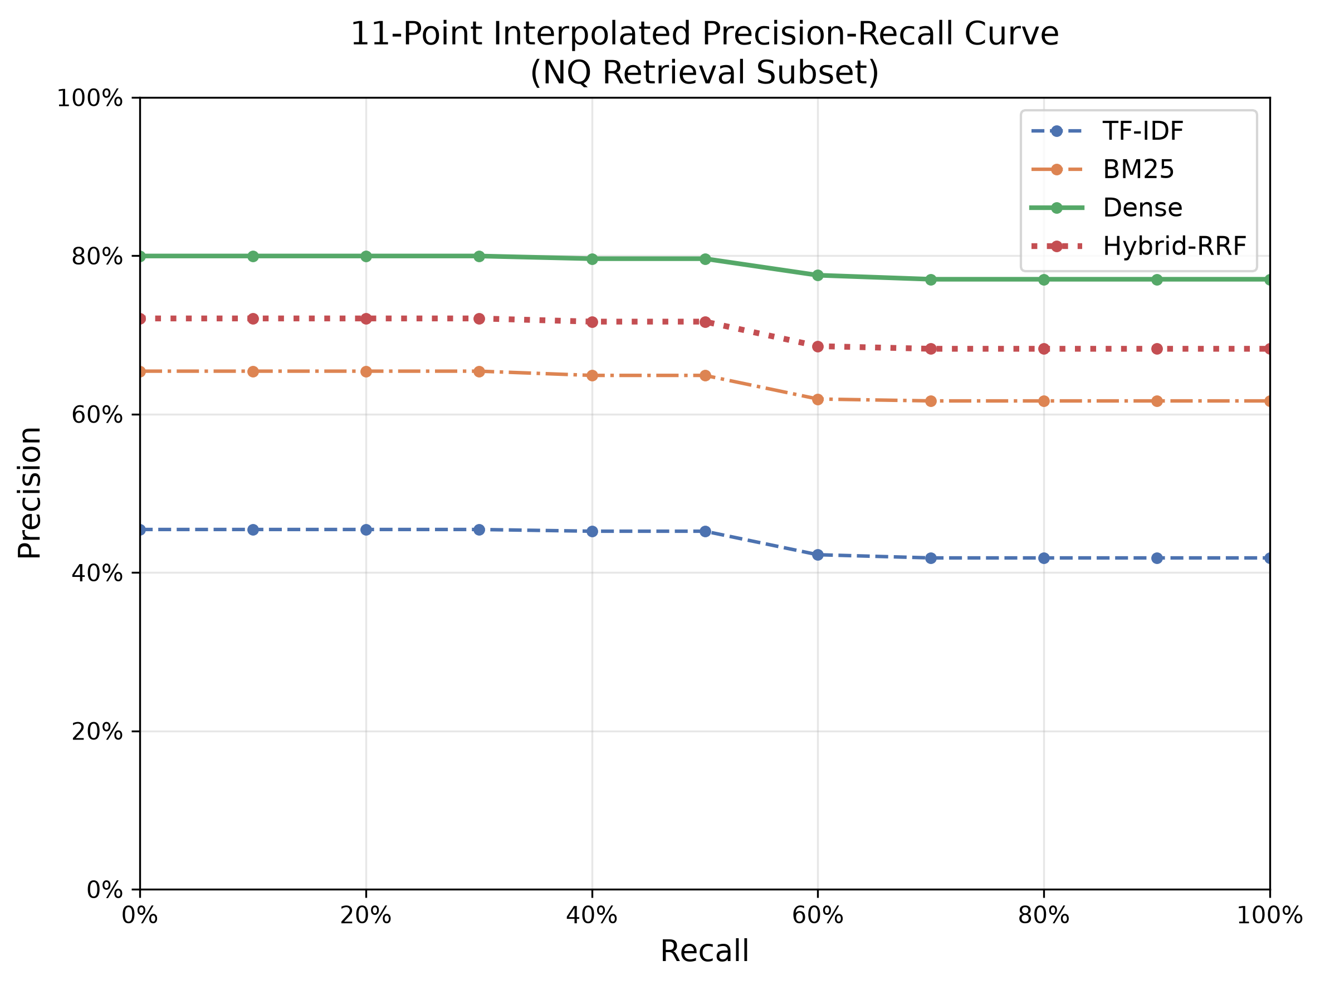  Figure 2: 11-point interpolated Precision–Recall curves. | 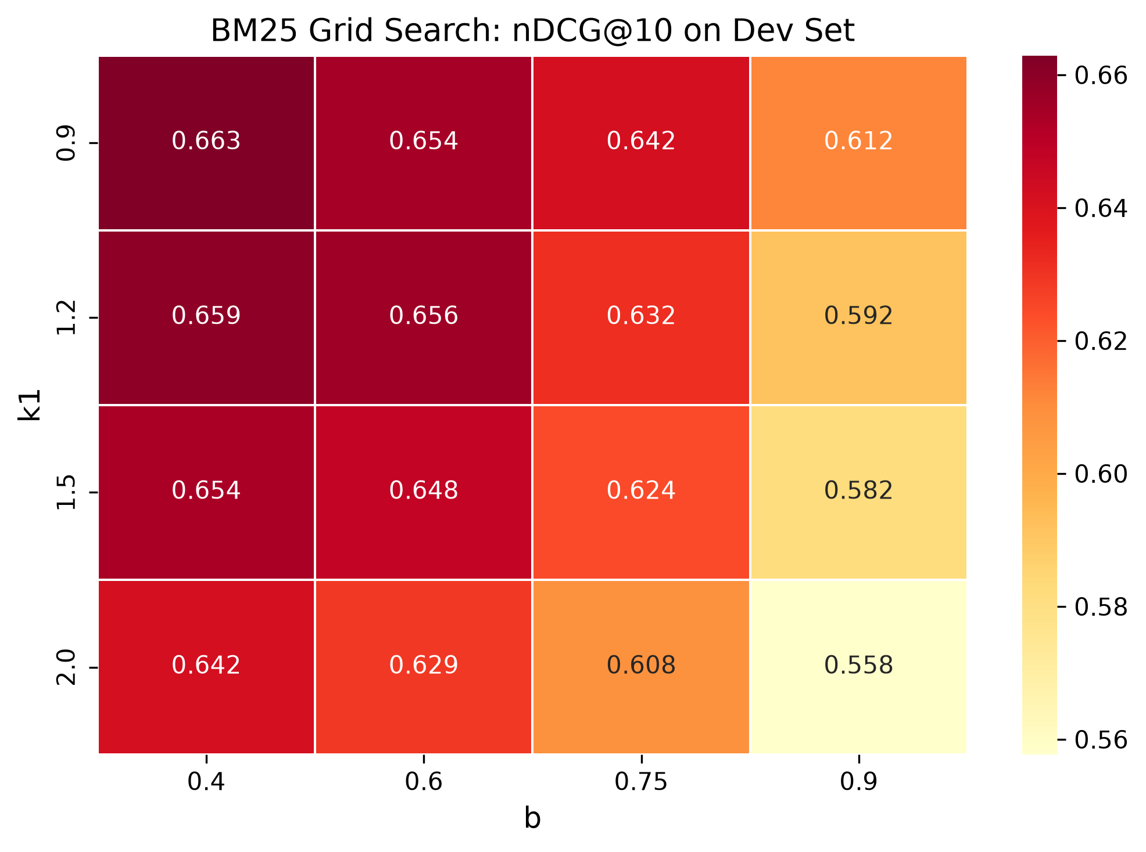  Figure 3: BM25 grid search (dev nDCG@10).
Figure 2 shows that the ordering Dense > Hybrid > BM25 > TF-IDF holds at every recall level. The curves are almost flat (dense falls only from about 0.80 to 0.77) because most queries have a single relevant passage, so precision depends mainly on whether tat passage is ranked first. Figure 3 shows that BM25 prefers low values of both parameters: dev nDCG@10 falls from 0.663 (k1 = 0.9, b = 0.4) to 0.558 (k1 = 2.0, b = 0.9). A weaker length penalty is plausible here because passages are short (48.9 tokens on average), so long-document correction adds little and can penalise the passage that contains the answer.
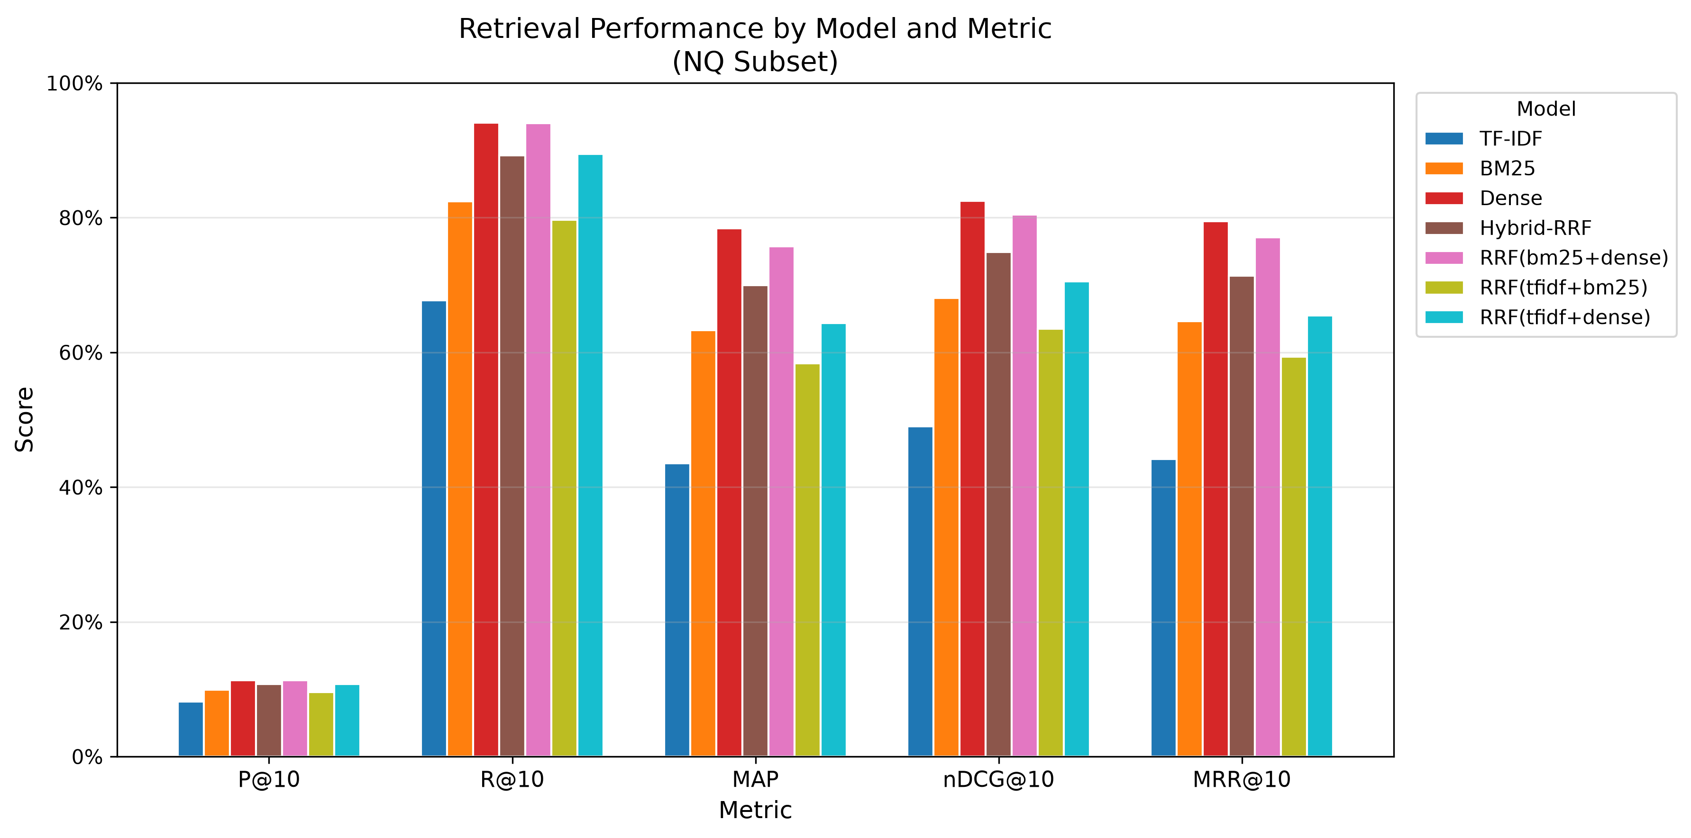
Figure 4: Metric comparison across all seven models.
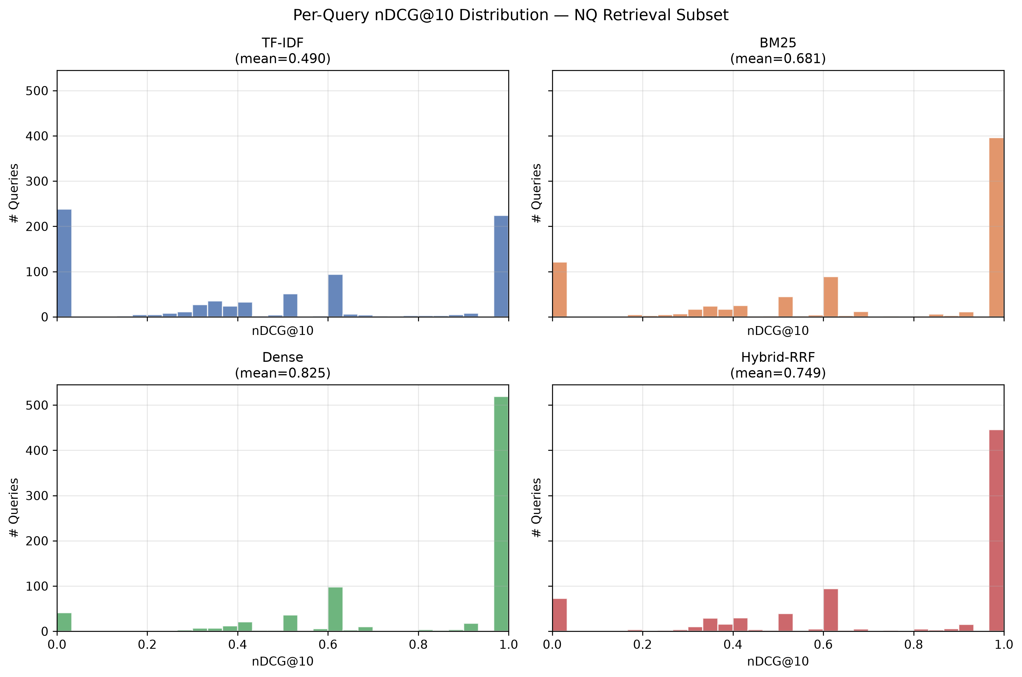  Figure 5: Per-query nDCG@10 distributions. | 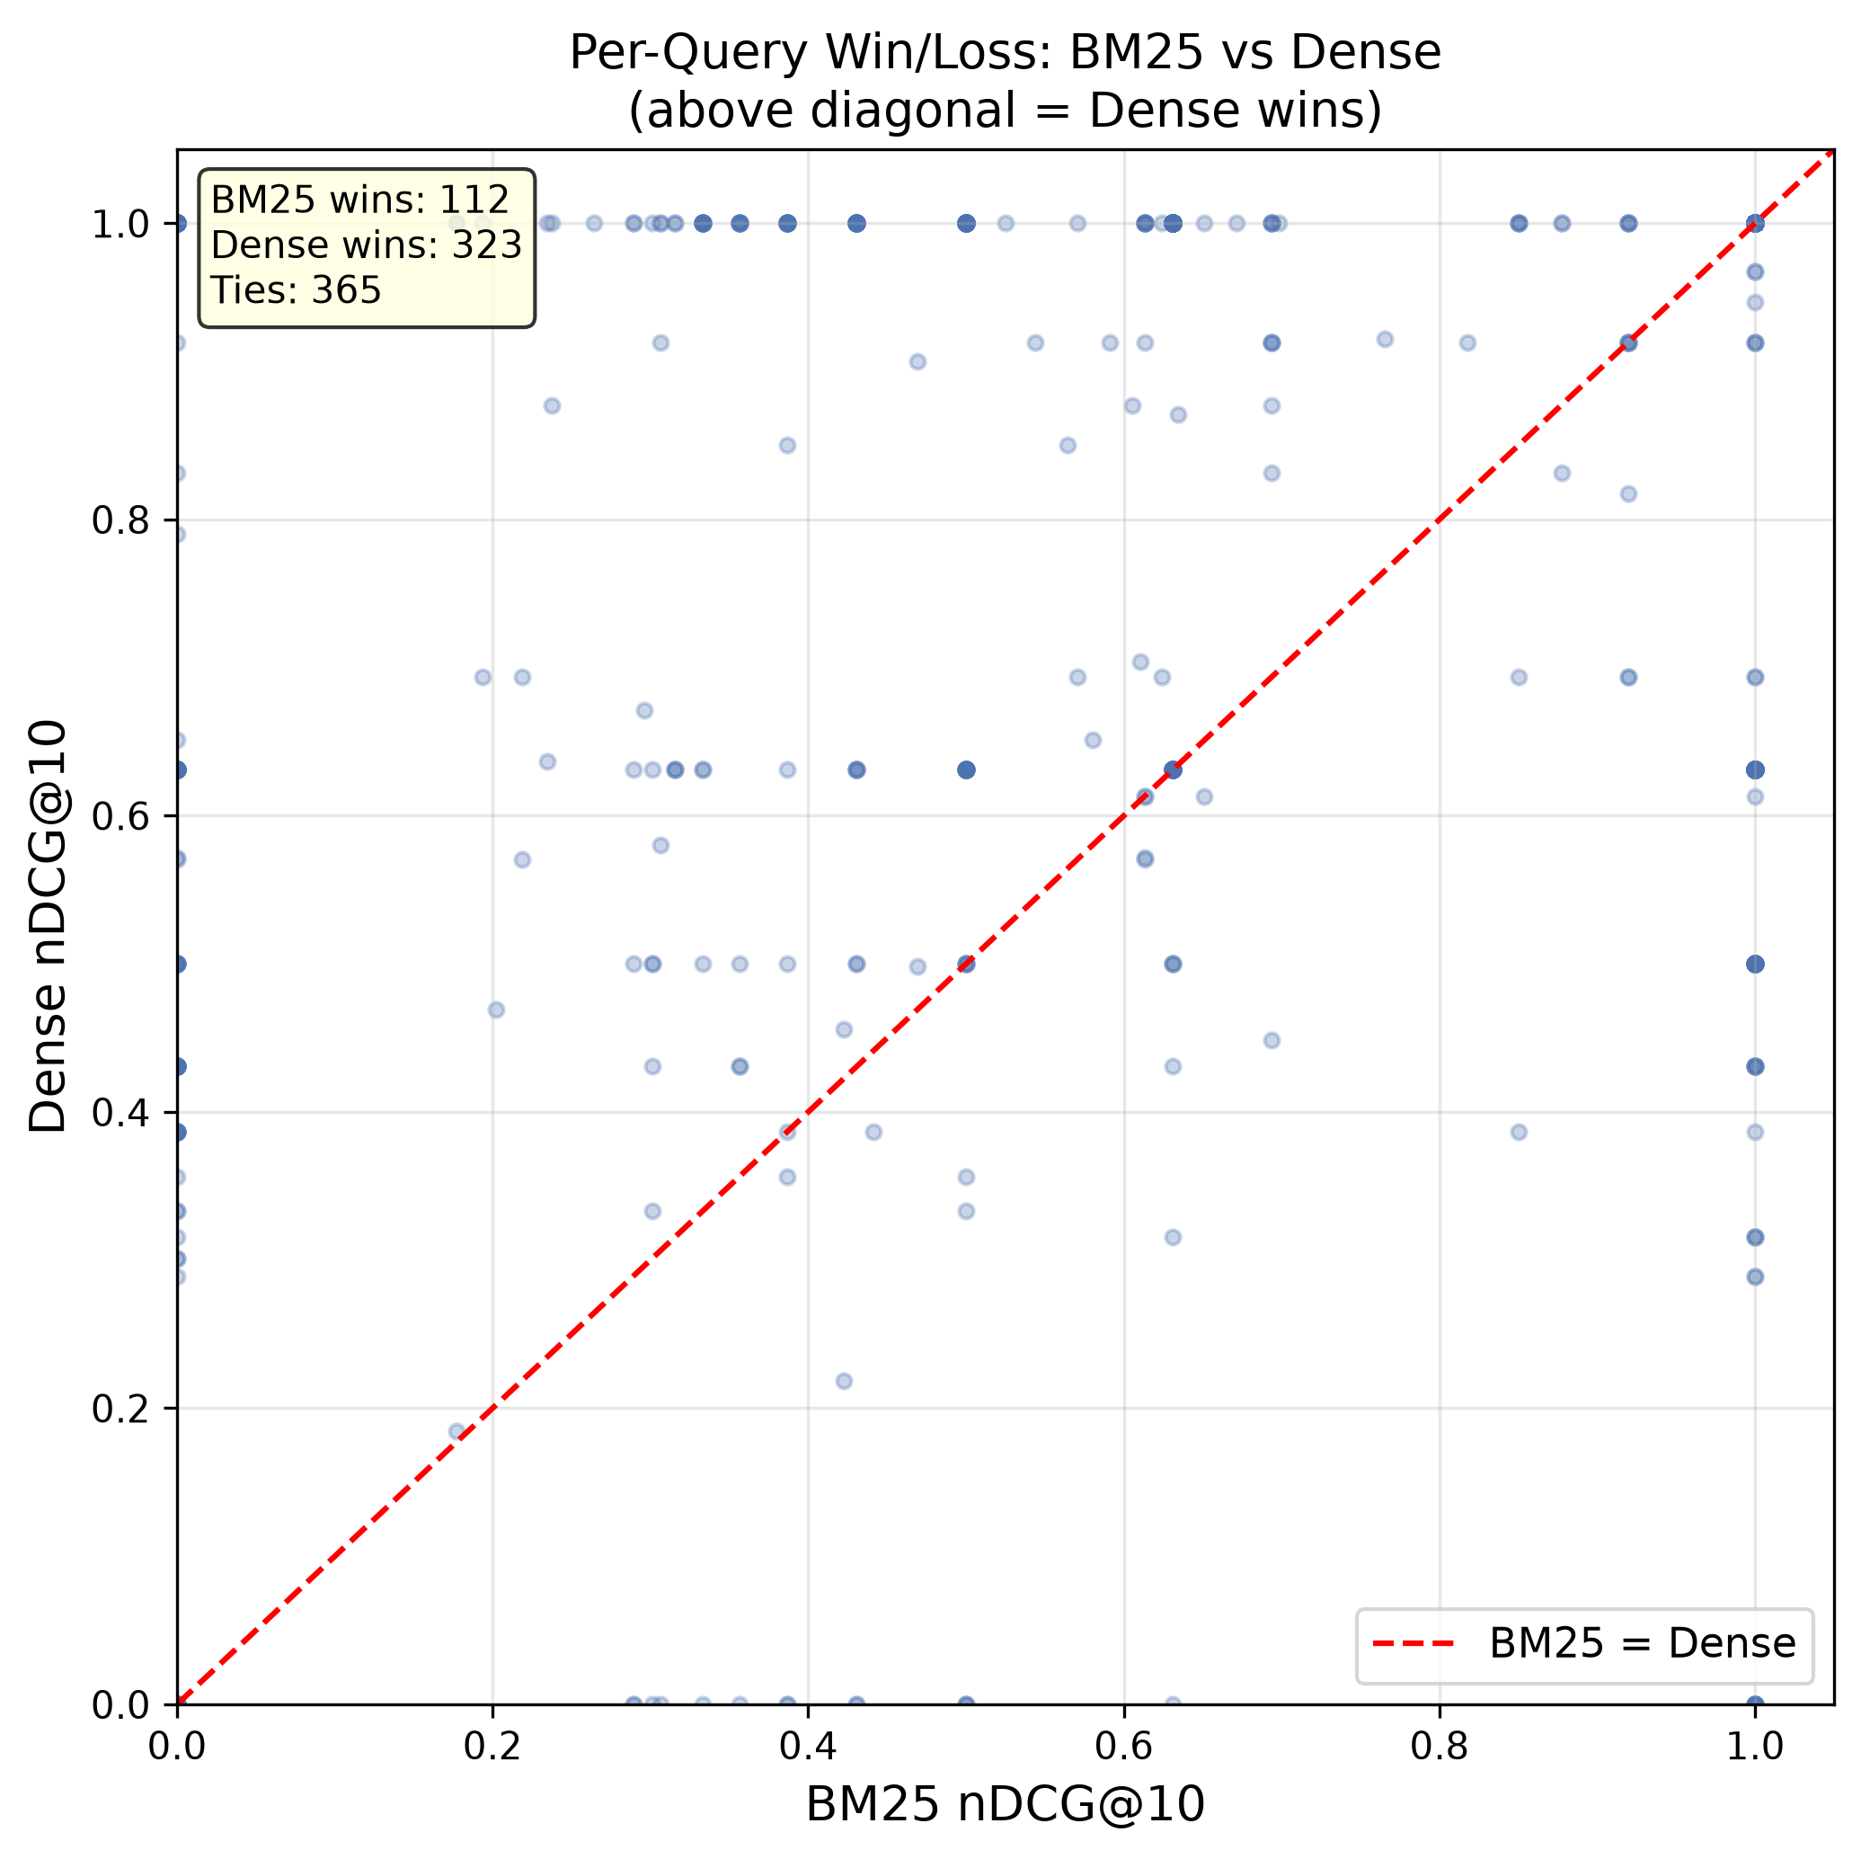  Figure 6: Per-query BM25 vs Dense nDCG@10.
Per-query behaviour. Figure 5 shows that scores are strongly bimodal: a query is usually either answered at rank one or missed in the top ten. Roughly 520 of the 800 queries receive a perfect nDCG@10 from the dense model, against about 395 for BM25 and about 224 for TF-IDF, while the number of complete misses falls from about 237 (TF-IDF) to about 120 (BM25) and about 40 (dense); the hybrid has roughly 72. Figure 6 compares BM25 and dense query by query: dense wins on 323 queries (40.4%), BM25 on 112 (14.0%) and the two tie on 365 (45.6%). The 112 BM25 wins are consistent with the cases where an exact rare term or name decides relevance, but dense wins nearly three times as often, which matches the vocabulary-mismatch pattern described in Section 2. Because RRF is built from rank positions, the 112 queries where BM25 is better cannot offset the larger group where it drags the fused rank down.
5. Conclusion
This work compared TF-IDF, BM25, Sentence-Transformer dense retrieval and RRF hybrid retrieval for evidence retrieval on Natural Questions. The dense retriever was the best system on all reported metrics (nDCG@10 = 0.825, MAP = 0.784), BM25 was a clear second (0.681, 0.633) and TF-IDF a distant third. Three-way RRF improved on both lexical models but was significantly worse than dense retrieval alone, so the common expectation that hybrid search outperforms every single retriever was not confirmed in this setting. The ablation explains why: a BM25 + dense fusion stays close to dense and gives marginally better Recall@50/100, while including the weak TF-IDF ranking pulls the fused ranking down.
Several limitations apply. Evaluation uses a subsampled corpus, one dataset and one dense encoder, and absolute scores are higher than on the full NQ corpus. RRF was run with equal weights and a fixed k = 60 without tuning, and no re-ranker was used. Natural Questions is also a favourable domain for semantic retrieval; datasets dominated by exact identifiers or technical terms may favour lexical or hybrid methods more. Future work will explore weighted or learned fusion that down-weights weak rankers, fusion limited to BM25 and dense lists, cross-encoder re-ranking of the fused top results, stronger dense models, and evaluation on the full corpus and additional benchmarks.
References
1. Robertson, S., Zaragoza, H.: The Probabilistic Relevance Framework: BM25 and Beyond. Foundations and Trends in Information Retrieval 3(4), 333–389 (2009)
2. Reimers, N., Gurevych, I.: Sentence-BERT: Sentence Embeddings using Siamese BERT-Networks. In: Proceedings of EMNLP-IJCNLP, pp. 3982–3992 (2019)
3. Cormack, G.V., Clarke, C.R., Buettcher, S.: Reciprocal Rank Fusion outperforms Condorcet and individual Rank Learning Methods. In: Proceedings of SIGIR, pp. 758–759 (2009)
4. Kwiatkowski, T., Palomaki, J., Redfield, O., et al.: Natural Questions: A Benchmark for Question Answering Research. Transactions of the Association for Computational Linguistics 7, 452–466 (2019)
5. Thakur, N., Reimers, N., Rücklé, A., Srivastava, A., Gurevych, I.: BEIR: A Heterogeneous Benchmark for Zero-shot Evaluation of Information Retrieval Models. In: NeurIPS Datasets and Benchmarks Track (2021)
6. Wang, W., Wei, F., Dong, L., Bao, H., Yang, N., Zhou, M.: MiniLM: Deep Self-Attention Distillation for Task-Agnostic Compression of Pre-Trained Transformers. In: Advances in Neural Information Processing Systems 33, pp. 5776–5788 (2020)

