MODULE 5

ETHICAL CONSIDERATIONS AND FUTURE TRENDS

SYLLABUS:
Ethical and Social Implications: Addressing trust and transparency, Potential societal impacts of blockchain adoption, Responsible block chain development and usage.

Future Trends and Challenges: Emerging technologies in blockchain (e.g., sharding, sidechains), Environmental impact and sustainability, Scalability and performance improvements.

Overview Ethical and Social Implications:
Ethical and Social Implications of Blockchain

Decentralization and Power Dynamics
      - Empowerment of Individuals: Blockchain technology enables individuals to have control over their own data and financial transactions, reducing reliance on centralized institutions.
      - Disruption of Traditional Power Structures: By decentralizing data storage and management, blockchain can challenge existing hierarchies in finance, governance, and information dissemination.

Privacy and Data Security
      - Anonymity vs. Transparency: While blockchain can enhance privacy through pseudonymity, the transparency of transactions can lead to concerns about the traceability of actions and the potential for misuse.
      - Data Ownership: Users have more control over their personal data, but questions arise regarding the implications of data being immutable and permanently recorded.

Financial Inclusion
      - Access to Services: Blockchain can provide financial services to unbanked populations, promoting economic inclusion and reducing disparities.
      - Potential for Exploitation: However, the same technology may also enable predatory practices, such as high-interest loans or scams targeting vulnerable individuals.

Environmental Impact
      - Energy Consumption: The energy-intensive nature of some blockchain protocols, particularly proof-of-work systems, raises concerns about their sustainability and environmental footprint.
      - Innovation in Sustainability: Conversely, blockchain can facilitate tracking of carbon credits and promote environmentally responsible practices.

Regulatory Challenges
      - Need for Regulation: The decentralized nature of blockchain poses challenges for regulators attempting to protect consumers and maintain market integrity.
      - Balancing Innovation and Oversight: Striking a balance between fostering innovation and implementing necessary regulations is critical for the responsible development of blockchain technology.

Social Trust and Misinformation
      - Building Trust: Blockchain can enhance trust through transparency and immutability, but the potential for misinformation and scams remains a significant risk.
      - Impact on Social Norms: Widespread adoption of blockchain may alter societal norms regarding trust, authority, and verification of information.

Ethics of Smart Contracts
      - Autonomous Execution: Smart contracts can execute transactions automatically, raising ethical questions about accountability in cases of disputes or unintended consequences.
      - Bias and Fairness: The algorithms governing smart contracts can inadvertently perpetuate biases, necessitating careful design and oversight.

Impact on Employment
      - Job Displacement: Automation through blockchain and smart contracts could lead to job losses in traditional sectors, requiring workforce retraining and adaptation.
      - Creation of New Roles: Conversely, blockchain technology also creates new job opportunities in areas like blockchain development, auditing, and compliance.

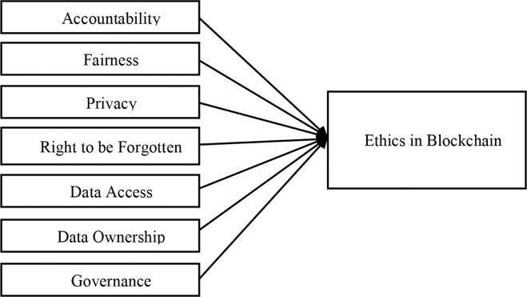

  - Addressing trust and transparency
Blockchain technology inherently promotes trust and transparency through its decentralized and immutable nature. Here’s an exploration of how these features contribute to ethical practices and the implications they carry.

Building Trust Through Decentralization

      - Reduction of Intermediaries: Traditional systems often rely on intermediaries (banks, brokers, etc.) to establish trust. Blockchain eliminates the need for these intermediaries by allowing parties to interact directly. This shift can foster greater trust among users who may be skeptical of centralized authorities.
      - Peer Verification: Transactions on a blockchain are validated by a network of participants rather than a single entity, reducing the risk of fraud. This collective verification process enhances trust among users who can rely on the network rather than an individual authority.

Transparency and Accountability

      - Immutable Ledger: Once data is recorded on a blockchain, it cannot be altered or deleted. This immutability ensures that all transactions are permanent and transparent, increasing accountability for all parties involved. Users can trace the history of transactions, which is particularly valuable in sectors like supply chain management and finance.
      - Open Access: Many blockchain networks are public, allowing anyone to view transaction histories. This openness can deter unethical behavior, as malicious actions are more likely to be exposed in a transparent system.

Ethical Implications of Transparency

      - Privacy Concerns: While transparency is beneficial, it raises ethical issues regarding user privacy. Public blockchains expose transaction details, which may lead to unwanted surveillance or profiling. Balancing transparency with the right to privacy is crucial.

      - Data Ownership: Users have more control over their data on blockchain. However, ethical questions arise around the implications of permanent data storage and the potential for misuse of information.

Trust in Smart Contracts

      - Automation and Fairness: Smart contracts execute automatically based on predefined conditions, which can enhance trust by removing human error and bias from the execution of agreements. However, the ethical design of these contracts is critical; poorly designed smart contracts can lead to unintended consequences and disputes.
      - Accountability: If a smart contract fails, determining accountability can be challenging. Ethical frameworks must be established to address who is responsible for rectifying issues arising from automated transactions.

Impact on Stakeholder Relationships

      - Empowerment of Users: Blockchain empowers users by giving them control over their transactions and data. This shift can enhance trust in relationships between consumers and businesses, as users can verify claims independently.
      - Collaboration and Innovation: The transparent nature of blockchain encourages collaboration among stakeholders, fostering innovation. Companies can work together more effectively, knowing that their interactions are recorded and verifiable.

Addressing Misinformation

      - Verification of Information: Blockchain can be used to verify the authenticity of information, combating misinformation. For instance, in journalism, blockchain can provide a reliable source for tracing the origins of news articles, enhancing trust in media.
      - Challenges of Trust in Decentralized Environments: Despite its advantages, the decentralized nature of blockchain can lead to challenges in trust, as users may struggle to discern credible sources within an open network. Ethical guidelines and standards are necessary to navigate these challenges.

Potential societal impacts of blockchain adoption
Blockchain technology, characterized by its decentralized and immutable nature, has the potential to profoundly influence various aspects of society. Its implementation can enhance transparency, trust, and security in multiple sectors, including finance, supply chain management, healthcare, governance, and more. However, it also raises critical concerns and challenges that must be addressed to maximize its benefits and mitigate risks.

Positive Societal Impacts

Enhanced Transparency and Trust
    - Impact on Governance: Blockchain can improve transparency in government by providing a public ledger of transactions, reducing corruption and fraud. For example, public contracts and expenditures can be recorded on a blockchain, allowing citizens to monitor government spending.
    - Impact on Business: In supply chain management, blockchain enhances traceability of goods, allowing consumers to verify the origins and journey of products. This can strengthen brand trust and encourage ethical consumption.

Financial Inclusion
    - Access to Services: Blockchain can bring financial services to unbanked and underbanked populations by providing access to decentralized financial systems (DeFi). This could empower individuals in developing nations who lack traditional banking infrastructure.
    - Cost Reduction: By eliminating intermediaries in financial transactions, blockchain can reduce transaction costs and increase efficiency, making financial services more affordable for more people.

Improved Healthcare Management
    - Data Interoperability: Blockchain can enhance the sharing of medical records across healthcare providers while ensuring patient privacy and consent. This leads to better coordinated care and improved health outcomes.

    - Drug Traceability: The technology can track pharmaceuticals through the supply chain, helping to combat counterfeit drugs and ensuring the integrity of medications.

Efficient Supply Chains
    - Traceability and Accountability: Blockchain can enhance supply chain efficiency by providing real-time data on product movement and status, which helps identify inefficiencies or disruptions quickly.
    - Sustainability: Organizations can use blockchain to ensure ethical sourcing practices, like verifying that raw materials are sustainably and responsibly sourced, which resonates with environmentally conscious consumers.

Empowerment through Decentralization
    - Control Over Data: Individuals can maintain ownership and control over their personal data on a blockchain, reducing the dependency on centralized entities that often exploit user data for profit.
    - Community Building: Blockchain can facilitate community-driven initiatives, such as decentralized autonomous organizations (DAOs), that empower individuals to influence governance and decision-making processes.

Negative Societal Impacts

Job Displacement
    - Automation of Roles: As organizations adopt blockchain solutions that automate processes previously managed by humans (e.g., record-keeping, auditing), there may be significant job losses in traditional roles.
    - Skill Gaps: There may be a growing divide between those with the skills to work with blockchain technology and those without, exacerbating economic inequality.

Regulatory and Legal Challenges
    - Regulatory Uncertainty: The rapid evolution of blockchain technologies often outpaces existing regulatory frameworks, creating uncertainty in compliance and governance. This could impede innovation and investment.
    - Legal Issues: Smart contracts, which execute automatically based on pre- defined conditions, can lead to disputes over enforcement and interpreting contractual terms in the absence of regulatory clarity.

Digital Divide
    - Access Disparities: The adoption of blockchain technology may amplify existing inequalities due to technological barriers. Marginalized communities, especially in developing regions, may not have the necessary access to technology or the internet.
    - Education and Literacy: A lack of understanding and literacy regarding blockchain technology can prevent meaningful participation in its benefits, leading to social exclusion.

Security and Privacy Concerns
    - Cybersecurity Risks: While blockchain is generally secure, it can still be vulnerable to cyberattacks (e.g., 51% attacks, smart contract vulnerabilities), undermining trust in the technology.
    - Privacy Issues: The transparency inherent in many blockchains can conflict with privacy rights. If incorrect data is published on a blockchain, correcting it can become extremely difficult.

Environmental Concerns
    - Energy Consumption: Proof-of-work blockchain systems (e.g., Bitcoin) are criticized for their high energy consumption, raising concerns about their environmental impact and sustainability.

    - Resource Allocation: The energy demands of mining operations can divert resources from more sustainable initiatives, exacerbating climate change and resource scarcity.

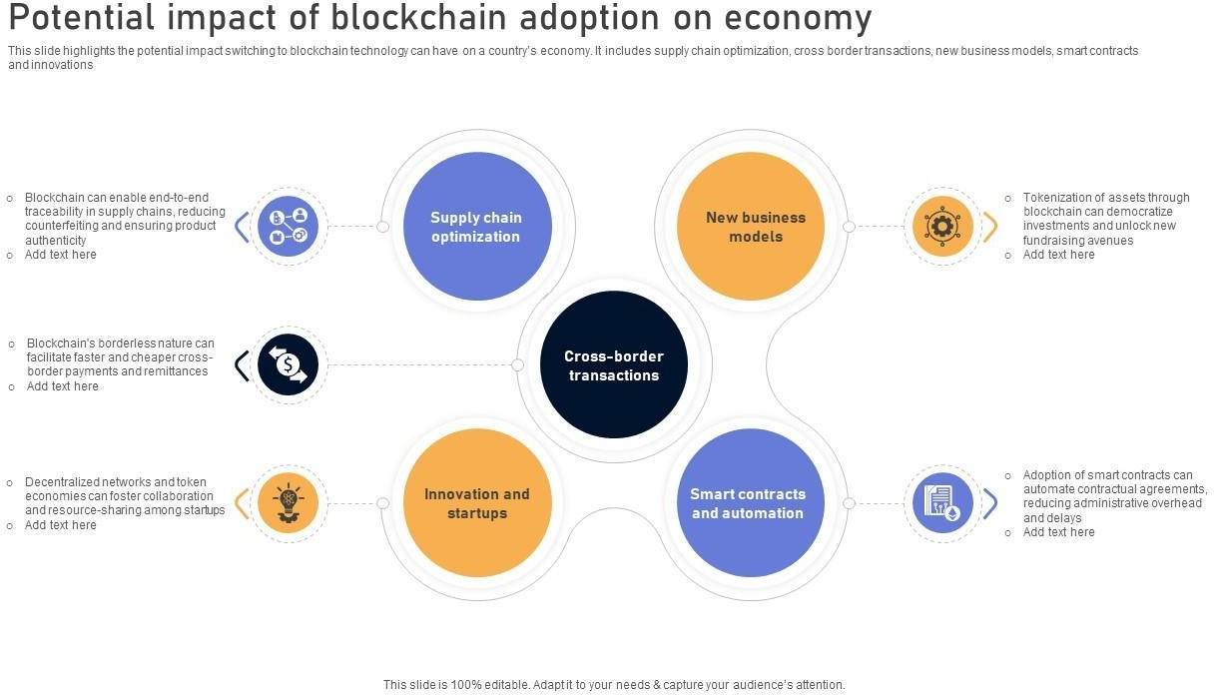

Responsible block chain development and usage
Blockchain technology holds great promise for enhancing transparency, decentralization, and security across various sectors. However, its adoption also presents significant ethical, social, and environmental challenges. Responsible development and usage of blockchain aim to mitigate risks and maximize benefits, ensuring that the technology contributes positively to society.

Principles of Responsible Blockchain Development

Transparency and Openness
  - Open Standards and Protocols: Promoting open-source development allows for community collaboration and scrutiny, which can lead to better security and innovations.
  - Clear Communication: Stakeholders (developers, users, and regulators) should communicate the potential and limitations of blockchain to ensure informed decision-making.

Ethical Design
  - User-Centric Approach: Design blockchain solutions with users’ best interests in mind, prioritizing usability, accessibility, and privacy. This involves engaging with users to understand their needs and concerns.
  - Incorporation of Ethical Guidelines: Develop and adhere to ethical guidelines that govern the use cases of blockchain technology, including data privacy, consent, and the potential for misuse.

Inclusivity and Accessibility
  - Universal Access: Strive to make blockchain technologies accessible to diverse populations, including those in underserved communities. This can involve creating user-friendly interfaces and providing educational resources.

  - Bridging the Digital Divide: Work towards reducing technological disparities by ensuring the necessary infrastructure (like internet access) is available to all users.

Sustainability
  - Environmentally Friendly Practices: Evaluate the energy consumption of blockchain systems and explore alternatives like proof of stake (PoS) or other consensus mechanisms that require less energy than proof of work (PoW).
  - Carbon Compensation: Organizations can invest in carbon offset projects to counterbalance the environmental impact of their blockchain operations.

Security and Privacy
  - Robust Security Practices: Implement strong security measures to safeguard against vulnerabilities, such as regular audits, penetration testing, and adherence to best practices in cryptography.
  - User Data Protection: Establish practices that prioritize user privacy, such as data anonymization and allowing users to retain control over their personal information.

Responsible Blockchain Usage

Compliance with Regulations
  - Adhering to Legal Standards: Blockchain implementations must comply with existing laws and regulations, including those related to data protection (e.g., GDPR) and financial transactions.
  - Proactive Engagement with Regulators: Engage in constructive dialogues with regulatory bodies to shape policies that are conducive to innovation while protecting public interests.

Ethical Use Cases
  - Avoiding Malicious Applications: Developers and organizations should avoid creating or supporting applications that can cause harm, such as fraud, money laundering, or identity theft.
  - Promotion of Social Good: Focus on use cases that have a positive social impact, such as transparent voting systems, identity verification for refugees, or tracking charitable donations.

Community Governance
  - Decentralized Decision-Making: Engage stakeholders in the governance of blockchain networks through decentralized decision-making processes, ensuring that diverse voices are heard and considered.
  - Consensus Mechanisms: Implement governance models that reflect community values and promote fairness, such as participatory governance structures.

Education and Awareness
  - User Education: Provide clear resources and educational programs to help users understand how to interact with blockchain technologies securely and effectively.
  - Raising Awareness: Organize workshops, webinars, and discussions to raise awareness about the ethical implications of blockchain and promote responsible practices within the community.

Continuous Improvement
  - Feedback Mechanisms: Establish channels for feedback from users and stakeholders to continuously improve blockchain implementations, adapting to new ethical challenges and user needs.
  - Monitoring and Evaluation: Regularly assess the societal impacts of blockchain technologies and make adjustments as needed to align with responsible practices.

Challenges to Responsible Blockchain Development and Usage

Rapid Technological Advancements
  - The fast-paced nature of blockchain innovation can make it difficult to keep pace with ethical considerations and regulations, necessitating adaptable frameworks.

Misinformation and Misunderstanding
  - The complexity of blockchain technology can lead to misunderstandings and misconceptions among users, making education and clarity essential.

Market Pressures
  - Competitive pressures may lead organizations to prioritize speed and innovation over responsible practices, potentially compromising ethical standards.

Balancing Innovation and Regulation
  - Striking a balance between fostering innovation and complying with necessary regulations can be challenging, especially in the dynamic landscape of blockchain technology

Blockchain to Build Responsible AI
As AI systems become increasingly prevalent in various sectors, concerns regarding their ethical implications, biases, and accountability have emerged. Likewise, blockchain technology provides a decentralized and immutable framework that can address many of these challenges. By combining blockchain and AI, organizations can ensure that AI systems are developed and used responsibly, adhering to ethical guidelines and societal norms.

Enhanced Transparency and Accountability
  - Auditable AI Models
    - Implementation: By maintaining a blockchain ledger of an AI model’s lifecycle—including data sources, training processes, decision-making algorithms, and outcomes—stakeholders can audit AI systems comprehensively.
    - Example: In the financial sector, AI algorithms that lend money can be recorded on a blockchain. If there are complaints about discriminatory lending practices, regulators can trace back the decisions through the immutable records to analyze the data used and how the model was trained.

Explainability
    - Implementation: AI systems can utilize blockchain to document not just the decisions they make but the rationale behind those decisions, making their operations more transparent.
    - Example: In healthcare, if an AI system recommends a treatment, a blockchain record could show the patient’s medical history, how the data was interpreted, and why a particular recommendation was made— allowing practitioners to understand and explain the AI’s reasoning to patients.

Data Integrity and Security
  - Immutable Data Storage
    - Implementation: Data used to train AI can be input into a blockchain, ensuring it cannot be altered or deleted. This mechanism aids in verifying the reliability of the input data.
    - Example: For autonomous vehicles, the data collected from sensors (road conditions, obstacles, etc.) can be stored on a blockchain. This creates a reliable history of what the vehicle encountered, aiding future computational predictions.

Secure Data Sharing
    - Implementation: Organizations can use blockchain to create a secure environment for sharing data among different entities. Access to this data can be governed by smart contracts, which can enforce data usage agreements without human intervention.
    - Example: In a medical research consortium, various stakeholders can contribute anonymized health data to a blockchain-based repository, allowing researchers access while ensuring participants' privacy.

Ethical AI Development
  - Decentralized Governance
    - Implementation: Blockchain can facilitate a community-driven governance model where decisions about AI algorithms and data ethics are made collectively, rather than by a single organization.
    - Example: A consortium of AI practitioners using blockchain can organize votes on guidelines for ethical AI implementation, with each member’s vote recorded securely and transparently on the blockchain.

Smart Contracts for Compliance
    - Implementation: Smart contracts can be programmed to ensure that AI systems adhere to specific regulations and ethical guidelines. This can be especially useful in executing automatic compliance audits.

    - Example: In finance, an AI trading algorithm can be programmed with smart contracts that automatically halt trading if specific conditions, such as market volatility or regulatory changes, occur, thereby maintaining ethical standards and compliance.

Mitigating Bias in AI
  - Diverse Data Sources
    - Implementation: Blockchain can incentivize diverse data contributions through tokens or rewards for participants supplying high-quality, representative data.
    - Example: In natural language processing (NLP), producers of language data from different demographies can be rewarded, encouraging inclusivity in training models that can understand and generate language more equitably.

Bias Tracking
    - Implementation: Organizations can implement blockchain-based tools to continuously monitor AI performance for bias, recording any discrepancies and enabling transparent corrective actions.
    - Example: A facial recognition system can regularly audit its performance against a blockchain record to track instances where it fails to correctly identify individuals across diverse demographic groups, allowing for continual improvement of the algorithm.

Enhanced Privacy Protections
  - Decentralized Identity Management
    - Implementation: Blockchain can provide users with self-sovereign identities, where individuals manage their data and control what information is shared with AI systems.
    - Example: In online platforms, users can use blockchain-based identities to authenticate themselves without revealing their personal information,

allowing AI systems to provide personalized experiences without compromising privacy.

Secure Data Marketplaces
    - Implementation: Blockchain can enable the creation of secure marketplaces for data sharing, where individuals have control over their data and can monetize it while protecting their privacy.
    - Example: Data owners can list their data (e.g., health data, preferences) on blockchain data marketplaces, where companies can purchase it for AI training, compensating the data owners while ensuring that any shared data adheres to privacy regulations.

Challenges to Implementing Blockchain in Responsible AI

Interoperability
  - Challenges: Integrating blockchain with existing AI frameworks and technologies can be complex, particularly due to varying standards and protocols.
  - Solutions: Developing interoperable blockchain solutions that can communicate with different AI platforms and data sources is crucial for successful implementation.

Scalability
  - Challenges: Many blockchain systems face scalability issues when processing a large number of transactions rapidly, which can hinder real- time AI applications.
  - Solutions: Exploring layer-2 solutions, such as sidechains or sharding, can facilitate handling larger volumes of transactions without compromising performance.

Regulatory Compliance
  - Challenges: The regulatory landscape is still evolving when it comes to AI and blockchain, making it difficult for organizations to navigate compliance with various laws and regulations.
  - Solutions: Engaging with regulators early in the development process and contributing to the development of regulatory frameworks can help ensure compliance and foster innovation.

Educational and Technical Barriers
  - Challenges: There may be a shortage of skilled professionals who understand both blockchain and AI technologies, which could limit their integration.
  - Solutions: Investing in education and training programs that focus on emerging technologies and their ethical implications can help build a more knowledgeable workforce.

Future Prospects

Evolving Ethical Standards
As blockchain and AI continuously develop, there will be an urgent need for evolving ethical standards that can address new challenges. Collaboration among technologists, ethicists, and lawmakers will be necessary to establish frameworks that promote responsible usage.

Growing Public Awareness
With increasing public discourse concerning data privacy and ethical technology practices, users are becoming more informed about what they expect from organizations. This awareness can drive demand for accountability and transparency, pushing more companies to adopt responsible AI practices.

Integration with Other Technologies
The convergence of blockchain, AI, IoT (Internet of Things), and advanced analytics will likely create even more use cases for responsible AI applications. For instance, IoT devices could leverage blockchain to ensure secure data collection and sharing for AI analytics, creating a robust and trustworthy ecosystem.

Innovations in AI
The responsible use of blockchain can lead to innovative AI applications that prioritize ethical considerations, such as community-centric decision-making models and bias-free algorithms. Organizations that prioritize these aspects may gain a competitive advantage in the marketplace.

Steps to Build a Responsible AI System Using Blockchain

Define Objectives and Scope

  - Identify the Purpose of the AI System

    - Determine the specific use case for AI (e.g., healthcare diagnostics, financial modeling, autonomous driving).
    - Establish clear objectives, including what ethical considerations and societal impacts need to be addressed.

Engage Stakeholders

    - Involve all relevant stakeholders, including users, domain experts, data providers, ethicists, and legal advisors, to gather diverse perspectives and requirements.

Data Acquisition and Management

  - Data Collection

    - Gather data from diverse, reliable sources to reduce bias and enhance model performance. Ensure that data is representative of the population that the AI system will serve.

Ensure Data Governance

    - Implement a data governance framework that defines ownership, management, and usage rights.
    - Use blockchain to track data provenance, ensuring that the sources of the data are transparent and verifiable.

Protect Data Privacy

    - Utilize blockchain-based secure storage and sharing mechanisms to maintain user privacy and comply with data protection regulations (e.g., GDPR).
    - Employ techniques such as data anonymization and encryption to safeguard sensitive information.

Ethical Framework Development

  - Establish Ethical Guidelines

    - Develop a set of ethical guidelines aligned with industry standards and best practices focusing on fairness, accountability, transparency, and privacy.
    - Consider the potential societal impacts of the AI application and how it can promote social good.

Implement Decentralized Governance

    - Create a governance model that allows for stakeholder participation. Use blockchain to document the decision-making processes transparently and ensure accountability.

Model Development

  - Design and Train AI Models

    - Design AI algorithms ensuring they adhere to ethical guidelines and are robust against biases.
    - Involve diverse teams during the training phase to ensure multiple viewpoints are accounted for in model development.

Record Training Processes on Blockchain

    - Use blockchain to document the training process, including datasets used, model parameters, and decisions made, facilitating transparency and audits in the future.

Implement Evaluation and Monitoring

  - Continuous Monitoring for Bias

    - Establish mechanisms on blockchain to monitor AI systems for bias and unfair outcomes continuously.
    - Use transparent reporting methods (such as blockchain-based logs) to record instances of bias or error, enabling swift corrective action.

Performance Evaluation

    - Regularly review the AI system’s performance against predefined metrics to ensure it meets ethical standards and objectives.
    - Engage stakeholders in evaluations to provide feedback and improve the model iteratively.

Deployment

  - Secure Deployment

    - Deploy the AI system on a secure platform that uses blockchain technology to ensure data integrity and prevent unauthorized modifications.

    - Utilize smart contracts to automate compliance checks and enforce ethical guidelines without manual intervention.

Informed Consent

    - Ensure that users are fully informed about how the AI system operates and how their data will be utilized. Obtain explicit consent for data usage and AI interaction.

Post-Deployment Evaluation

  - User Feedback and Iteration

    - Collect feedback from users and stakeholders after deployment to identify areas for improvement. Utilize blockchain to maintain an immutable record of feedback over time.
    - Continuously update models based on user feedback, incorporating new data, insights, and evolving ethical standards.

Reporting and Accountability

    - Use blockchain to create transparent, auditable reports on the AI system’s performance, compliance with ethical guidelines, and any incidents of bias or failure.
    - Establish clear accountability mechanisms for stakeholders involved in the development and deployment of the AI system, documenting roles and responsibilities on the blockchain.

Community Engagement and Education

  - Engage with the Community

    - Foster an ongoing dialogue with the community impacted by the AI system. Address concerns, gather input, and keep stakeholders informed of changes and improvements.
    - Develop community-centric initiatives that allow users to contribute to data collection and model training, ensuring diverse representation.

Education and Training

    - Provide training programs for stakeholders on the ethical use of AI and blockchain technologies, ensuring all users understand their rights and responsibilities in the ecosystem.
    - Educate team members on the importance of ethical AI and blockchain integration, enhancing awareness and competence across the organization.

Review and Adaptation

  - Periodic Review

    - Conduct periodic reviews of the AI system and its impact on society and stakeholders, using blockchain records to inform assessments.
    - Update ethical guidelines and operational procedures based on the findings and evolving societal expectations.

Adaptation to New Regulations

    - Stay informed on changes in regulations surrounding AI and blockchain technologies. Adapt systems and practices to ensure compliance with new legal and ethical requirements.

Future Trends and Challenges:
- Increased Adoption Across Industries

Mainstream Integration
    - Expansion Beyond Finance: Industries are recognizing the benefits of blockchain in improving operational efficiency, security, and transparency. For instance, in healthcare, blockchain can securely store patient records, ensuring they are only accessible to authorized personnel.

Use Case Examples:
      - Supply Chain: Companies like IBM and Walmart are using blockchain to enhance supply chain transparency, enabling tracking of products from origin to consumer—thus minimizing food fraud and ensuring ethical sourcing.
      - Real Estate: Blockchain can streamline property transactions, reduce fraud, and simplify title management by providing a clear and immutable record of ownership.

Decentralized Finance (DeFi)
    - Access to Financial Services: DeFi platforms allow users to lend, borrow, and trade assets without relying on traditional banks and intermediaries. This democratizes finance and provides services to individuals in underbanked regions.
    - Smart Contracts: DeFi utilizes smart contracts—self-executing agreements coded into the blockchain—to automate processes like loan agreements without requiring a middleman, thus reducing costs and time for users.

Interoperability and Standardization

Cross-Chain Solutions
    - Blockchain Interoperability: As multiple blockchain platforms emerge, solutions that allow different blockchains to communicate are essential.

Protocols like Polkadot and Cosmos are designed to enable inter- blockchain communication and data sharing.
    - Benefits: Enhanced interoperability could facilitate asset exchange and data sharing across different blockchain networks, leading to a more integrated ecosystem.

Standardization Efforts
    - Uniform Standards: Developing industry-wide standards for blockchain protocols can aid adoption, as companies prefer to work with compliant systems. Standardization could simplify the integration of blockchain with existing infrastructures.
    - Industry Initiatives: Organizations like the Enterprise Ethereum Alliance (EEA) and the Hyperledger Project are working towards creating standards and frameworks to foster collaboration and compatibility among different blockchain applications.

Enhanced Scalability Solutions

Layer 2 Solutions
    - Performance Improvement: Layer 2 technologies, such as the Lightning Network (for Bitcoin) and Optimistic Rollups (for Ethereum), help mitigate congestion by processing transactions off the main blockchain while maintaining finality and security.
    - Scalability Example: For instance, with the Lightning Network, transactions are conducted off-chain, and only the final results are settled on the blockchain, significantly increasing the number of transactions per second.

Sharding
    - Partitioning Data: Sharding divides a blockchain into smaller, manageable pieces called shards, allowing parallel processing of transactions. This enhances throughput and reduces latency.

    - Implementation Examples: Ethereum 2.0 aims to implement sharding as part of its transition to proof of stake, allowing the network to handle a much higher capacity of transactions.

Increased Focus on Sustainability

Eco-Friendly Consensus Mechanisms
    - Transition to Proof of Stake (PoS): Many projects are moving towards less energy-intensive consensus mechanisms. PoS, for example, requires validators to hold and stake tokens rather than solving complex mathematical problems, drastically reducing energy consumption.
    - Ethereum's Upgrade: Ethereum’s transition to Ethereum 2.0 exemplifies this focus, where the network aims to shift from PoW to PoS to decrease its carbon footprint significantly.

Green Blockchain Initiatives
    - Carbon Offset Projects: Blockchain projects are emerging that focus exclusively on sustainability, such as Algorand, which has committed to being carbon-negative.
    - Renewable Energy Markets: Blockchain can facilitate trading in renewable energy certificates, enabling consumers and businesses to invest in green energy sources more easily.

Integration with Other Emerging Technologies

AI and Blockchain Synergy
    - Data Security & Training: The integration encourages responsible AI development by using blockchain for data provenance, ensuring AI models are trained on high-quality, verifiable datasets.
    - Autonomous Operations: AI can enhance blockchain capabilities by automating decision-making processes in smart contracts based on real- time data analytics.

IoT and Blockchain
    - Secure Device Communication: By connecting IoT devices to a blockchain, the data generated can be securely recorded, shared, and analyzed. This enhances security and reduces the risk of manipulation.
    - Supply Chain Use Cases: IoT devices equipped with blockchain can provide real-time tracking data in supply chains, verifying product authenticity and monitoring conditions such as temperature during shipping.
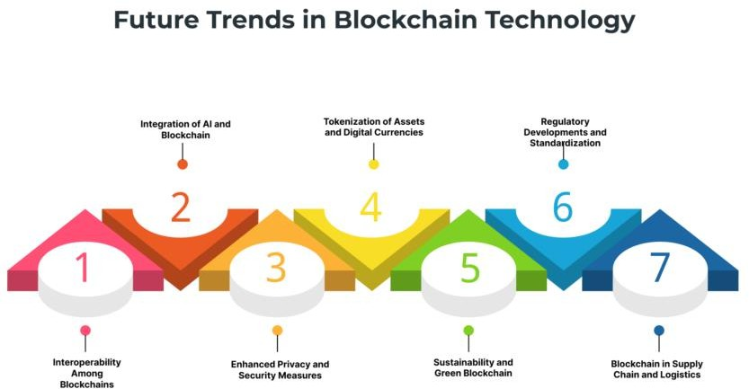

Emerging Technologies in Blockchain
    - Sharding

Definition
Sharding is a database partitioning technique leveraged in blockchain networks to improve scalability. Instead of a single blockchain handling every transaction, sharding splits the blockchain into smaller, manageable segments called shards. Each shard is responsible for processing a subset of transactions.

How Sharding Works
  - Partitioning Data: Each shard contains its own data and transaction history. For instance, if a blockchain processes transactions related to multiple accounts, sharding could divide these transactions so that different shards handle different sets of accounts.
  - Parallel Processing: Shards operate independently and thus can process transactions simultaneously rather than sequentially. This parallelization increases the overall transaction throughput of the network.
  - Consensus Mechanism: Each shard can use its consensus mechanism to validate its transactions, which can vary from one shard to another. This means differing consensus rules, such as proof of work or proof of stake, can be utilized.

Benefits of Sharding
  - Scalability: By allowing multiple transactions to be processed at once, sharding significantly increases the number of transactions per second (TPS) that the blockchain can handle.
  - Efficiency: Reducing the block size and limiting the amount of data each node needs to process lowers the burden on the network and its participants, thus improving the system’s efficiency.

  - Resource Optimization: Nodes only need to maintain data for a specific shard rather than the entire blockchain, which can reduce storage and computational requirements.

Challenges of Sharding
  - Complexity: Implementing sharding can be technically complex. Developers face challenges in ensuring that shards remain secure and effectively communicate with each other without vulnerabilities.
  - Security Risks: If a shard experiences a significant amount of activity, it might become a target for attacks. Additionally, if shard assignments are not handled effectively, it could lead to uneven distribution of data and processing power.

Example Implementations
  - Ethereum 2.0: One of the most notable applications of sharding is Ethereum 2.0, which plans to introduce sharding as part of its upgrade to improve scalability and overall network performance.
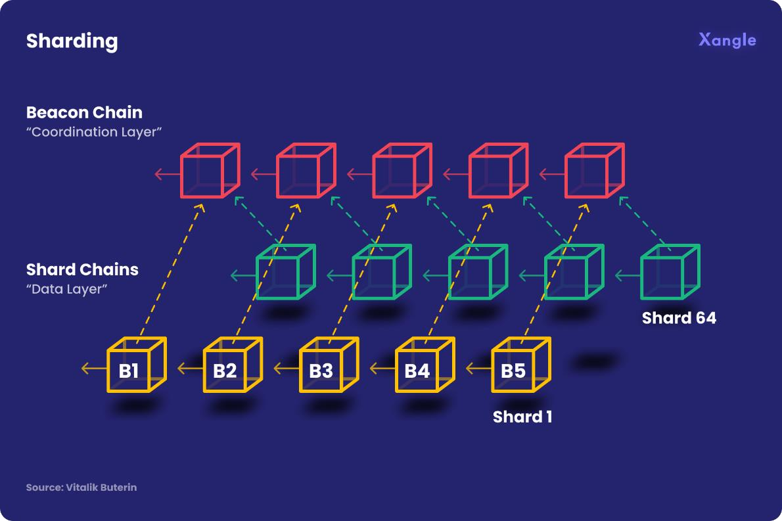

Sharding is a form of data partitioning that breaks down the L1 blockchain into several chains or shards. In the case of the Ethereum chain, shard chains are created by sharding the Ethereum chain into smaller pieces. Meanwhile, nodes are divided by group of which each of them is allocated to each shard. This decreases the workload of network validators by requiring each validator to only store and manage one shard of the network instead of the whole blockchain. Below are certain rules and patterns that should be followed when converting the transactions into smaller shards.
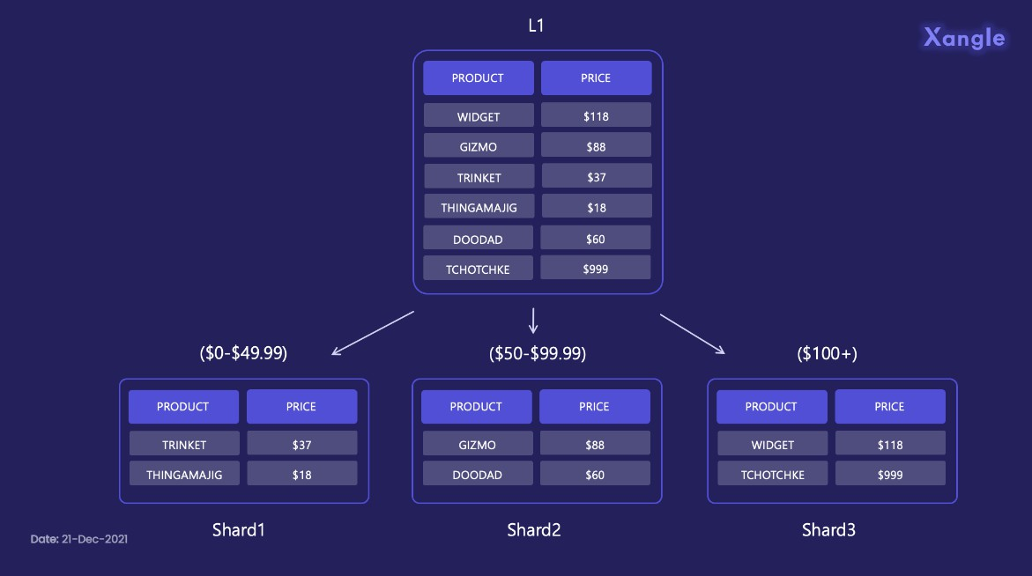

Sidechains

Definition
A sidechain is a separate blockchain that runs parallel to the main blockchain (the "mainchain"). It allows for the interaction and transfer of assets between the two chains, enabling processes that do not affect the main chain's performance directly.

How Sidechains Work
  - Two-Way Peg: Sidechains are often designed with a two-way peg mechanism, allowing assets to be transferred between the mainchain and sidechain. Users can lock assets on the mainchain, and corresponding tokens are issued on the sidechain.
  - Independent Consensus: Sidechains can utilize their consensus mechanisms, which differ from those of the mainchain. This independence allows them to implement protocols best suited for their specific use cases, improving performance and adaptability.

Benefits of Sidechains
  - Scalability and Flexibility: Sidechains can reduce congestion on the mainchain by moving transactions and smart contracts that require different functionalities to a specialized sidechain.
  - Resource Management: As sidechains can be optimized for specific tasks, they allow for better resource management, ensuring that the mainchain is not bogged down by every transaction.
  - Feature Experimentation: Developers can experiment with new features and enhancements on sidechains without risking the stability of the main blockchain. This can foster innovation and accelerate development cycles.

Challenges of Sidechains
  - Security Concerns: Sidechains could introduce new security vulnerabilities because they draw on separate consensus mechanisms. If sidechains are compromised, it could potentially impact the assets linked to the mainchain.
  - Complexity of Transactions: Transitioning assets between chains adds complexity to the process and could lead to potential user errors or misunderstandings about how assets interact across chains.

Example Implementations
  - Liquid Network: The Liquid Network by Blockstream is a well-known example of a sidechain for Bitcoin. It allows users to transact more privately and quickly by moving Bitcoin assets to a sidechain where transactions can be confirmed more rapidly.
  - RSK (Rootstock): RSK is a smart contract platform that is merge-mined with Bitcoin and provides a sidechain for executing Ethereum-like smart contracts while securing them with the Bitcoin blockchain.
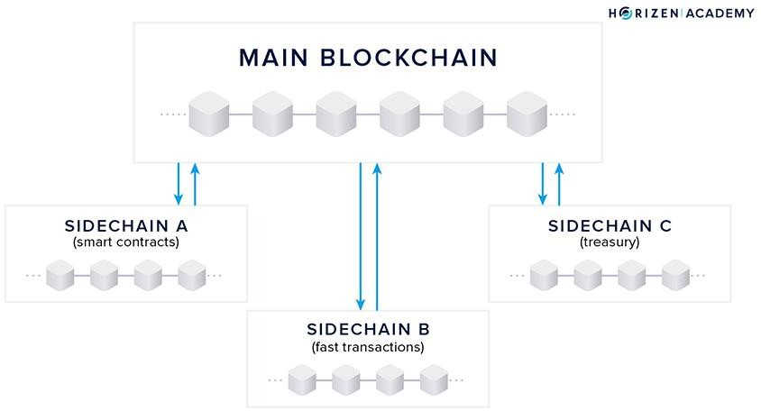

Environmental impact
The environmental impact of blockchain technology, particularly those networks that utilize energy-intensive consensus mechanisms like proof of work (PoW), has become a significant concern as the technology has gained traction. The energy consumption of blockchain networks can lead to substantial carbon footprints and environmental ramifications. Let’s explore this impact in detail, including its causes, consequences, and potential solutions.

Energy Consumption of Blockchain Networks
- Consensus Mechanisms
  - Proof of Work (PoW): PoW is a consensus algorithm that requires miners to solve complex mathematical puzzles to validate transactions and create new blocks. This process is computationally intensive and requires significant energy resources.
    - Example: Bitcoin, the most prominent cryptocurrency, operates on PoW and has been criticized for its high energy consumption. Estimates indicate that Bitcoin’s network uses more electricity than some countries.
  - Proof of Stake (PoS) and Other Methods: In contrast to PoW, PoS and other consensus mechanisms, like Delegated Proof of Stake (DPoS) and Proof of Authority (PoA), require much less energy as they do not depend on computationally difficult puzzles.
    - Example: Ethereum is transitioning to PoS with Ethereum 2.0, which is expected to significantly reduce its energy consumption by eliminating the need for resource-intensive mining.

Data Centers and Mining Farms
  - Mining Operations: Blockchain mining requires the use of large data centers or mining farms filled with GPUs or ASICs that consume vast amounts of electricity 24/7.

  - Electricity Sources: Many mining operations are powered by fossil fuels, contributing to greenhouse gas (GHG) emissions. Regions with cheaper electricity prices, often relying on coal or natural gas, attract mining farms, exacerbating the environmental impact.

Consequences of High Energy Consumption

Carbon Footprint
  - Greenhouse Gas Emissions: The high energy demands of PoW blockchains lead to significant carbon emissions, especially in regions dependent on fossil fuels.
  - Environmental Crisis Connection: The carbon footprint from blockchain mining activities contributes to global warming and climate change, challenging international climate goals.

Resource Depletion
  - Electrical Infrastructure: The concentrated energy demands can strain local electrical grids, leading to higher costs for electricity for consumers and businesses and possible infrastructure failures.
  - Water Usage: In some cases, mining operations use water for cooling systems, further impacting local water resources, especially in arid regions.

E-Waste Generation
  - Hardware Lifespan: Mining equipment often has a short useful life due to the rapid advancements in technology. As miners seek more efficient hardware, older equipment becomes obsolete, leading to substantial amounts of electronic waste (e-waste).
- Disposal Issues: E-waste contains toxic metals and materials that can harm the environment if not disposed of properly, resulting in severe ecological damage.

Solutions and Strategies for Mitigating Environmental Impact

Transition to Sustainable Energy Sources
  - Renewable Energy: Encouraging miners to adopt renewable energy sources—like solar, wind, or hydropower—can reduce the carbon footprint of blockchain operations.
    - Example: Some mining facilities are set up near renewable energy sources, capitalizing on excess energy produced during off-peak hours and reducing reliance on fossil fuels.

Adoption of Energy-Efficient Consensus Mechanisms
  - Shift to PoS and Alternatives: By migrating from energy-intensive algorithms like PoW to alternatives such as PoS, blockchain platforms can dramatically decrease their energy consumption.
    - Example: Ethereum’s transition to PoS is expected to reduce its energy usage by approximately 99.5%, making it much more sustainable.

Offsetting Carbon Emissions
  - Carbon Credits and Offsetting: Blockchain projects can offset their carbon emissions through investments in renewable energy projects, afforestation, or initiatives aimed at carbon capture and storage.
  - Partnerships with Environmental Initiatives: Collaborating with organizations focused on environmental sustainability can create a positive impact and promote eco-friendly practices within the blockchain community.

Innovations in Mining Technology
  - Energy-Efficient Hardware: Investment in more energy-efficient mining hardware is crucial. Newer technologies often provide better performance without significantly increasing energy consumption.
  - Cooling Solutions: Advanced cooling techniques can help reduce the electricity used in mining operations, making them more environmentally friendly.

Regulatory Frameworks
  - Government Regulations: Policymakers can introduce regulations that encourage sustainable practices in blockchain and cryptocurrency mining. This could include incentives for using renewable energy or penalizing excessive carbon outputs.
  - Industry Standards: Establishing industry-wide standards regarding energy consumption and environmental responsibility can help guide blockchain projects toward sustainability.
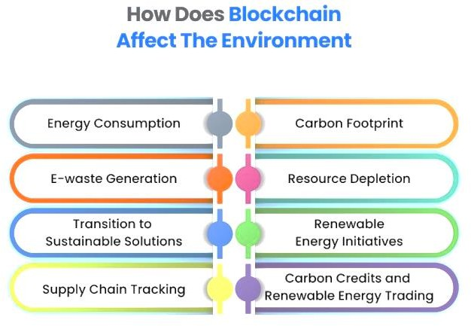

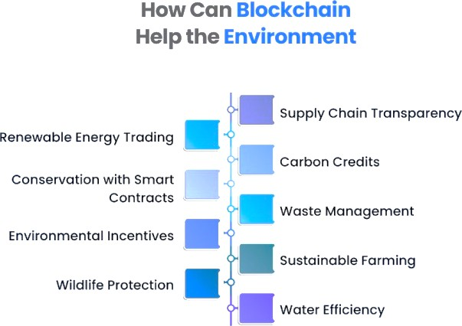

Environmental sustainability
Blockchain environmental sustainability refers to the application of blockchain technology to promote sustainable practices, enhance transparency in environmental initiatives, and facilitate the responsible use of natural resources. As the blockchain ecosystem evolves, stakeholders are increasingly focusing on how this technology can mitigate its environmental impact and contribute positively to sustainable development. Below, we explore the relationship between blockchain and environmental sustainability, including the benefits, challenges, and innovative applications.

Understanding the Environmental Impact of Blockchain
- Energy Consumption
  - Proof of Work (PoW): Many popular cryptocurrencies (like Bitcoin) use the PoW consensus mechanism, which is energy-intensive. This has raised concerns about the carbon footprint of blockchain operations, especially when powered by fossil fuels.
  - Transition to Proof of Stake (PoS): To address these concerns, several blockchains are transitioning to PoS, which consumes significantly less energy. PoS relies on validators who are selected to create new blocks based on the number of tokens they hold and are willing to "stake" rather than competing to solve complex mathematical puzzles.

E-Waste Generation
  - Hardware Lifespan: As mining technology advances, older machines become obsolete quickly, contributing to electronic waste (e-waste). This poses environmental hazards if not recycled or disposed of properly.

The Role of Blockchain in Promoting Environmental Sustainability
- Enhancing Transparency and Traceability
  - Supply Chain Transparency: Blockchain provides a immutable ledger that can track the origin and journey of products. This transparency is

invaluable in ensuring ethical sourcing, reducing fraud, and promoting sustainable practices in industries like agriculture, forestry, and fisheries.
    - Example: Companies like IBM’s Food Trust use blockchain to allow consumers to trace the origin of food products, thereby encouraging responsible agricultural practices.

Supporting Renewable Energy Initiatives
  - Decentralized Energy Markets: Blockchain allows for the creation of peer-to-peer energy trading systems where individuals can buy and sell renewable energy directly. This encourages the use of renewable sources and enhances grid efficiency.
    - Example: Projects like Power Ledger and LO3 Energy enable consumers to trade excess solar energy with their neighbors, promoting local and sustainable energy consumption.

Facilitating Carbon Credits and Offsetting
  - Carbon Trading Platforms: Blockchain can streamline the trading of carbon credits, allowing businesses to buy and sell the right to emit carbon dioxide. This promotes financial incentives for lowering emissions and investing in sustainability.
    - Example: Projects like Verra and AirCarbon work on using blockchain to facilitate greater transparency and efficiency in carbon credit trading systems.

Improving Resource Management
  - Water Management: Blockchain can help track water usage in agricultural and industrial processes, ensuring more sustainable management of this vital resource. It can also monitor and enforce compliance with regulations to prevent over-extraction.

  - Natural Resource Tracking: Blockchain enables better tracking of the origin and sustainability credentials of raw materials (like timber or minerals), allowing businesses and consumers to make more informed decisions.

Innovative Applications of Blockchain for Sustainability
- Decentralized Autonomous Organizations (DAOs)
      - Community-Led Initiatives: DAOs can facilitate environmental projects by allowing communities to govern sustainable initiatives collectively. This democratic approach can foster local engagement and accountability.
        - Example: A DAO focused on reforestation could allocate funds and manage projects aiming to plant trees based on community votes.

Sustainable Agriculture
  - Blockchain in Agriculture: By using blockchain, farmers can record practices and manage certifications for organic or sustainable farming. This can improve accountability and market access for smallholder farmers.
    - Example: Blockchain platforms can provide transparent records of farming inputs (like fertilizers) and practices, helping farmers access premium prices for sustainably produced goods.

Circular Economy Initiatives
  - Waste Management Tracking: Blockchain can facilitate circular economy practices by tracking materials through their lifecycle, ensuring they are reused or recycled rather than discarded.
    - Example: Companies can use blockchain to trace plastic products to ensure they are returned and recycled correctly, promoting a closed- loop system.

Challenges and Considerations
- High Energy Consumption
  - Ongoing Challenges: Despite the transition to more energy-efficient consensus mechanisms, environmental sustainability in blockchain remains a concern, particularly with the proliferation of PoW networks.
  - Incentivizing Renewable Energy: Encouraging the integration of renewable energy sources in blockchain operations is crucial to minimize the environmental impact.

Regulatory Uncertainty
  - Need for Clear Policies: The lack of a coherent regulatory framework for cryptocurrency and blockchain can hinder the growth of environmentally sustainable practices. Effective policy interventions could drive the adoption of sustainable practices.

Balance Between Innovation and Sustainability
  - Tech-Development Trade-off: As blockchain technology advances, it is essential to balance innovation with ecological responsibility, ensuring that new solutions do not inadvertently contribute to environmental degradation.
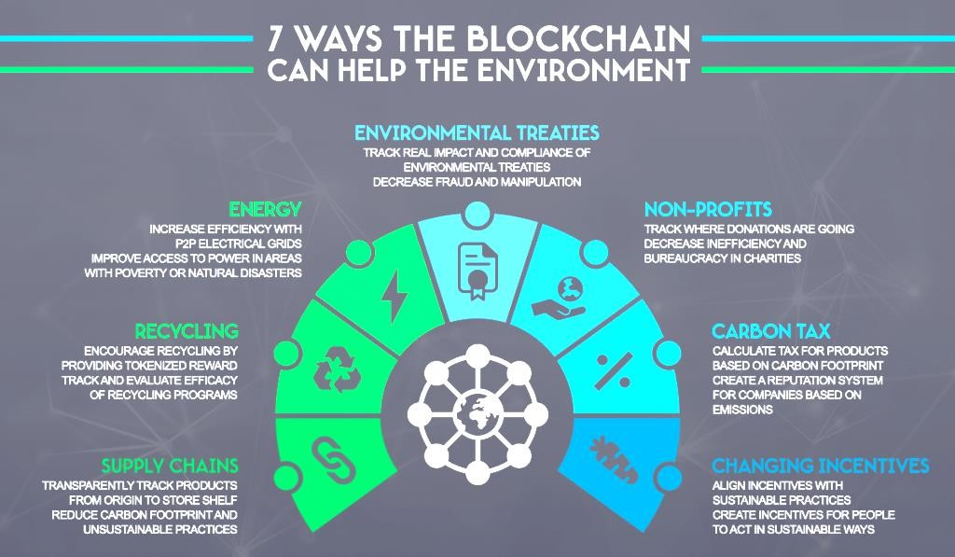

Scalability in block chain
Scalability in blockchain refers to the ability of a blockchain network to handle an increasing amount of transactions or operations efficiently without compromising performance. As blockchain technology has gained popularity, scalability has emerged as one of the most significant challenges, influencing the effectiveness and adoption of different blockchain platforms. Below is a detailed explanation of the concept, the various factors affecting scalability, the challenges involved, and potential solutions.

Definition of Scalability
Scalability in blockchain pertains to the capacity of a blockchain network to accommodate a higher volume of transactions and support a growing number of users while maintaining latency and throughput performance. Scalability is a crucial aspect for any payment network, decentralized application (dApp), or digital asset platform, as it determines how well a system can grow without sacrificing user experience.

The Scalability Trilemma
A key framework in discussing blockchain scalability is the Scalability Trilemma, proposed by Ethereum co-founder Vitalik Buterin. It posits that blockchain systems must balance three critical characteristics:
- Decentralization: How distributed the network is among its participants. Highly decentralized systems are less vulnerable to censorship and attacks, but they can struggle with scalability due to the need for consensus among numerous nodes.
- Security: Refers to the network's ability to protect against attacks and fraud. A secure blockchain resists malicious activities, but achieving this often requires more complex consensus mechanisms or additional processing power, which can hinder scalability.
- Scalability: The capability to handle a growing number of transactions, allowing the blockchain to perform efficiently under increased load.

The challenge lies in optimizing all three simultaneously, as enhancing one characteristic can negatively impact the others.

Factors Affecting Scalability
- Throughput (Transactions Per Second - TPS)
  - TPS refers to the number of transactions a blockchain network can process in a given time frame. Higher TPS rates generally indicate better scalability.
  - Comparison Example: Bitcoin can typically handle around 7 TPS, while traditional payment systems like Visa can process thousands of transactions per second.

Block Size and Block Time

  - Block Size: The number of transactions contained within a block. Increasing block size can improve TPS but may lead to longer propagation times and increased chances of orphaned blocks.
  - Block Time: The time it takes to create a new block. Shorter block times can enhance throughput but may increase the likelihood of forks and decrease security.

Consensus Mechanisms
  - Different consensus algorithms have varying impacts on scalability. For instance, proof of work (PoW) can be slower due to the intensive computational tasks required, while proof of stake (PoS) can enhance scalability by allowing quicker validation of transactions.

Network Latency
- The time it takes for data to travel across the network affects transaction confirmation times and overall efficiency. Lower latency enables faster transaction processing.

Challenges to Scalability
- Network Congestion
  - As user demand increases, the network may face congestion, leading to slower transaction speeds and increased transaction costs. When blocks fill up, users may need to pay higher fees to prioritize their transactions.

Trade-Offs with Decentralization
  - Achieving high scalability often requires more centralized processing or fewer nodes to reach consensus quickly. This conflicts with the core principle of decentralization that many blockchain advocates support.

Complexity of Solutions
  - Many proposed solutions for scalability involve significant technical complexity, which may lead to difficulties in implementation and increase the risk of bugs or vulnerabilities.

Solutions to Scalability Issues

- Layer 2 Solutions
Layer 2 solutions involve off-chain processing to relieve congestion on the main blockchain (Layer 1). These solutions allow transactions to occur independently while still leveraging the security of the main chain.

Examples:
    - Lightning Network: A second layer for Bitcoin that allows for fast, off-chain transactions through payment channels.
    - Plasma and State Channels: For Ethereum, allowing transactions to occur off-chain but periodically settling back onto the Ethereum blockchain.

Sharding
  - Definition: Sharding divides a blockchain into smaller partitions (shards) that can process transactions independently. Each shard handles its own transactions, reducing the load on any single node.

  - Implementation: Ethereum 2.0 plans to implement sharding as part of its framework to enhance scalability by allowing parallel processing of transactions across multiple shards.

Increasing Block Size
  - Some blockchains have opted to increase block sizes to accommodate more transactions per block. This, however, may lead to other challenges, such as increased storage and bandwidth requirements.

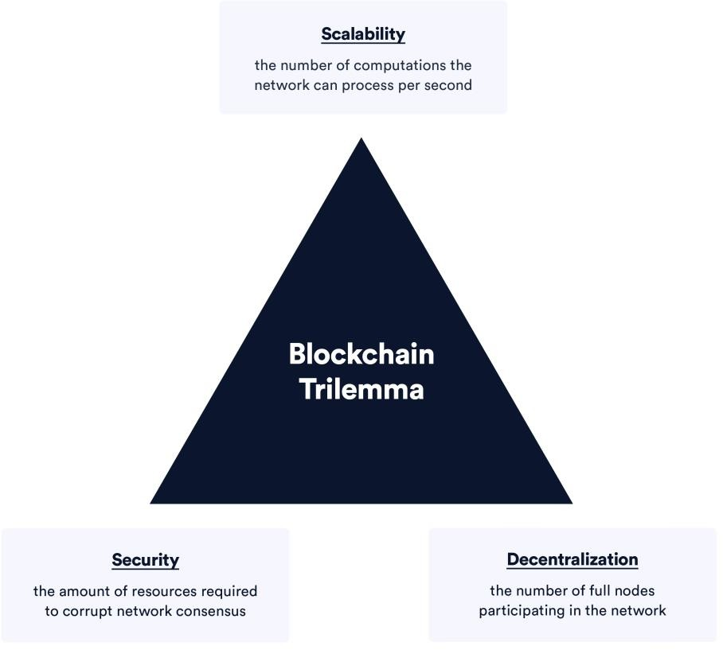

Blockchain performance improvements
Blockchain performance improvements focus on addressing the scalability, speed, cost, and efficiency of blockchain systems. These improvements are necessary as the demand for decentralized applications and blockchain-based transactions increases. Let's go over some key performance improvement strategies that have been explored and implemented across blockchain networks:

Layer 2 Solutions

Layer 2 solutions are built on top of the main blockchain (Layer 1) and aim to improve scalability and performance without changing the underlying protocol. They are important because they allow users to perform transactions off-chain (i.e., not directly on the main blockchain) but still rely on the blockchain for finality and security.
  - How it works: Transactions are executed off-chain on Layer 2, and only the final results are written back to the main blockchain. This reduces the load on the main chain and speeds up transaction processing.

Examples:

    - Lightning Network (Bitcoin): Users can open payment channels to conduct off-chain transactions, and only the final balances are recorded on the Bitcoin blockchain, reducing the need for every micro-payment to be directly validated by miners.
    - Optimistic Rollups (Ethereum): Instead of executing every transaction on- chain, rollups bundle multiple transactions and execute them off-chain. The Ethereum blockchain serves as a data availability layer and ensures transaction validity.
    - ZK-Rollups (Ethereum): These use zero-knowledge proofs to validate batches of transactions. The key advantage of ZK-Rollups is that they provide faster finality and are more scalable than Optimistic Rollups, as they use cryptographic proofs to assure correctness.

Benefits:

    - Higher Throughput: Significantly increases the number of transactions per second (TPS).
    - Lower Costs: Transaction fees are drastically reduced because less data is stored on the main blockchain.
    - Faster Transactions: Instantaneous finality on Layer 2 networks makes the experience faster compared to waiting for multiple block confirmations on Layer 1.

Sharding

Sharding refers to breaking the blockchain into smaller, manageable pieces, known as "shards." Each shard can process its own transactions, and they can run in parallel. This reduces congestion on the main chain and allows for better scalability.
  - How it works: Instead of every node maintaining the full state of the blockchain, each shard has its own set of validators and keeps track of only part of the blockchain's data. Shards communicate with each other, but they can process transactions independently.
  - Example: Ethereum 2.0 is planning to implement sharding as a key feature to scale the network. Each shard will handle a subset of transactions and smart contracts, making the network more efficient.

Benefits:

    - Scalability: Sharding can theoretically increase throughput by orders of magnitude because the network can process many transactions simultaneously across multiple shards.
    - Efficiency: The resources required by each validator are reduced, as they no longer need to validate the entire blockchain, making it easier for users to join the network.

Challenges:

    - Cross-shard Communication: Shards need to communicate with one another to ensure that the entire blockchain remains consistent. This introduces complexity in terms of data synchronization and consistency.
    - Security Risks: With more decentralized and specialized validators for each shard, there’s a potential for attacks targeting smaller shards, though this can be mitigated with proper design.

Consensus Algorithm Improvements

The consensus mechanism is the backbone of any blockchain, determining how the network agrees on the validity of transactions and updates to the ledger. Different consensus models have various trade-offs in terms of speed, energy consumption, and security.
  - Proof of Stake (PoS): In PoS, validators are chosen to propose new blocks based on how much cryptocurrency they have staked in the network. This reduces the energy consumption compared to Proof of Work (PoW), where miners solve complex puzzles to validate transactions.
    - Example: Ethereum is transitioning from PoW to PoS through Ethereum 2.0, significantly improving scalability and reducing energy consumption.
  - Delegated Proof of Stake (DPoS): In DPoS, token holders vote for delegates to validate transactions on their behalf. This reduces the number of validators, making the network more efficient and faster.
    - Example: EOS is a popular blockchain that uses DPoS to achieve faster transaction finality and lower transaction costs.
  - Proof of Authority (PoA): In PoA, only a small number of pre-approved authorities validate transactions. This model works well for private or consortium blockchains.
    - Example: VeChain and some enterprise blockchains use PoA because it allows for faster consensus without the computational cost of PoW.

Benefits of Improved Consensus Mechanisms:

    - Lower Energy Consumption: PoS and DPoS are much more energy-efficient than PoW.
    - Higher Throughput: More efficient consensus mechanisms lead to faster block times and increased TPS.
    - Better Security: Some consensus algorithms, like PoS, are more secure against certain attacks (e.g., 51% attacks) than PoW.

Sidechains

Sidechains are independent blockchains linked to a main blockchain. They allow assets to be transferred back and forth between the main chain and sidechains, which can operate under different consensus mechanisms and rules.
  - How it works: The main blockchain serves as a “settlement layer,” while sidechains handle transactions that are more resource-intensive or require different consensus mechanisms. Sidechains can be customized for specific use cases, such as faster transaction speeds or privacy features.
  - Example: Polygon (formerly Matic) is a sidechain that operates alongside Ethereum to improve transaction speed and reduce fees. It allows developers to run decentralized applications (dApps) in a more scalable manner.

Benefits:

    - Increased Scalability: Sidechains help offload transaction volume from the main blockchain, which can reduce congestion and improve performance.
    - Flexibility: Sidechains can have custom rules, allowing for innovation without risking the stability of the main blockchain.

Challenges:

    - Security Concerns: Sidechains may not be as secure as the main blockchain, depending on how they are designed and how assets are transferred.

    - Complexity: Managing multiple chains can increase system complexity.

Transaction Compression and Aggregation

These techniques reduce the amount of data that needs to be processed, transmitted, and stored by using more efficient data structures and cryptographic methods.
  - How it works: By aggregating multiple transactions into a single unit or compressing transaction data, blockchain networks can reduce the load on the system, saving storage space and processing time.

Examples:

    - zk-SNARKs and zk-STARKs: These are zero-knowledge proofs that enable a blockchain to prove that a transaction is valid without revealing the transaction’s data. This helps with privacy and reduces data overhead.
    - Optimistic Rollups: Aggregating multiple transactions into a single batch and using fraud proofs to ensure correctness.

Benefits:

    - Reduced Block Size: Compressing transaction data reduces the blockchain’s storage requirements.
    - Increased Efficiency: Reduces the need to validate every individual transaction, which increases throughput and lowers costs.

State Channels

State channels allow participants to conduct multiple transactions off-chain, only recording the final outcome on-chain. They are ideal for microtransactions or applications that require frequent interaction.
  - How it works: State channels use smart contracts to facilitate off-chain transactions. The parties involved can agree on updates to the state without involving the blockchain for each update, only submitting the final result once the channel is closed.

  - Example: Raiden Network is a state channel solution for Ethereum, enabling instant and low-fee payments off-chain.

Benefits:

    - Instant Transactions: Transactions are almost instant because they are conducted off-chain.
    - Low Fees: Since the main blockchain is not involved in every transaction, fees are greatly reduced.
    - Scalability: State channels allow thousands of transactions to happen without congesting the blockchain.

Blockchain Compression Techniques

Compression techniques help reduce the amount of data stored on the blockchain, improving scalability and node performance.
  - How it works: Data such as transactions, state updates, or smart contract data can be compressed to save space. These methods might include specialized data structures (like Merkle trees) or even off-chain storage mechanisms.

Benefits:

    - Smaller Blockchain Sizes: Reduces storage requirements for nodes, making it easier for users to participate in the network.
    - Faster Syncing: New nodes can synchronize faster as the blockchain size is smaller.

QUESTION BANK

Addressing Trust and Transparency
  - What is the role of trust in blockchain technology, and how does it differ from traditional centralized systems?
  - How does blockchain ensure transparency in transactions, and what challenges exist in making this transparency accessible to all users?
  - Can blockchain be considered completely trustworthy? What potential vulnerabilities could undermine trust in blockchain systems?
  - In what ways can blockchain technology impact privacy, and how can it be balanced with transparency?
  - How do blockchain’s decentralized nature and consensus mechanisms help build trust among participants?
  - What ethical concerns arise when blockchain technology is used to store sensitive personal data?
  - How can blockchain developers ensure that trust in their systems is not eroded by malicious actors or flawed implementation?

Potential Societal Impacts of Blockchain Adoption
  - What are the potential societal benefits of widespread blockchain adoption?
  - What societal challenges could arise from blockchain technology, particularly with regard to financial inclusion or inequality?
  - How might blockchain affect the future of work and job creation in various industries?
  - Can blockchain technology help address social justice issues, such as identity verification, land rights, or voting systems?
  - What impact could blockchain have on global supply chains and consumer rights?
  - How might blockchain adoption affect governmental regulation and accountability, particularly in areas like taxation and law enforcement?
  - How can blockchain be used to address issues of corruption and fraud in both private and public sectors?

Responsible Blockchain Development and Usage
  - What are the key principles that should guide responsible blockchain development?

  - How can developers ensure the ethical use of blockchain technology, especially when designing applications for financial or healthcare sectors?
  - What potential risks exist when developing blockchain technology for widespread use, and how can these be mitigated?
  - How can blockchain developers ensure they are promoting inclusivity, accessibility, and fairness in blockchain systems?
  - What role should government regulation play in ensuring that blockchain technology is used responsibly?
  - What ethical considerations must be made when developing smart contracts or decentralized applications (dApps)?
  - How can the blockchain community encourage ethical decision-making among developers, users, and stakeholders?

Future Trends and Challenges
- Emerging Technologies in Blockchain (e.g., Sharding, Sidechains)
  - What is sharding, and how does it contribute to improving blockchain scalability and performance?
  - How do sidechains help address the limitations of the main blockchain, and what are the risks associated with their use?
  - What are the key differences between sharding and other scalability solutions, such as layer 2 protocols or rollups?
  - What emerging blockchain technologies hold the most promise for enabling new use cases or industries?
  - How does the use of sidechains impact the security and decentralization of the parent blockchain?
  - What challenges do developers face when integrating new technologies like sharding into existing blockchain networks?
  - How might sharding and sidechains influence the future design of decentralized finance (DeFi) applications?

Environmental Impact and Sustainability

  - What is the environmental impact of Proof of Work (PoW) and Proof of Stake (PoS) consensus mechanisms, and how do they compare in terms of energy consumption?
  - What are some blockchain projects focused on reducing environmental impact, and what strategies do they use?
  - Can blockchain be made more sustainable, or is the technology inherently energy- intensive?
  - How can blockchain developers and stakeholders mitigate the carbon footprint associated with blockchain networks?
  - What role does blockchain play in sustainability efforts across industries like agriculture, energy, and waste management?
  - How do the environmental costs of blockchain technology impact its adoption and perception by the public and policymakers?
  - What potential solutions exist for offsetting or reducing blockchain’s environmental impact, such as using renewable energy or designing more efficient protocols?

Scalability and Performance Improvements
  - What is the significance of scalability in blockchain, and what challenges do existing blockchain networks face in terms of scalability?
  - How do sharding, rollups, and Layer 2 solutions contribute to the scalability of blockchain networks?
  - What are the trade-offs between scalability, security, and decentralization in blockchain design?
  - What advancements in consensus algorithms, such as Proof of Stake (PoS), are being explored to improve blockchain scalability?
  - How do performance improvements such as transaction compression and aggregation help reduce blockchain congestion and improve transaction speed?
  - What factors should be considered when optimizing blockchain performance for different use cases, such as financial transactions vs. supply chain management?
  - How will improvements in blockchain scalability affect the overall user experience and the adoption of decentralized applications (dApps)?
  - What role do sidechains, state channels, and off-chain solutions play in addressing the performance limitations of current blockchain systems?

General Questions on Blockchain’s Future
  - How will the development of new blockchain technologies shape the future of industries like healthcare, finance, and logistics?
  - What role should government regulation play in ensuring that blockchain networks remain scalable, secure, and environmentally sustainable?
  - How can the blockchain community balance the pursuit of technological innovation with ethical and social considerations?
  - What potential challenges might arise as blockchain adoption becomes more widespread, particularly with regard to security, trust, and societal impact?
  - What is the future of interoperability between blockchain networks, and how might cross-chain solutions evolve?

