**Jenkins**

**To learn the Jenkins YouTube Link:** [**Jenkins PlayList**](https://www.youtube.com/playlist?list=PLhW3qG5bs-L_ZCOA4zNPSoGbnVQ-rp_dG)

**Steps to download the Jenkins for the Windows**

* Go to the Jenkins Website and You can Download the **“Jenkins.war”** File from the Site or you can also go for past Releases -> [**Jenkins.war**](https://updates.jenkins.io/download/war/)
* After Downloading the Jenkins.war file you can move that to Another folder or create the new folder for the Jenkins and paste that file to there

**Steps to Starts the Jenkins Server**

* To start the Jenkins Server, you have to go to the folder where you placed the Jenkins.war file
* Open the command Prompt and navigate to the folder where Jenkins is
* To start the Jenkins Server, we are Using one Command that is

**“ java –jar jenkins.war ”**

* It will start the Server on the Default port 8080 if you want to change the Port number, we have to add httpPort=<Your Port Number> like

**“ java –jar jenkins.war httpPort=9090 “**

* Go to the Browser and type **localhost:8080** and enter your admin Credentials and log in to the Jenkins (if you don't know the admin cred while login for the first time you can search for the .Jenkins -> secrets -> initialAdminPassword)

**Integrate the Maven to the Jenkins**

* To integrate the Maven to the Jenkins, open your Jenkins on the website
* Go the Manage Jenkins -> Plugins -> Available Plugins -> Search bar
* Search for Maven Integration Plugin and install it
* After that go to the manage Jenkins -> Tools
* In that you will get one option **“Maven Installations”** Click on that and give the name as **“mvn”**  and click on the install automatically checkbox
* Save and apply

**Trigger the Jobs from the Local Machines**

* Create one new Job and Select the **free style Project**
* In Source Code Management select it to option **None**
* In the down you will get the option **Build Steps** click on the add Build steps and select the option **Invoke top-level Maven Targets**
* In the Maven Version you select the maven version you have added mvn
* In the goals add the **test** or **clean test** both are okay

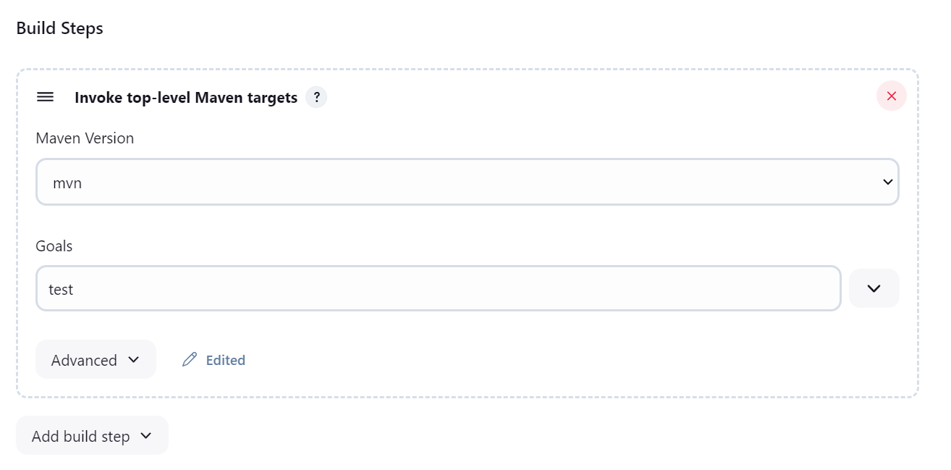

* To run the TestNG in the last you will get the **Post Build Actions**
* In that add the new post build action and select the option Publish the TestNG results and enter as shown below (add TestNG report plugin if not showing option)

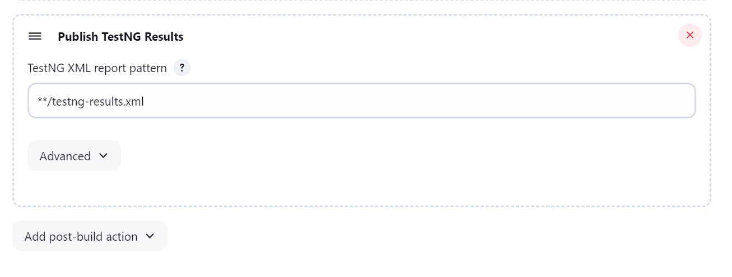

* Now apply and save the Job and Run the test Job

**Trigger the Jobs from the GitHub**

* Create Job and Select the Free Style Project
* In source code Management you will get option **Git** Select that one (if the option is not visible add the **Git Plugin** to the Project)
* In the Repository URL paste your Repo URL of the git
* If the project is public, no need to give the Credentials if the project is private you need to give the GitHub credentials

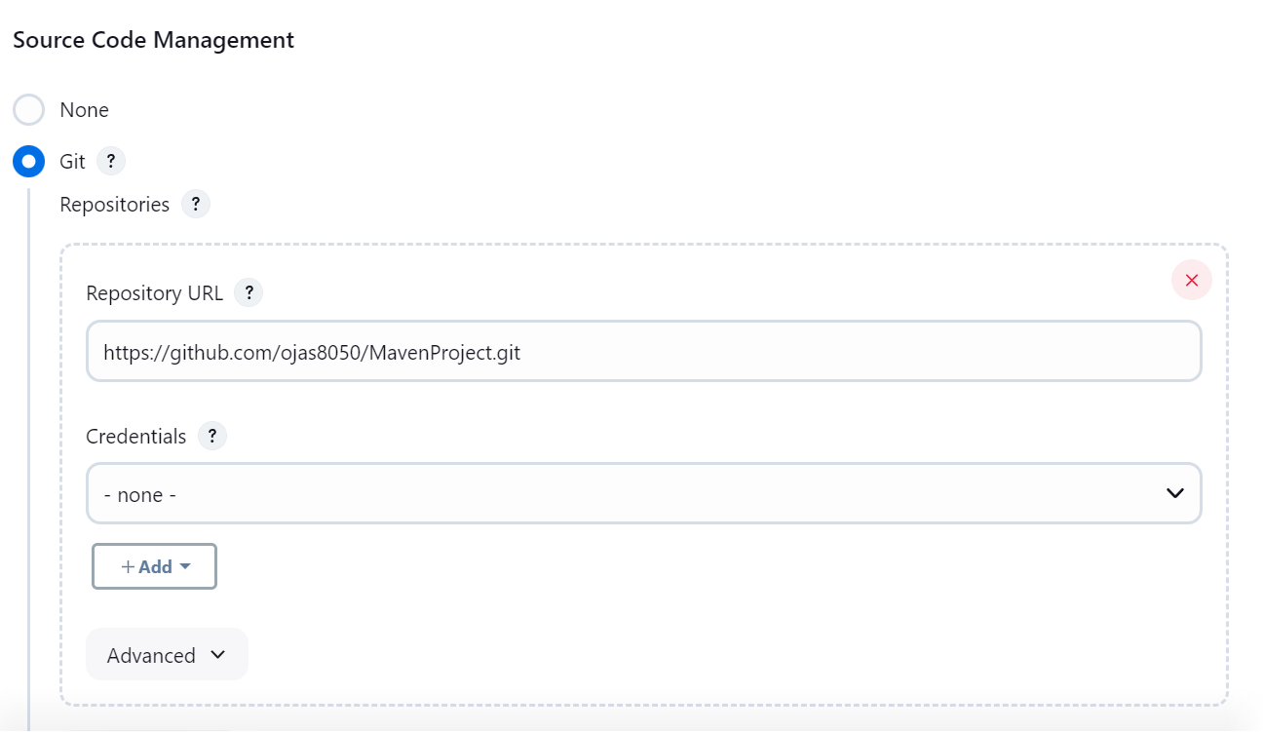

* And don't change anything be as it is
* In the down you will get the option **Build Steps** click on the add Build steps and select the option **Invoke top-level Maven Targets**
* In the Maven Version you select the maven version you have added mvn
* In the goals add the **test** or **clean test** both are okay
* Click on apply and save and then Build Your Project

**Generate HTML Report**

* Go the Job and click on configure
* In the down you will get the option **Post-Build Actions** click on the add Build steps and click on the **Publish HTML reports (**if the option is not showing the install the HTML publisher plugin**)**
* In the HTML directory to archive you have to add that path where your reports are Generating (IntelliJ the reports will generate in the target/surefire-reports folder)
* In the Index Page add the .html file (generally it will be index.html)

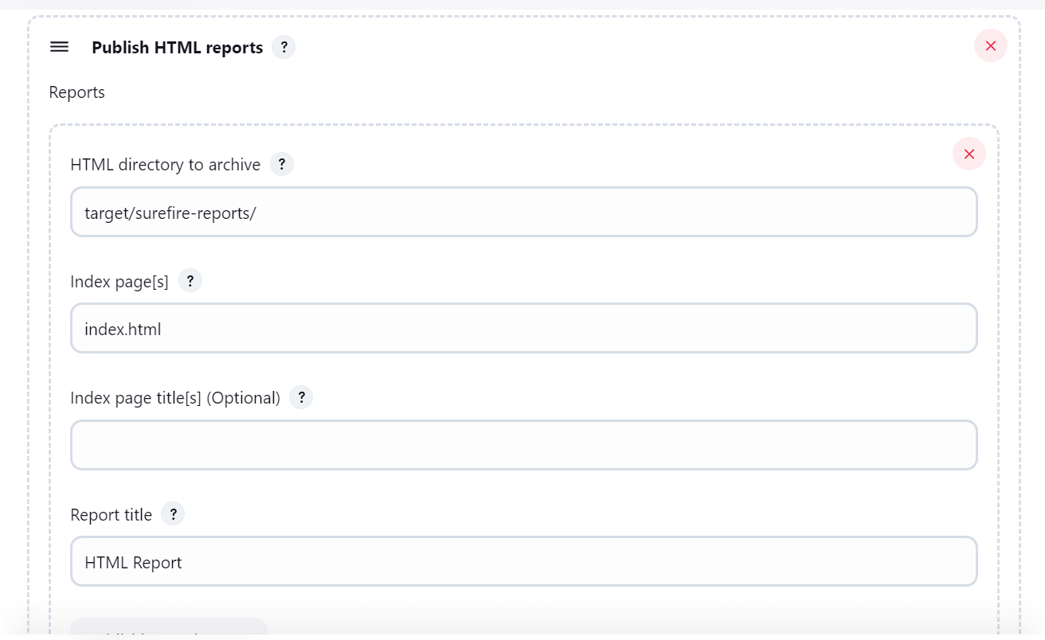

* Click on the Apply and save and run the Job again it will generate the HTML reports

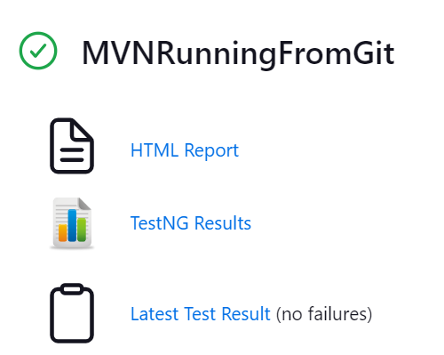

**Send the Build Reports to the Mail**

* Install the plugin **Email Extension** and **Email Extension Templet Plugin**
* Go to your email, go into the setting and in the Security option Turn on the **Two-factor Authentication (Its Mandatory)**
* After this in in the setting only search for the **App Passwords**

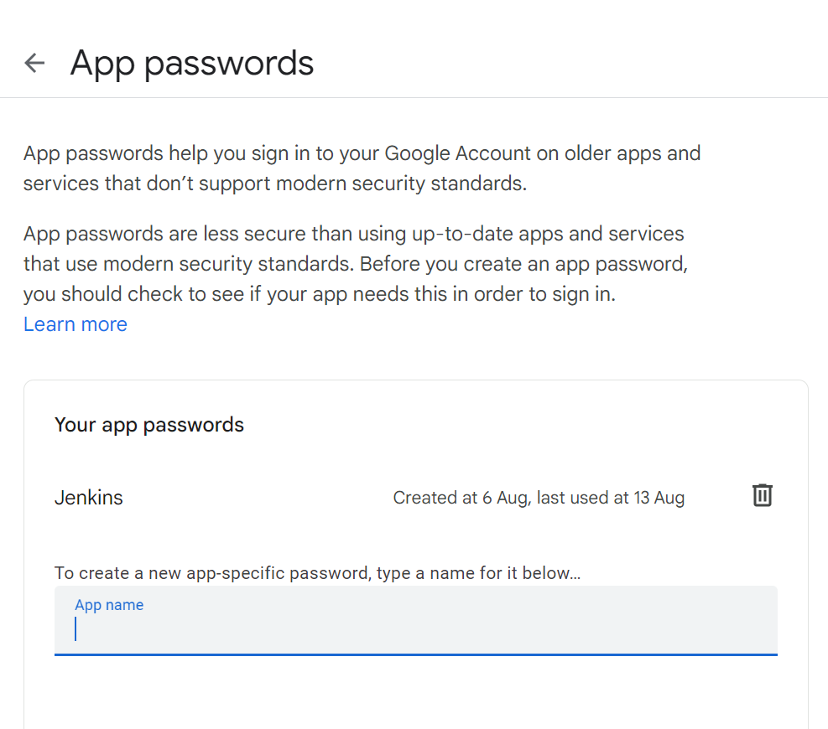

* Give the App name as **Jenkins** Click on the Create
* It will Generate some Code copy that code and save it somewherebecause its only one-time view (and its very useful in as the password)
* Then go the Manage Jenkins -> System
* Search for the **Extended E-mail Notification**
* In the SMTP Server Textbox add **“smtp.gmail.com”** and in the SMTP port put **“465”**
* Go the Advance in the advance you will get one option called Credentials
* To add new Credentials, click on the Add button and you will get the Interface like this

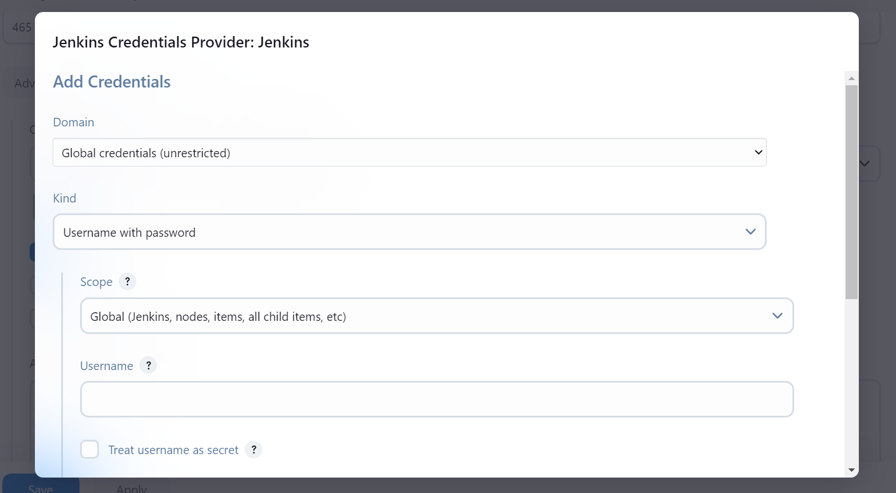

* In the Kind select the Option Username with password
* In the username give the **Email ID**
* In the password Section you add the password which you have copied from the Gmail App password
* If you want to add the description you can add in the Description Textbox
* Click on Add and the Credentials are Added to the Jenkins
* In the Credentials select your Email Cred that you have added
* Select the option **Use SSL**

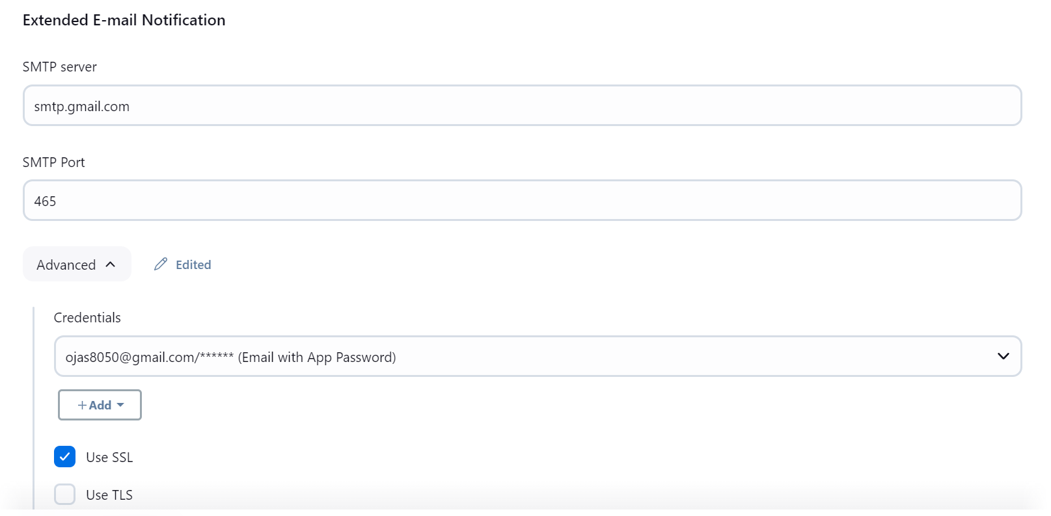

* After this you will get one option **Test configuration by sending test email** click on that
* In the Test email Recipient add the mail id on which you want to send the Reports
* Then click on Test Configuration
* Click on Apply and Save
* Then go to the Test job -> configure
* In the Post Build Actions, you will get one option called **Editable Email Notification**
* In that option there is Project Recipient List in that field add the Email on where you want to send the report
* Don't change any default values
* In that option only in the last you will get **Attachments**
* In the Attachments give the path where your reports are Present (IntelliJ it will be in target/surefire-reports)
* And give the path like “target/surefire-reports/index.html” if you want to change the file then change it to “target/surefire-reports/emailable-report.html” or any else also you can give

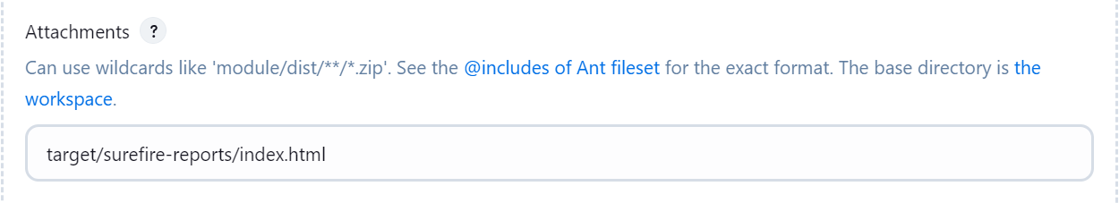

* Now apply and save the settings
* Then run the Job you will get the mail
* Reference: Click to see the Video -> [YouTube Video](https://www.youtube.com/watch?v=g-Blt_cYFrI)