Write a C program to simulate the following CPU scheduling algorithm to find turnaround time and waiting time and arrival time

- FCFS
Code: #include <stdio.h>

int main()
{
int n,i,j;

printf("Enter total number of processes: ");
scanf("%d",&n);

int pid[n], at[n], bt[n], ct[n], tat[n], wt[n];

for(i=0;i<n;i++)
{
pid[i]=i+1;
printf("Process %d\n",pid[i]);
printf("Arrival time: ");
scanf("%d",&at[i]);
printf("Burst time: ");
scanf("%d",&bt[i]);
}

int temp;

for(i=0;i<n-1;i++)
{
for(j=i+1;j<n;j++)
{
if(at[i]>at[j])
{
temp=at[i]; at[i]=at[j]; at[j]=temp;
temp=bt[i]; bt[i]=bt[j]; bt[j]=temp;
temp=pid[i]; pid[i]=pid[j]; pid[j]=temp;
}
}
}

int current_time=0;

for(i=0;i<n;i++)
{
if(current_time < at[i])
current_time = at[i];

ct[i] = current_time + bt[i];
tat[i] = ct[i] - at[i];
wt[i] = tat[i] - bt[i];

current_time = ct[i];
}

float avg_tat=0, avg_wt=0;

printf("\nProcess ArrivalTime BurstTime CompletionTime TurnaroundTime WaitingTime\n");

for(i=0;i<n;i++)
{
printf("%d\t%d\t%d\t%d\t\t%d\t\t%d\n",pid[i],at[i],bt[i],ct[i],tat[i],wt[i]);
avg_tat += tat[i];
avg_wt += wt[i];
}

printf("\nAverage Turnaround Time: %.2f",avg_tat/n);
printf("\nAverage Waiting Time: %.2f",avg_wt/n);
printf("\nOjashwi Shrestha 1WA24CS197");
return 0;
}

Output:
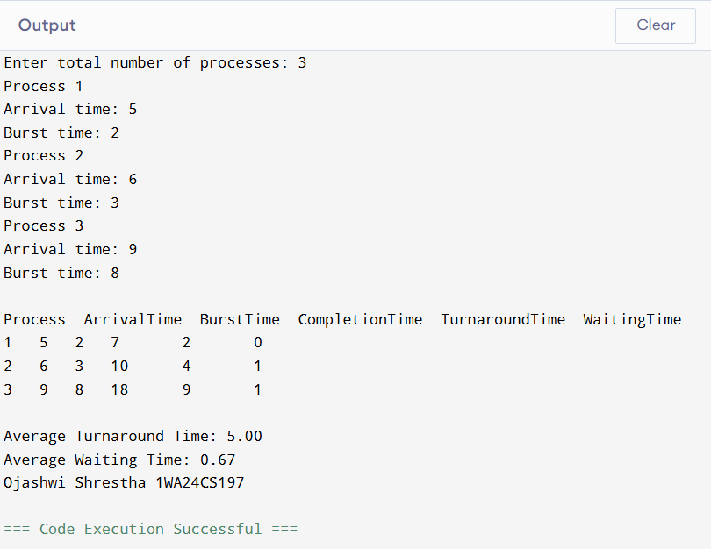

- SJF non preemptive
Code:
#include <stdio.h>

int main()
{
int n,i,j;

printf("Enter number of processes: ");
scanf("%d",&n);

int pid[n], at[n], bt[n], ct[n], tat[n], wt[n], finished[n];

for(i=0;i<n;i++)
{
pid[i]=i+1;
finished[i]=0;
}

printf("Enter arrival times:\n");
for(i=0;i<n;i++)
scanf("%d",&at[i]);

printf("Enter burst times:\n");
for(i=0;i<n;i++)
scanf("%d",&bt[i]);

int completed=0,current_time=0,min_index;
float avg_tat=0,avg_wt=0;

while(completed<n)
{
int min_bt=9999;
min_index=-1;

for(i=0;i<n;i++)
{
if(at[i]<=current_time && finished[i]==0)
{
if(bt[i]<min_bt)
{
min_bt=bt[i];
min_index=i;
}
}
}

if(min_index==-1)
{
current_time++;
}
else
{
ct[min_index]=current_time+bt[min_index];
tat[min_index]=ct[min_index]-at[min_index];
wt[min_index]=tat[min_index]-bt[min_index];

current_time=ct[min_index];
finished[min_index]=1;
completed++;
}
}

printf("\nSJF scheduling:\n");
printf("PID\tAT\tBT\tCT\tTAT\tWT\n");

for(i=0;i<n;i++)
{
printf("P%d\t%d\t%d\t%d\t%d\t%d\n",pid[i],at[i],bt[i],ct[i],tat[i],wt[i]);
avg_tat+=tat[i];
avg_wt+=wt[i];
}

printf("\nAverage turnaround time:%f",avg_tat/n);
printf("\nAverage waiting time:%f",avg_wt/n);
printf("\nOjashwi Shrestha 1WA24CS197");

return 0;
}

Output:
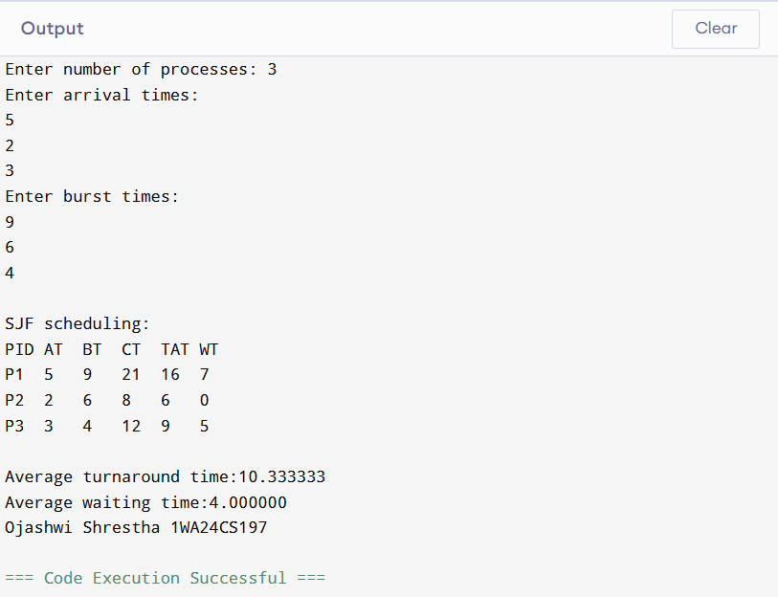

- SJF preemptive
Code:
#include <stdio.h>

int main()
{
int n,i,time=0,completed=0,min_index;

printf("Enter the number of processes: ");
scanf("%d",&n);

int pid[n],at[n],bt[n],rt[n],ct[n],tat[n],wt[n];

for(i=0;i<n;i++)
{
pid[i]=i+1;
printf("Enter arrival time and burst time for process %d: ",i+1);
scanf("%d%d",&at[i],&bt[i]);
rt[i]=bt[i];
}

while(completed<n)
{
int min_bt=9999;
min_index=-1;

for(i=0;i<n;i++)
{
if(at[i]<=time && rt[i]>0)
{
if(rt[i]<min_bt)
{
min_bt=rt[i];
min_index=i;
}
}
}

if(min_index==-1)
{
time++;
}
else
{
rt[min_index]--;
time++;

if(rt[min_index]==0)
{
completed++;
ct[min_index]=time;
tat[min_index]=ct[min_index]-at[min_index];
wt[min_index]=tat[min_index]-bt[min_index];
}
}
}

float avg_wt=0,avg_tat=0;

printf("\nPID\tAT\tBT\tCT\tTAT\tWT\n");

for(i=0;i<n;i++)
{
printf("%d\t%d\t%d\t%d\t%d\t%d\n",pid[i],at[i],bt[i],ct[i],tat[i],wt[i]);
avg_wt+=wt[i];
avg_tat+=tat[i];
}

printf("\nAverage Waiting Time: %.2f",avg_wt/n);
printf("\nAverage Turnaround Time: %.2f",avg_tat/n);
printf("\nOjashwi Shrestha 1WA24CS197");
return 0;
}

Output:
