Name: ojas kamlekar | Roll No.: 251 | Section: C | Branch: CSE

PRACTICAL NUMBER: 10

AIM:
Develop a YACC program for code generator.

THEORY:

The YACC Code Generation Process
The fundamental idea is to use syntax-directed translation. While YACC's main job is to parse your source code's grammar, you can embed C code, called semantic actions, directly into your grammar rules.
When YACC's parser matches a specific rule, it executes the associated semantic action. In a code generator, this action is designed to emit (print) corresponding machine code or, more commonly, an intermediate representation (IR) like Three-Address Code (3AC). This process directly translates the source structure into the target language.
How It Works: A Simplified Flow Diagram
This diagram shows how YACC fits into a compiler pipeline, focusing on the moment parsing actions produce target code.
[ (Source Code) [Lexer (Lex)] _> [Tokens] _ [Parser (YACC)] > [Abstract Syntax Tree (AST)] |
| [Semantic Actions] > (Code Generator) > [Intermediate/Machine Code]
]
In the example above, the parser builds an AST, and then either during the build or by traversing it later, the embedded actions generate the code.

Interactive Code Generation Explorer
To make this concept concrete, I’ve built an interactive explorer. It focuses on converting arithmetic expressions (which have a clear hierarchical structure perfect for YACC) into a standard intermediate representation: Three-Address Code (3AC).

The Core Mechanism: Syntax-Directed Translation (SDT)
YACC generates a bottom-up parser (specifically LALR). It reads the source code, builds a parse tree from the leaves (bottom) up to the root, and executes C code every time it completes a branch. This process is called Syntax-Directed Translation.
To make this work, YACC relies on Attributes:
  - Synthesized Attributes: These are values computed from the children nodes and passed up to the parent node. Because YACC is bottom-up, it relies almost entirely on synthesized attributes.
    - Example in YACC: When reducing E -> E1 + E2, the value of E ($$) is synthesized from E1 ($1) and E2 ($3).
  - Inherited Attributes: These are values passed down from a parent to its children or between siblings. YACC struggles with these natively, which is why compilers often build a full tree first before generating code.

Intermediate Representation (IR)
Directly translating high-level code (like C or Java) into machine code (like x86 assembly) in one step is incredibly difficult and makes the compiler highly inflexible. Instead, the code generator inside YACC usually outputs an Intermediate Representation (IR).
The two most common forms of IR are:
- Abstract Syntax Tree (AST): A tree structure that strips away unnecessary syntax (like semicolons and parentheses) and strictly represents the operations.
- Three-Address Code (3AC): A linearized, assembly-like code where every instruction has at most three operands (usually two sources and one destination).
  - Format: result = operand1 operator operand2
  - Example: x = a + b * c becomes:
    - t1 = b * c
    - t2 = a + t1
    - x = t2
In standard compiler practicals, your YACC program is usually acting as an Intermediate Code Generator that prints out 3AC.

The Three Pillars of Target Code Generation
If your compiler is moving past IR and generating actual, runnable machine code, the backend must solve three massive problems. A naive code generator just blindly prints instructions, but a production compiler optimizes them.
- Instruction Selection
The compiler must map the IR into the specific instructions of the target CPU.
  - The Challenge: A single IR operation might be translated into several different machine instructions depending on the architecture. For example, multiplying by 2 could be done using a MUL instruction or a bitwise SHIFT LEFT (which is much faster).

- Register Allocation
CPUs have a very limited number of high-speed registers (e.g., 16 or 32). Accessing registers is lightning-fast; accessing RAM is slow.
  - The Challenge: The compiler must decide which variables stay in registers and which are "spilled" into standard memory at any given time.
  - The Solution: Compilers often use a technique called Graph Coloring to figure out which variables are used at the same time and ensure they are assigned different registers.

- Instruction Scheduling
Modern CPUs execute multiple instructions at once (pipelining) and can reorder them on the fly.
  - The Challenge: If instruction 2 depends on the result of instruction 1, the CPU pipeline might stall, wasting time.
  - The Solution: The code generator reorders the emitted assembly instructions to keep the CPU pipeline full, without changing the logical outcome of the program.

Memory and Runtime Management
Finally, the code generator must emit "boilerplate" code to manage the program's memory while it runs.
When you write a YACC rule to handle a function definition (e.g., function_decl -> TYPE ID '(' params ')' '{' body '}'), the code generator doesn't just translate the body. It must also emit:
  - Prologue Code: Assembly instructions to set up the Activation Record (stack frame). It pushes the old base pointer to the stack and allocates space for the function's local variables.
  - Epilogue Code: Instructions to clean up the stack, restore previous pointers, and return control (and a return value) to the caller.

CODE:
LEX CODE:
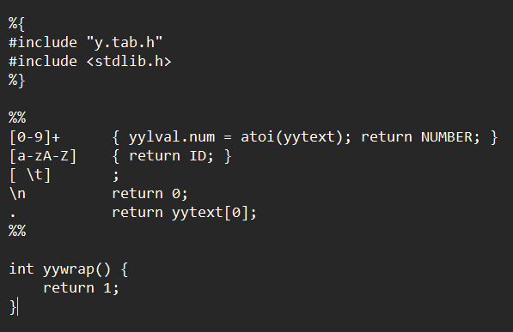
YACC CODE:
%{
#include <stdio.h> #include <stdlib.h>

int yylex(); // ⬛ ADD THIS void yyerror(char *s);

int temp_count = 1; char* new_temp() {
char *temp = (char*)malloc(10); sprintf(temp, "t%d", temp_count++); return temp;
}

void yyerror(char *s) { printf("Error: %s\n", s);
}
%}

%union { int num; char* str;
}

%token <num> NUMBER
%token ID
%left '+'
%left '*'
%type <str> expr

%%

stmt : expr { printf("Result stored in %s\n", $1); }
;

expr : expr '+' expr {

char *temp = new_temp();
printf("%s = %s + %s\n", temp, $1, $3);
$$ = temp;
}
| expr '*' expr {
char *temp = new_temp();
printf("%s = %s * %s\n", temp, $1, $3);
$$ = temp;
}
| '(' expr ')' { $$ = $2; }
| NUMBER {
char *temp = new_temp(); printf("%s = %d\n", temp, $1);
$$ = temp;
}
;

%%

int main() {
printf("Enter expression: "); yyparse();
return 0;
}

OUTPUT:
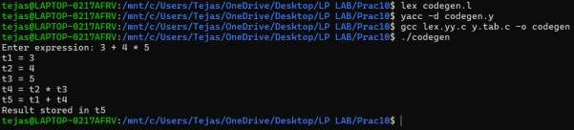

CONCLUSION:

The Capstone of Compiler Design
To wrap up your practical, here is a concise conclusion that summarizes the entire process of building a code generator using YACC:
Building a code generator with YACC bridges the critical gap between understanding a program's structure and executing its logic. While YACC is traditionally known as a parser, leveraging Syntax-Directed Translation (SDT) allows it to act as a powerful engine for code generation.
By embedding semantic actions (C code) directly into grammar rules, the compiler can simultaneously validate the syntax of the source code and emit the corresponding target instructions.
Key Takeaways for Your Practical:
- The Translation Bridge: The code generator successfully translates high-level constructs (like arithmetic expressions) into low-level instructions.
- Syntax-Directed Translation is the Engine: The process relies entirely on matching bottom-up grammar rules and synthesizing attributes (like temporary variables) up the parse tree.
- Intermediate Code as a Stepping Stone: Instead of jumping straight to complex machine code, outputting an Intermediate Representation (IR) like Three-Address Code (3AC) makes the compiler more flexible and platform-independent.
- Setting the Stage for the Backend: The generated code provides the foundational structure needed for the final stages of a production compiler, including instruction selection, register allocation, and optimization.
Ultimately, implementing this phase proves that a compiler is not just a text checker, but an active translator that converts human-readable logic into a format ready for machine execution.

