Bansilal Ramnath Agarwal Charitable Trust’s VISHWAKARMA INSTITUTE OF TECHNOLOGY, PUNE – 411037.

(An Autonomous Institute Affiliated to Savitribai Phule Pune University, Pune.)



**SEM-6 EDI Project**

**AMPHIBIOUS ROBOT**

**Guided By**

PROF. (DR.) M. B. CHAUDHARI

**Presented By**

T.Y. Mech. C Batch 1 Group 1

Year 2020-2021

| **Roll No.** | **Name** | **Gr. No.** |
| --- | --- | --- |
| 5 | Yohaan Kudtarkar | 11810298 |
| 10 | Pratiksha Kulkarni | 11810603 |
| 14 | Madhura Kunachi | 11810913 |
| 22 | Ojas Mandlecha | 11810880 |
| 24 | Shubham Mane | 11810247 |

**INDEX**

| **SR.NO** | **CONTENT** | **PAGE.NO.** |
| --- | --- | --- |
| 1. | Certificate | 4 |
| 2. | ACKNOWLEDGEMENT | 5 |
| 3. | ABSTRACT | 6 |
| 4. | INTRODUCTION | 6 |
| 5. | LITERATURE REVIEW | 7 |
| 6. | MECHANICAL DESIGN | 9 |
| 7. | CAD DESIGN | 13 |
| 8. | ANALYSIS | 17 |
| 9. | COST | 19 |
| 10. | CONCLUSIONS | 21 |
| 11. | REFERENCES | 27 |

CERTIFICATE

This is to certify that the project entitled “**AMPHIBIOUS ROBOT** ” by students of division C whose roll numbers are 5, 10, 14, 22 and 24 of Vishwakarma Institute of Technology, Pune as a EDI project of 6th sem for session 2020-2021 is a bonafide record of project carried out by us under the supervision and guidance of PROF. (DR.) M. B. CHAUDHARI **,** Department Of Mechanical Engineering.

The project is real and has not been submitted to any other university.

DATE: / /

Place:

**Prof M.B.CHAUDHARI**

ACKNOWLEDGEMENT

The objective of this project is to provide a clear and thorough presentation of theory and practical knowledge of Amphibious robots.

To achieve this objective , the group members by no means have worked alone as these ideas have been shaped by comments, suggestions and acceptance given by **Prof.(Dr) M.B.CHAUDHARI**, Department of Mechanical Engineering .

We are thankful to **Prof.(Dr) M.B.CHAUDHARI** for his guidance, support and inputs in this course project without which it wouldn’t have been a success.

We express our sincere thanks to the management of Vishwakarma Institute of Technology, Pune for allowing us to carry out such educational projects.

We express our feelings and respect towards our parents, without their blessings, help and motivation this project could not have been completed and would have been just a dream for us.

We are thankful to all those whom we might have inadvertently failed to mention here but have a positive contribution in successful completion of this project.

# Group Members

Yohaan Kudtarkar

Pratiksha Kulkarni

Madhura Konachi

Ojas Mandlecha

Shubham Mane

**Abstract**

***Biomimetic robots can potentially perform better than conventional robots in underwater vehicle designing. This paper describes the design of the propulsion system and depth control of a robotic fish. In this study, We have referred to the natural creature knife fish, we have designed and implemented an undulating fin to produce propulsive force. This undulating fin is a segmental anal fin that produces sinusoidal wave to propel the robot. This paper presents the mechanical design, control system design and experimental evaluation of a biomimetic underwater robot with undulating fin propulsion. First, a 3D model of the robot was established in Solidworks. Power to the fin is given with the help of servo motors. These servo motors regulate the direction and depth of swimming. Simulation of the robot was done by using the software Comsol***

*Keywords:* ***Undulating fin propulsion; Biomimetic robot; Underwater robot*.**

1. **Introduction**

Currently, underwater vehicles generally use propellers or water pumps as their propulsion systems, which cannot meet the growing demand of underwater applications. In contrast, the biomimetic robots outperform the conventional underwater robots in aspects of low noise, long duration and high maneuverability, which not only draw attentions of researchers but also widely used in the underwater applications, such as close-up exploration of underwater life , spatially explicit water column sampling and water quality monitoring . Replication of the fish swimming patterns is an effective method to develop biomimetic underwater robots. There are two main categories for swimming modes of fish: Body and/or Caudal Fin (BCF) propulsion, and Median and/or Paired Fin (MPF) propulsion which are according to the different parts of the fish body utilized for propulsion. Undulating fin propulsion is a typical MPF mode, which is inspired by stingrays or knight fish, and often equipped with the characteristics of good maneuverability, environmental protection and high swimming efficiency at low speed. Therefore, a number of studie*s* have been devoted to the modelling , computational fluid dynamics (CFD) simulation , hydrodynamic analysis and control methods of the undulating fin propulsion. Unlike BCF propulsion, the body of undulating fin robots can maintain its stability, which allows robots to be embedded with some sensors or modules (such as gyro sensor or camera) to obtain data or images without the interference of vibration. But undulating fin robots usually operate at lower speed due to their lower utilization of the body than that of BCF mode. Vertical movement ability of underwater vehicles is necessary for underwater work, but most robots cannot use undulating fin propulsors to achieve vertical motion, which limits the application field of them. Thus, these robots tend to assemble robots to overcome these defects. The principles of the design are as follows:

* High efficiency
* Low noise
* Untethered control

1. **Literature review**

[1]“Design, Fabrication and Hydrodynamic Analysis of a Biomimetic Robot Fish” presents the design, its fabrication and hydrodynamic analysis of a biomimetic robot fish. In CFD analysis flow around the steady state fish is smooth flow as it has streamlined shape. Whereas the body pushes water behind due to motion of its fin and of motion of body.

[2] “Hydrodynamics of an Undulating Fin for a Wave Like Locomotion System Design” presents the mechanical design, control system design and experimental evaluation of a wave-like robotic ﬁsh. In which results confirmed that asymmetrical undulation generates a hydrodynamic lift while the x-component velocity propels the robotic fish forward. This asymmetrical hydrodynamic lift, however, can be eliminated in a dual-fin design employing a pair of symmetric fins commonly seen in natural fin-based fish such as stingray, knife fish and cuttlefish.

[3]“Design, Fabrication and Hydrodynamic Analysis of a Biomimetic Robot Fish” aims to design a model of biomimetic fish in ADAMS software, fabricate and CFD analysis of it to improvise the fabricated fish. Fish swim with pushing water behind like carangiform fish, also it performs functions like turning, moving up-down.

The primary objective of the project is to design the CAD model of the robot and do the Static, CFD and FSI analysis of it in COMSOL Multiphysics and Ansys software to optimize the structure and also to simulate the fin mechanism.

1. **MECHANICAL DESIGN**

**1. Mechanical structure**

This overall prototype is 563 mm long, 422.5 mm width, 120 mm high, weighing 3 kg in air, and comprises two major parts: a 3-D printed resin body and an undulating fin propulsion system. The robot body can be further divided into two parts : the lower cabinet and the upper cover. These two parts are fixed by using screws. Two holes on the cover are used for battery charging and for other electronic components. Since the main movements of this robot are forward swimming and turning, the front and two sides of the body are designed to be streamlined to reduce the drag force due to fluid. The propulsion system consists of a pair of undulating fins symmetrically on both sides and each undulating fin consists of8 waterproof servo motors,8 fin rays and a membrane made of *2* mm thickness rubber. The servo motors, fin rays and fin membranes were all mounted by screws.

The buoyancy and the weight of the robot have roughly calculated, and made it neutrally buoyant, which is important for vertical motion. To achieve self-adjusted balance ,the robot is bottom-heavy.

**2. Undulating fin propulsor**

The undulating fin propulsor consists of fin rays, flexible membranes and driving devices. The fin rays are actuated by waterproof servo motors ( the driving devices), and are interconnected by a flexible membrane. The membrane will produce a traveling wave on its surface due to the oscillations of fin rays to generate propulsion force.

**Calculations**

1. **Fin**

A. Fin length

The decision was to use 8 rays to have the flexibility to change the phase delay.

Fin length is further used for calculation of wavelength and specific wavelength.

L = (N − 1) x dray + c

B.Wavelength

Wavelength is an important parameter of waves and is the distance between two points on the wave.

It is calculated from the wave speed and frequency.

ƛ =*

C. No. of waves

At a phase shift of 60◦ , quite a smooth sine wave can be achieved.

W =*ɸ0

D. Specific wavelength

The specific wavelength directly depends on the phase delay. The restrictions of the phase delay can be transferred to the specific wavelength.

λs =

1. **Calculation for the velocity of the bot**

To calculate the velocity of the bot ,it’s necessary to find the mass of the water being displaced by the fin. The frequency of the fin was decided to be 2Hz , as it would reduce the speed requirement for the motor. Wavenumber can be used to specify quantities other than spatial frequency.

The formula for calculating the mass of water displaced by the fins is:

M water=

k =

ɸ = Angle through which fin moves up and down

Vbody = * V

V = λ * f

**Calculation for the amplitude**

Determination of the right equation of amplitude enveloping is necessary as it will affect the control of the bot along with the change in electronics that are used. Type of amplitude envelope is decided upon their efficiency . The amplitude of every point along the fins is determined by the equation :

A(x) =

Where, A(x) = Function of amplitude with respect to x.

x = distance of the point from the start of the fin.

h = amplitude of the center of the fin.

L = length of the fin.

1. **Torque**

**i. Considering medium as water:**

The major part of force or pressure acting on the robot will be due to the height of the water column.

Note: Lift and drag forces are not considered here.

𝜏=𝐹 ×𝑅

𝑅= 𝑤𝑓𝑖𝑛/2

𝐹=𝑃 ×𝐴

𝑃= 𝜌𝑤 𝑔ℎ

𝐴= 𝑙𝑎𝑟𝑐×𝑤𝑓𝑖𝑛

𝑙𝑎𝑟𝑐=2√(𝑎2+𝜋2/4)

𝐹=2𝜌𝑤𝑔ℎ √(𝑎2+𝜋2/4)

𝝉 =𝝆𝒘 𝒈𝒉𝑾𝒇𝒊𝒏𝟐 √(𝒂𝟐+𝝅𝟐/𝟒)

Where , 𝑤𝑓𝑖𝑛 = Width of fin

𝜌𝑤 = Density of water

h = Height of water above robot

a = Amplitude of wave

**ii. Considering medium as Air (Locomotion on land):**

The weight is divided between 16 servo motors (8 on each side).

The y- components of the frictional force get cancelled out.

The x-components of the vectors get added which provides the necessary force for motion.

𝑓= 𝜇𝑀𝑔

𝐹_𝑥=0.8𝑓

𝐹_(𝑥,𝑚)= 0.8/8 𝑓= 𝑓/10

𝝉= 𝑭(𝒙,𝒎) x 𝒘𝒇𝒊𝒏= (𝝁𝑴𝒈𝑾𝒇𝒊𝒏)/𝟏𝟎

Where, 𝜇 = Coefficient of friction between fin and land.

M = Mass of robot

Fx = Friction force in x- direction

Fx,m=Force on each motor

W = width of fin

Servo motor requirements (according to calculations)

Torque required of the motor for the motion of the robot on land will be 13 kg cm ( 1.3 Nm) and in water will be 11 kg cm (1.1 Nm). Weight of the motor is approximately 60 to 80 gms.

Servo Motor selected and its Specification

i. Torque: 28 - 32 kg cm

ii. Operating Voltage: 4.8 - 6 V

iii. Weight: 78 gms

iv. T (time period) = 0.26 sec

v. F (maximum Possible) = 3.84 Hz

Table No.1 Parameters considered

| **Parameters** |  | **Values** |
| --- | --- | --- |
| No. of Rays | N | 9 |
| Wave form | θ(t) | sine wave |
| Phase delay | φ | 90⁰ |
| Ray Distance | dray | 53.5 mm |
| Fin length | Fl | 483 mm |
| Number of waves | Nw | 1.333 |
| Wavelength | ƛ | 323.5 mm |
| Specific wavelength | ƛs | 0.67 |

Velocity of the robot was calculated by considering 4 different values of frequency. At frequency 1 Hz velocity is calculated as 0.14 m/s , at frequency of 2Hz velocity is 0.28 m/s, at frequency of 2.5 Hz velocity is 0.35 m/s. In this case the maximum value of frequency is 3Hz which is calculated from the time period. Thus the maximum velocity of the body at 3 Hz is 0.42 m/s .

**3. Motion control method**

The movement of the robot is controlled by adjusting the parameters including frequency f ,amplitude A , phase shift ɸ0 and deflection angle ɸb of the two undulating fins .A and f are related to the force generated by the undulating fins, and ɸ0 is related to the direction of the force. In spite of the undulating fins also generating the force in the vertical and lateral direction, these forces do not contribute to the locomotion of the robot, so only the force along the direction of propagation of the wave has been taken into consideration . When ɸ0 > 0 ,the undulation propagates towards the last fin rays, creating forward thrust. Conversely, whenɸ0 < 0 creates backward thrust. Note that ‘A’ should be adjusted as well with ɸ0 . It illustrates the basic motion control method for the robot. When the forces produced by the two fins have the same magnitude and direction, the robot will move along the straight line in the direction opposite to the fin’s undulation . When the thrust of two forces are equal but in opposite directions, in-place rotation is instigated . Any asymmetry of the thrust will cause the robot to turn . The vertical motion is achieved by adjusting the deflection angle ɸb . When ɸb> 0 or ɸb< 0 , the propulsive force is correspondingly lower or higher than the center of gravity, causing rising or diving motion.

**IV. CAD DESIGN**

The first part model of the servo motor was made with the help of the online product configuration which was available. An important point here was to consider the position of wire coming out of the servo which decides it’s orientation and alignment in the robot. The next part was the fin ray. It is the part connecting the servo motor to the fin membrane. Three versions were developed through optimization. First version used the servo horn and separate fin membrane which connected using nuts and bolts. This made the assembly difficult and so a single part was modelled coming from the horn and fin ray. This not only makes the assembly easy but also improves the strength. Analysis of version 2 (detailed explanation in the fin ray analysis) had deformation on the free end. So a more optimised design, the free end which is connected to the fn membrane was made thicker, was developed in version 3.

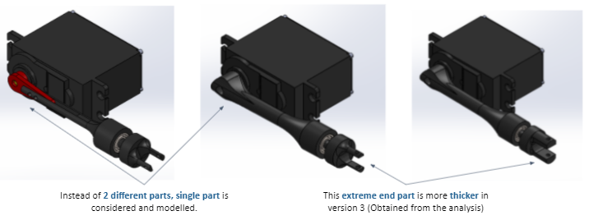

(a) (b) (c)

Fig 1: Fin Ray Versions (a) version 1 (b) version 2 (c) version 3

The CAD model (version 1),Fig 1, shows the primitive design of the robot. Hydrodynamics was not considered while designing this version. Main motive of this design was to give sufficient space and proper arrangement of all the components. In version 2, fig 2, a nose was added after the CFD was performed on version 1. If a battery or electronic component is to be replaced instead of disassembling the whole robot two dismantlable compartments were provided on the cover of the main body. After CFD of version 2, based on the results, version 3 was modelled in CAD software. More efficient and hydrodynamic nose was designed. Dummy fin rays on both the sides of the robot were added to terminate the fin properly and to perform an effective starting of the wave. In version 4, fig 4, two shark fins were added which further helped to cut the flow, providing a smoother passage. Lids were provided at the top of the body cover for ease of access to battery and electronic components. The overall dimension of the robot was 563 x 422.5 x 120 mm and the weight estimation, with the help of software, was around 3334 kg. The material considered for robot main body, body cover and fin ray is ABS. The fin membrane should be flexible enough for undulating motion, therefore silicone rubbers (elastomer) were selected.

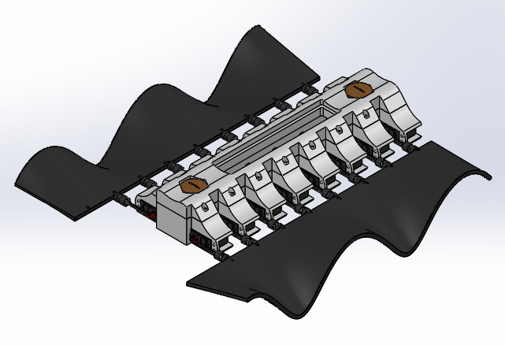

Fig 2: CAD model (version 1)

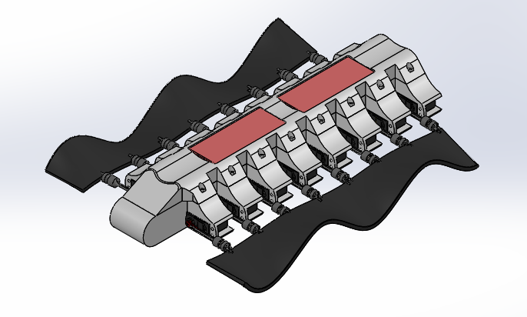

Fig 3: CAD Model (version 2)

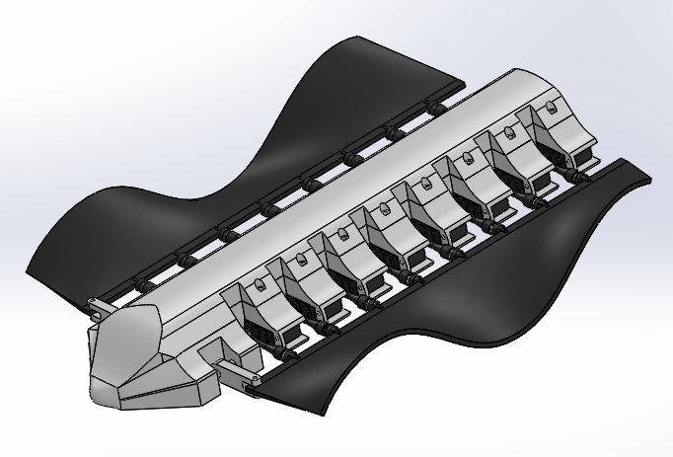

Fig 4: CAD Model (version 3)

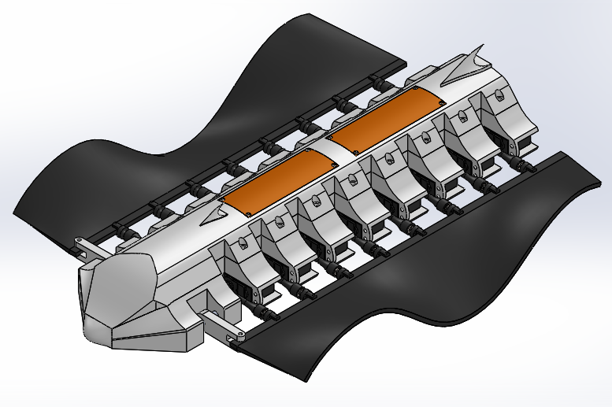

Fig 5: CAD Model (version 4)

**V. ANALYSIS**

1. **Static structural**

The material considered for robot main body, main body cover and fin ray is ABS. The fin membrane should be flexible enough for undulating motion, therefore silicone rubbers (elastomer) were selected. Static structural analysis was performed on fin ray and main body and main body cover assembly. Continuous analysis was performed until either the material reached allowable deformation or allowable factor of safety. This was done by changing the pressure which was applied during static structural analysis. For the static structural analysis of fin rays the end connected to the shaft of the motor was kept fixed and rest on the faces pressure, 0.3MPa, was applied. As mentioned earlier, analysis on two versions were performed.

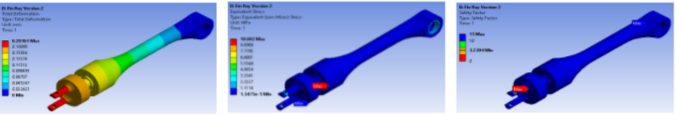

Fig 6: Deformation (mm) Version 2 Fig 7: Von Mises Stress(Mpa) Version 2 Fig 8: Factor Of Safety (version 2)

Fig 9: Deformation (mm) Version 3 Fig 10: Von Mises Stress(Mpa) Version 3 Fig 11: Factor Of Safety (version3)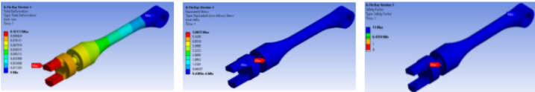

Table No.2 Analysis Results of Fin ray version 2 and 3

| **Version** | **Deformation (mm)** | | **Stress (MPa)** | | **Factor of safety** | |
| --- | --- | --- | --- | --- | --- | --- |
| **Max** | **Min** | **Max** | **Min** |
| Version 2 | 0.2036 | 0 | 10.002 | 1.35E-05 | 3.23 | 50% Reduction in optimised design |
| Version 3 | 0.1017 | 0 | 5.985 | 9.43E-04 | 6.47 |

There was almost 50% reduction in each of the parameters, deformation and stress, which can be viewed in table no 2. The stresses of version1 were well within the limits but the deformation was considerably high. Therefore in the following version the free end was made thicker giving it sufficient strength which was verified during its analysis which showed much less deformation and stresses with almost 6.47 factor of safety. In static structural analysis of the main body the inner surfaces were kept fixed and on all the outer surfaces pressure of 0.3MPa was applied. The assembly, Fig 12 and 13, showed a deformation of 0.1 mm and stress of 1.38MPa which is well within the limits as the the yield strength if ABS is 18.7 MPa.

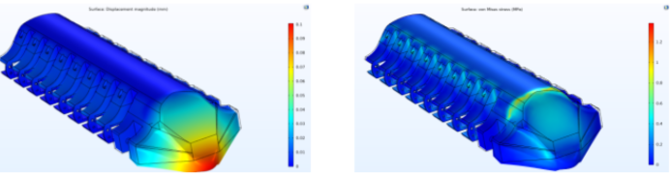

Fig 12: Deformation (mm) Fig 13: Von Mises Stress (MPa)

1. **CFD Analysis**

**Details of Boundary Conditions**

Table No. 3. Analysis Details

| **Material** | Water |
| --- | --- |
| **Flow** | Laminar |
| **Boundary Conditions** | **Value** |
| Initial Values | Velocity= -0.6m/s (X-direction)  Pressure= 0.097atm |
| Wall Condition | No Slip |
| Inlet | Normal Inflow Velocity=0.6m/s |
| Outlet | Static Pressure= 0.097atm  Backflow Suppression |
| Open Boundary | Normal Stress= 9806.38N/m2 |
| **Mesh** | Physics Controlled= Coarse |

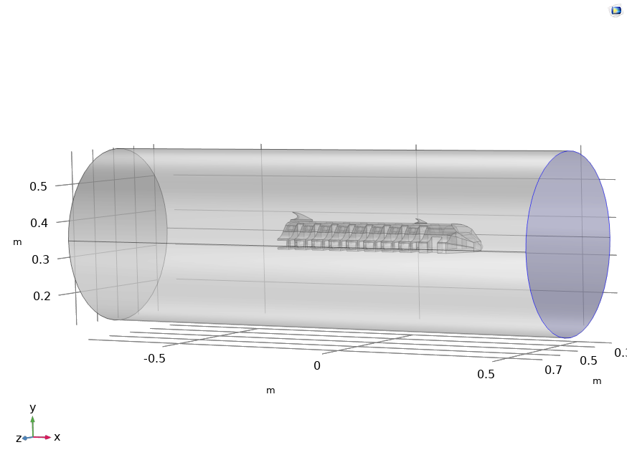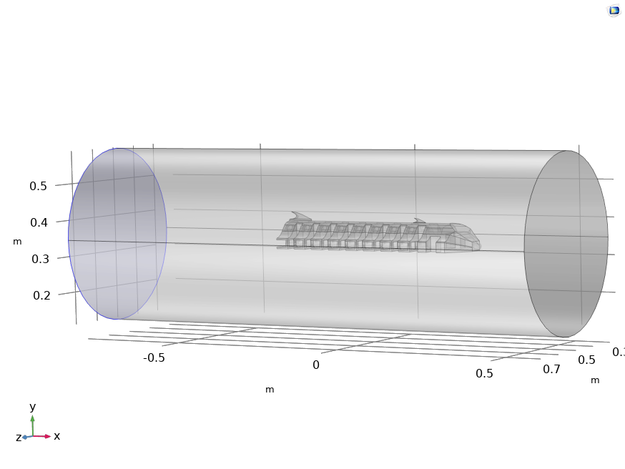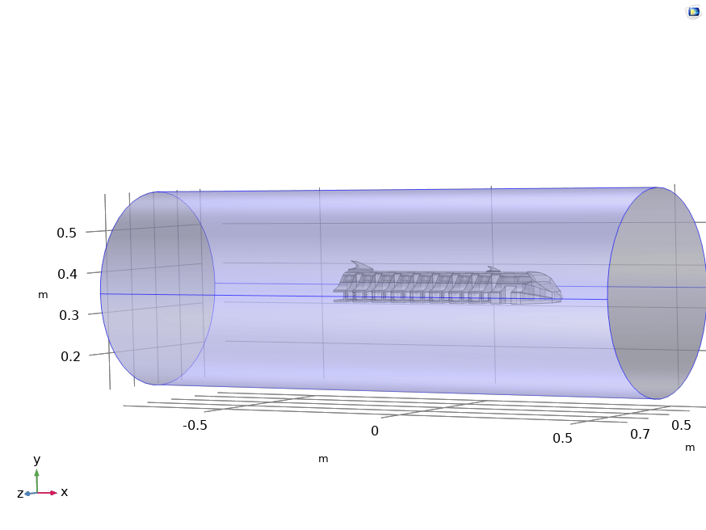

Fig.14: Boundary Conditions

**Flow Streamline**

From the velocity streamlines, we can see that in version 3 and 4 the streamlines do not deflect a lot and have a smooth profile through the geometry. The vortices formed are also less in version 3 and 4, whereas in version 1 there is a significant amount of flow separation leading to more vortex generations thereby increasing drag and instability. The streamlines also stick to the surface of the body. The shark fin further helps to cut the flow providing a smoother passage. We can also see the distance needed for the flow to recuperate in the earlier versions than in the final optimised design.

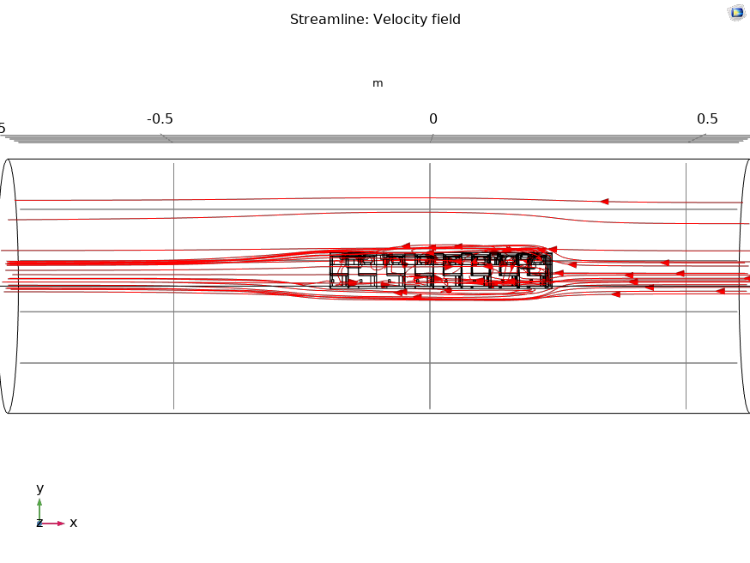

Fig 15: Streamline: Velocity Field (version 1)

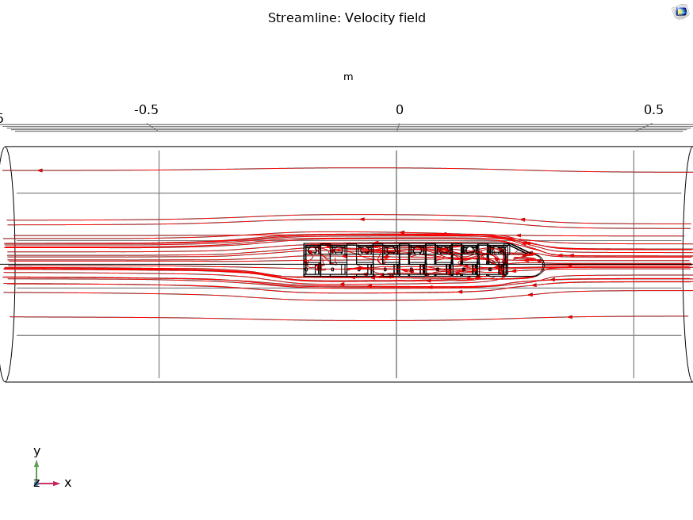

Fig 16: Streamline: Velocity Field (version 2)

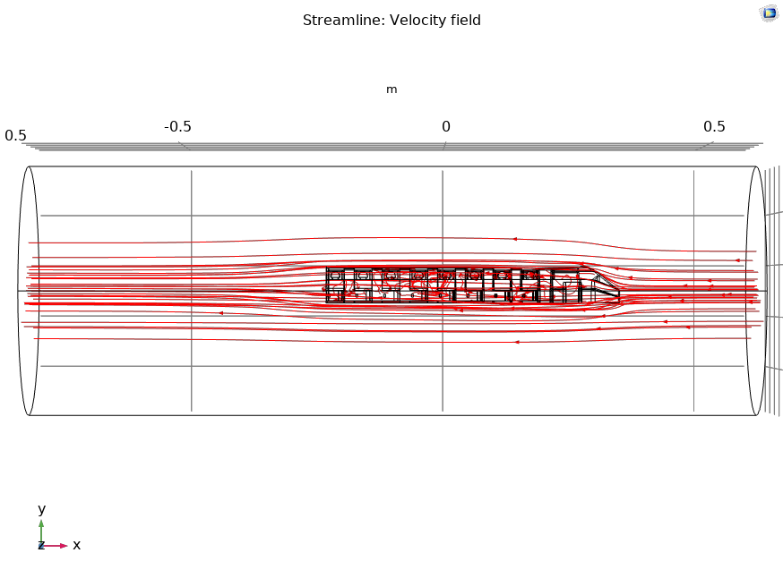

Fig 17: Streamline: Velocity Field (version 3)

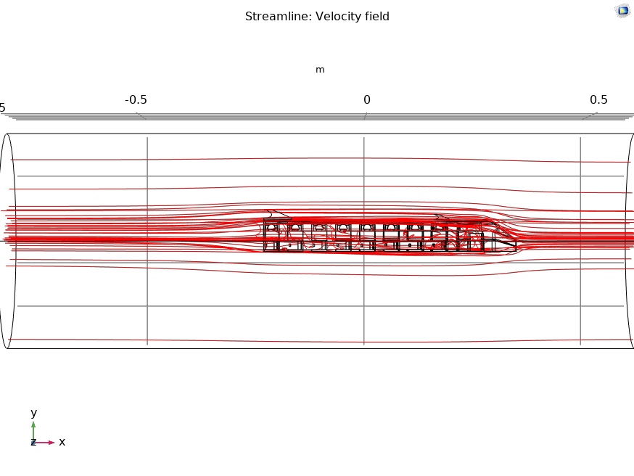

Fig 18: Streamline: Velocity Field (version 4)

**Velocity Profile**

Velocity of the flow at the front face comes to almost zero showing the stoppages on the flow loading to increase drag. At the edges it can also be seen that the velocity increases more than the inflow velocity signifying the formulation of vortices. In version 1 of the design, there is a significant amount of area where the flow velocity is reduced which has been overcome in the optimised design.

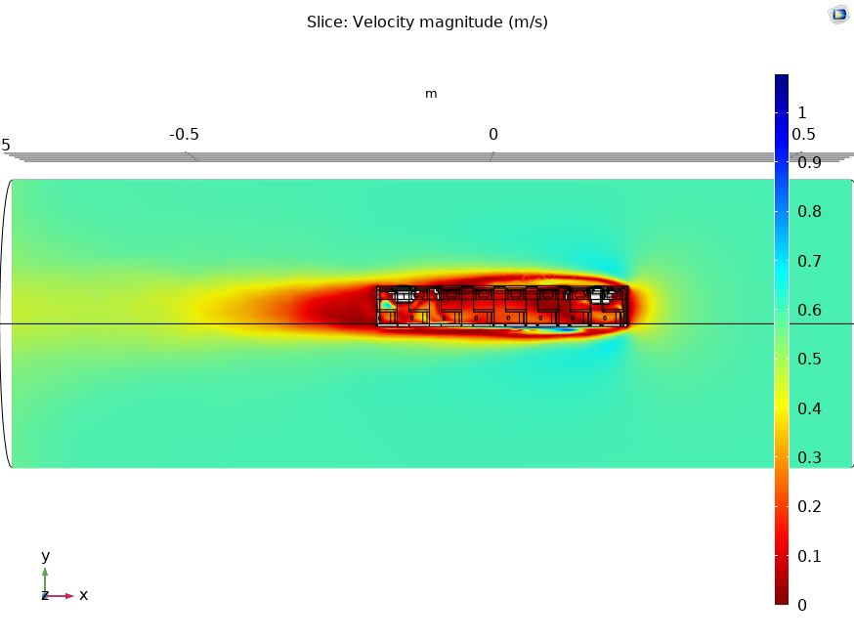

Fig 19: Velocity magnitude (version 1)

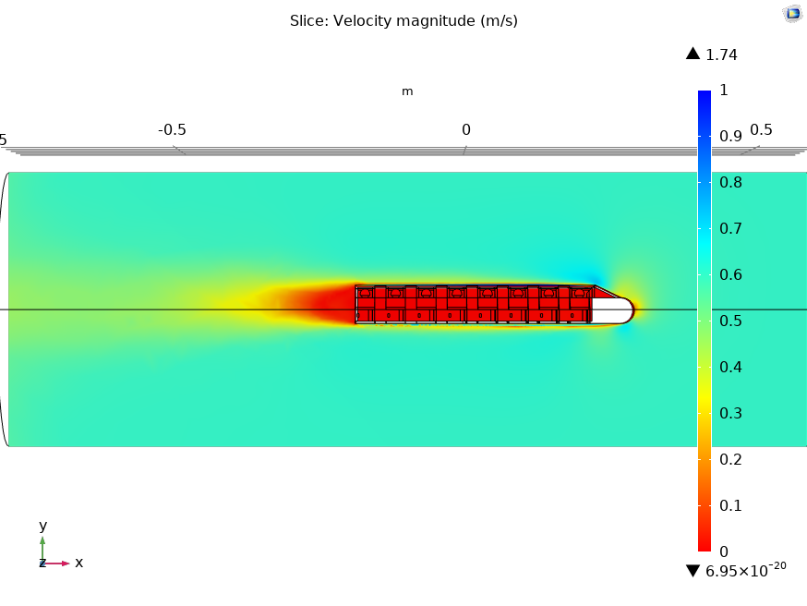

Fig 20: Velocity magnitude (version 2)

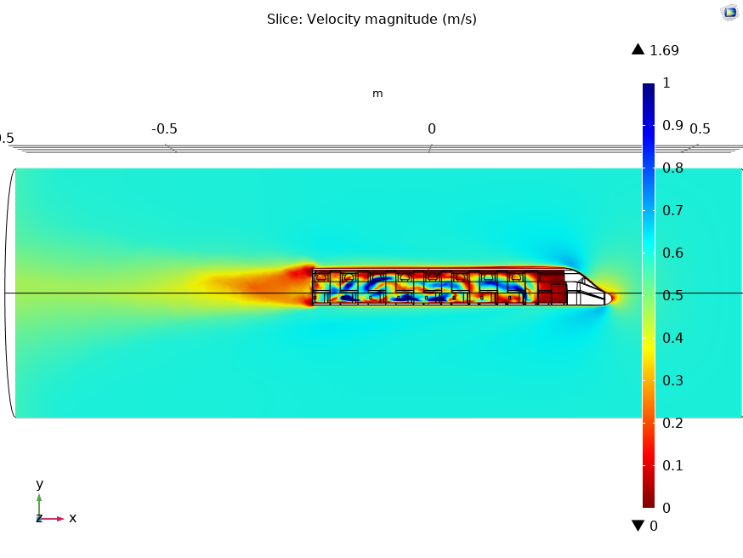

Fig 21: Velocity magnitude (version 3)

**Surface pressure**

Pressure drag is the force pushing or resisting the flow. The front of the robot where the water hits and almost comes to a stand still is where the pressure is the highest. This is known as the stagnation pressure. This is what we are trying to optimise in the designs. Hence, we have reduced the frontal area which completely stops the flow by giving a sloping nose to the robot. The low pressure zones are areas where the water curves and speeds up which leads to disturbances and instability.

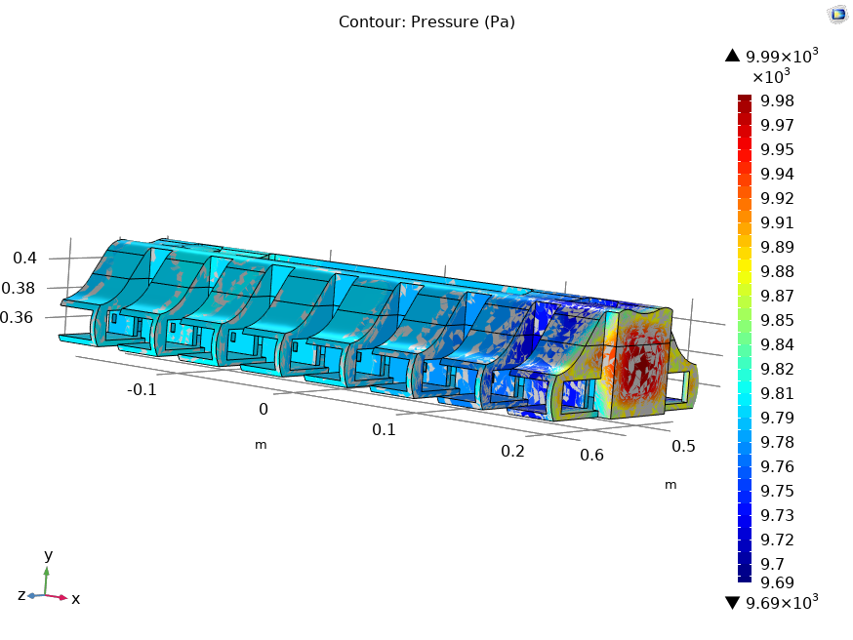

Fig 22: Pressure Contour (version 1)

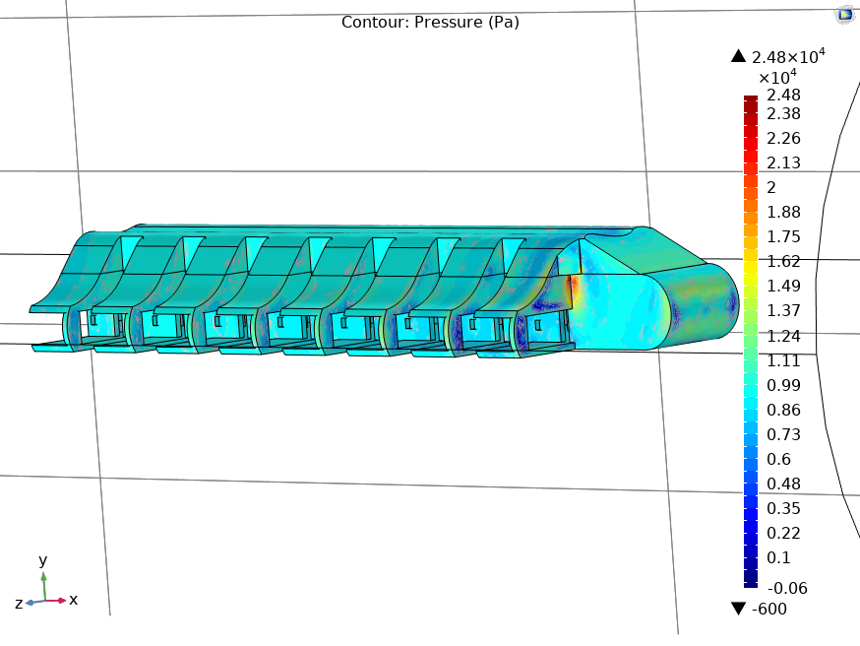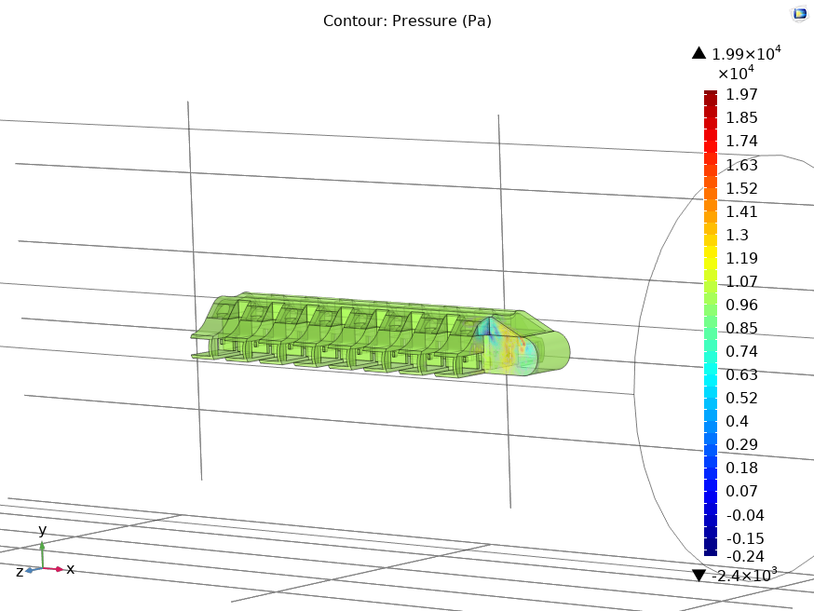

Fig 23: Pressure Contour (version 2)

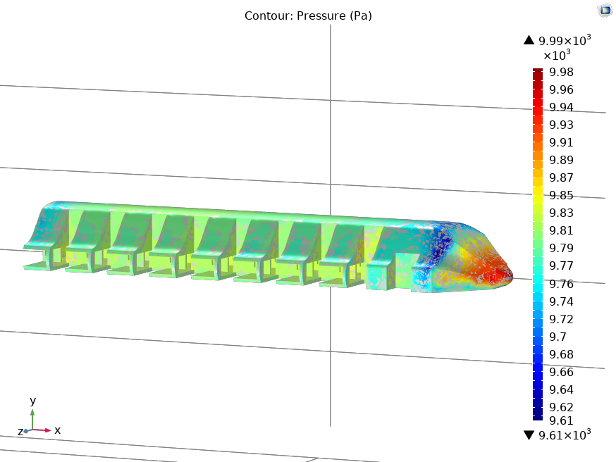

Fig 24: Pressure Contour (version 3)

Table No. 4: Tractive Force due to variation of frontal area

| **x-component** | **Version 1** | **Version 2** | **Version 3** |
| --- | --- | --- | --- |
| **Pressure Force** | -66.012N | -64.926N | -76.411N |
| **Total Traction** | 66.013N | 64.868N | 76.413N |

By surface integration of the frontal area of the robot, we can see that the total tractive force of Version 3 is the highest signifying that the body is more streamlined than the earlier versions.

**VI. COST**

Table No. 5: Estimated weight of components

| **Components** | **Weight**  **(grams)** | **Quantities** | **Total Weight**  **(grams)** |
| --- | --- | --- | --- |
| Main Body | 450 | 1 | 450 |
| Body Cover | 161 | 1 | 161 |
| Fin Ray | 4.5 | 16 | 72 |
| Dummy Fin Ray | 10 | 2 | 20 |
| Servo Motor | 78 | 16 | 1248 |
| Bearings | 50 | 16 | 800 |
| Fin Membrane | 290 | 2 | 580 |
| **Total Weight** |  |  | **3331** |

Table No. 6: Estimated cost of components

| **Components** | **Quantities** | **Unit Price**  **(Rs.)** | **Total Price**  **(Rs.)** |
| --- | --- | --- | --- |
| Main Body | 1 | 6000 | 6000 |
| Body Cover | 1 | 2500 | 2500 |
| Fin Ray | 16 | 40 | 640 |
| Dummy Fin Ray | 2 | 100 | 200 |
| Servo Motor | 16 | 400 | 6400 |
| Bearings | 16 | 25 | 400 |
| Fin Membrane | 2 | 125 | 250 |
| **Total Cost** |  |  | **15500** |

**VII. VERIFICATION AND VALIDATION**

Verification is the process of determining that a model implementation accurately represents the developer’s conceptual description of the model and the solution to the model. In simple words it is about solving the right equations right and quantifying the errors. Estimation of iterative convergence error is comparing the results obtained with different convergence criteria or limits. The numerical solution of a flow problem requires an iterative process of solving the discrete algebraic equations. Due to limitations in computer power and time, the iteration sequence will be stopped when the solution is sufficiently close to the final solution. Iterative convergence error is the difference between a given solution and solution that would be obtained after an infinite number of iterations. Validation is the process of determining the degree to which a model is an accurate representation of the real world from the perspective of the intended uses of the model.

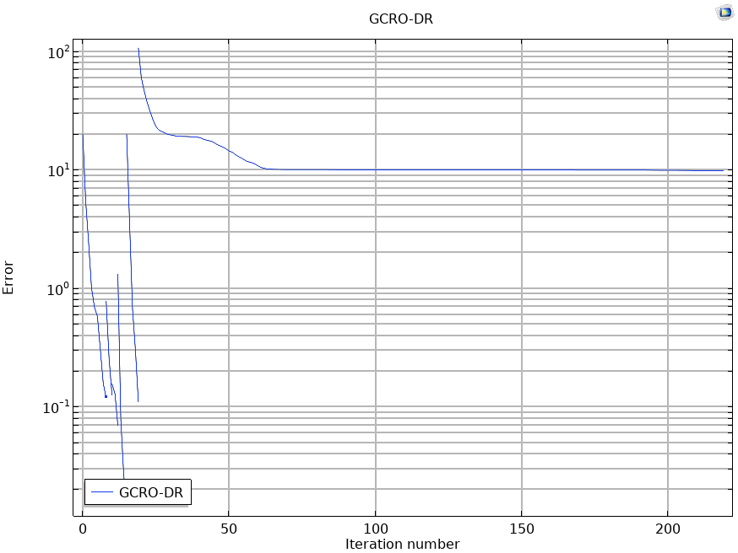 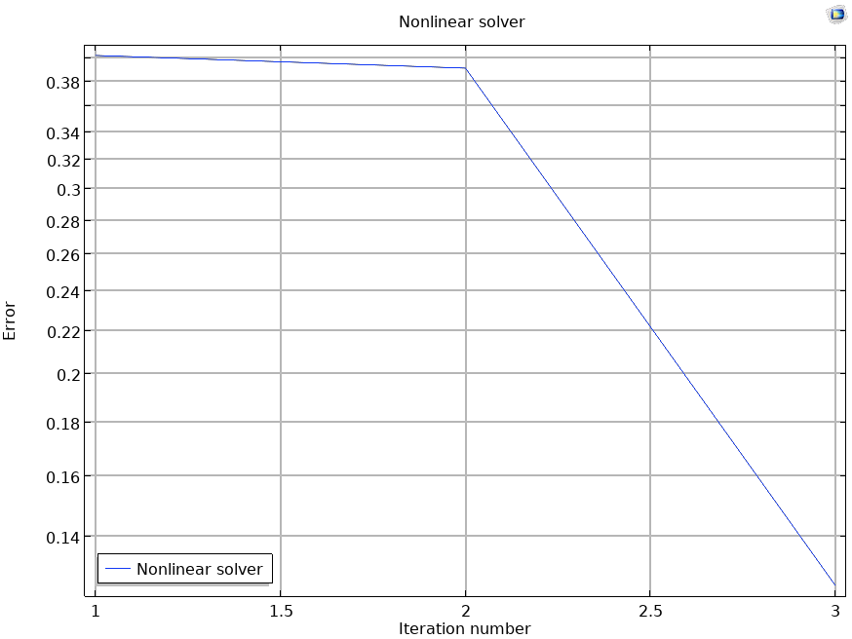

Fig. 25. Convergence Plots

Further refining of mesh sizes will yield smaller errors thereby providing better results. Due to the restriction in computational power and time the mesh select is coarse.

The below equations are solved flow a stationary laminar flow study:

ρ(u∙∇)u= ∇∙[ -pI+K ]+F

ρ∇∙u=0

K= μ(∇u+(∇u)^T)

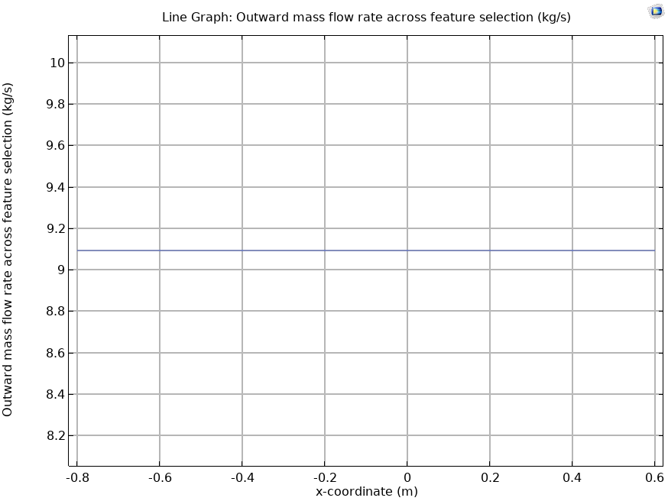

Fig. 26. Mass flow rate

The graph in Fig. 26 shows the conservation of mass across our simulation model thereby validating the simulation results.

We are solving laminar flow equations as when the robot is moving in a large water body the flow is generally laminar and additionally the speed of the robot is less than 0.6m/s which signifies that turbulence model need not be used.

**VIII. CONCLUSION**

The maximum possible frequency is 3Hz which provides the speed of 0.42m/s. for a robot with a mass of 3kg. The velocity of the robot was directly proportional to the amplitude and frequency of the undulating mechanism. The frequency of the membrane depends on the maximum possible speed of the motor. All the body parts of the robot were able to withstand a pressure of 0.3 MPa with ease. This pressure corresponds to 20 m height of water. The optimisation in design was done with the help of CFD analysis. The pressure and velocity profiles were found out to better understand the flow characteristics.

**IX. CHALLENGES**

The calculations of velocity and forces acting on the robot were challenging. One of the main challenges was development of flexible fin membrane and the development of hydrodynamic design of the robot in solidworks CAD software. The CFD, FSI analysis of the various versions of the robot required too much computational power. The CFD analysis took about 10-15 hours to solve while some of them even took 18 hours.

**X. References**

1. Stephen Battersby, “NewScientist”, Secrets of slithering lie in weight on the scales, Jun. 2009.
2. W.Rebel, “GearBoxRotLinScrew”, commons.wikimedia.org, https://commons.wikimedia.org/wiki/File:GearBoxRotLinScrew.gif (accessed Apr. 5, 2020)
3. Fangfang Liu, Kok-Meng Lee, Fellow, IEEE, and Can-Jun Yang. Hydrodynamics of an Undulating Fin for a Wave-Like Locomotion System Design , Aug. 2011
4. Mohsen Siahmansouri , Ahmad Ghanbari ,Design, “Implementation and Control of a Fish Robot with Undulating Fins”, Oct. 2011.
5. “Modelling and parametric study of modular undulating fin rays for fish robots” , Mar. 2009
6. Benjamin Peter, Roman Ratnaweera,”Design and Evaluation of a Fin-Based Underwater Propulsion System”, May 2011.
7. Hyung-Soo Kim et.al , “Design and fabrication of Soft Morphing Ray Propulsor: Undulator and Oscillator”, May 2016.
8. R. K. Katzschmann, J. DelPreto, R. MacCurdy, and D. Rus, “Exploration of underwater life with an acoustically controlled soft robotic fish,” Science Robotics, vol. 3, ear 3449, 2018.
9. D. Li, Z. Zeng, J. Cao, D. Lu, C. Xiong, and L. Lian, “A bio-inspired underwater glider with undulatory fin for long-duration, spatially explicit water column sampling,” IEEE/OES Autonomous Underwater Vehicles (AUV), pp. 62-68, 2016.
10. Z. Wu, J. Liu, J. Yu, and H. Fang, “Development of a novel robotic dolphin and its application to water quality monitoring,” IEEE/ASME Transactions on Mechatronics, vol. 22, pp. 2130-2140, 2017.
11. M. Sfakiotakis, D. M. Lane, and J. B. C. Davies, “Review of fish swimming modes for aquatic locomotion,” IEEE Journal of oceanic engineering, vol. 24, pp. 237-252, April 1999.
12. K. Low, “Modelling and parametric study of modular undulating fin rays for fish robots,” Mechanism and Machine Theory, vol. 44, no. 3, pp. 615–632, 2009.
13. A. Willy and K. Low, “Development and initial experiment of modular undulating fin for untethered biorobotic AUVs,” in 2005 IEEE International Conference on Robotics and Biomimetics (ROBIO), 2005, pp.45–50.
14. M. Sfakiotakis, D. Lane, and J. Davies, “Review of fish swimming modes for aquatic locomotion,” IEEE Journal of Oceanic Engineering, vol. 24, no. 2, pp. 237–252, 1999.
15. Madsen, P., “How ships’ traffic noise affects whales in a shipping channel,” 2003, [Online; accessed April 2009].