
Step1:Inspect news.tsv
Behaviors.tsv
And see How many users?
How many news?
Average history length?
How many zero history users?
Distribution of click counts?
Step 2:
Next start with defining news encoder
1.Items in news dataset contains title,category,subcategory etc.
Take all-MiniLM-L6-v2(sentence embedding model)
It is trained to convert an entire sentence into a semantic vector.\
So input to encoder is:
Ti=news title string
We will give title as the input to all-MiniLM-L6-v2 and it outputs 384-dimension vector
(As it is a pretrained model)
Step 3:Define user attributes from MIND dataset which we need to give as input for Attribute encoder
As demographic attributes like age,gender,location are not available in MIND dataset
Since demographic attributes are unavailable in news recommendation datasets, we define user attributes as observable early preference signals derived from exposure and minimal interaction. These attributes provide a prior preference estimate before stable behavioral patterns emerge.
From behaviors.tsv:
- impression time
- candidate news
- clicked news
- user id
So user attributes must be constructed from:
1. very early interactions
2. exposure patterns
3. content priors
So we are preparing meaningful attributes from the prior available information to start with
So we take 3 levels of attributes
1.Exposure attribute: Exposure attribute is the categorical distribution of articles presented to the user in the current impression
Impression contains N120-0 N55-1 N89-0 N200-0 N305-0(NewsID-label)
For exposure attribute label can be ignored
Step1:Read the impression column and remove the click labels
Eg: news IDs=[N120, N55, N89, N200, N305]
Step 2: Look up category from news.tsv
As news.tsv contains news id and category we can take category from this
Step3: count frequencies and convert to probability distribution
For a category k,
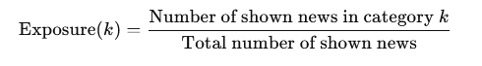
For example:from impressions row we get news IDs=[N120, N55, N89, N200, N305]
After looking up categories from news.tsv we get categories for news ids
Like N120-sports,N55-politics etc
If we get categories like sports-2,politics-3,tech-1
Total shown news=5
Now compute exposure=[2/5,3/5,1/5]
We get the exposure vector
2.Early click attribute
We get the clicked news in shown impressions
Initially when a impression is shown to users some have label 1 and some have label 0
Out of clicked news how many belong to each category is calculated?
For category k
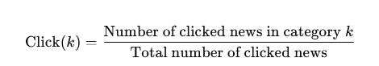
If no news is clicked, vector is always zeros
Example:
N120-0 N55-1 N89-0 N200-0 N305-0
In this impression, N55 is clicked see N55 category from news.tsv and see other categories as well for the news ids—[1/1,0,0]
We get early click vector
3.semantic prior attribute
In this attribute we take what kind of articles the user prefers in meaning
Each news attribute has columns like title,abstract in MIND dataset
So instead of taking only category we capture topic style
Step 1:From news.tsv and miniLM preprocessing we already have each news article converted to a fixed vector of 384 dimensions
Step2:Take 1 row from behaviors.tsv and extract clicked news
Eg: impressions: N1-0 N2-1 N3-0 N4-1
So N2 and N4 are user clicks
From previous miniLM step get embeddings of clicked news (which we got by taking title) .so we get N2 and N4 vectors
Step 3: Formula to calculate semantic prior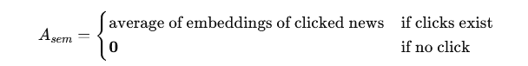
Eg: N2 → [0.0, 0.9, 0.1, 0.0]
N4 → [0.7, 0.2, 0.0, 0.0]
Add vectors and divide by no of clicks..the obtained vector is the semantic prior vector
Now we got the 3 vectors-Exposure attribute vector,click attribute vector and semantic prior attribute vector
Now concatenate the 3 vectors
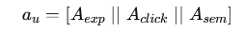
This means keep all vector values in a single long vector.
Now we get the final attribute feature vector
Now this is just a raw feature vector.
It is not yet a user embedding.
It cannot directly interact with news embeddings.
So we design attribute encoder for this
Attribute Encoder using gated projection fusion
To convert attribute features to user preference embedding we use attribute encoder
is the input to the attribute encoder
But before that as news embeddings are in 384 dimensional space user embedding must also be 384 dimensional space
So we transform each attribute into 384-D.
1.Exposure projection
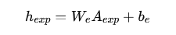
Where
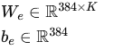
The matrix has 384 rows and K columns
We is initialized -When you define a neural network layer, the framework:
- automatically creates this matrix
- fills it with small random values
then computes
be is the bias it is also automatically created in nn.linear and randmoly initialized

During Training
After computing prediction loss:
Backpropagation computes gradients for:
- W_e
- b_e
- all other parameters
Then optimizer updates
So weights gradually move from random to meaningful

Same way we do for click projection and semantic projection
2.click projection
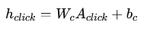
Output is
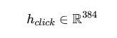
3.Semantic projection
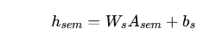
Output is
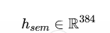
Next step in attribute encoder is compute gating weights
Compute gates from
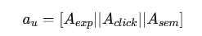
So we compute importance scores, convert scores to probabilities(softmax), weighted average
1.linear transformation
We want 3 outputs:
- one score for exposure
- one score for click
- one score for semantic
so 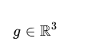
to convert we use linear layer
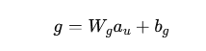
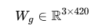
Wg is initialised using nn.Linear it creates matrix with random initialization whose values are updated while training by doing backpropagation
2.Using softmax convert scores to probabilities
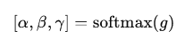
Each gate score is a weighted sum of all raw attributes.
i.e g1=w1,1a1+w1,2a2+…..w1,420a420+b1
g=[g1,g2,g3]
Each gi is just a number.
•g1​ → importance score for exposure
•g2​ → importance score for click
•g3 → importance score for semantic

apply softmax
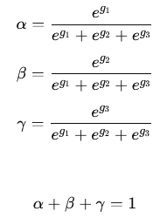
So they get normalized weights
Now do fusion
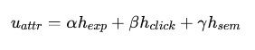
So the output of attribute encoder is a 384-dimensional attribute-based user embedding
History Encoder
Convert a sequence of clicked news into a behavioral user embedding
From MIND: Each user has clicked history
Each news already has embedding from MiniLM which is of 384 dimension
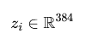
In behaviors.tsv we have history of clicked items for that user at that time
So if a user clicked L news
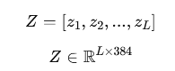
So the input of history encoder is (batch_size,L,384)
History encoder takes already computed embeddings and learns which clicks are more important and aggregate them into a single 384-dimensional vector
Step2: self attention pooling is taken as a modeling strategy to aggregate clicked news embeddings
Self-attention pooling learns how important each clicked article is and then computes a weighted average of them.
Self-attention pooling computes importance per item from item embedding itself
Compute Importance Score for Each Click
i)For each clicked embedding zi
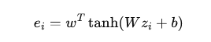
W - transforms embedding into “importance space”
w is a learnable parameter vector.(It projects transformed importance score into a single importance score)
W, b, and w are learnable parameters of the history encoder they are randomly initialized
learned through backpropagation
This is raw importance score..so we get e1,e2…eL
ii)Normalize scores(softmax)
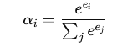
For each score ei,take exponential of each score divided by sum of exponentials
iii)compute user history
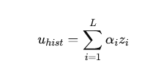
So more important clicks contribute more.
So we get weighted average of row vectors
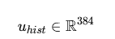
It is a behavior-based user embedding.
Next compute
Attribute–Behavior Alignment Loss
Only when: User has history (L > 0) compute alignment loss
If zero-history: alignment loss is skipped
Compute
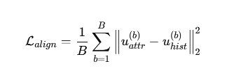
means if expanded
If each embedding has dimension d=384 then
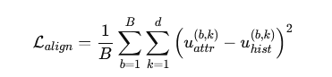
b- index of user in batch
k- index of embedding dimension (1 to 384)
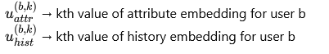
This alignment loss act as a regularizer Smooth transition from cold → warm, Better generalization to unseen users
It male sure Attribute representation should approximate behavioral representation
Without alignment loss,
• Attribute encoder learns only from final recommendation signal.
• History encoder learns independently.
• No guarantee they represent similar preference directions.
Adaptive user fusion module
i)concatenate both embeddings
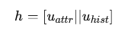
ii)compute fusion gate


h we get from above
Wf is the weight matrix which initialized randomly and learned during training updated using backpropagation
This is created using linear layer
bf is the bias vector learned learned via nn.linear
iii)Final user embedding:
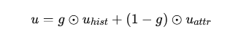
If gk=0- attribute dominates dimension k(for cold start users)
If gk=1 – history dominates dimension k(for warm users)
(For few clicks users,)during training gk might be 0.3,0.6 etc so it takes 40% from history and 60% from attribute
Scoring layer
For each candidate news item zj in the impression:
We compute a relevance score
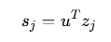
Convert Scores to Probabilities
Apply softmax
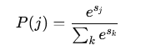
During training->calculate recommendation loss for that impression
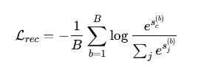
After scoring and before backpropagation lrec is computed
Calculate Total loss
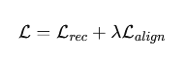
λ. is the hyperparameter so this should be tuned
As alignment loss is usually smaller scale than cross-entropy start λ =0.01 and test with 0.001,0.01,0.05,0.1
The alignment coefficient λ\lambdaλ is selected via grid search over the validation set to balance recommendation accuracy and attribute-behavior consistency
During testing
- Compute scores sj
- Sort candidates by score
- Select Top-K
That produces:
Top-k recommendations.
Summary
Training flow
Preprocessing:
1.Precompute all news embeddings using MiniLM
2. For each impression in behaviors.tsv:
- Extract user history
- Extract candidate news
- Identify clicked news (label)
Forward pass
For each batch of impressions:
1.Attribute Encoder
From exposure + early click + semantic prior
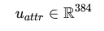

2.History Encoder
If user has history:
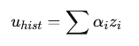
Else 0
3. Alignment Loss (if history exists)
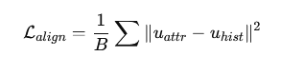
4.Adaptive fusion
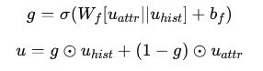
5. Click Prediction
For candidate news zj
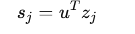

6. Recommendation Loss
Cross-entropy over candidates:
7. Total Loss
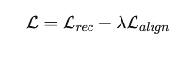

8. Backpropagation
Update:
- Attribute encoder
- History encoder
- Fusion layer
- Scoring
MiniLM remains frozen.
Testing flow:
1. Same as training:
- Compute u_attr
- Compute u_hist
- Apply adaptive fusion
- Get final user embedding u
2. Score Candidate News
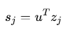

3. Rank
Sort scores:
Top-k highest recommendations.

