Project 1: SSH Brute Force Detection in Splunk
Kali (Attacker) → attacks → Ubuntu (Target/Victim)
↓
auth.log captures events
↓
Splunk ingests auth.log
↓
Dashboard + Alerts fire
Ubuntu IP:
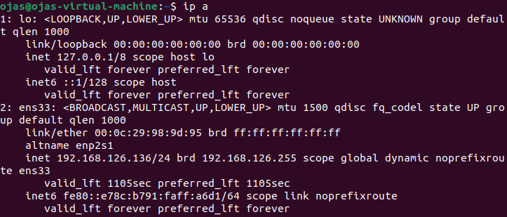
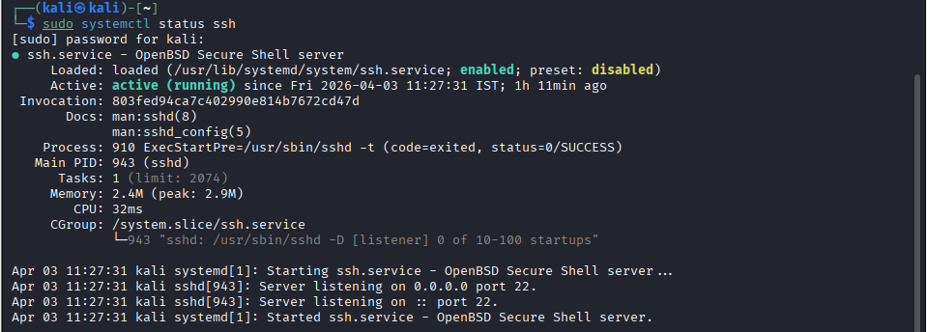
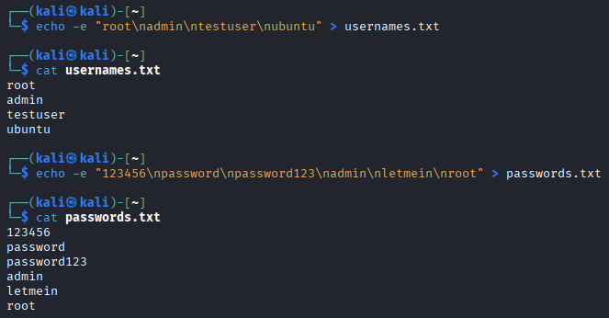
Tool 1 : hydra
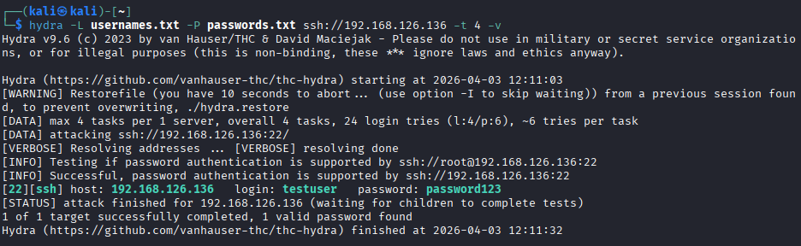
Failure attempts 1:
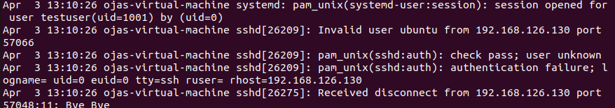
2:
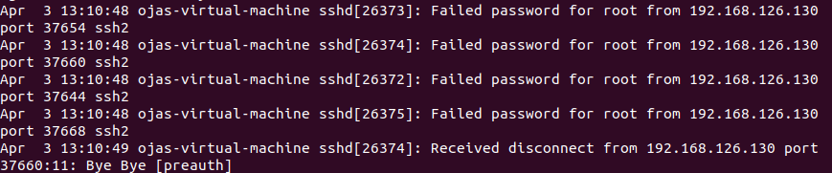

Success:
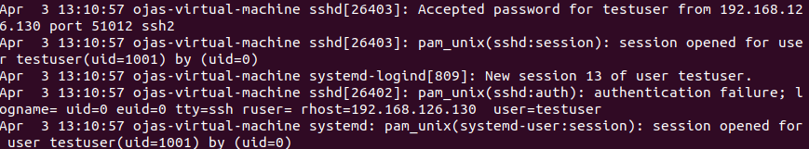
All failed SSH logins:
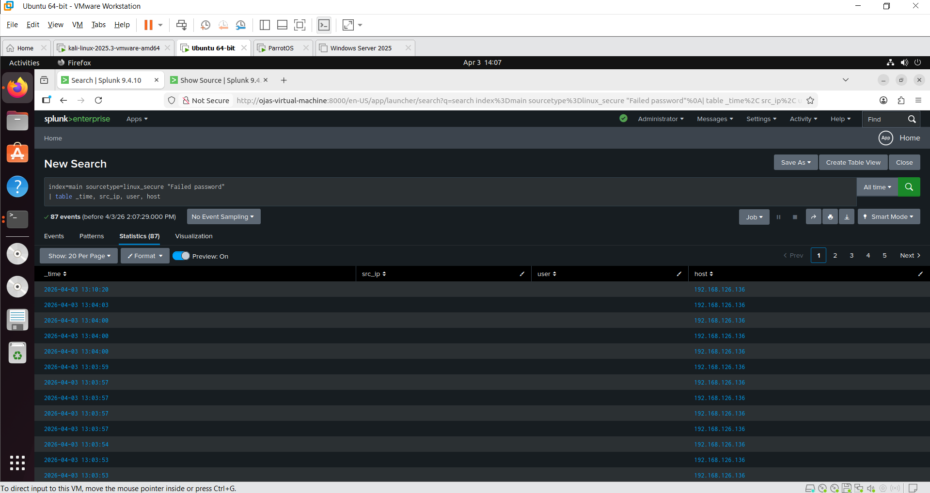
Search 2: Count Failed Attempts per Source IP
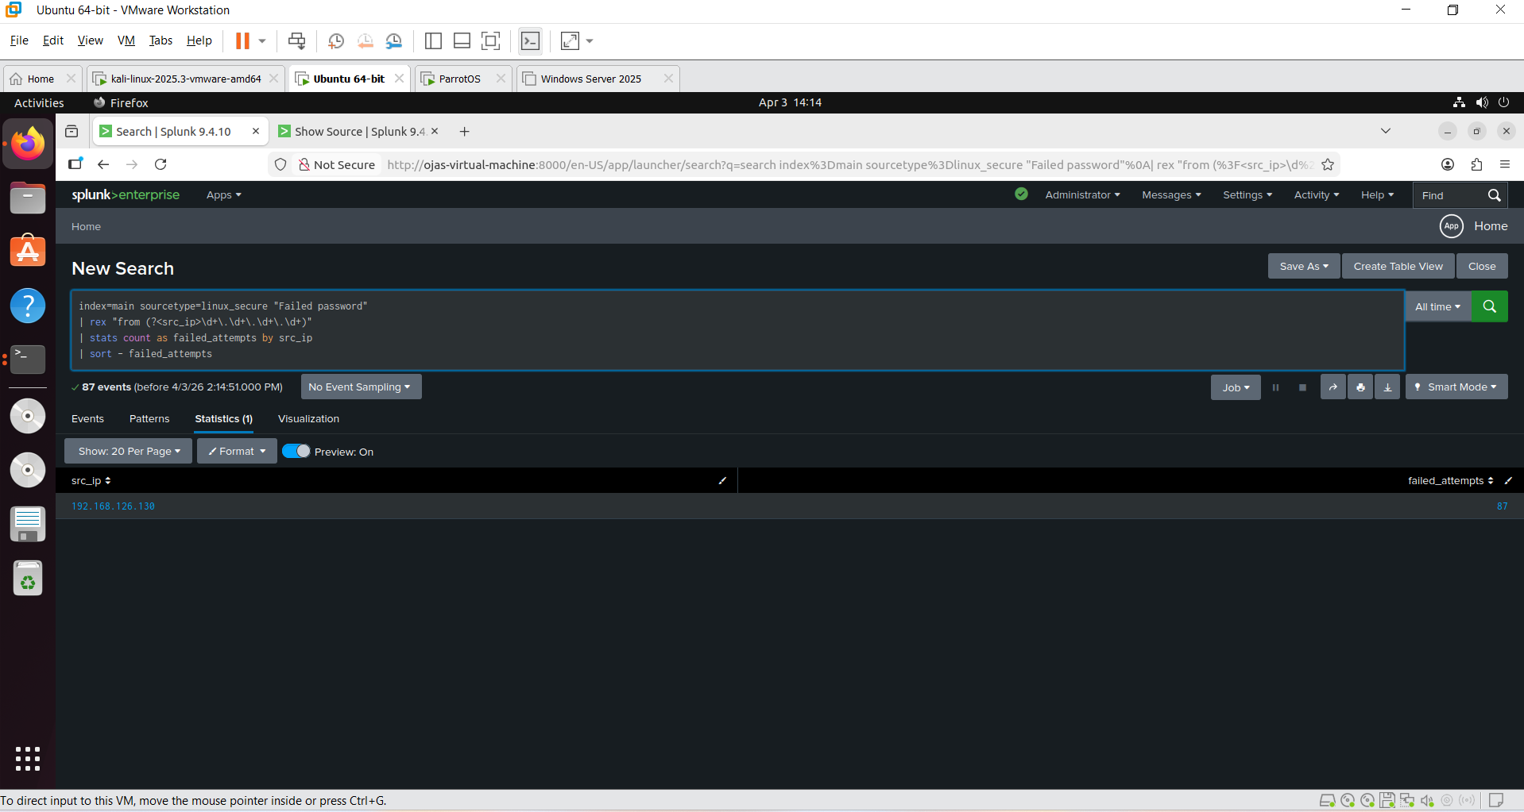

Search 3: Brute Force Threshold Detection (>5 failures in 5 mins)
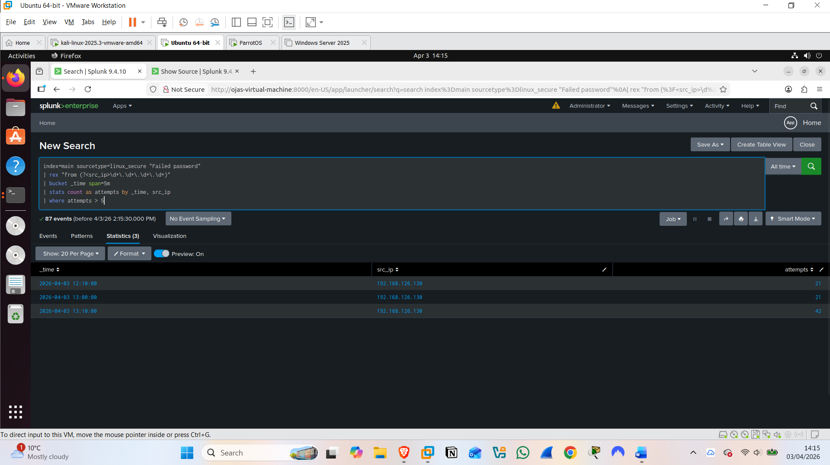
Search 4: Success After Failures (The Dangerous Pattern)
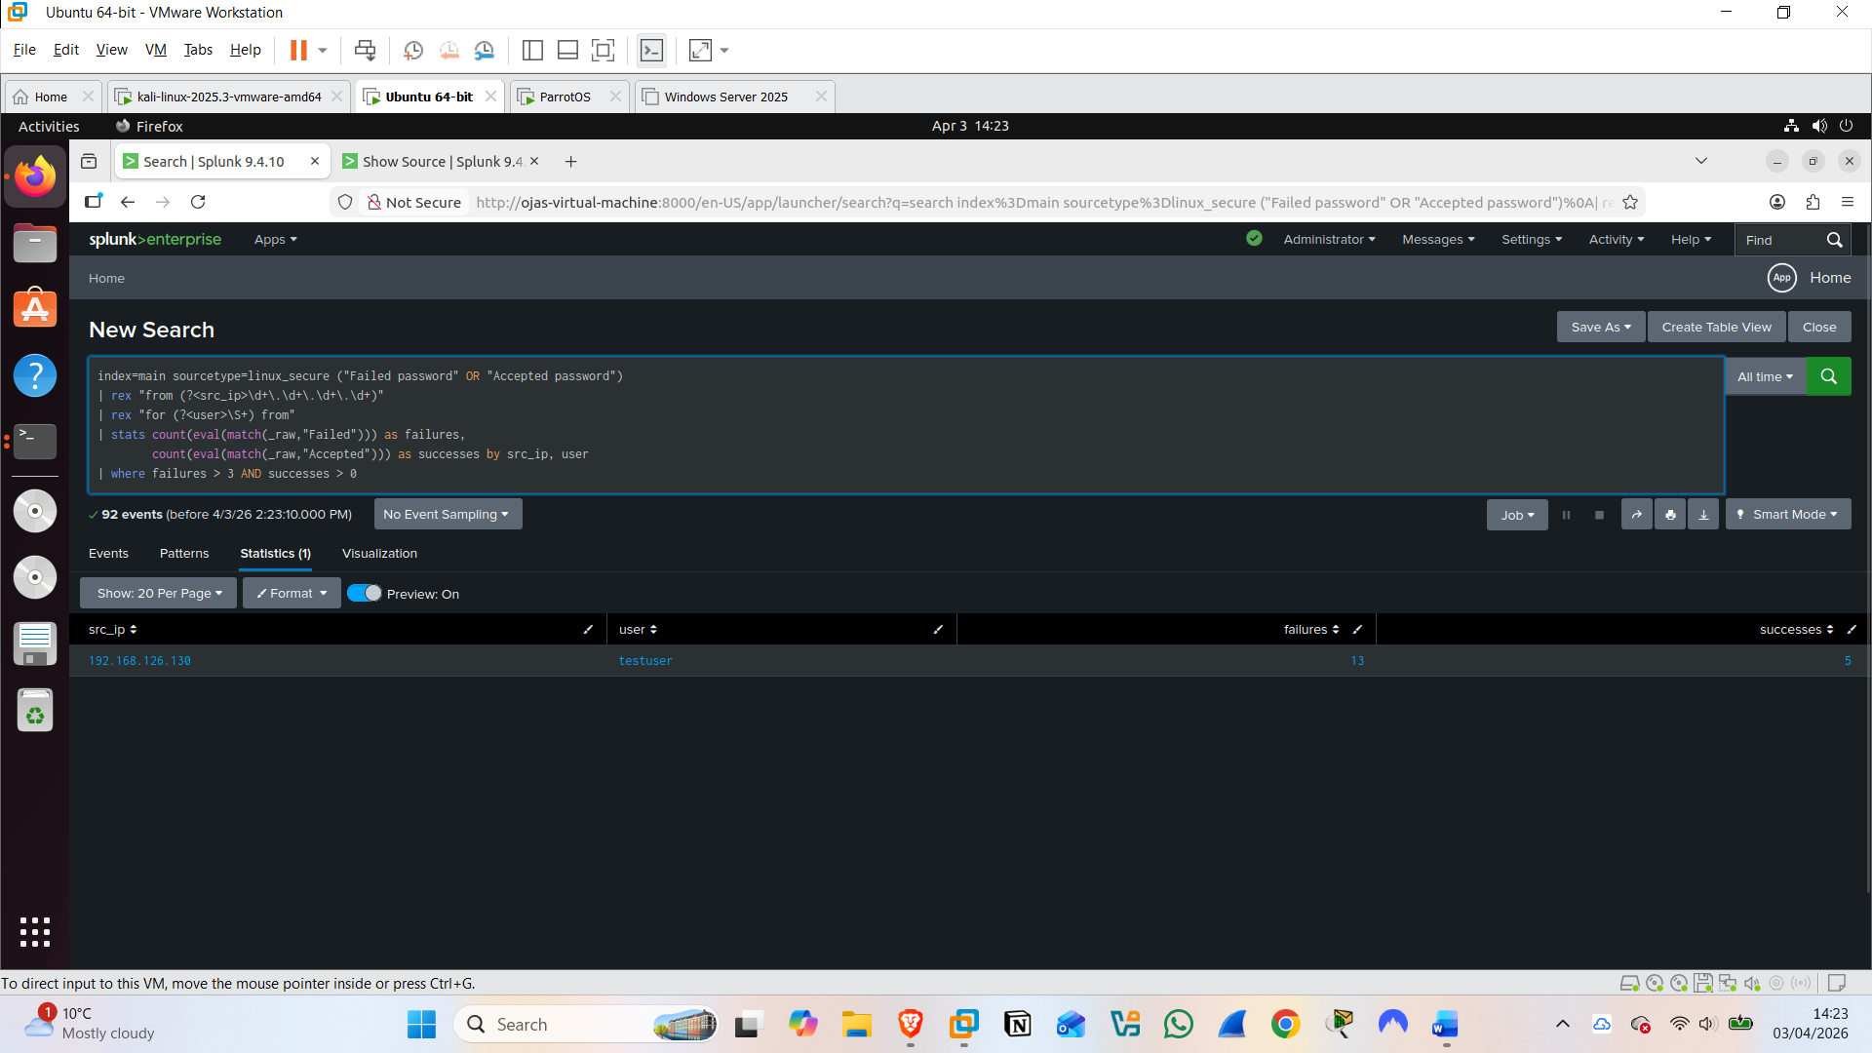

Dashboard:
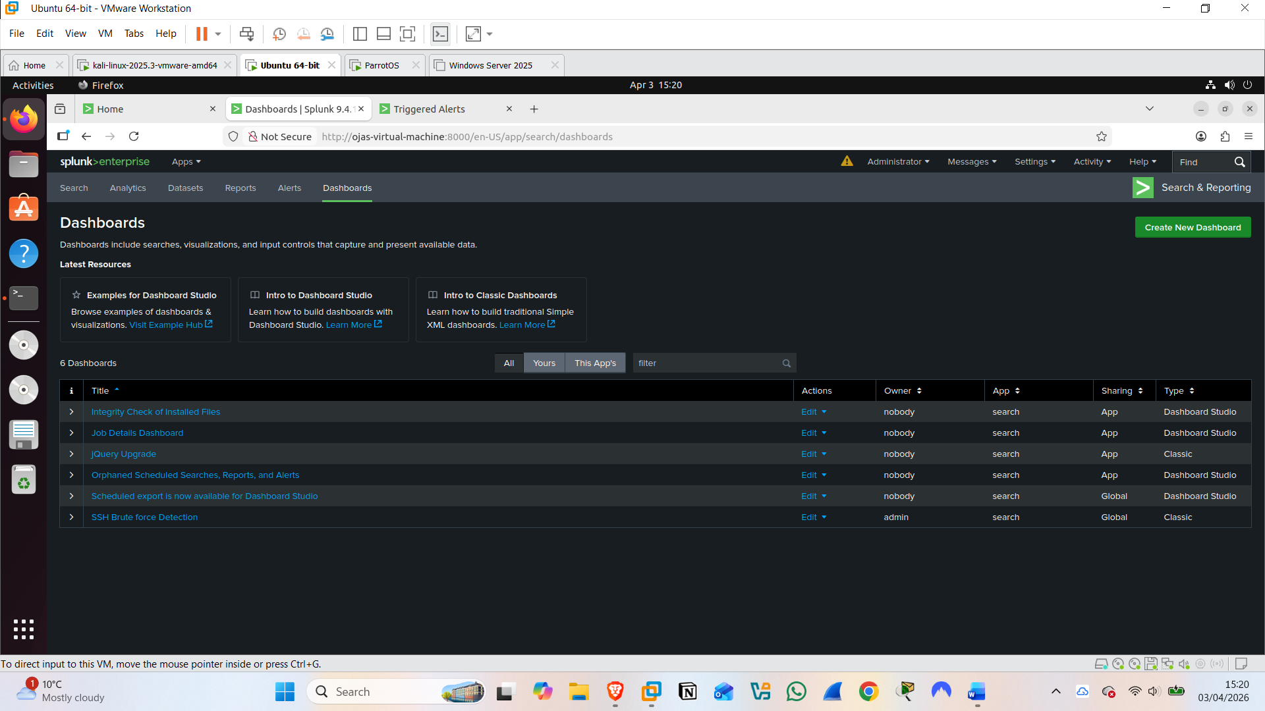
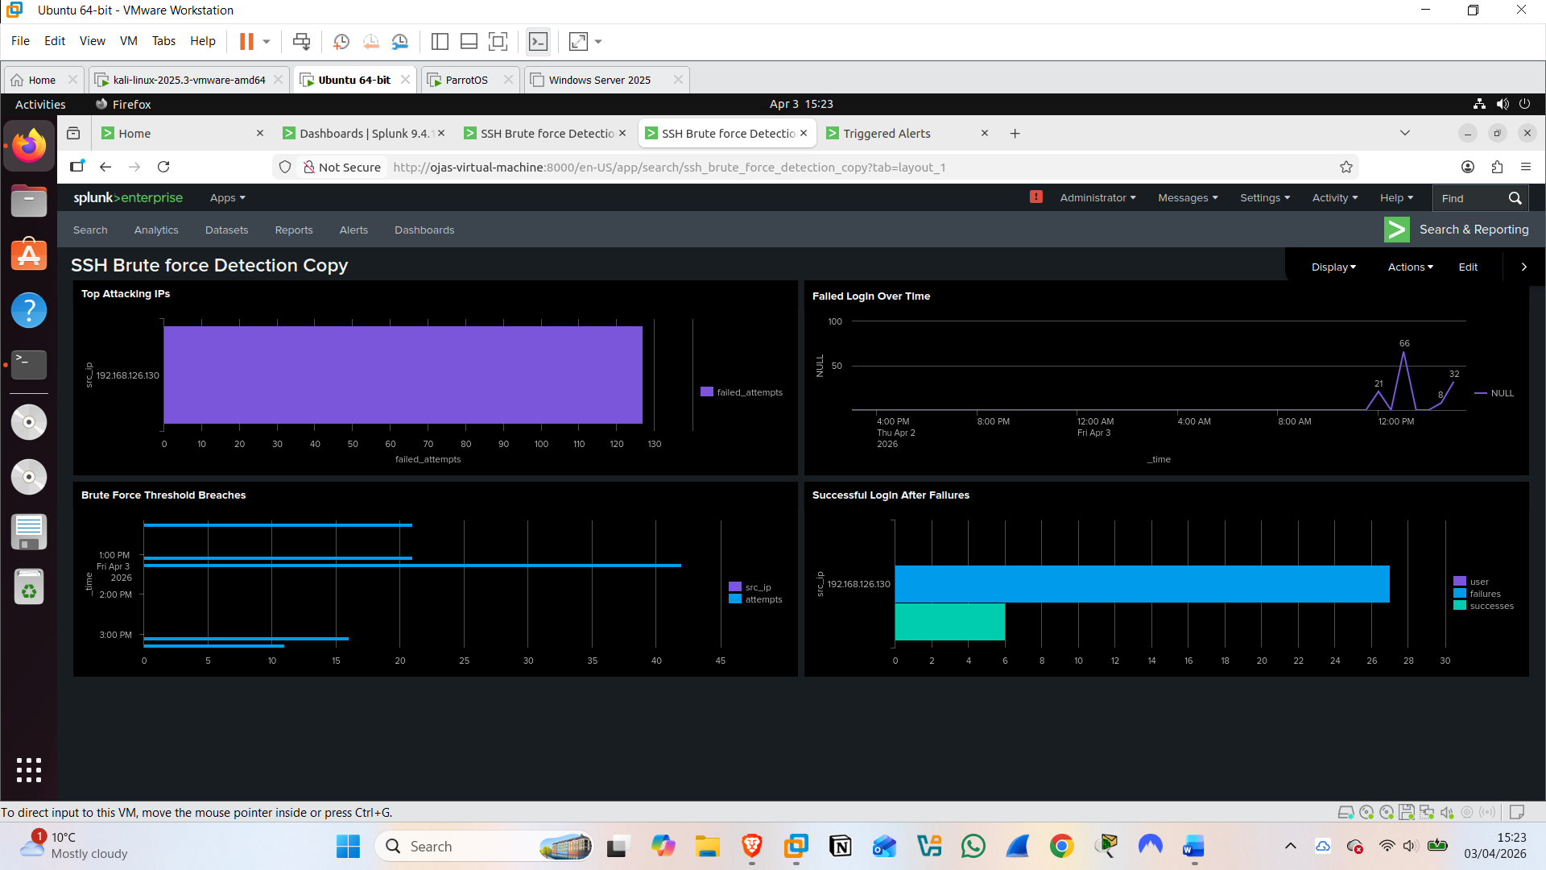

Alert triggered: >5 failure attempts in 5 mins
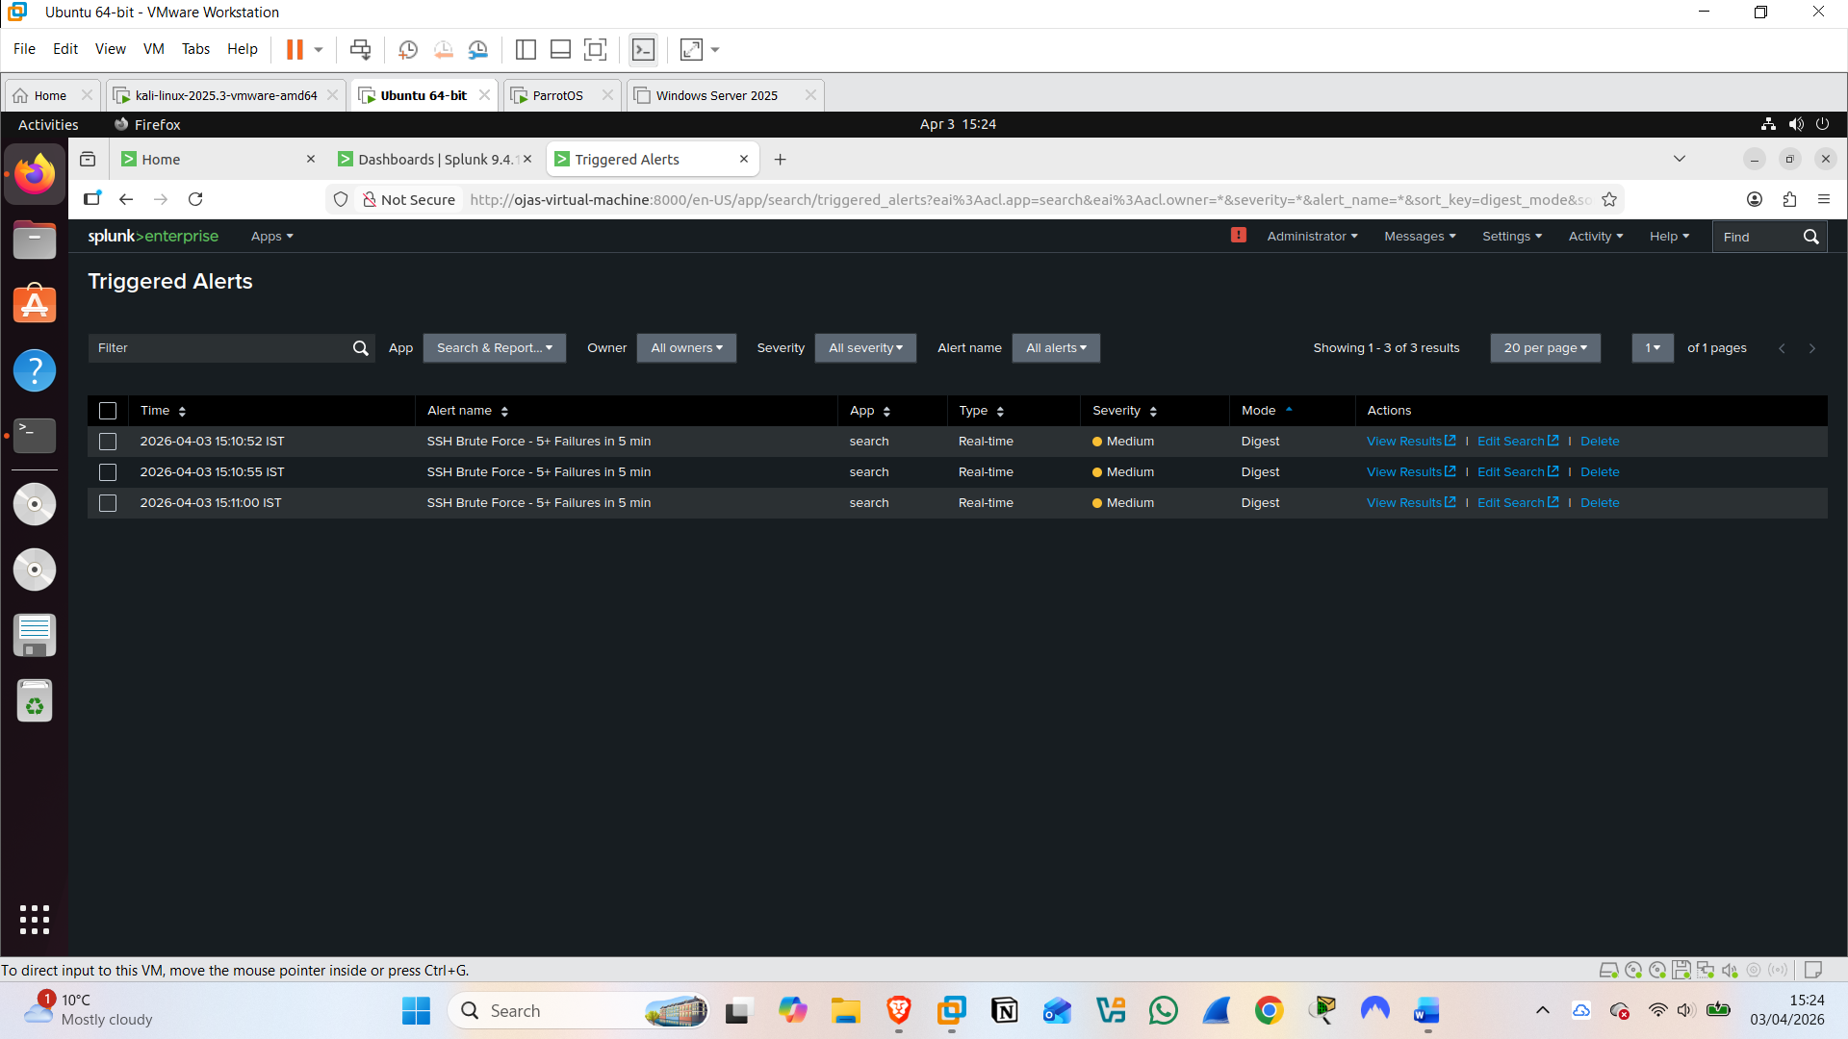
Before attack:
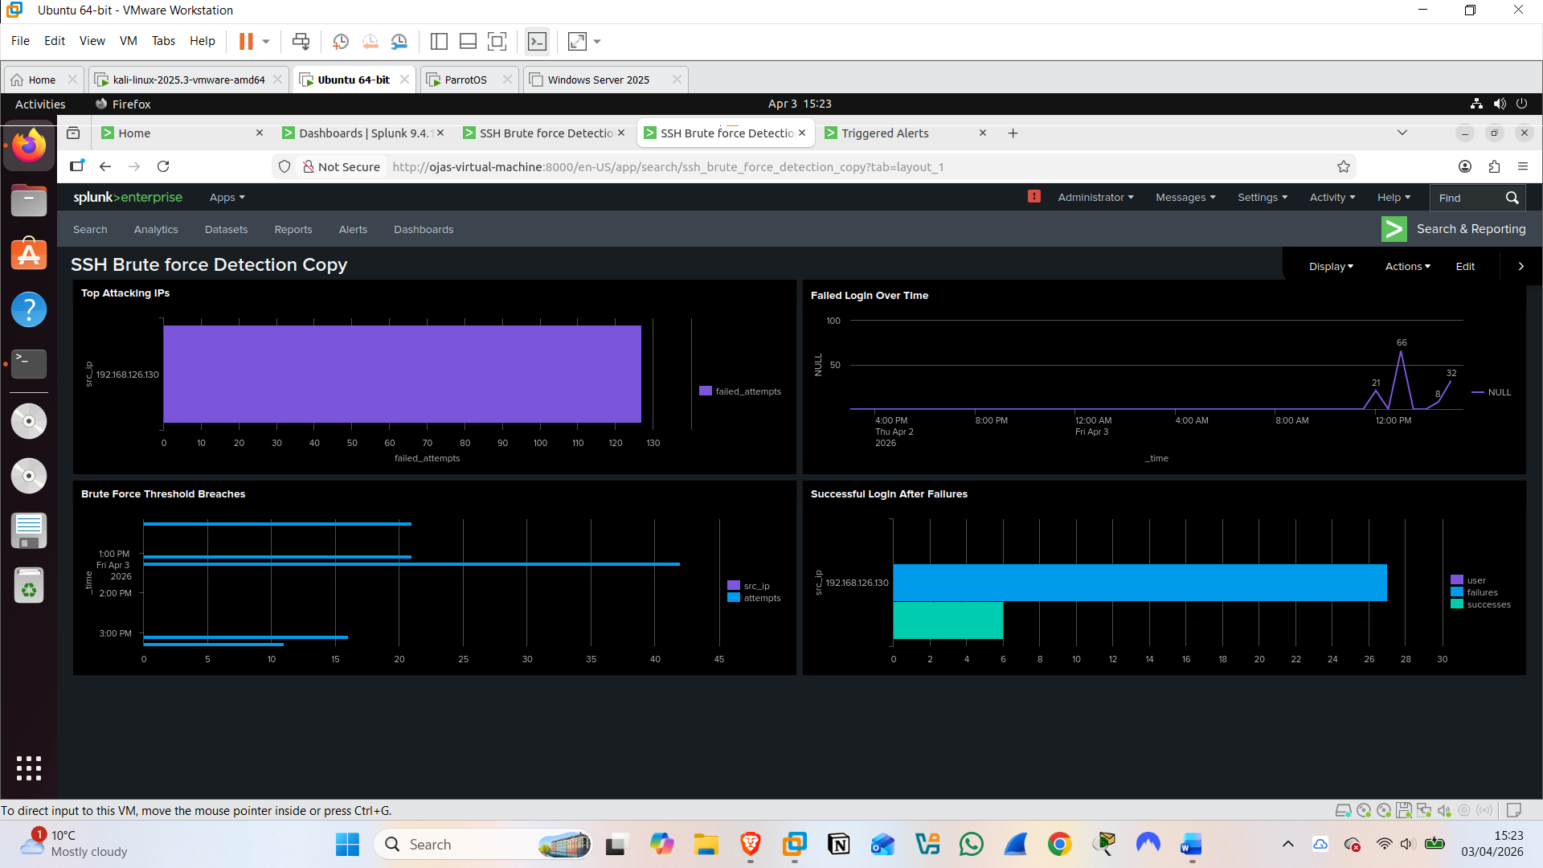

After attack: using hydra -L usernames.txt -P password.txt ssh<ip>-t 20 -v
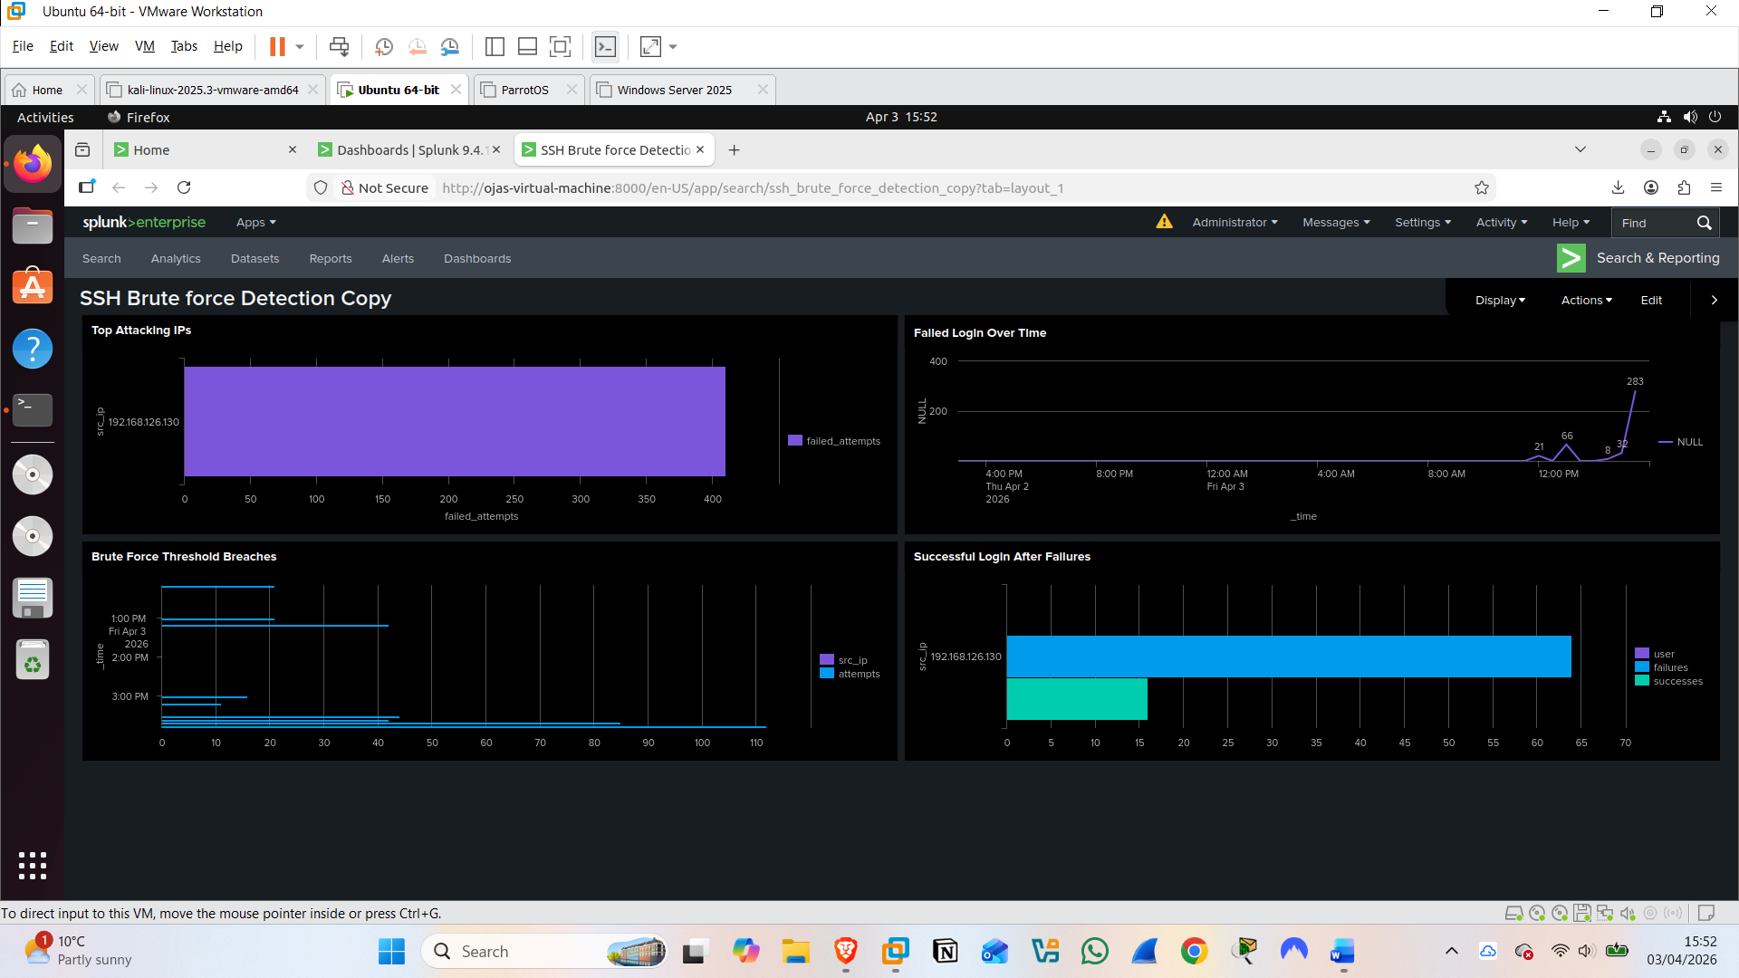
MITRE ATT&CK T1548 — Abuse Elevation Control Mechanism
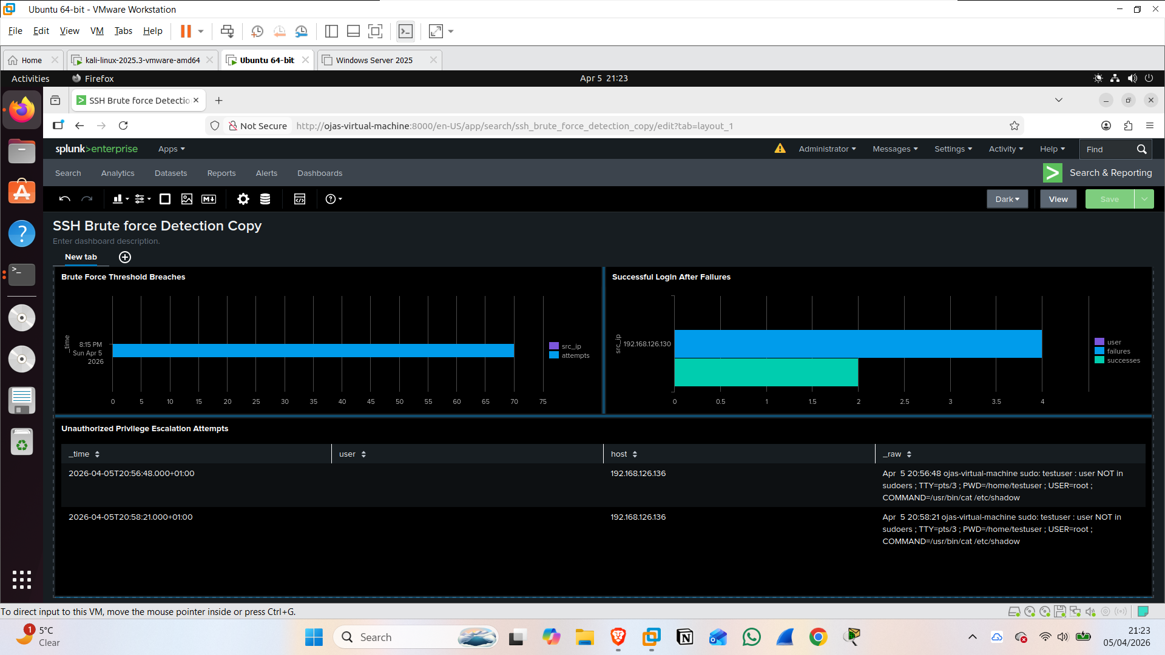

Tool 2: medusa
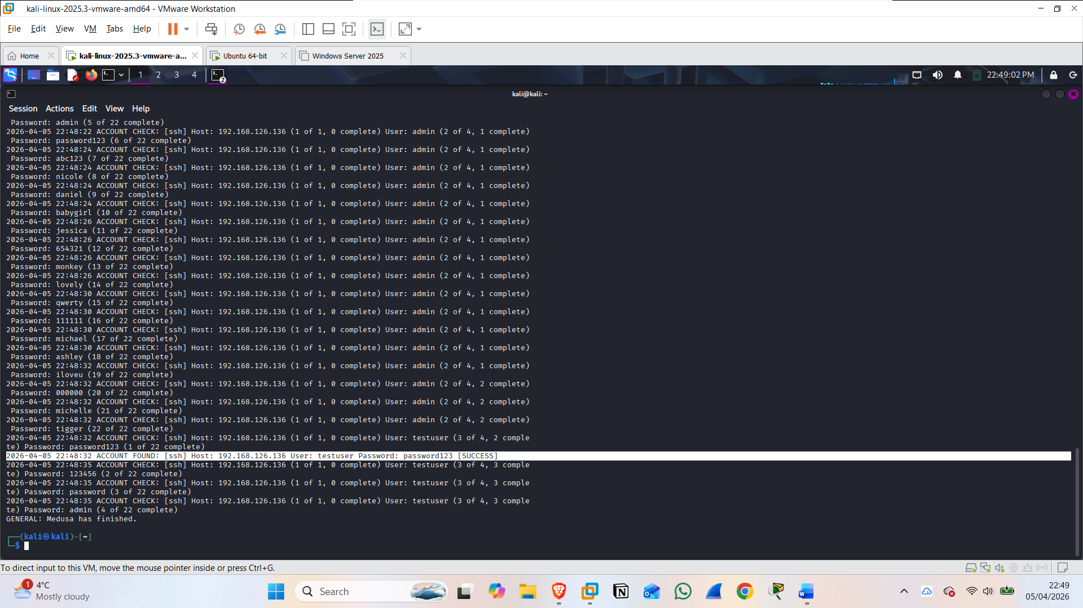

Incident Summary:
- Date/Time of attack:
- Attacker IP:
- Target IP:
- Usernames attempted:
- Total failed attempts:
- Was login successful? Which account?
- Time between first failure and successful login:
- Alert that fired:
- Recommended action: Block src_ip at firewall, disable testuser account

