**Assignment2_OJAS_PHANSEKAR_001826636**

**2)**

**a) Total sales**

**SQL Query:** select sum(Total)as TotalSales from dbo.invoice;

**Input Tables:** dbo.invoice

**Input Columns :** Total

**Output Columns :** TotalSales

**Total Number of Rows in results :** 1

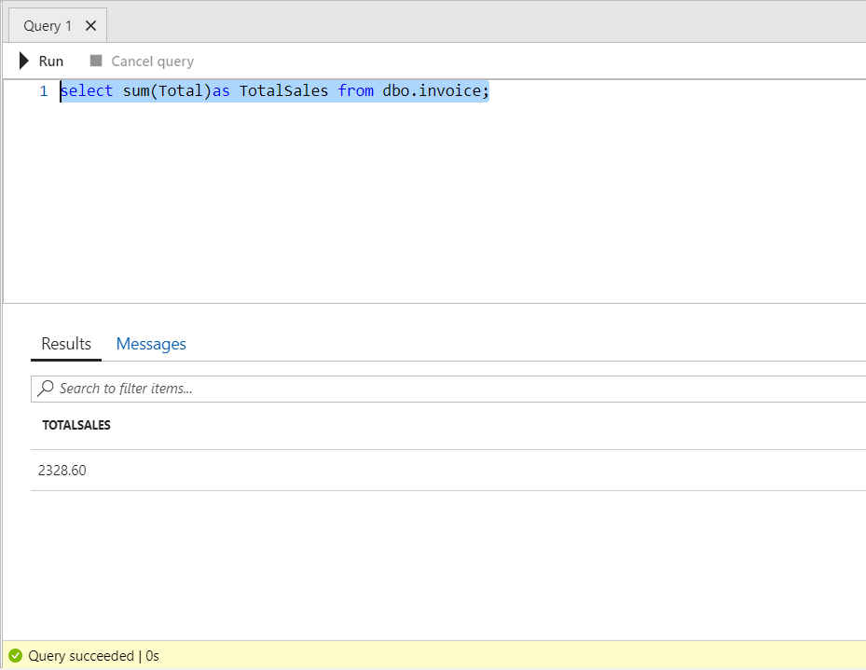

**b) Total Sales by Country – Ranked**

**SQL Query:** select customer.country,sum(Total)as TotalSales from dbo.invoice inner join customer on invoice.CustomerId = customer.CustomerId group by customer.country order by TotalSales DESC;

**Input Tables:** invoice,customer

**Input Columns :** country, Total

**Output Columns :** country,TotalSales

**Total Number of Rows in results :** 24

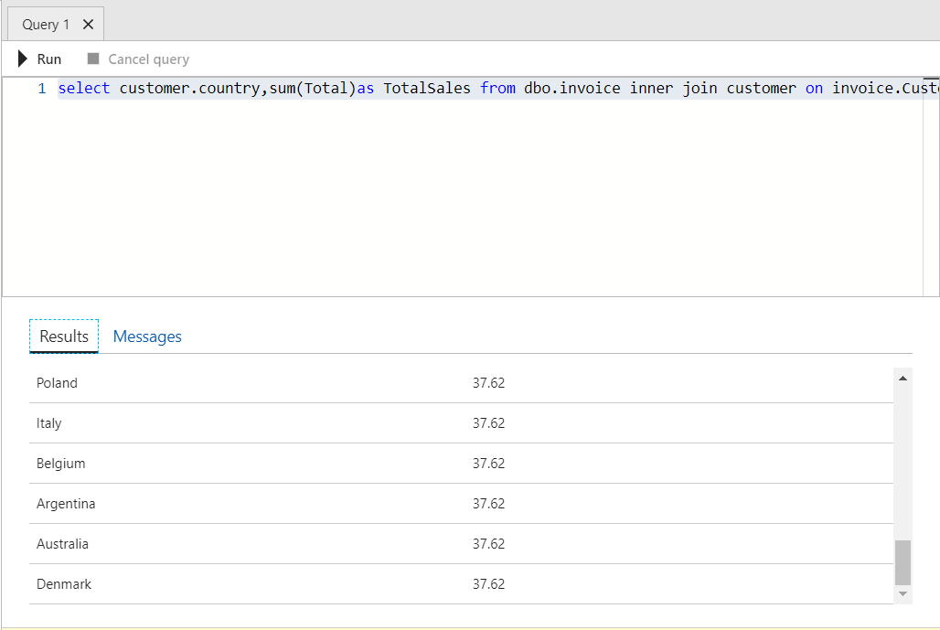

c) Total sales by country,state,city

**SQL Query:** select customer.Country, customer.State , customer.City ,sum(Total)as TotalSales from dbo.invoice inner join customer on invoice.CustomerId = customer.CustomerId group by customer.Country, customer.State , customer.City order by TotalSales DESC;

**Input Tables :** customer, invoice

**Input Columns :** country, state,city,Total

**Output Columns :** country,state,city,TotalSales

**Total Number of Rows in results :** 53

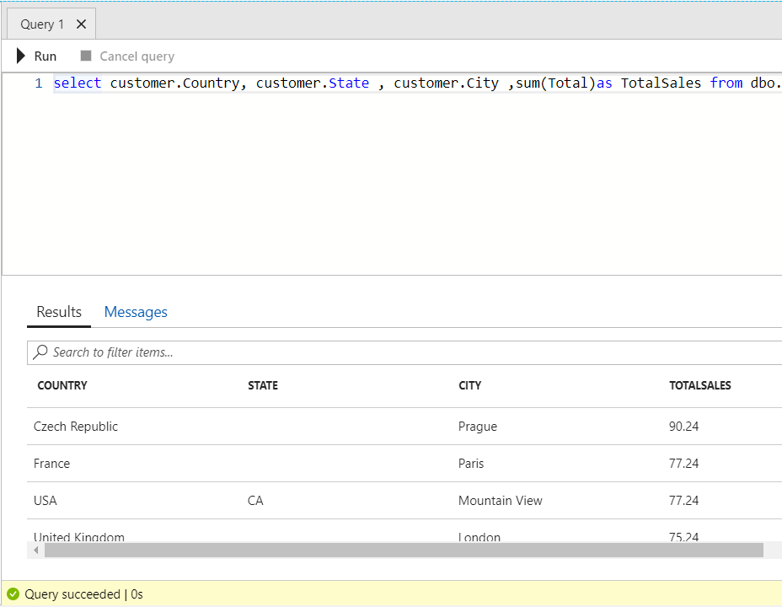

d)Total sales by customer – ranked

**SQL Query:** select (customer.FirstName + SPACE(1) + customer.LastName ) as FullName ,sum(Total)as TotalSales from dbo.invoice inner join customer on invoice.CustomerId = customer.CustomerId group by (customer.FirstName + SPACE(1) + customer.LastName ) order by TotalSales DESC;

**Input Tables:** customer,invoice

**Input Columns :** customer.FirstName,customer.LastName,

**Output Columns :** FullName,TotalSales

**Total Number of Rows in results :** 59

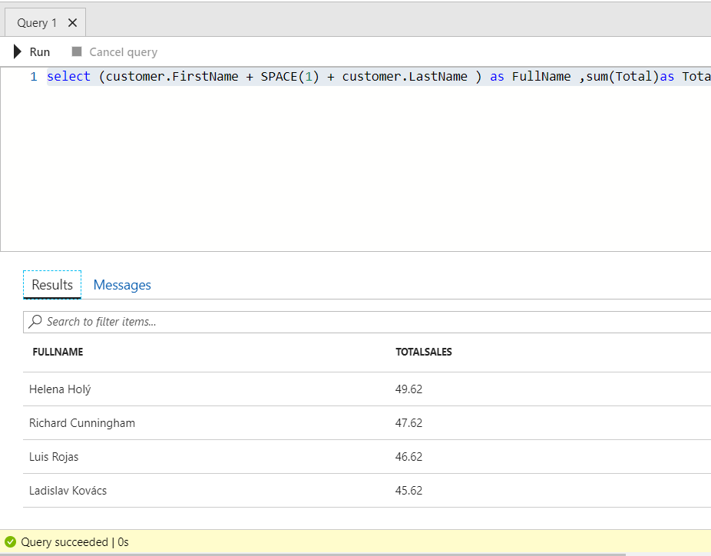

e)Total sales by artist – ranked

**SQL Query:** select artist.Name,sum(invoiceline.Quantity*invoiceline.UnitPrice) as Total_Sales from invoiceline inner join track on invoiceline.TrackId = track.TrackId inner join album on track.AlbumId = album.AlbumId inner join artist on artist.ArtistId = album.ArtistId group by artist.Name order by Total_Sales DESC;

**Input Tables:** artist,invoiceline,album,track

**Input Columns :** artist.Name,invoiceline.Quantity,invoiceline.UnitPrice,invoiceline.TrackId,track,TrackId,track.AlbumId,album.AlbumId,artist.ArtistId,album.ArtistId

**Output Columns :** Name,Total_Sales

**Total Number of Rows in results :** 32

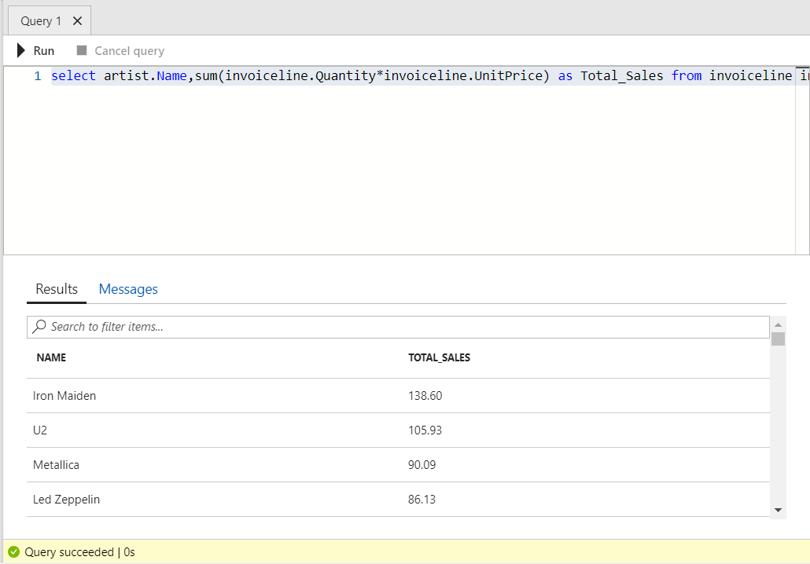

f)Total sales by album – ranked

**SQL Query:** select album.Title,sum(invoiceline.Quantity*invoiceline.UnitPrice) as Total_Sales from invoiceline inner join track on invoiceline.TrackId = track.TrackId inner join album on track.AlbumId = album.AlbumId group by album.Title order by Total_Sales DESC;

**Input Tables:** album,track,invoiceline

**Input Columns :** album.Title,invoiceline.Quantity,invoiceline.UnitPrice,invoiceline.TrackId,track.TrackId,track.AlbumId,album.AlbumId

**Output Columns :** title,Total_Sales

**Total Number of Rows in results :** 303

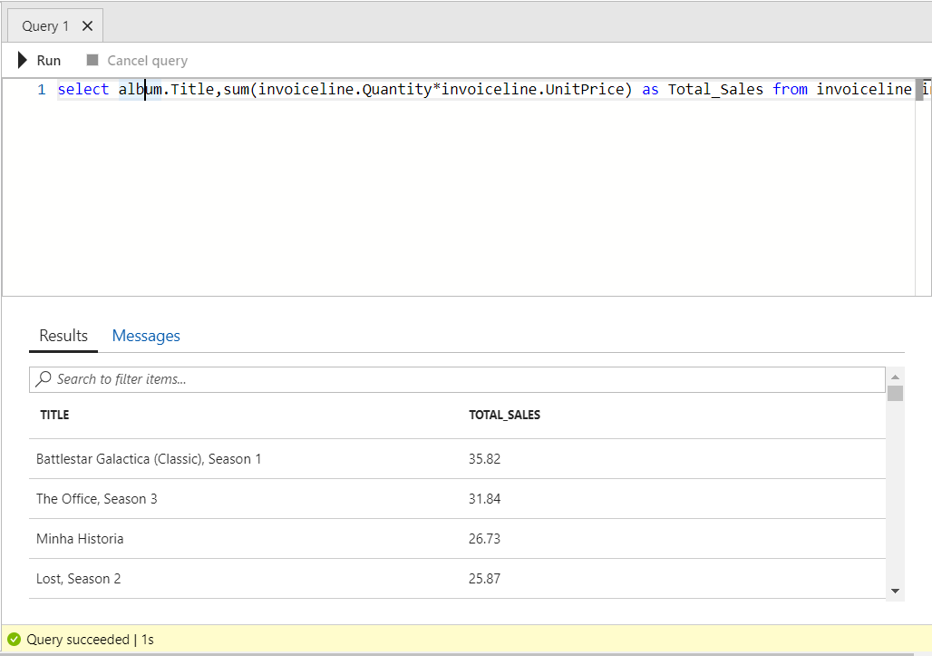

g) **Total** Sales by employee(Sales Person) – ranked

**SQL Query:** select (employee.FirstName + SPACE(1) + employee.LastName ) as FullName ,sum(Total)as TotalSales from dbo.invoice inner join customer on invoice.CustomerId = customer.CustomerId inner join employee on customer.SupportRepId = employee.EmployeeId group by (employee.FirstName + SPACE(1) + employee.LastName ) order by TotalSales DESC;group by productCat.name order by Total_Sales desc;

**Input Tables:** invoice,customer,employee

**Input Columns :** employee.FirstName,employee.LastName,invoice.Total

**Output Columns :** FullName,TotalSales

**Total Number of Rows in results :** 3

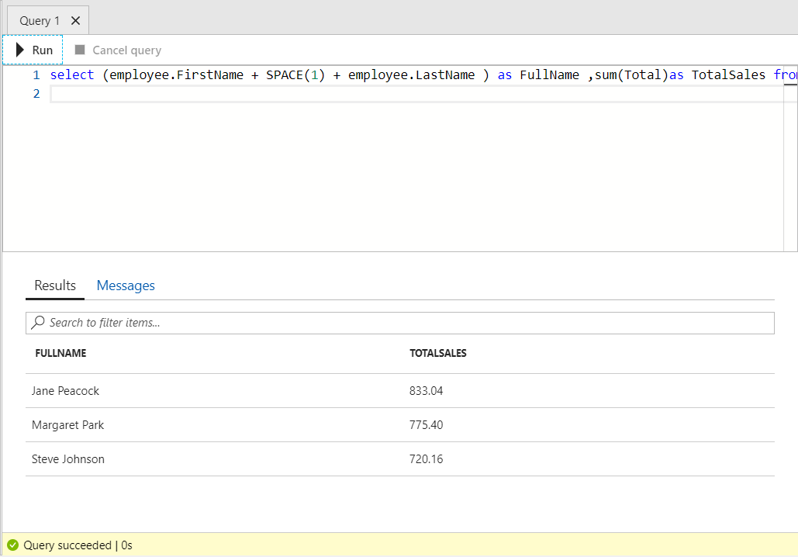

h) **Total Track bought and total revenue by media type**

**SQL Query:** select mediatype.name,count(track.TrackId) as TracksBought, sum(invoiceline.UnitPrice*invoiceline.Quantity) as TotalRevenue from invoiceline inner join track on invoiceline.TrackId = track.TrackId inner join mediatype on track.MediaTypeId = mediatype.MediaTypeId group by mediatype.Name order by TotalRevenue DESC;

**Input Tables:** invoiceline,track,mediatype

**Input Columns :** mediatype.name,track.TrackId,invoiceline.UnitPrice,invoiceline.Quantity

**Output Columns :** name, TRACKSBOUGHT, TOTALREVENUE

**Total Number of Rows in results :** 5

