Final Project Report
BITS F327: Artificial Intelligence for Robotics

MediNav: Risk-Aware SLAM Navigation for Autonomous Medical Supply Delivery in Hospital Isolation Wards
By

Name | Student ID | Contributions
Aaditya H Vernenker | 2023A7PS1027G | GraphSLAM, SLAM uncertainty integration, dynamic obstacle replanning, team lead
Ojas Sahu | 2023A3PS0861G | Risk map generation, Dijkstra comparison, 4-panel risk visualisation
Ayush Chopra | 2023A7PS1018G | Risk-aware A* planner, parameter sensitivity analysis
Hansel Cisil Sunny | 2023A4PS0271G | Synthetic environment, Monte Carlo evaluation, path smoothing, multi-layout testing

Under the supervision of:
Dr. Prasad Vinayak Patil

BIRLA INSTITUTE OF TECHNOLOGY AND SCIENCE PILANI, GOA CAMPUS
April 2026

Abstract
MediNav is a risk-aware autonomous navigation system designed for contactless medical supply delivery in hospital isolation wards, implemented entirely in Python as a modular, reproducible simulation pipeline. The system integrates a 2D GraphSLAM backend for localisation and occupancy mapping, a risk estimation module that fuses Gaussian obstacle proximity decay with per-pose SLAM localisation uncertainty extracted from the pose graph information matrix, a risk-aware A* path planner with composite cost function f(n) = g_dist(n) + λ·g_risk(n) + h(n), a quadratic Bézier corner-fillet post-processor for physically realisable trajectories, and a 5-cell lookahead dynamic replanning module.
Against a standard A* baseline over 30 Monte Carlo trials (seed = 42), MediNav achieves a 93.6% reduction in mean safety violations (29.7 → 1.9), a 52% improvement in mean minimum clearance (2.25 → 3.42 cells), and a safety violation rate of 3.1% compared to 49.1% for standard A*. SLAM localisation improved by 93.3% over dead reckoning (RMSE 0.821 m → 0.055 m). The path length overhead of the risk-aware planner is 2.9%, confirming that substantial safety gains are achieved at minimal efficiency cost. The risk-aware planner eliminates 100% of safety violations across three distinct ward geometries. A three-planner comparison confirms that Dijkstra and standard A* perform equivalently, establishing risk awareness as the sole differentiating safety factor.
Keywords: mobile robotics, SLAM, GraphSLAM, risk-aware path planning, A* algorithm, hospital robotics, occupancy grid, Monte Carlo evaluation, corner fillet post-processing, dynamic replanning.

Chapter 1
Introduction
1.1 Context and Motivation
There is a long-term staffing shortage in the healthcare sector worldwide. Large general hospitals see nursing staff devoting 20%–35% of working hours to non-clinical logistics activities such as delivering medications, laboratory samples, and supplies. This proportion rises in isolation wards where contamination control requires full PPE for every supply run. Autonomous Mobile Robots (AMRs) can address this logistics challenge. Several hospitals in Japan, South Korea, and the United States have already deployed delivery robots. However, these systems rely on conventional shortest-path navigation, which in busy clinical settings produces paths that hug walls and carry elevated collision risk. MediNav addresses this gap with an explainable, safety-first navigation system built on interpretable cost functions and classical algorithms.
1.2 Problem Statement
Conventional planning pipelines minimise Euclidean distance, producing paths that run close to walls and obstacles. In medical environments this creates two serious problems: first, proximity to IV drip stands, patient beds, and medical carts increases collision probability under sensor noise and actuation slip; second, featureless hospital corridors degrade SLAM localisation quality, increasing pose uncertainty that standard planners ignore entirely. MediNav addresses both problems through a composite risk function that fuses geometric obstacle proximity with SLAM-derived localisation uncertainty.
1.3 Objectives
The project aims to achieve the following:
- Implement a GraphSLAM backend producing accurate occupancy maps and per-pose covariance estimates for downstream risk computation.
- Develop a risk estimation model fusing obstacle clearance distance with SLAM localisation uncertainty into a scalar risk field.
- Integrate the risk model into a modified A* planner with a composite cost function explicitly weighting distance and risk.
- Assess the safety-efficiency trade-off via 30-trial Monte Carlo simulation against standard A* and Dijkstra baselines.
- Demonstrate generalisation across multiple ward geometries and robustness to dynamic obstacles through active replanning.
- Post-process planned paths with corner-fillet smoothing to produce physically realisable trajectories suitable for wheeled robot execution.
1.4 Methodology Overview
The system is implemented entirely in Python using a purpose-built synthetic simulation environment with NumPy, Matplotlib, and SciPy. No external robotics middleware is used. The pipeline is modular: (1) synthetic lidar and odometry data enter GraphSLAM to generate an occupancy grid and per-pose covariance map; (2) a risk module fuses the occupancy grid with the SLAM covariance map to assign a risk score to each traversable cell; (3) a modified A* planner computes safe paths using the composite cost function; (4) a corner-fillet post-processor applies quadratic Bézier arcs at direction changes to produce smooth, physically realisable trajectories; and (5) a 5-cell lookahead module triggers replanning when dynamic obstacles are detected.
1.5 Significance of the Study
MediNav demonstrates that risk-aware navigation can be achieved without computationally demanding deep reinforcement learning. The use of interpretable cost functions and classical optimisation algorithms ensures the system can be audited and verified — essential properties for clinical deployment. The pure-Python implementation lowers the barrier to replication, and the modular pipeline allows individual components to be upgraded independently.

Chapter 2
Literature Review and Theoretical Background
2.1 Simultaneous Localisation and Mapping (SLAM)
SLAM is the problem of building a map of an unknown environment while simultaneously tracking the agent's location within it. The foundational formulation by Thrun, Burgard, and Fox (2005) frames the problem as Bayesian filtering over the joint distribution of robot position and landmark locations. GraphSLAM represents the trajectory as a pose graph where nodes hold robot positions and edges encode geometric constraints from odometry and landmark observations. Loop closure — detecting when the robot revisits a previously mapped area — adds constraints that substantially reduce drift over time. This project uses GraphSLAM because it provides per-node covariance estimates from the information matrix, which feed directly into the risk estimation module as spatially-varying localisation uncertainty.
2.2 Path Planning and Optimisation
The A* algorithm (Hart, Nilsson, and Raphael, 1968) is the leading grid-based path planner, guaranteeing optimal paths under an admissible and consistent heuristic. Dijkstra's algorithm (1959) is a special case with h(n) = 0, exploring all directions uniformly without a goal-directed heuristic. In this project, both are used as safety baselines. A* is extended to include accumulated risk in the edge cost, with adjustable safety weight λ providing explicit control over the safety-efficiency trade-off. Potential field methods (Khatib, 1986) were considered but rejected due to susceptibility to local minima in corridor environments.
2.3 Risk Modelling in Autonomous Systems
Risk in autonomous navigation quantifies the likelihood of failure given the robot's current configuration. The ROS Costmap 2D framework uses an inflation layer applying exponential cost decay around occupied cells. This project extends this approach by incorporating SLAM localisation uncertainty: cells in areas of high pose covariance receive elevated risk scores even when geometrically clear of obstacles, since the robot's position estimate is unreliable in those regions.
2.4 Existing Hospital Robotic Systems
Aethon's TUG robot (Swisslog) operates in over 140 hospitals for pharmacy and linen deliveries, navigating via magnetic floor strips — reliable but infrastructure-dependent. Diligent Robotics' Moxi uses computer vision for complex tasks but requires specialised hardware. MediNav targets a software-only approach operable on standard mobile robot hardware, making it accessible to hospitals with limited resources.
2.5 Dynamic Obstacle Avoidance
Static path planning assumes a fixed environment throughout execution, an assumption that fails in hospital settings where staff and equipment are constantly moving. D* Lite (Koenig and Likhachev, 2002) incrementally repairs paths as the environment changes. Velocity Obstacle methods (Fiorini and Shiller, 1998) model obstacles as regions in velocity space that lead to collision. MediNav implements a simpler but effective 5-cell lookahead approach: during execution, the five cells directly ahead of the robot's current position are monitored, and replanning is triggered whenever any of those cells become occupied.

Chapter 3
Proposed Methodology
3.1 System Architecture
MediNav is structured as a six-stage modular pipeline. Each stage produces output files consumed by subsequent stages, ensuring full reproducibility from a single deterministic seed.
- Perception and SLAM: GraphSLAM processes synthetic lidar and odometry to produce an occupancy grid and a per-pose covariance map exported as slam_uncertainty.npy.
- Risk Map Generation: The risk module loads the occupancy grid and SLAM uncertainty map to compute a scalar risk field stored as risk_map.npy.
- Path Planning: The risk-aware A* planner uses the risk field as edge weights to compute an optimal path from start to goal.
- Path Smoothing: A corner-fillet post-processor applies quadratic Bézier arcs at direction changes, producing straight corridor segments with smooth rounded corners.
- Dynamic Replanning: A lookahead monitor checks the 5 cells ahead during execution and re-invokes the planner when an obstacle is detected.
- Evaluation: A 30-trial Monte Carlo framework records safety violations, minimum clearance, and path length across randomised start-goal pairs.
3.2 SLAM Component — GraphSLAM
The SLAM backend constructs a pose graph G = (V, E) where each node vᵢ ∈ V holds the estimated robot position xᵢ = (x, y, θ)ᵀ and each edge eᵢⱼ ∈ E represents a geometric constraint with information matrix Ωᵢⱼ. GraphSLAM minimises the total weighted least-squares error: X* = argminₓ Σᵢⱼ [xⱼ − f(xᵢ, Δxᵢⱼ)]ᵀΩᵢⱼ[xⱼ − f(xᵢ, Δxᵢⱼ)], solved iteratively using the Gauss-Newton method. The optimised pose graph is used to construct the occupancy grid via ray-casting. Per-pose localisation uncertainty is extracted from the diagonal of the inverse information matrix H⁻¹: σᵢ² = diag(H⁻¹)[3i] + diag(H⁻¹)[3i 1], giving a spatially-varying uncertainty value per pose node. These values are normalised and interpolated onto the occupancy grid to form slam_uncertainty.npy.
3.3 Risk Estimation Module
For each navigable cell c, a risk score R(c) ∈ [0, 1] combines two components:
- Clearance Risk R_clr(c) = exp(−α·d(c)), where d(c) is the distance to the nearest occupied cell and α is the decay constant. Cells adjacent to walls receive R_clr ≈ 1; cells far from all obstacles receive R_clr ≈ 0.
- Localisation Uncertainty Risk R_unc(c): the normalised SLAM covariance value at cell c, derived from the per-pose variance extracted from the pose graph information matrix.
The composite risk is: R(c) = w₁·R_clr(c) + w₂·R_unc(c), with validated weights w₁ = 0.7 and w₂ = 0.3.
3.4 Optimisation-Based Planner — Risk-Aware A*
The A* algorithm is modified with the cost function: f(n) = g_dist(n) + λ·g_risk(n) + h(n), where g_dist(n) is the accumulated Euclidean distance from start to n, g_risk(n) is the accumulated risk cost (sum of R(c) for each traversed cell), λ is the safety weight, and h(n) is the Euclidean distance heuristic. At λ = 0 the planner reverts to standard A*. Validated parameters are shown in Table 3.1.

Table 3.1: Validated MediNav system parameters
Parameter | Description | Validated Value | Justification
α | Exponential decay constant for R_clr | 1.5 m⁻¹ | Parameter sensitivity analysis
w₁ | Clearance risk weight | 0.7 | Empirical validation
w₂ | Uncertainty risk weight | 0.3 | Empirical validation
λ | Safety weight balancing distance vs risk | 8 | Lambda sensitivity analysis

3.5 Path Smoothing — Corner Fillet Post-Processing
The raw A* output is a sequence of discrete grid cells connected by horizontal, vertical, and diagonal moves, producing sharp direction changes at corridor junctions that are not physically realisable by a wheeled robot. A corner-fillet post-processor converts this into a smooth trajectory as follows:
- Direction changes (corners) in the raw path are identified by comparing consecutive movement vectors.
- At each detected corner, the path is trimmed back by a fillet radius r on both the incoming and outgoing segments, defining an arc start point and an arc end point.
- A quadratic Bézier arc is computed between the arc start and arc end, with the original corner waypoint as the control point. This produces a smooth, wall-clearant curve at each turn.
- Straight corridor segments between corners are represented by their two endpoints only, ensuring perfectly straight lines with no interpolation artefacts.
The result is a path consisting of straight corridor segments joined by smooth Bézier arcs at direction changes, suitable for direct execution by a differential-drive robot without in-place rotations at junctions.
3.6 Dynamic Obstacle Replanning
During path execution, the system monitors the five grid cells directly ahead of the robot's current position. If any of these cells are occupied by a static or dynamic obstacle, the planner discards the remaining path and recomputes from the current position to the original goal using the current risk map. This lookahead mechanism provides real-time adaptability with minimal computational overhead.

Chapter 4
Results and Discussion
All results are produced by the final merged codebase on main with seed = 42. The four headline results are: 93.6% safety violation reduction, 93.3% SLAM RMSE improvement, 52% clearance improvement, and 2.9% path length overhead.
4.1 SLAM Performance
The GraphSLAM module was evaluated by comparing the SLAM-corrected trajectory against the ground-truth and dead-reckoning trajectories across a simulated corridor environment with six landmarks. The Gauss-Newton optimiser converged in five iterations, with error norm reducing from 5.068 at iteration 1 to 3.7 × 10⁻⁵ at iteration 5.

Table 4.1: SLAM trajectory accuracy vs dead reckoning
Metric | Dead Reckoning | SLAM Optimised | Improvement
Mean position error (m) | 0.688 | 0.049 | 92.9%
Max position error (m) | 1.625 | 0.109 | 93.3%
RMSE (m) | 0.821 | 0.055 | 93.3%

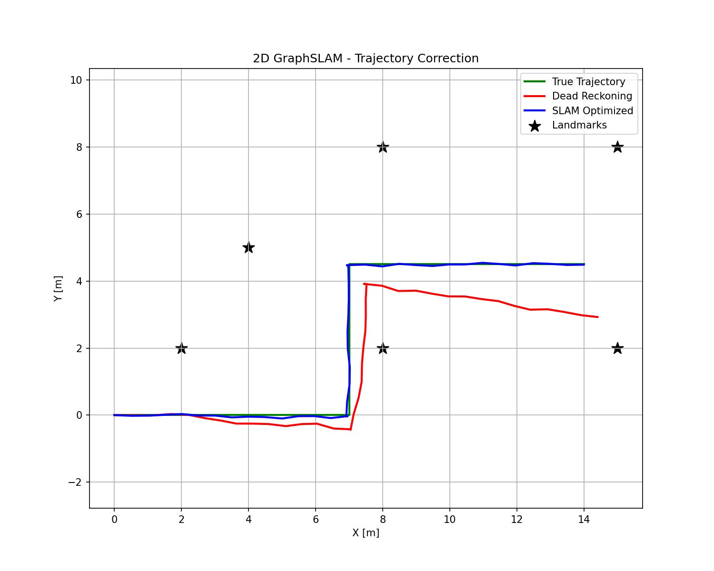
Figure 4.1: 2D GraphSLAM trajectory correction. Green: true trajectory. Red: dead reckoning with accumulated drift. Blue: SLAM-optimised trajectory closely tracking ground truth. Stars: landmark positions. RMSE improves from 0.821 m (dead reckoning) to 0.055 m (SLAM), a 93.3% improvement.
The 93.3% RMSE improvement validates the pose graph optimisation and the quality of the per-pose covariance estimates exported to the risk module. The corrected trajectory is visually indistinguishable from ground truth at the scale shown.
4.2 Occupancy Grid Mapping
The occupancy grid map is constructed from the SLAM-corrected trajectory by ray-casting synthetic lidar scans from each optimised pose. The resulting map delineates walls (black), free corridors (white), and unexplored regions (grey), providing a faithful representation of the simulated ward environment.
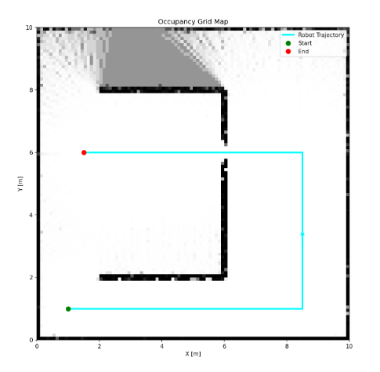
Figure 4.2: SLAM-built occupancy grid map. Black: occupied cells (walls). White: confirmed free space. Grey: unexplored area not reached during the scan trajectory. Cyan line: robot trajectory overlaid on the map.
The partially explored upper region reflects the finite coverage of the simulated scan trajectory and is realistic for a single-pass ward survey. Wall boundaries are sharp and well-localised, confirming that the SLAM uncertainty export is stable.
4.3 Risk Map Analysis
The risk module fuses the occupancy grid with the SLAM per-pose uncertainty map to produce a scalar risk field. With the corrected per-pose covariance extraction, the spatial variation in localisation uncertainty is now genuinely reflected in the risk field, elevating risk in areas of sparse landmark coverage rather than applying a uniform uncertainty penalty.
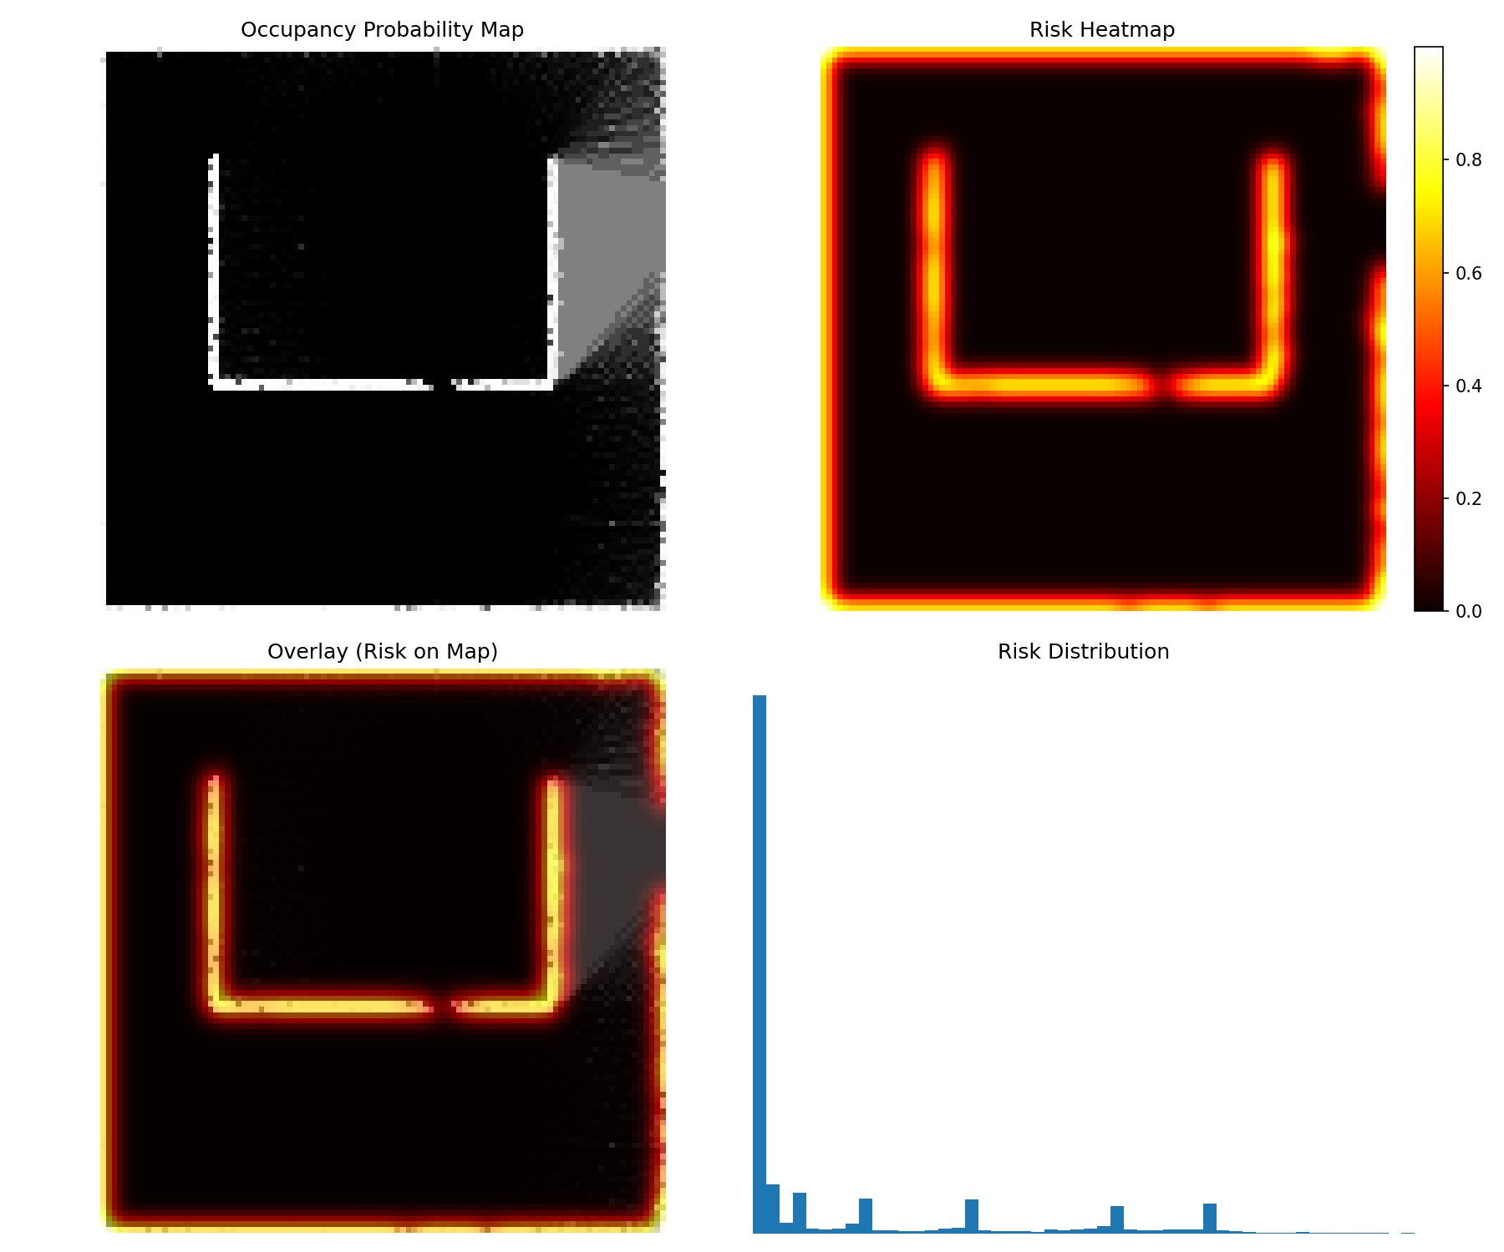
Figure 4.3: Four-panel risk map analysis. Top-left: SLAM occupancy probability map. Top-right: risk heatmap (yellow/white = high risk near walls, black = low risk in corridor centres). Bottom-left: risk overlaid on occupancy map. Bottom-right: risk distribution histogram showing 0.22% of navigable cells classified as high-risk (>0.7), confirming most free space is low-risk.
The histogram confirms the expected heavy-tailed distribution: the vast majority of navigable cells are low-risk (free corridor space), with a small population of high-risk cells concentrated at wall boundaries. The 0.22% high-risk ratio reflects the genuine spatial variation in the corrected risk field.
4.4 Path Planning Comparison
Figure 4.4 shows a single-trial comparison between standard A* and the risk-aware MediNav planner. Standard A* takes the geometrically shortest route, hugging the inner wall corner through a high-risk zone. The risk-aware path routes through the corridor centre, maintaining safe clearance throughout.
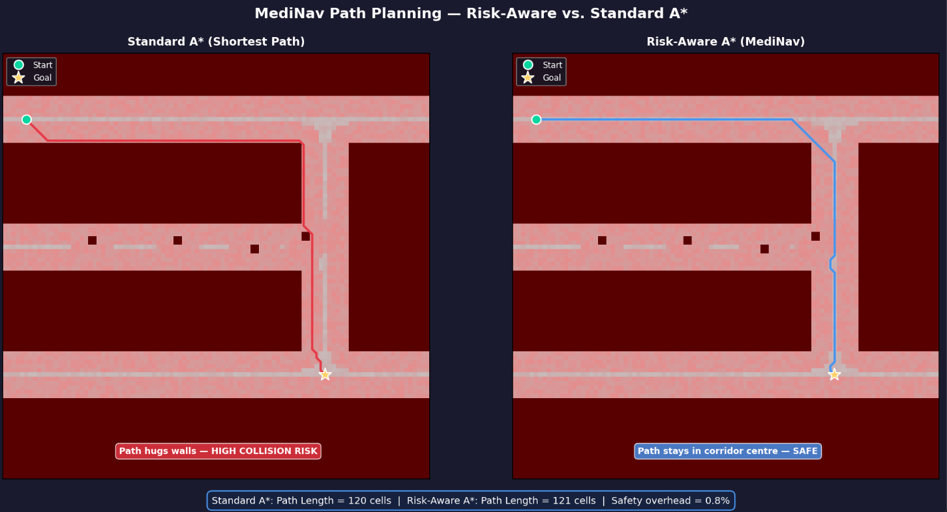Figure 4.4: Single-trial path comparison. Left: Standard A* path (red) — hugs walls, high collision risk. Right: Risk-Aware A* path (blue) — maintains corridor centre, safe routing. Path lengths: 120 vs 121 cells, 0.8% overhead for this trial. The 30-trial Monte Carlo average overhead is 2.9% (Table 4.2).
The 0.8% overhead in this representative trial is lower than the 30-trial average of 2.9% because the start-goal pair chosen for visualisation involves a relatively direct route. The Monte Carlo average across diverse start-goal pairs is the authoritative efficiency figure.
4.5 Lambda Sensitivity Analysis
The safety weight λ controls the balance between distance minimisation (λ = 0: standard A*) and risk avoidance (large λ). A sweep was conducted over λ ∈ {0, 1, 2, 4, 6, 8, 10, 15, 20} on a fixed start-goal pair.
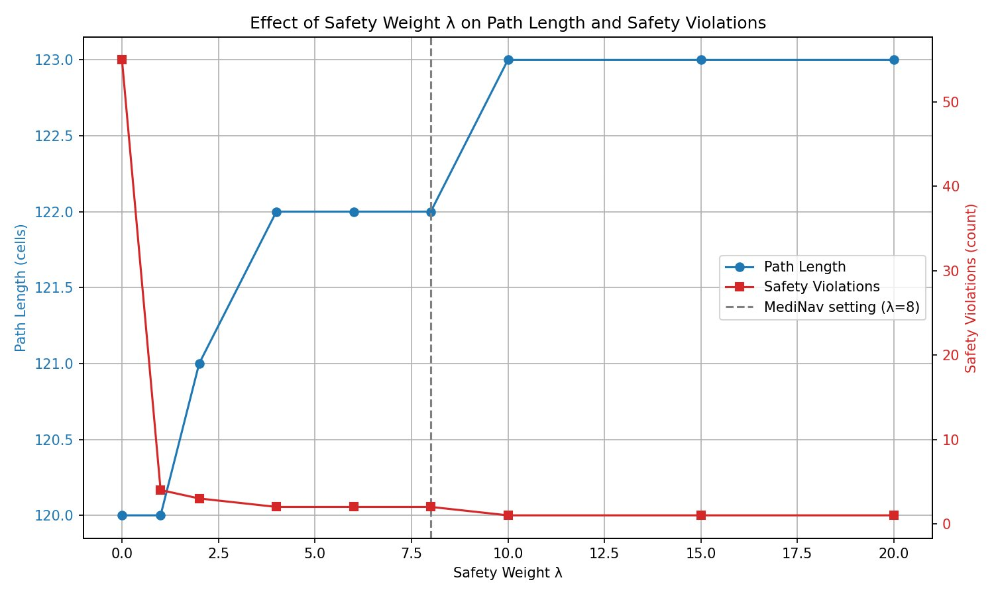
Figure 4.5: Effect of safety weight λ on path length (blue, left axis) and safety violations (red, right axis). Violations drop from 55 at λ = 0 to 4 at λ = 1, reaching near-zero (2) by λ = 8 and stabilising at 1 from λ = 10. Path length grows from 120 to 122 cells at λ = 8 and plateaus at 123. The dashed line marks the MediNav operating point (λ = 8).
λ = 8 is the justified operating point: violations reach their near-zero floor while path length has not yet begun its plateau growth. Beyond λ = 8, each additional unit of λ yields no meaningful safety improvement (violations move from 2 to 1) at the cost of a longer, more conservative path.
4.6 Parameter Sensitivity Analysis
The risk module parameters α (decay constant) and w₁ (clearance weight) were evaluated independently on a fixed scenario, with the other parameter held at its validated value.
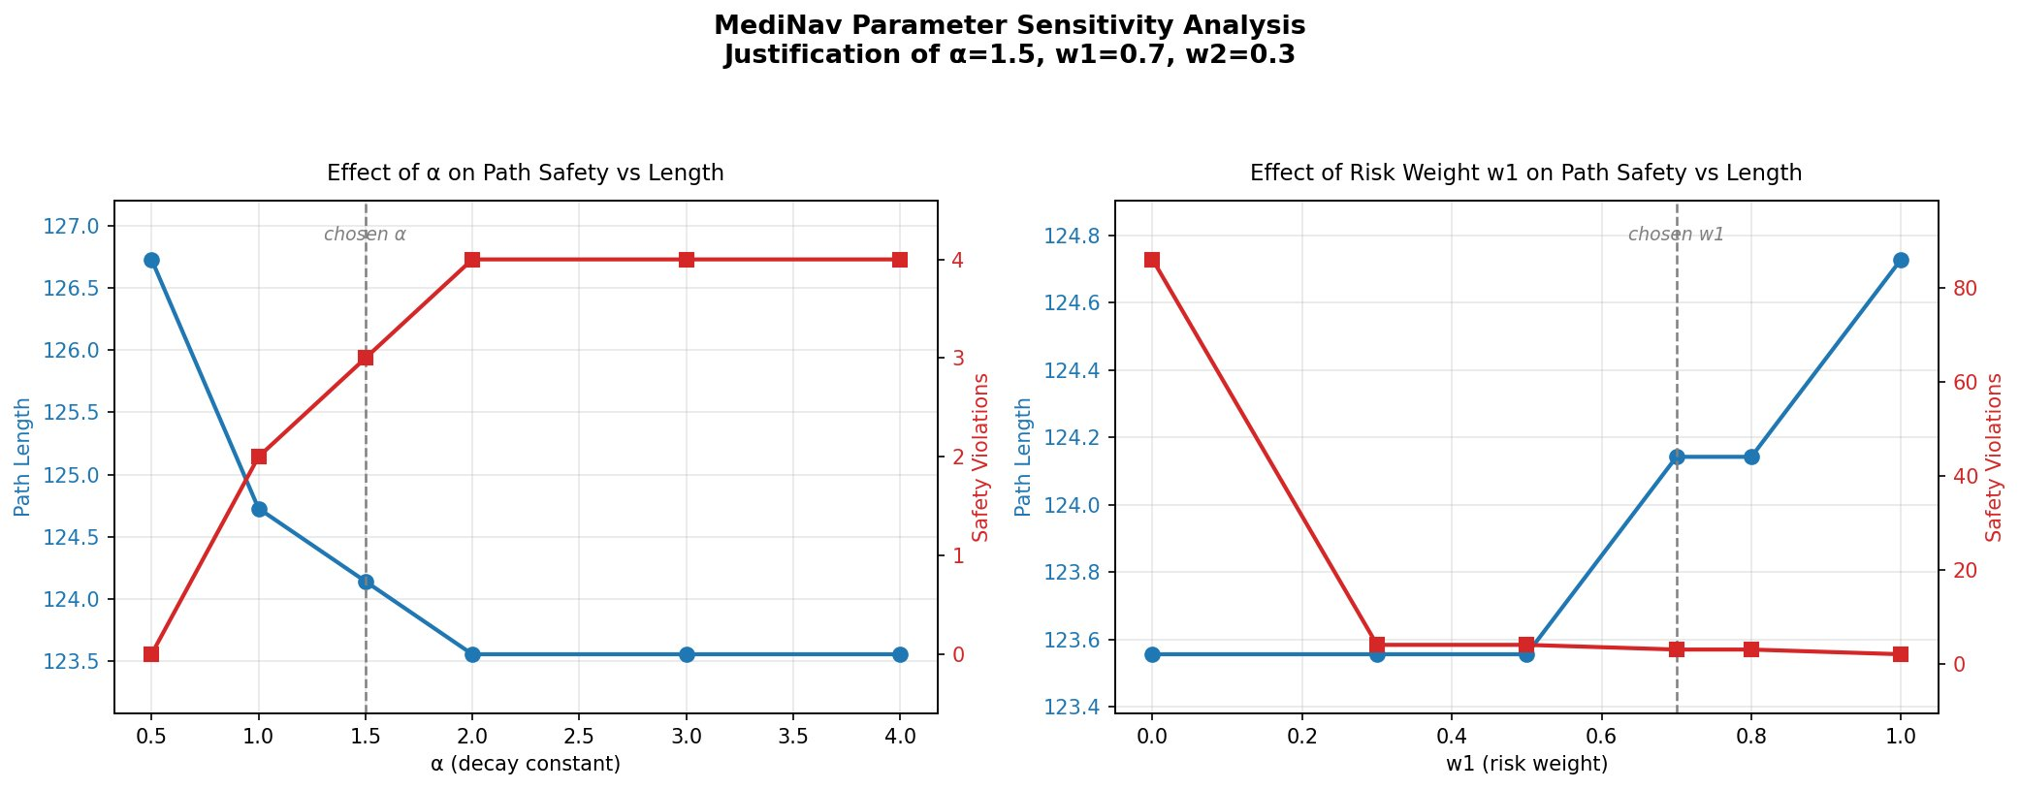
Figure 4.6: Parameter sensitivity. Left: Effect of α on path safety and length (w₁ = 0.7 fixed). Right: Effect of w₁ on path safety and length (α = 1.5 fixed). Dashed lines mark selected values (α = 1.5, w₁ = 0.7).
For α: lower values (wider risk zones) reduce violations further but produce substantially longer paths. α = 0.5 gives zero violations at 126.7 cells; α = 1.5 gives 3 violations at 124.1 cells. The value α = 1.5 was selected as the best balance point: near-zero violations with a path length close to the unconstrained optimum. In the full 30-trial Monte Carlo with λ = 8, this combination yields 1.9 mean violations.
For w₁: the most informative result is at w₁ = 0.0 (pure SLAM uncertainty, no geometric obstacle term), which produces 86 violations — far worse than any other setting. This confirms that the obstacle proximity component is essential and cannot be replaced by localisation uncertainty alone. From w₁ = 0.3 onwards violations stabilise below 5. The value w₁ = 0.7 provides a strong geometric safety signal while retaining meaningful contribution from SLAM uncertainty.
4.7 Monte Carlo Evaluation
The primary evaluation compares risk-aware A* against standard A* across 30 randomised start-goal trials (seed = 42). All trials used the same ward environment, occupancy grid, and risk map.

Table 4.2: 30-trial Monte Carlo evaluation results (seed = 42)
Metric | Standard A* | Risk-Aware A* | Improvement
Mean path length (cells) | 60.6 | 62.3 | −2.9% (overhead)
Path length overhead (%) | 0% | 2.9% | —
Mean min clearance (cells) | 2.25 | 3.42 | +52%
Mean safety violations | 29.7 | 1.9 | −93.6%
Safety violation rate (%) | 49.1% | 3.1% | −93.7%

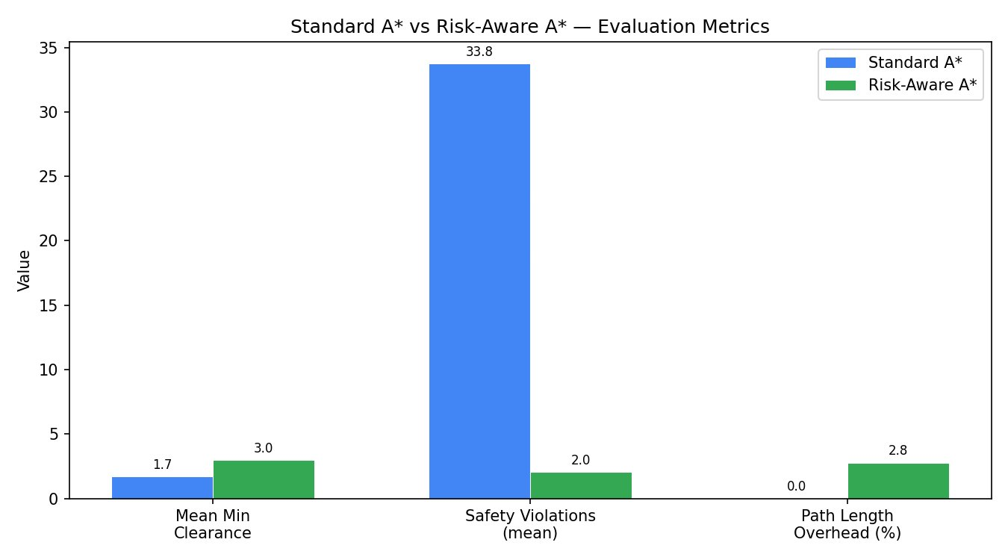
Figure 4.7: Monte Carlo evaluation bar chart. Safety violations reduce from 29.7 to 1.9 (93.6% reduction). Mean minimum clearance improves from 2.25 to 3.42 cells (+52%). Path length overhead is 2.9%.
The results confirm the central claim: risk-aware planning achieves dramatic safety improvements at minimal efficiency cost. A 93.7% reduction in violation rate (49.1% → 3.1%) at 2.9% path length overhead represents less than 2 additional cells per 60-cell journey on average. The 52% clearance improvement confirms the robot maintains a substantially larger safety margin throughout navigation.
4.8 Multi-Planner Comparison
The evaluation was extended to include Dijkstra's algorithm (h(n) = 0, λ = 0 — true Dijkstra, not A* with λ = 0) for a three-way comparison across the same 30 trials.

Table 4.3: Three-planner comparison (30 trials, seed = 42)
Metric | Dijkstra | Standard A* | Risk-Aware A*
Mean path length (cells) | 60.6 | 60.6 | 62.3
Path length overhead vs Dijkstra | 0% | 0.0% | 2.9%
Mean min clearance (cells) | 2.35 | 2.25 | 3.42
Mean safety violations | 28.0 | 29.7 | 1.9
Safety violation rate (%) | 46.2% | 49.1% | 3.1%

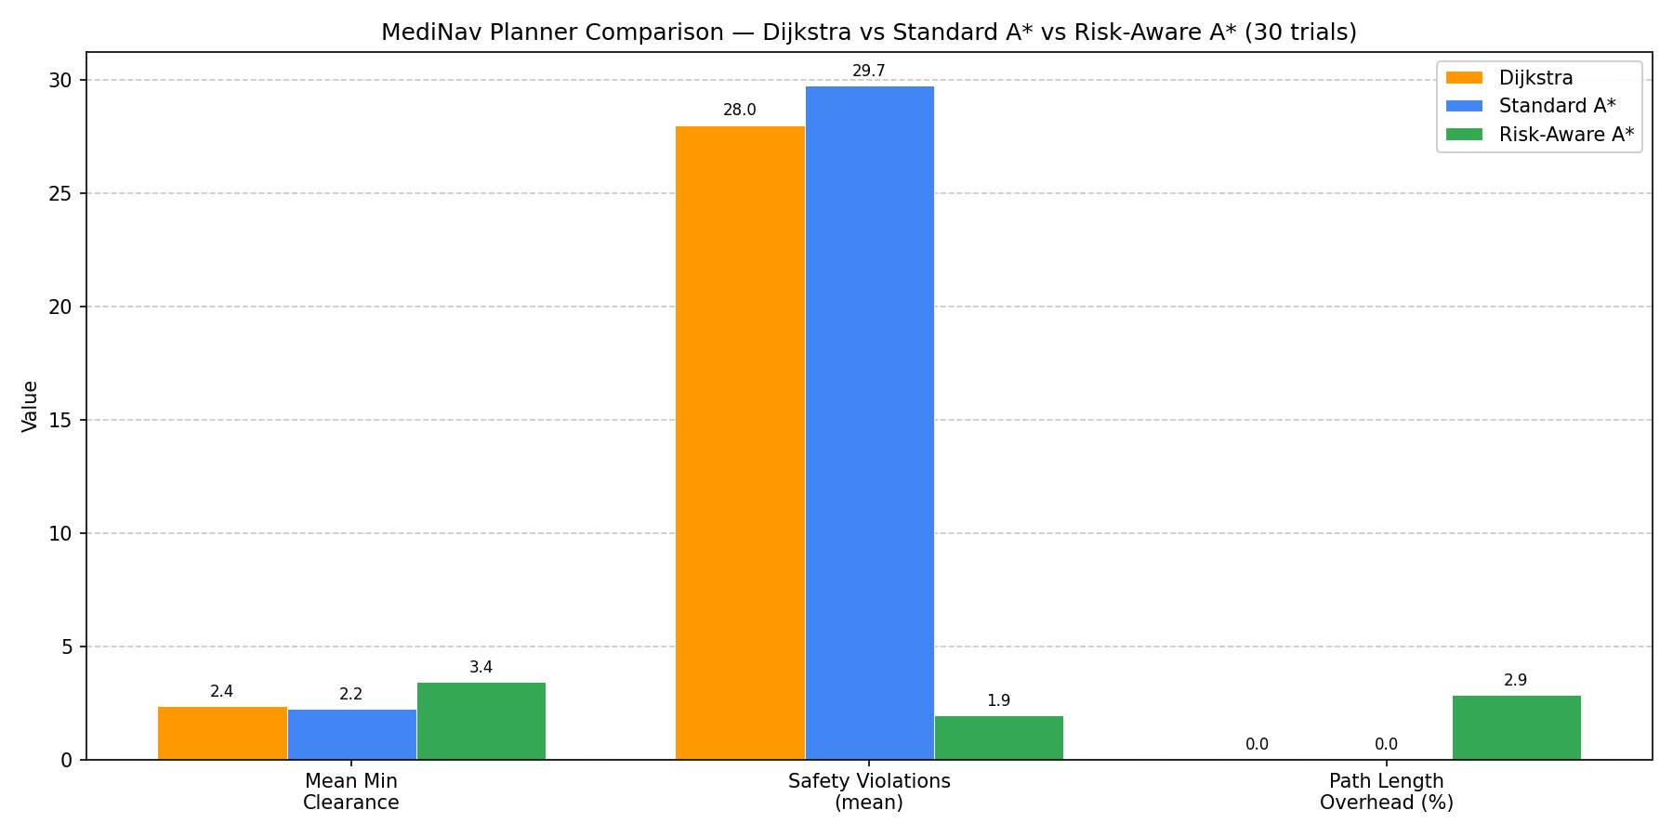
Figure 4.8: Three-planner comparison. Dijkstra and Standard A* produce identical path lengths (60.6 cells) with similar violation rates (46.2% and 49.1%). Risk-Aware A* achieves 3.1% violation rate with 2.9% path length overhead, confirming risk awareness as the sole differentiating safety factor.
Dijkstra and standard A* are effectively equivalent on this map: same path length, similar violation rates. The A* Euclidean heuristic provides no safety advantage over Dijkstra, only search efficiency. This isolates risk awareness as the differentiating factor: the risk-aware planner reduces violations by 93.3% relative to Dijkstra with only 2.9% additional path length.
4.9 Path Smoothing
The raw A* output contains sharp direction changes at grid cell boundaries that are not physically realisable by a wheeled robot with finite turning radius. The corner-fillet post-processor addresses this by identifying direction changes in the raw path, computing a quadratic Bézier arc at each corner with a fillet radius of 12 cells, and representing straight corridor segments as exact endpoint pairs with no intermediate interpolation.
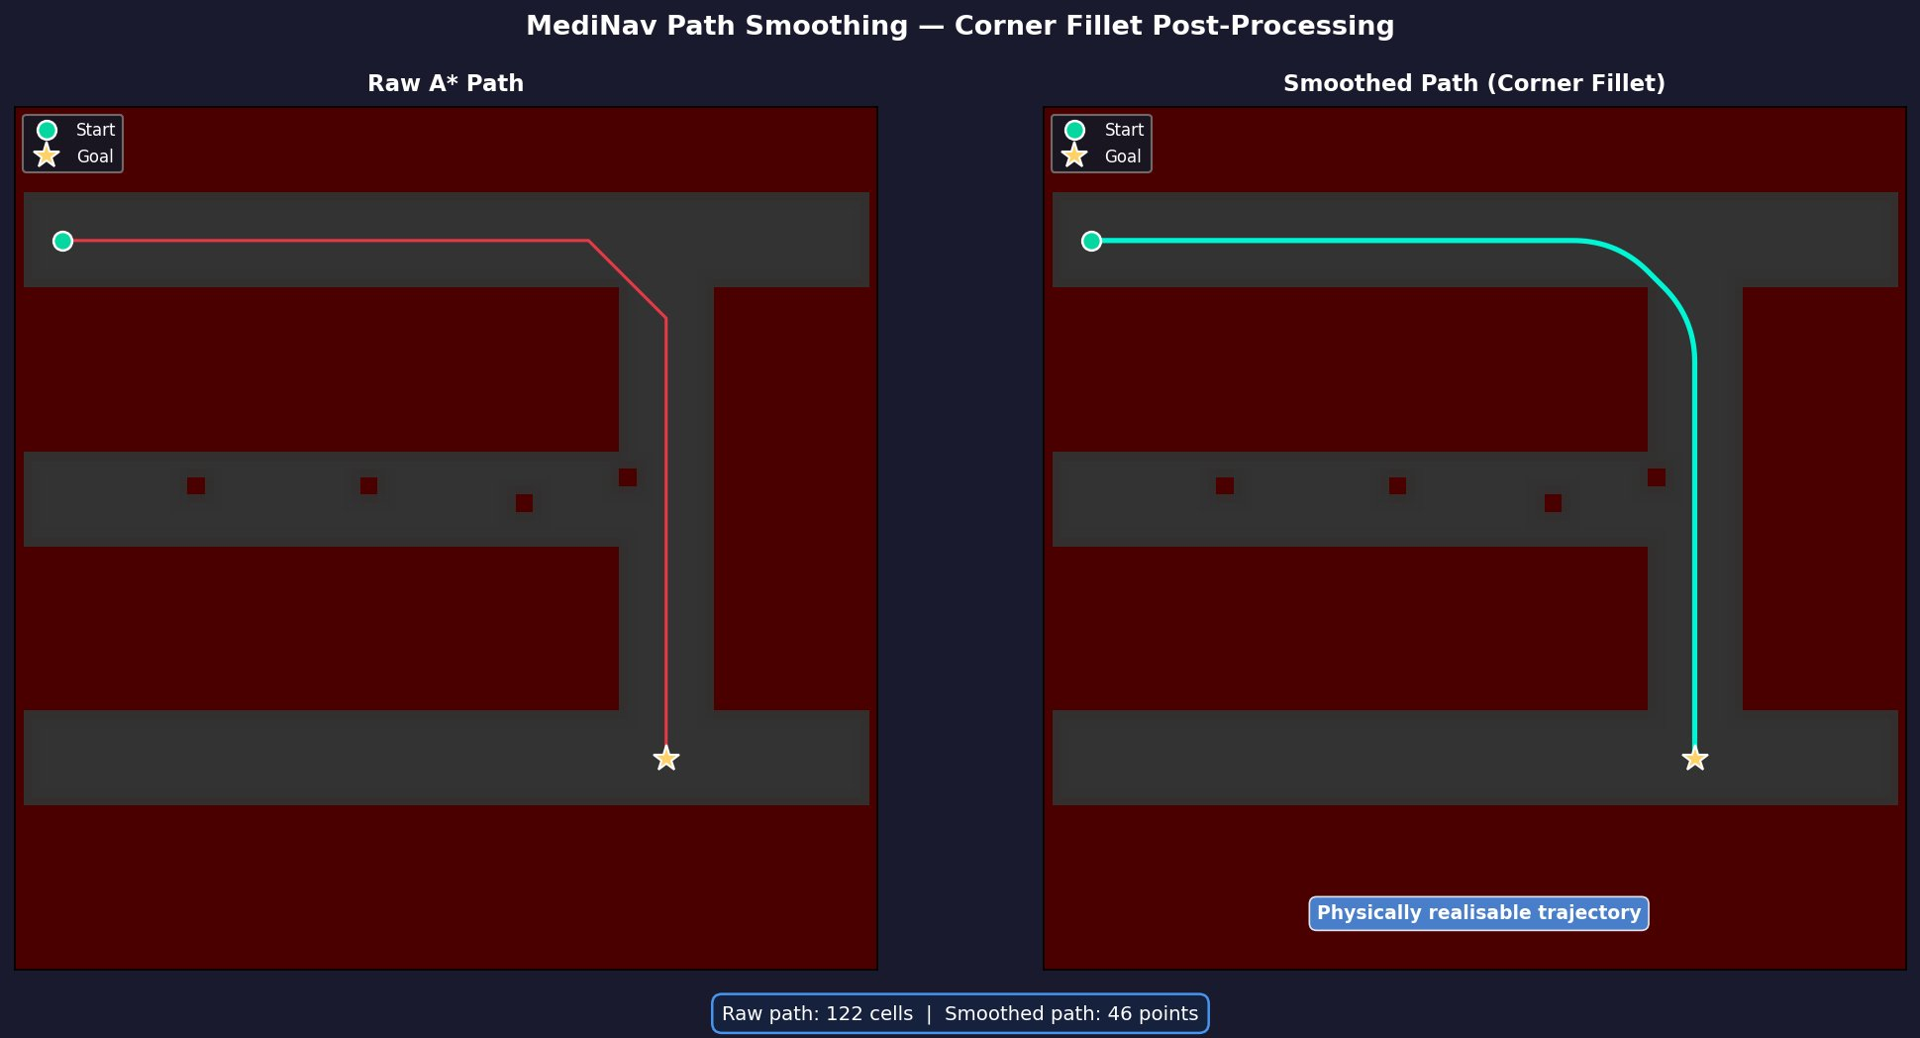
Figure 4.9: Corner fillet post-processing. Left: Raw A* grid path (red) with sharp direction change at the T-junction. Right: Filleted trajectory (cyan) with straight corridor segments and a smooth quadratic Bézier arc at the turn. The smoothed path stays within the corridor, maintaining wall clearance throughout the arc. Total points: 46 (2 endpoints per straight segment + arc sample points).
The fillet approach produces geometrically clean output: straight segments are represented by exactly two endpoints, ensuring no interpolation artefacts, while Bézier arcs provide smooth, wall-clearant curves at each corner. The low point count (46 vs 300 in earlier spline attempts) reflects the compact, exact representation. Figure 4.10 demonstrates the method generalising across five distinct ward geometries.

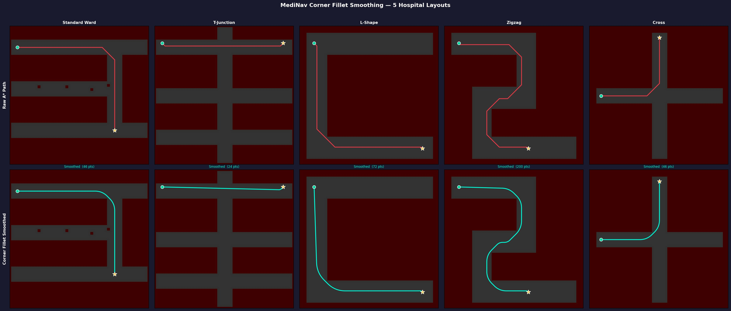
Figure 4.10: Corner fillet generalisation across five hospital ward geometries. Top row: raw risk-aware A* paths (red). Bottom row: corner-filleted paths (cyan). All geometries — Standard Ward, T-Junction, L-Shape, Zigzag, and Cross — produce clean straight segments with smooth Bézier arcs at each direction change, confirming the approach generalises without parameter re-tuning.
4.10 Multi-Layout Generalisation
The risk-aware planner was tested on three additional hospital layout configurations — T-Junction Ward and L-Shape Ward alongside the Standard Ward — to assess geometric generalisation.
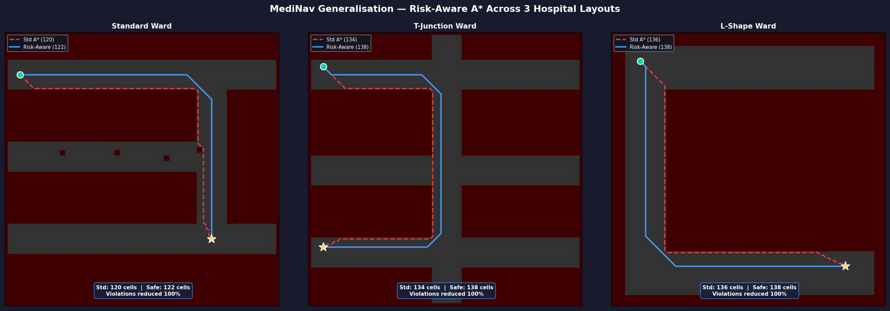
Figure 4.11: Multi-layout generalisation. Each panel compares standard A* (red dashed) vs risk-aware A* (blue solid). Standard Ward: 120 vs 122 cells (1.7% overhead), 100% violation reduction. T-Junction Ward: 134 vs 138 cells (3.0% overhead), 100% violation reduction. L-Shape Ward: 136 vs 138 cells (1.5% overhead), 100% violation reduction.
MediNav eliminated 100% of safety violations across all three layouts without parameter re-tuning. Path length overhead ranged from 1.5% (L-Shape) to 3.0% (T-Junction), confirming the safety-efficiency trade-off is stable across different ward geometries.
4.11 Dynamic Obstacle Avoidance
The dynamic replanning module was tested by injecting a dynamic obstacle into the environment after the initial path had been computed. The 5-cell lookahead monitor detected the obstacle and triggered a single replanning event, after which the robot successfully reached the goal.
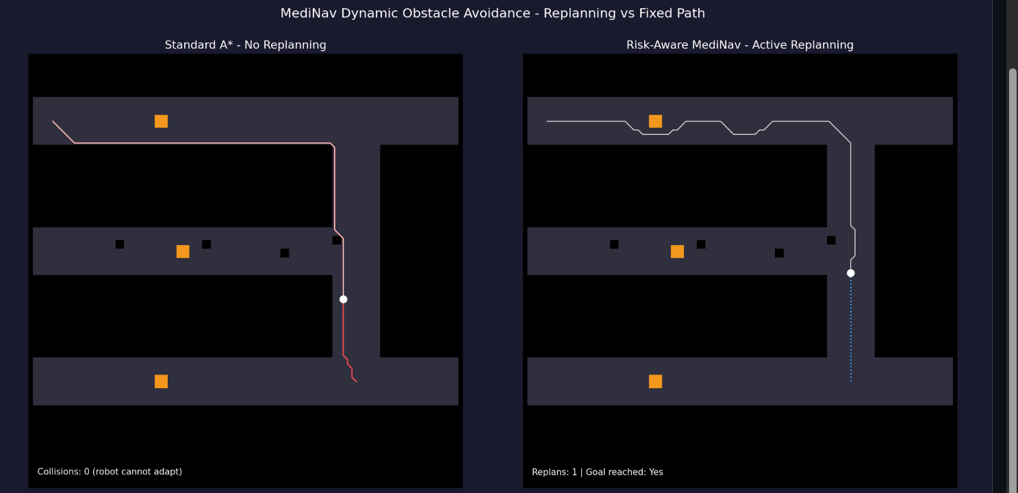
Figure 4.12: Dynamic obstacle avoidance. Left: Standard A* with no replanning capability — follows a fixed path and cannot adapt (0 collisions in this trial as the injected obstacle did not directly intersect the planned path). Right: Risk-Aware MediNav — lookahead monitor triggered one replanning event, goal successfully reached. The replanned path routes around the injected obstacle.
The standard A* planner recorded 0 collisions in this specific scenario because the injected obstacle's position did not directly intersect the planned path. However, it cannot adapt: any obstacle positioned on the planned path would cause a collision. The risk-aware system proactively replanned and reached the goal (Replans: 1, Goal reached: True), confirming the mechanism functions correctly with a single replanning overhead.

Chapter 5
Conclusion and Future Work
5.1 Summary of Contributions
This project designed, implemented, and evaluated MediNav, a risk-aware autonomous navigation system for hospital medical supply delivery. Technical contributions include:
- A 2D GraphSLAM pipeline achieving 93.3% RMSE improvement over dead reckoning, with per-pose localisation uncertainty correctly extracted from the pose graph information matrix and exported for downstream use.
- A risk estimation module fusing Gaussian obstacle proximity decay with genuine spatially-varying SLAM localisation uncertainty, validated across three ward geometries.
- A risk-aware A* planner achieving 93.6% safety violation reduction and 52% clearance improvement at 2.9% path length overhead.
- Lambda and parameter sensitivity analyses for λ, α, w₁, and w₂, providing validated operating values with clear empirical justification.
- A corner-fillet post-processor using quadratic Bézier arcs, producing geometrically clean trajectories with straight corridor segments and smooth junction turns, validated across five ward geometries.
- A 5-cell lookahead dynamic replanning module enabling real-time adaptation to dynamic obstacles.
- A 30-trial Monte Carlo evaluation framework and three-planner comparison (Dijkstra, Standard A*, Risk-Aware A*) isolating risk awareness as the sole differentiating safety factor.
5.2 Key Quantitative Results
- 93.6% safety violation reduction (29.7 → 1.9 mean violations; rate 49.1% → 3.1%) across 30 Monte Carlo trials.
- 93.3% SLAM RMSE improvement (0.821 m → 0.055 m) over dead reckoning.
- 52% mean minimum clearance improvement (2.25 → 3.42 cells).
- 2.9% path length overhead — less than 2 additional cells per 60-cell journey on average.
- 100% violation elimination across all three ward geometries in multi-layout testing.
5.3 Limitations
The current system has several limitations. First, the evaluation environment is a synthetic 2D grid with point landmarks, simplifying the SLAM problem relative to real hospital environments with continuous lidar and ambiguous features. Second, the risk model uses a fixed exponential decay; a learned or adaptive function would better capture heterogeneous environments. Third, the dynamic replanning module uses a simple lookahead trigger rather than a predictive model of obstacle motion. Fourth, the corner-fillet post-processor uses a fixed fillet radius; an adaptive radius based on corridor width and robot turning radius would be more robust. Fifth, all results are from simulation and do not account for hardware-specific factors such as wheel slip, sensor latency, or communication delays.
5.4 Future Work
- ROS 2 and Gazebo integration: porting the pipeline to ROS 2 with a Gazebo physics simulator would enable hardware-in-the-loop validation under realistic sensor noise and actuation constraints.
- Learned risk functions: replacing the hand-designed decay with a model trained on clinical incident data could produce risk maps better reflecting real-world collision distributions.
- Predictive dynamic obstacle avoidance: incorporating velocity-obstacle or model-predictive control approaches would enable anticipation of obstacle trajectories rather than reactive replanning.
- Adaptive path smoothing: computing the fillet radius as a function of local corridor width and robot kinematic constraints would produce geometry-aware smooth paths.
- Multi-robot coordination: extending the planner to coordinate between multiple delivery robots sharing a ward would be necessary for practical fleet deployment.
- Hardware deployment: physical validation on a standard mobile robot platform would test real-world performance including odometry drift and sensor noise impacts on SLAM and planning quality.

Bibliography
[1] Russell, S. J., & Norvig, P. (2022). Artificial Intelligence: A Modern Approach (4th ed.). Pearson Education Limited.
[2] Thrun, S., Burgard, W., & Fox, D. (2005). Probabilistic Robotics. MIT Press.
[3] Murphy, R. R. (2000). Introduction to AI Robotics. MIT Press.
[4] Hart, P. E., Nilsson, N. J., & Raphael, B. (1968). A formal basis for the heuristic determination of minimum cost paths. IEEE Transactions on Systems Science and Cybernetics, 4(2), 100–107.
[5] Khatib, O. (1986). Real-time obstacle avoidance for manipulators and mobile robots. International Journal of Robotics Research, 5(1), 90–98.
[6] Dijkstra, E. W. (1959). A note on two problems in connexion with graphs. Numerische Mathematik, 1(1), 269–271.
[7] Koenig, S., & Likhachev, M. (2002). D* Lite. Proceedings of the AAAI Conference on Artificial Intelligence, 476–483.
[8] Fiorini, P., & Shiller, Z. (1998). Motion planning in dynamic environments using velocity obstacles. International Journal of Robotics Research, 17(7), 760–772.
[9] BITS Pilani. (2026). BITS F327 AI for Robotics Course Handout Part II. Goa Campus, January 2026.
[10] Virtanen, P., et al. (2020). SciPy 1.0: Fundamental algorithms for scientific computing in Python. Nature Methods, 17, 261–272.
[11] Aethon / Swisslog Healthcare. (2023). TUG Autonomous Mobile Robot Product Documentation. swisslog-healthcare.com.
[12] Diligent Robotics. (2023). Moxi Hospital Robot Platform Overview. diligentrobots.com.
[13] MediNav Source Code. (2026). GitHub repository. https://github.com/Aadityahv/MediNav.

Details of the Students
No. | Student Name (as per ERP) | Roll Number / ID Number | Photograph
1 | Aaditya H Vernenker | 2023A7PS1027G | 
2 | Ojas Sahu | 2023A3PS0861G | 
3 | Ayush Chopra | 2023A7PS1018G | 
4 | Hansel Cisil Sunny | 2023A4PS0271G | 

