**BASIC LIFE SUPPORT (BLS)**

**Basic life support** (**BLS**) is a level of medical care which is used for victims of **life**-threatening illnesses or injuries until they can be given full medical care at a hospital. It can be provided by trained medical personnel, including emergency medical technicians, paramedics, and by qualified bystanders.

CPR is easy to learn and it’s a skill that everybody should have. It’s good to know that you can help if someone near you needs CPR.

**Who Can Attend** -- Anyone who wants to learn CPR , Health care Providers , Any Speciality Doctor, Any Medical Fraternity , Nursing , Paramedical Staff , Gym Trainers.

**What you’ll gain**

This course is a mixture of less theory and more practice. On completion

* Know when and how to apply CPR for an adult, child and baby
* **AED (Automated External Defibrillator)**
* Know what to do if someone is choking
* Helps your workplace to meet health and safety standards

**Duration** -- 8 hours (Single Day)

**Certification** – AHA (American Heart Association) Card -- Valid Globally.

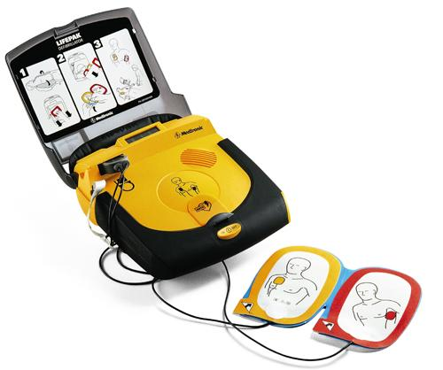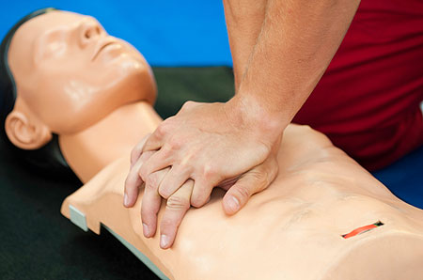

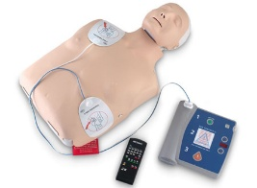



**ADVANCED CARDIAC LIFE SUPPORT (ACLS)**

**Advanced cardiac life support** (**ACLS**) refers to a set of clinical interventions for the urgent treatment of [cardiac arrest](https://en.wikipedia.org/wiki/Cardiac_arrest), [stroke](https://en.wikipedia.org/wiki/Stroke) and other life-threatening medical emergencies, as well as the knowledge and skills to deploy those interventions.

### Types of algorithms

### C:\Users\Dr Mrugesh\Desktop\New folder\slide_22.jpg

Electrocardiogram Interpretation Cardiac Arrest Algorithm  
Acute Coronary Syndromes Algorithm  
PEA / Asystole Algorithm  
VF / Pulseless VT Algorithm  
Bradycardia Algorithm  
Tachycardia Algorithms  
Respiratory Arrest Algorithm  
Suspected Stroke Algorithm

**Who Can Do** – Medical Fraternity, MBBS, BHMS, BAMS, Nursing Staff, ICU/ Emergency Staff

**Benefit** – Will Build up Confidence level to Work in Emergency / ICU Areas, Specially Using Team Approach.

**Duration – 2** Days

**Certification** -- AHA (American Heart Association) Card – Valid Globally.

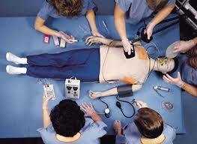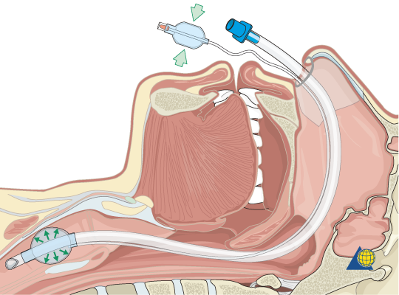

**Basic Emergency Care** (**BEC)**

**Basic Emergency Care**, is a study about Basics of lots of topics which are going to be Helpful in **Day to Day Practise** in Any Department of Hospital like Emergency, ICU, Wards, OT or Clinics.

**Topics –**

* ECG
* Patient Assessment **Who Can Attend --**
* Chest x ray Medical Officers /MBBS/BHMS/
* Basic Life Support / CPR BAMS/Interns /ICU / ER Staff.
* Chest Pain **Duration** – **6** **Sundays**
* Breathlessness Certified by
* Stroke “**ACADEMY OF EMERGENCY MEDICINE“**
* Basic CT scan
* Trauma
* Fractures

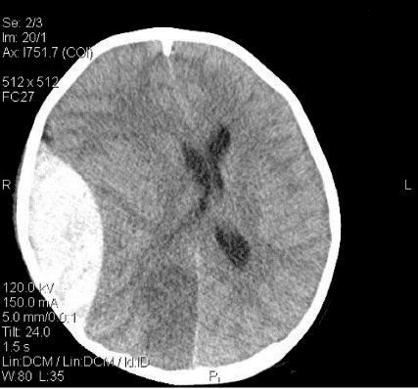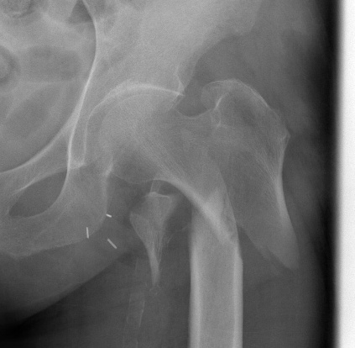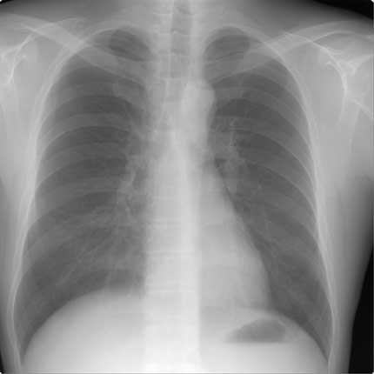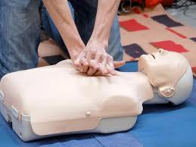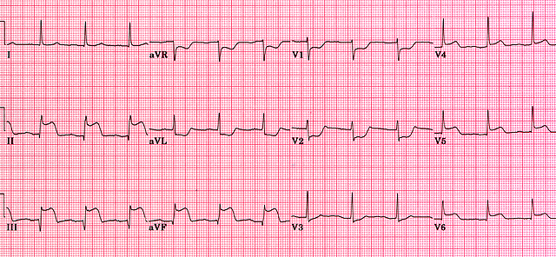

**WORKSHOP**

1. **CPR Workshop –**

**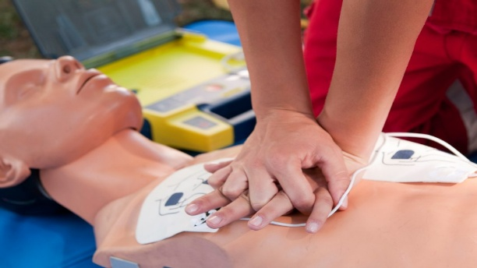**

**Cardiac Arrest**

**CPR**

**AED**

1. **Basic Trauma Care**

**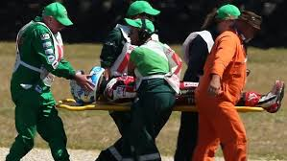Initial Management**

**Spine Importance**

**Practical Approach**

**Emergency Procedures**

1. **Airway Management**

**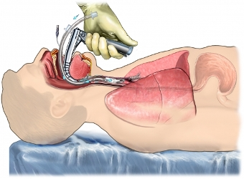**

**Basic Airway**

**Advanced Airway**

**Equipment**

**Duration -- 4 to 5 Hours (Each Workshop)**

**Eligibility – Any Medical Personnel / Doctors / Staff Training /**

**Paramedics.**

**Advanced Trauma Life Support (ATLS)**

**Advanced trauma life support** (commonly abbreviated **ATLS**) is a training program for medical providers in the management of acute trauma cases.

ATLS is now widely accepted as the standard of care for initial assessment and treatment in trauma centres. The premise of the ATLS program is to treat the greatest threat to life first. It also advocates that the lack of a definitive diagnosis and a detailed history should not slow the application of indicated treatment for life-threatening injury, with the most time-critical interventions performed early.

**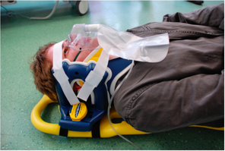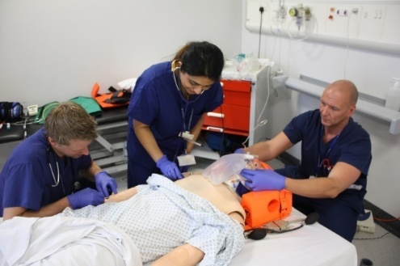**

**Eligibility – MBBS and Above Degree Holders.**

**Duration – 3 Days.**

**Certified by – American College of Surgeons (ACS).**

**International Trauma Life Support (ITLS)**

**International Trauma Life Support** is dedicated to the education in managing out-of-hospital trauma situations.

## **Course Content**

* Patient assessment and management
* Basic and advanced airway management
* Needle chest decompression and fluid resuscitation
* Spinal motion restriction including rapid extrication, helmet removal, log-roll, and long/backboard/scoop stretcher utilization
* Extremity immobilization and traction splint application

## ***Course Length*** - **16 hours**

***Certified by* -- American College of Emergency Physicians, Alabama Chapter.**

***Eligibility* -- Emergency Medical Providers such as Physicians, Nurses, Emergency Technicians, Paramedics**.