AVIRAL CONSULTING · LOGISTICS STRATEGY NOTE
Railway Parcel: A Transformative Operating Model
Indian Railways is moving beyond incremental parcel improvements toward a transformative model—one that can multiply parcel revenue and act as a logistics enabler for Viksit Bharat 2047.

1. The Strategic Shift
The parcel segment has historically grown through piecemeal upgrades. The next leap requires a different posture: treat parcel as a productized, ecosystem-led logistics offering rather than a residual capacity business attached to passenger trains.
Core principle: sharpen where Railways already creates unmatched value—network control and middle-mile connectivity—while partnering for non-core capabilities such as first-mile booking, last-mile delivery, and specialized technology.

2. Core Competency Focus
The transformative model asks Railways to excel in functional competencies of the network and middle mile, and to orchestrate the broader parcel ecosystem around that spine.
- Ecosystem Orchestration — Coordinate multiple stakeholders so the network behaves as one reliable logistics system.
- End-to-End Digital Integration — Shared visibility, booking, and handoff data across rail, terminal, and LSP systems.
- Innovation & Product Development — Parcel trains, VPU/SLR configurations, roll-cage products, and saleable service designs.
- Partner for Non-Core Work — Work with LSPs, tech providers, and specialists for customer-facing and edge operations.

3. Infographic — Model at a Glance
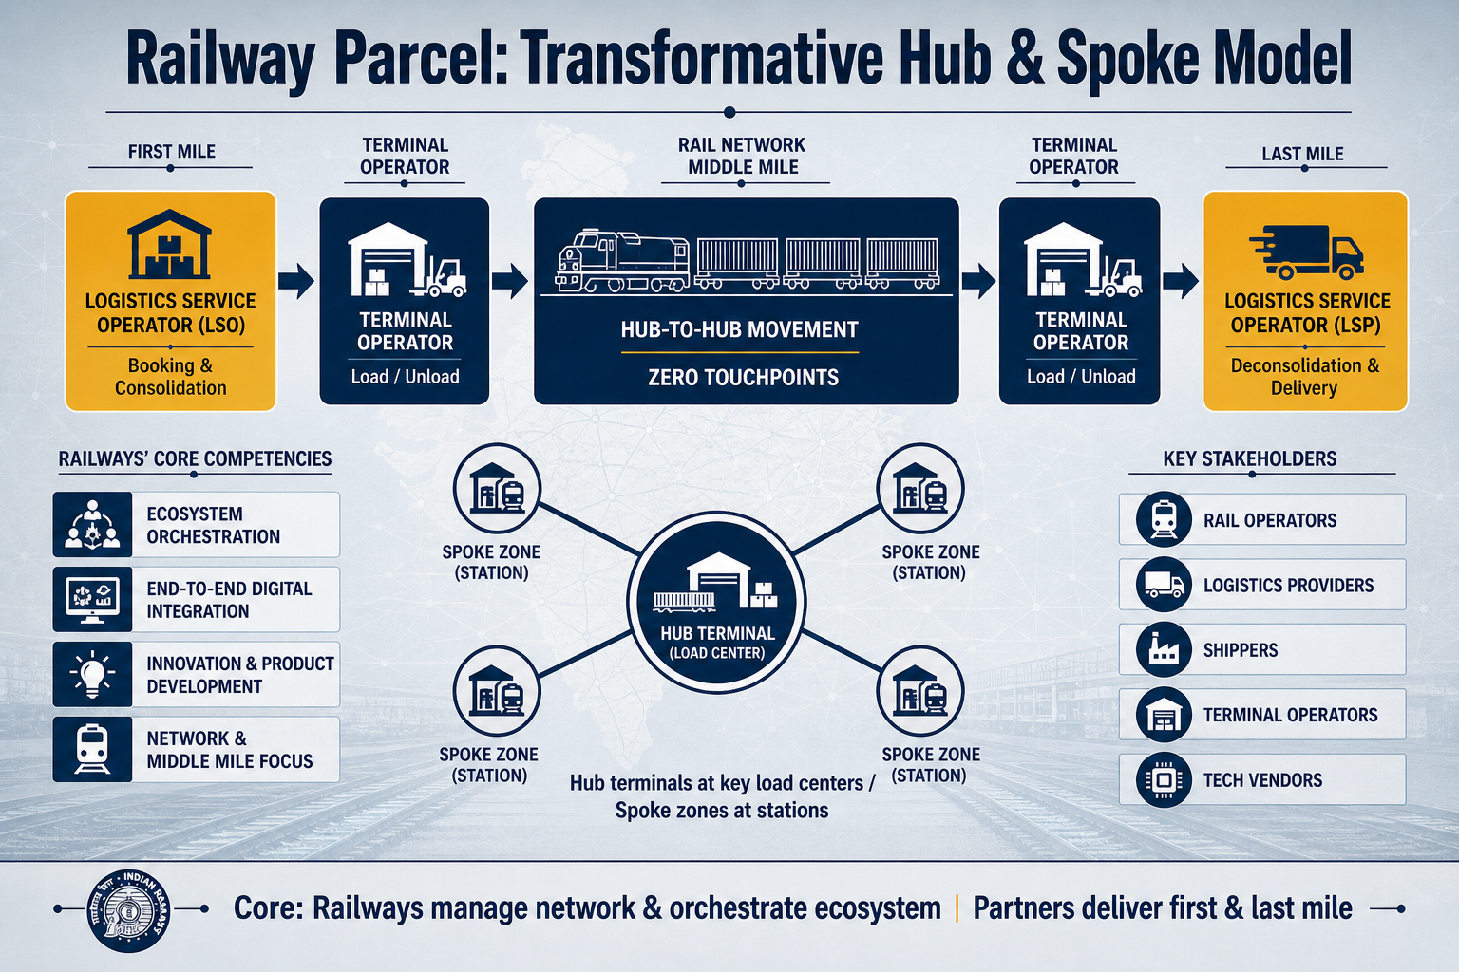
Figure 1. Railways own the middle-mile network and ecosystem control; logistics partners own customer-facing first and last mile.

4. The Integration Imperative
Today’s parcel value chain is fragmented. Rail operators optimize track capacity and schedules; logistics providers chase door-to-door timelines; shippers demand cost and reliability; terminal operators manage transfer efficiency; technology vendors build tracking and automation. Each actor is competent—but incentives and systems are not aligned.
That fragmentation is the single greatest barrier to seamless door-to-door parcel solutions that can compete with integrated private networks. Breaking silos requires shared technology platforms and aligned commercial incentives, with Railways positioned to manage the network (line-haul) and control the ecosystem.

Key stakeholders
- Rail Operators — Focus on track capacity and train scheduling.
- Logistics Providers — Prioritize door-to-door delivery timelines.
- Shippers — Demand cost efficiency and reliability.
- Terminal Operators — Manage transfer efficiency and storage.
- Tech Vendors — Develop tracking and automation tools.

5. Operating Schematic: First Mile → Rail → Last Mile
The commercial model separates customer-facing logistics work from the rail spine, while keeping handoffs crisp at dedicated parcel interfaces.

Role summary
- Logistics Service Operator / Provider — owns customer interface, booking, consolidation and deconsolidation centers, and final delivery.
- Terminal Operator — connected rail-head operations—segregation, loading/unloading, receiving, and transshipment—on an activity-based revenue model.
- Rail Network — solely middle-mile connectivity using parcel trains / VPU / SLR / customized consists, including roll-cage operations for SLR.
Dedicated parcel terminals are required at key hub locations; spoke locations can use dedicated parcel space within existing railway station premises.

End-to-end flow
First Mile | Terminal | Rail Network | Terminal | Last Mile
LSP / LSO  Customer facing  Booking & revenue  Consolidation | Segregation  Load / unload  Push to rail  Activity-based revenue | Middle mile only  Parcel trains / VPU / SLR  Dedicated or shared  Rolling inventory | Receive from rail  Segregation  Transshipment  Activity-based revenue | Same LSP typically  Deconsolidation  Customer delivery  Own infrastructure
Figure 2. Clear role split across the parcel chain, with Railways as the middle-mile backbone. Terminals earn activity-based revenue from LSPs.

6. Hub & Spoke Network Design
The network should mirror express-cargo practice: concentrate volume at hubs, move hub-to-hub with zero intermediate touchpoints, and use short-haul parcel trains for regional spoke distribution.

Design rules
- Establish dedicated parcel terminals (hubs) at key load-generation and consumption centers.
- Run hub-to-hub moves with zero intermediate touchpoints for speed, reliability, and minimal handling.
- Enable hub-to-spoke connectivity with short-haul parcel trains for faster regional distribution.
- Spokes do not need full terminals—allocate dedicated parcel zones in existing stations from which LSPs move cargo to their own centers.
- Design unidirectional volume logic: upward toward hubs for aggregation; downward toward spokes for delivery.
- Terminal operators manage luggage/parcel booking and train connections under a revenue-share with Railways, using predefined size/weight limits for faster processing.

7. Why This Model Matters
By concentrating Railways on network excellence and ecosystem control—and letting specialist partners own customer-facing edges—the parcel business can become both more reliable and more saleable. Shared digital rails, clean commercial interfaces, and hub-and-spoke physical design together convert fragmentation into a competitive door-to-door product.
Outcome ambition: a scalable parcel platform that multiplies railway revenue while strengthening India’s multi-modal logistics backbone on the path to Viksit Bharat 2047.
Based on: Presentation for chatgpt.pptx · Aviral Consulting · Private & Confidential

