**DATASET DETAILS**

Dataset offers climate resilience information containing the events such as EQ, and DR in the USA, Canada, and Mexico in 2024. Each record captures Event details: Earthquake or drought, geographical area, and year of occurrence. Geographical data: Details of longitude and latitude. Weather conditions: Such as average, maximum, and minimum temperature, relative humidity, wind velocity, amount of precipitation, the UV radiation index, and the state of the atmosphere such as sunny, light snow, and the like. I like that this dataset gives clues about how weather variables develop in areas prone to natural disasters. Auxiliary features associated with each event type or location can be analyzed and can provide knowledge of how temperature or humidity changes to the event.

1. **LINE CHART**

* **Purpose:** The line chart shows the average temperature which has been constantly increasing throughout the year.
* **Observations:** If the format used dates, then the appearance of any fluctuations in temperature. For instance, fluctuation in temperature change may be in harmony with the timescale or, it may also reflect the effects relating to a particular event.

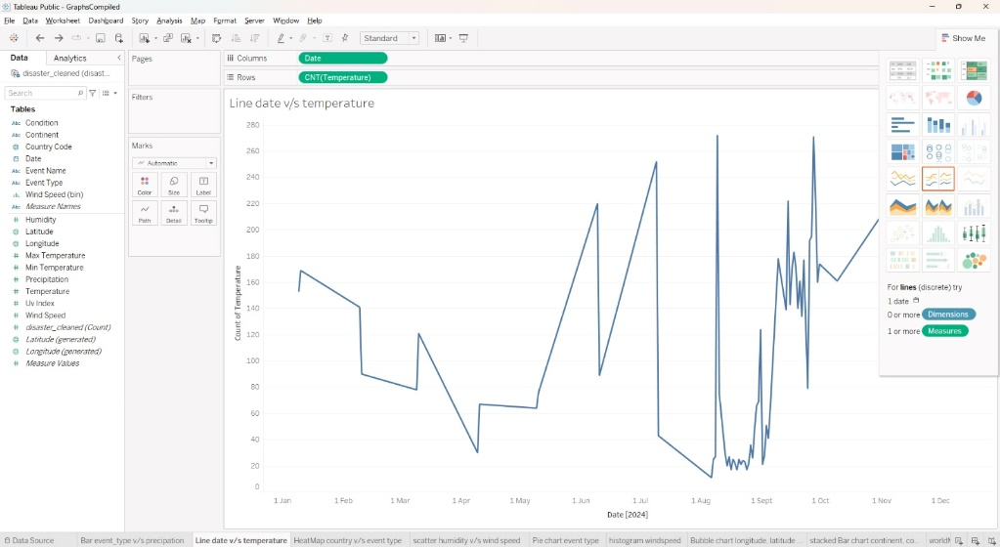

1. **HEATMAP**

* **Purpose:** This would show the distribution of earthquakes and droughts across different regions.
* **Observations:** Identify if certain locations experience more earthquakes or droughts. For example, California-Nevada and Central California may show more earthquakes, reflecting their seismically active nature.

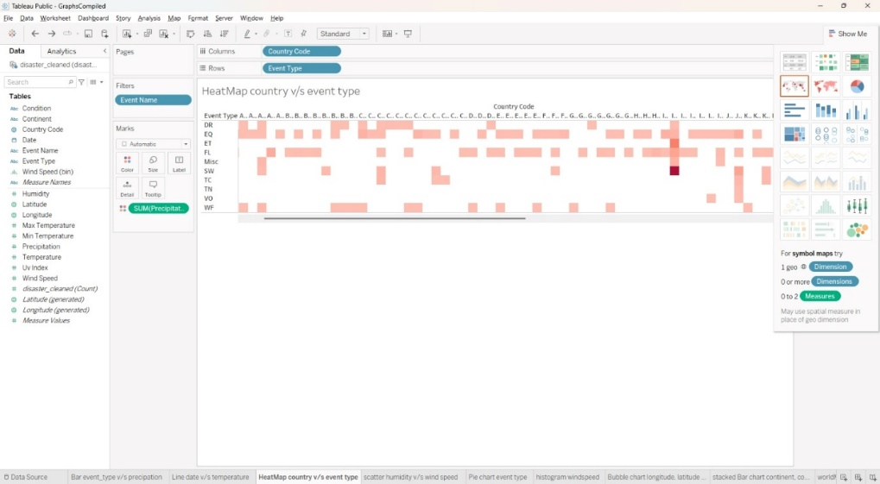

1. **SCATTER PLOT**

* **Purpose:** It is seen in the scatter plot given above how much humidity and wind speed are there for different events in the dataset. This assists in determining whether or not two of these weather variables have a relation.
* **Observations:** They show trends, thereby pointing out which ranges of the humidity are related to what ranges of wind speed. For instance, low rainfall zones with low humidity and different wind velocities may be interpreted as dry conditions that are sometimes associated with irregular winds. That is high humidity accompanied by high velocity could represent storm-inclined conditions probably in areas prone to earthquakes.

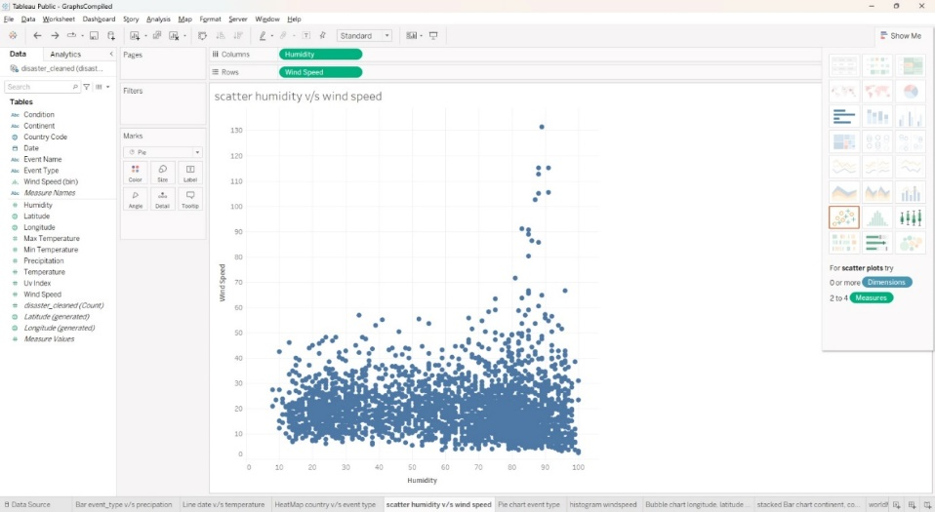

1. **PIE CHART**

* **Purpose:** The pie chart depicts the proportion or percentage of various kinds of events including earthquakes, droughts, etc in the given input data set. This visualization provides an idea of the relative occurrence of each type of event.
* **Observations:** The pie chart depicts the difference between one type of event and another type. This proved useful for quickly getting an overview of what types of occurrences dominate the natural realm, and therefore what planning for preparedness and recovery should primarily entail in each of these categories.

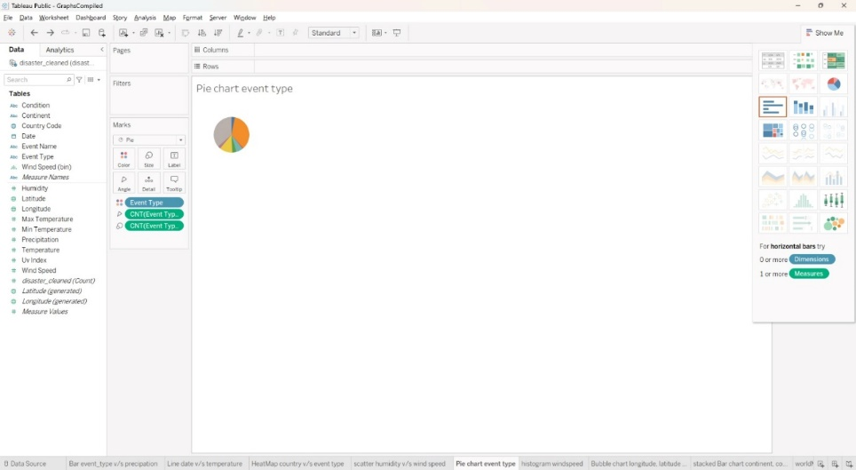

1. **HISTOGRAM**

* **Purpose:** The histogram visualizes the distribution of **wind speeds** across different events in the dataset.
* **Observations:** The histogram may show certain wind speed ranges as more common, with peaks around specific values. For instance, if lower wind speeds are more frequent, it could indicate that most events occur in relatively calm conditions. On the other hand, if higher wind speeds are common, it might suggest that certain regions are prone to more intense weather activity.

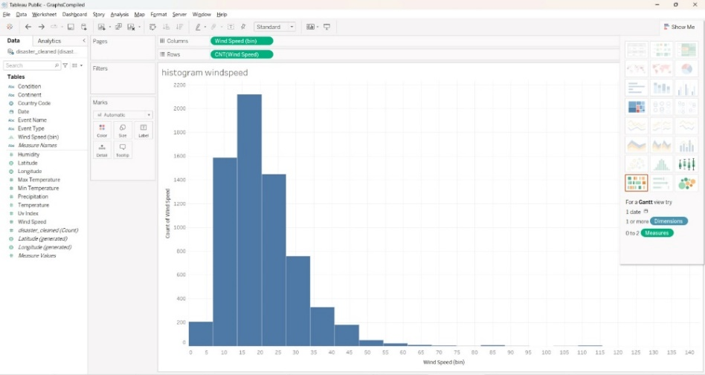

1. **BUBBLE CHART**

* **Purpose:** The bubble chart represents **longitude** and **latitude** as the position coordinates for different events, with the **size of each bubble corresponding to the UV index**.
* **Observations:** The chart shows clusters of events in certain geographical regions, which can indicate hotspots of natural events like earthquakes or droughts. Larger bubbles in specific areas suggest higher UV indexes, which could correlate with regions experiencing more intense sunlight or specific climate conditions.

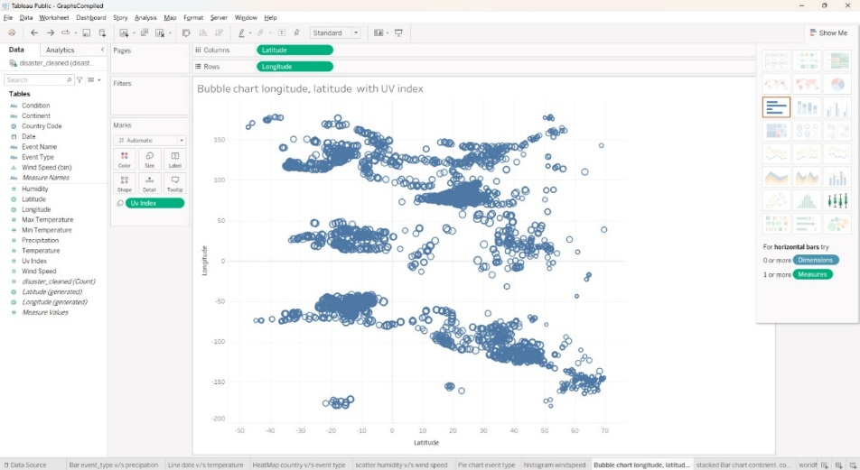

1. **STACKED BAR CHART**

* **Purpose:** The stacked bar chart shows the **count of events** for each **continent**, with different colors representing **event types** (e.g., earthquakes and droughts).
* **Observations:** The chart reveals that certain continents experience more of one event type than another. For instance, North America might have a higher frequency of earthquakes, indicated by a larger section of the corresponding color in the stacked bars. Conversely, other continents might show a more balanced or different distribution, highlighting regional differences in natural events.

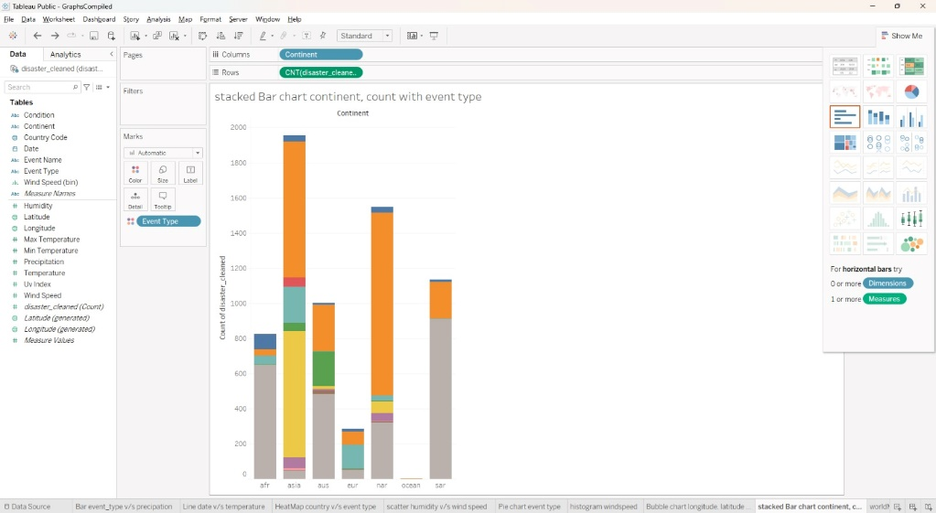

1. **SYMBOL MAP**

* **Purpose:** The symbol map plots **longitude** and **latitude** to display the **geographic locations** of recorded events on a map.
* **Observations:** The map may show concentrations of events in certain areas, identifying regional hotspots. For instance, clusters along specific longitude and latitude coordinates could indicate areas more prone to seismic or drought activity. Patterns in event distribution can reveal geographic trends, such as coastal or inland areas experiencing more frequent events.

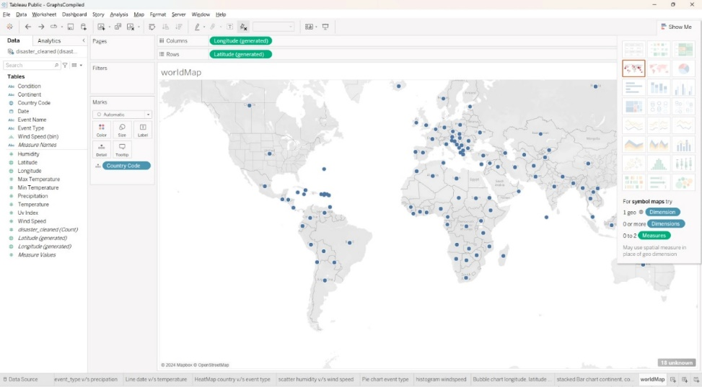

1. **HORIZONTAL BAR CHART**

* **Purpose:** The horizontal bar chart displays **event types** (e.g., earthquakes and droughts) on the y-axis with corresponding **precipitation levels** on the x-axis.
* **Observations:** The chart shows that certain event types are associated with higher or lower levels of precipitation. For instance, drought events might have little to no precipitation, reinforcing dry conditions, while earthquakes could display a broader range of precipitation levels.

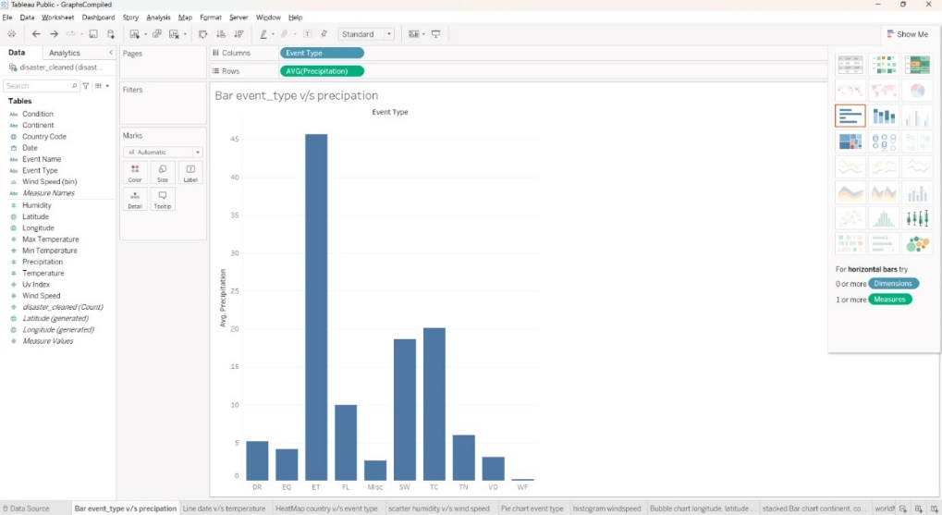

1. **PACKED BUBBLE CHART**

* **Purpose:** The packed bubble chart displays the **maximum temperature** for each **continent**, with bubble size corresponding to the temperature level.
* **Observations:** The chart shows larger bubbles for certain continents, indicating higher maximum temperatures in those areas. For instance, if Africa or Asia has the largest bubbles, it suggests that these regions experience more intense heat events. Smaller bubbles on other continents could reflect milder maximum temperatures.

