Solved by: Ojaswini Nimbalkar

Dare

(and stack overflow)

**Problem 1**

* Parse fixed width file
* Generate a fixed width file using the provided spec (offset provided in the spec file represent the length of each field).
* Implement a parser that can parse the fixed width file and generate a delimited file, like CSV for example.
* DO NOT use python libraries like pandas for parsing. You can use the standard library to write out a csv file (If you feel like)
* Language choices (Python or Scala)
* Deliver source via github or bitbucket
* Bonus points if you deliver a docker container (Dockerfile) that can be used to run the code (too lazy to install stuff that you might use)
* Pay attention to encoding

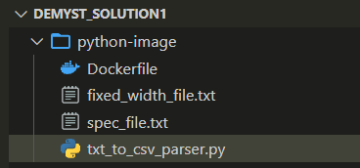**Overview of the files created:**

**How to run:**

1] Create a folder named ‘python-image’ and store the given files in this folder.

2] Navigate to the current directory.

cd .\python-image\

3] Build the docker image:

4] Run the image:

5] The output.csv file will be created in the ‘python-image’ folder after the above command is run.

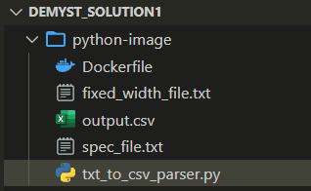**(The above walkthrough is given in case the docker container doesn’t work as I am struggling to upload it on the hub currently due to access issues)**