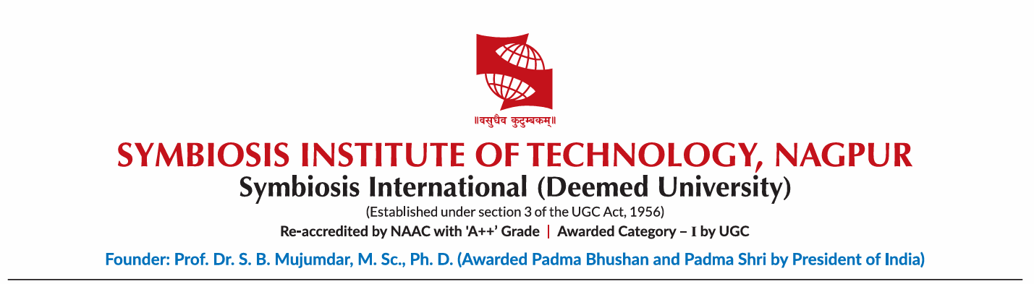

A MINI PROJECT REPORT

ON

Student Management System

For the Course
Java (Flexi Credit)

Submitted By
Ojaswini Thote (24070521048)
IVth Sem Section A

Student Management System

Problem Definition

Design a Java program to manage student information using inheritance. Create a base class Person that stores common details like name and age. Derive a class Student that includes additional attributes such as roll number and marks. Further extend it into another class GraduateStudent with specialization details. The program should display complete student information using inherited properties.

class Person {
String name;
int age;

Person(String name, int age) {
this.name = name;
this.age = age;
}

void displayPerson() {
System.out.println("Name: " + name);
System.out.println("Age: " + age);
}
}
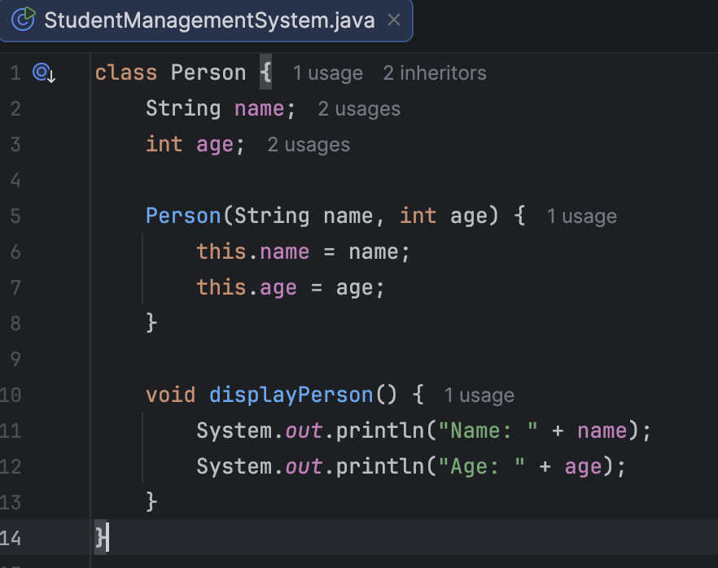
class Student extends Person {
int rollNo;
double marks;

Student(String name, int age, int rollNo, double marks) {
super(name, age);
this.rollNo = rollNo;
this.marks = marks;
}

void displayStudent() {
displayPerson();
System.out.println("Roll Number: " + rollNo);
System.out.println("Marks: " + marks);
}
}
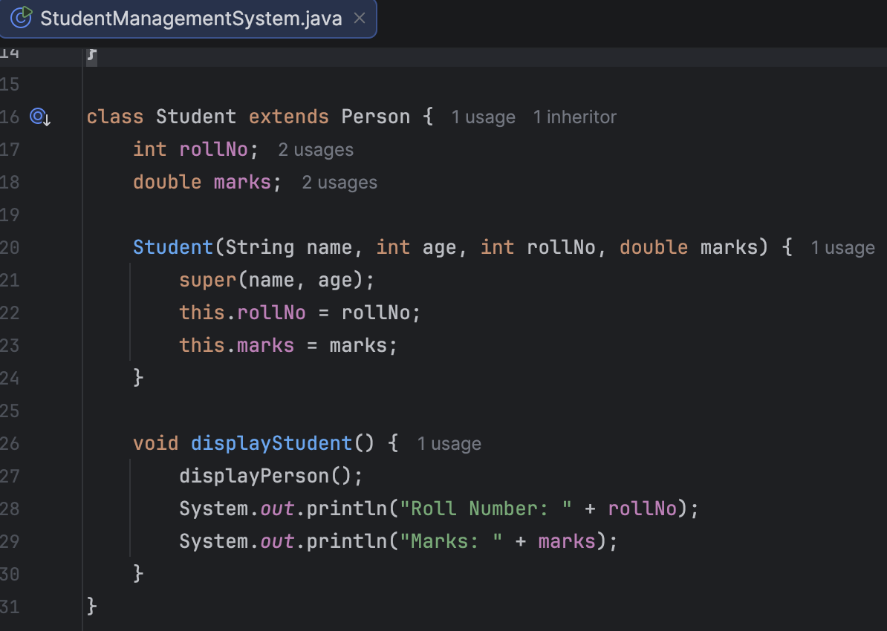
class GraduateStudent extends Student {
String specialization;

GraduateStudent(String name, int age, int rollNo, double marks, String specialization) {
super(name, age, rollNo, marks);
this.specialization = specialization;
}

void displayGraduateStudent() {
displayStudent();
System.out.println("Specialization: " + specialization);
}
}
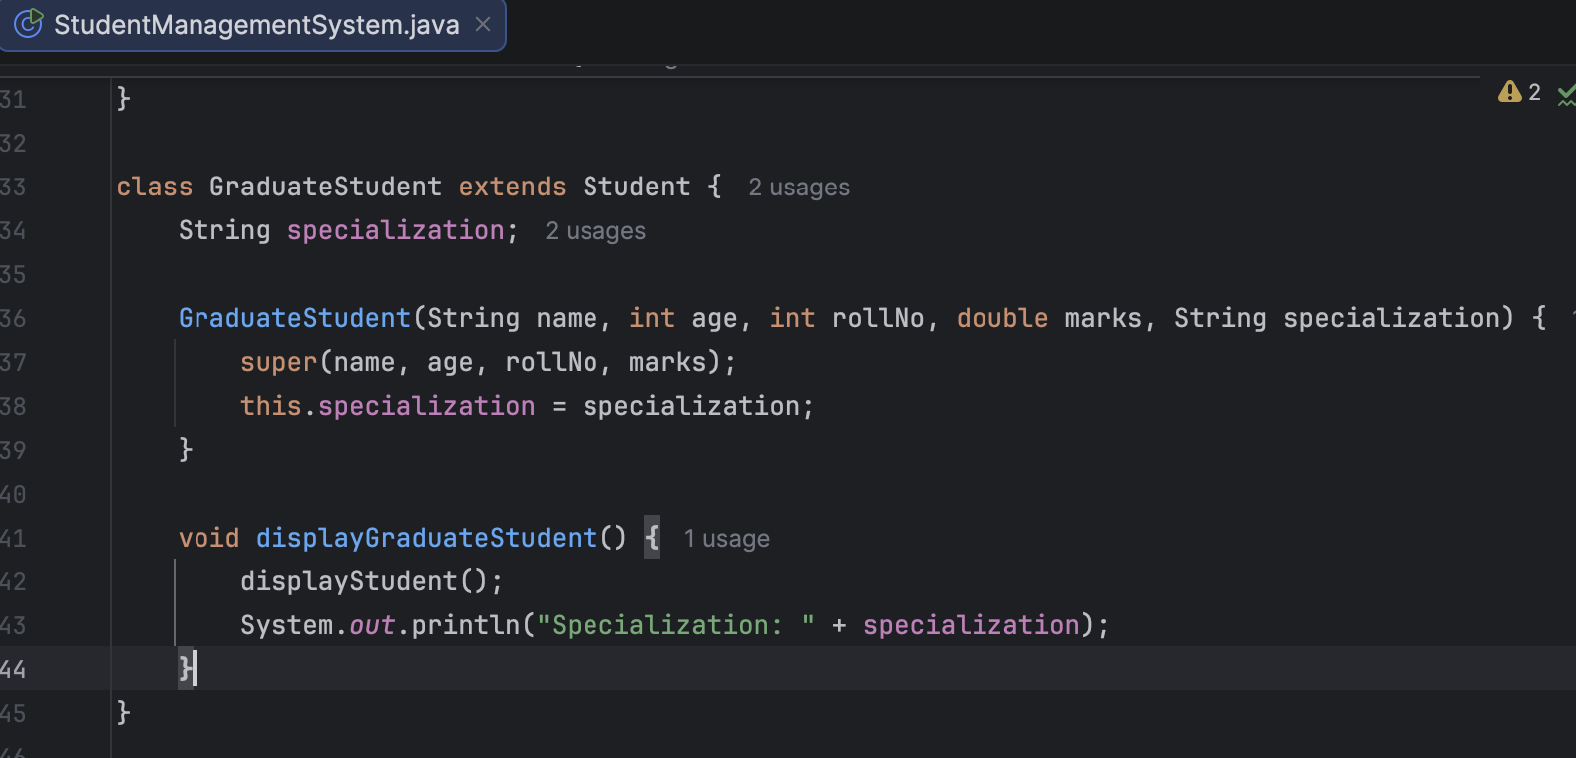
public class StudentManagementSystem {
public static void main(String[] args) {

GraduateStudent gs = new GraduateStudent(
"Ojaswini", 20, 48, 88.5, "Computer Science"
);

System.out.println("----- Student Details -----");
gs.displayGraduateStudent();
}
}
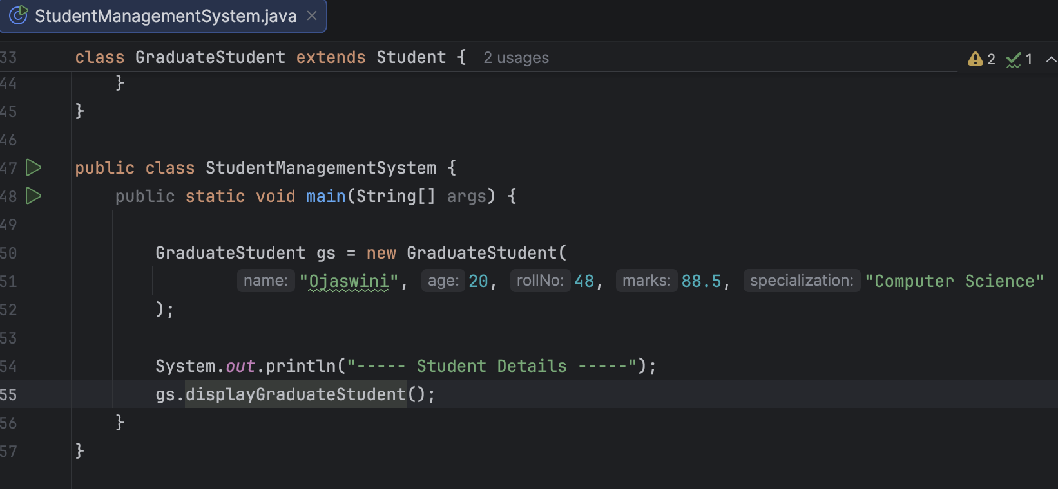
Output:
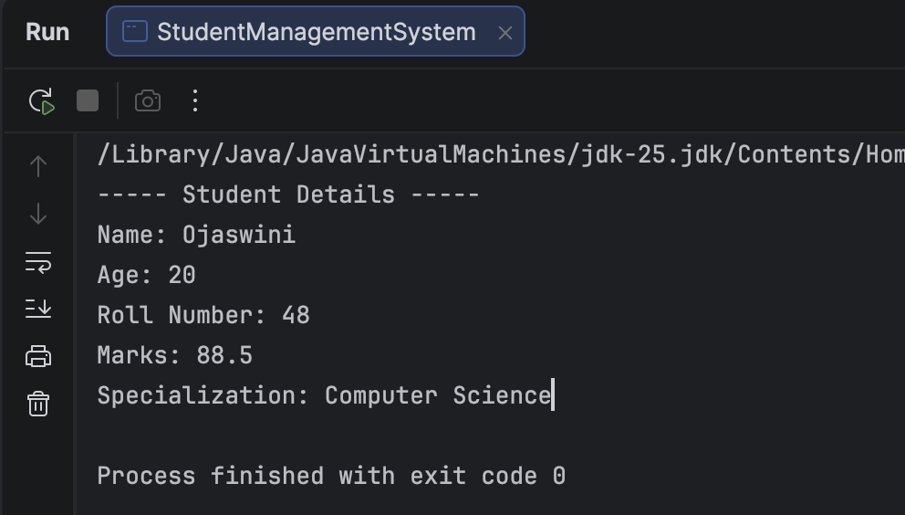
Conclusion
The Student Management System was successfully implemented using the concept of inheritance in Java. The program demonstrates how common attributes such as name and age can be defined in a base class (Person) and reused in derived classes (Student and GraduateStudent), reducing code duplication and improving modularity. By extending classes step-by-step, additional features like roll number, marks, and specialization were efficiently incorporated.

