TEI-Bench: A Controlled, Held-Out Evaluation of the Target-Evaluate-Improve Loop Across 31 Agentic Tasks
Orkhan Javadli (MIT) · Anni Zimina (Stanford)
Code & data: https://github.com/ojavadli/tei-bench

Abstract
Evaluation-guided, automated prompt optimization promises to improve agentic large-language-model (LLM) systems without manual prompt engineering, yet most supporting evidence is anecdotal: single tasks, in-sample evaluation, and subjective LLM-as-judge metrics scored by a model from the same family as the system under test. We present TEI-Bench, a controlled study of the Target-Evaluate-Improve (TEI) loop — a GPA-style multi-dimensional evaluator coupled to a GEPA-style reflective, Pareto-based prompt optimizer — across 31 agents spanning 31 industries. We adopt three safeguards absent from prior demonstrations: (i) a strict train/test split so all reported scores are on held-out inputs; (ii) an objective primary endpoint (accuracy / exact match) computed in code, with the four GPA dimensions as secondary; and (iii) judge-agent separation, optimizing and judging a weaker model (claude-haiku-4-5) with a stronger, different model (claude-sonnet-4-5). On held-out test data, TEI raises the objective score from 0.682 to 0.857 (mean delta = +0.175, 95% CI [+0.115, +0.237], paired t = 5.60, p = 4.3e-06, Cohen's d_z = 1.01; 23/1/7 win/loss/tie). Improvements concentrate on tasks with measurable headroom and on the dimensions a prompt can control (execution accuracy and target alignment), while reasoning soundness is essentially unchanged. We release all code, the 31 task datasets, every agent output trace, and all optimized prompts.

Method & Design (summary)
- Unit of analysis: one agent = one (task, baseline prompt) pair; each measured twice on the SAME held-out test set (baseline vs TEI-optimized prompt). n = 31 paired.
- Models: agent under test = claude-haiku-4-5; judge + optimizer = claude-sonnet-4-5 (stronger, different model -> reduces self-preference bias).
- Primary endpoint: objective, code-computed accuracy / exact match (no LLM). Secondary: four GPA dimensions (judge-scored).
- Optimizer (GEPA-style): reflective mutation on failing TRAIN examples + system-aware merge, Pareto front; never sees the test split.
- Pre-registered analysis: paired t-test, Wilcoxon signed-rank, Cohen's d_z, 10,000-sample bootstrap CI, Holm correction; headroom subset (baseline < 0.9).
- Compute: 6834 LLM calls, $9.74, 54 min wall.

Results: aggregate (held-out, n = 31 paired)
Endpoint | Base | TEI | Δ | 95% CI | t | p | d_z
Objective (primary) | 0.682 | 0.857 | +0.175 | [+0.115, +0.237] | 5.60 | 4.3e-06 | 1.01
GPA aggregate | 0.898 | 0.934 | +0.036 | [+0.018, +0.058] | 3.44 | 0.002 | 0.62
— target alignment | 0.910 | 0.958 | +0.048 | [+0.027, +0.076] | 3.75 | 7.6e-04 | 0.67
— reasoning soundness | 0.898 | 0.899 | +0.001 | [-0.021, +0.019] | 0.06 | 0.950 | 0.01
— execution accuracy | 0.905 | 0.979 | +0.074 | [+0.044, +0.108] | 4.33 | 1.5e-04 | 0.78
— output integrity | 0.878 | 0.900 | +0.023 | [-0.005, +0.052] | 1.53 | 0.136 | 0.27
Win/loss/tie on the objective endpoint: 23/1/7. Wilcoxon p = 2.2e-05. Headroom subset (baseline < 0.9, n = 25): delta = +0.206, p = 6.4e-06, d_z = 1.15.
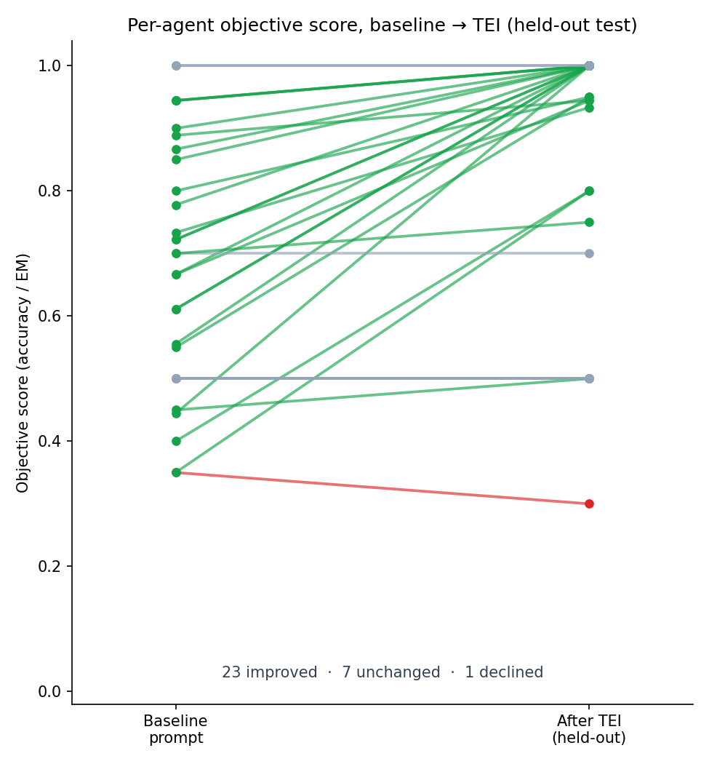
Figure 1. Per-agent held-out objective score, baseline -> TEI.
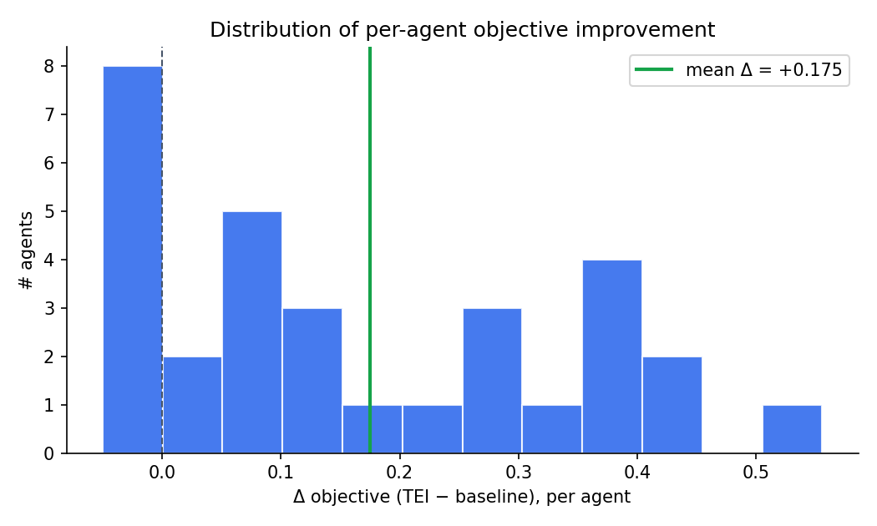
Figure 2. Distribution of per-agent objective improvements.
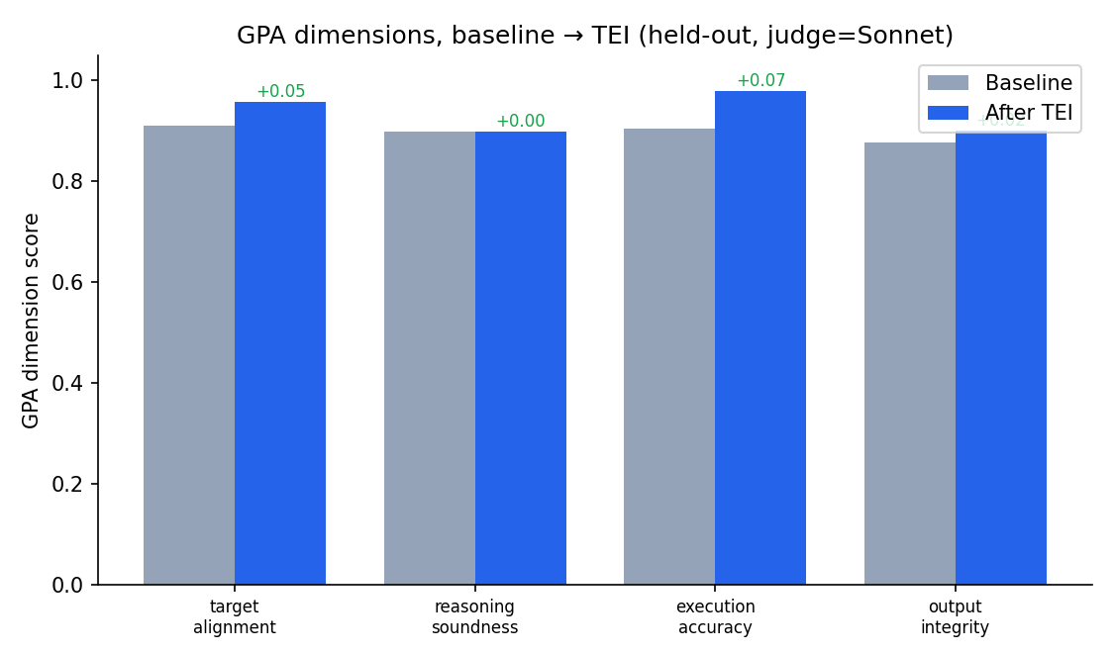
Figure 3. GPA dimensions before/after (held-out).
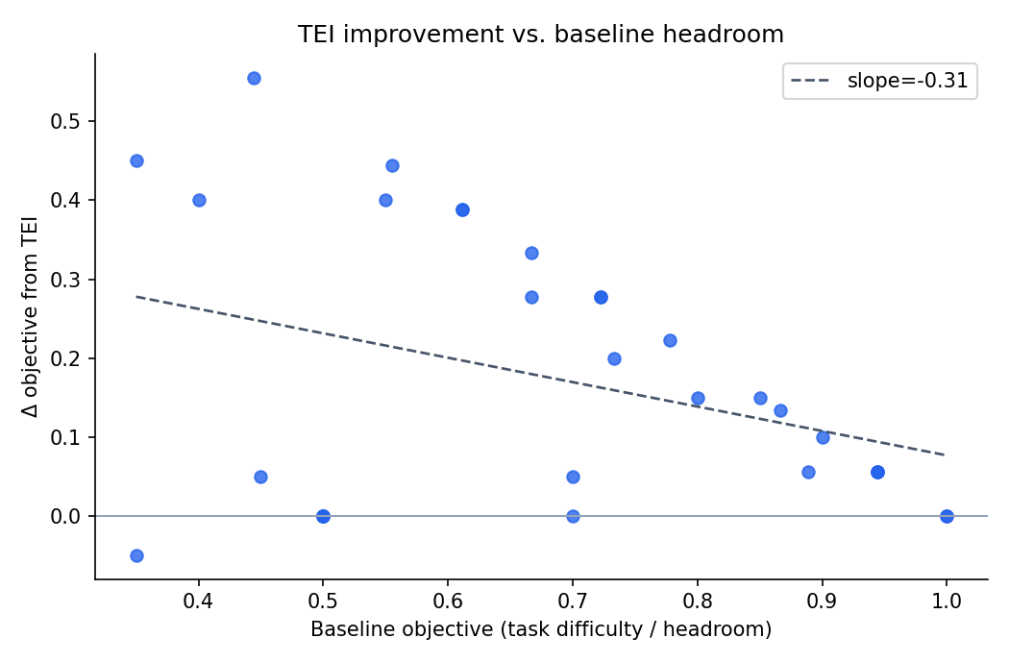
Figure 4. Improvement vs. baseline headroom.

Results: per-agent (held-out)
Agent | Industry | Base | TEI | Δobj | ΔGPA
agri_crop_issue | Agriculture / AgriTech | 0.556 | 1.000 | +0.444 | +0.004
community_forum_topic | Online Community | 0.700 | 0.700 | +0.000 | -0.022
consumer_sentiment_5 | Consumer Insights | 0.350 | 0.300 | -0.050 | +0.033
cybersec_alert | Cybersecurity | 0.722 | 1.000 | +0.278 | -0.004
edtech_question_router | EdTech | 0.800 | 0.950 | +0.150 | +0.247
edu_gsm8k | Education | 0.900 | 1.000 | +0.100 | -0.002
edu_math_word | Education | 0.867 | 1.000 | +0.133 | +0.003
energy_meter_event | Energy / Utilities | 0.722 | 1.000 | +0.278 | +0.013
fin_banking_intent | Finance / Banking | 1.000 | 1.000 | +0.000 | +0.029
gaming_support | Gaming | 0.611 | 1.000 | +0.389 | +0.034
gov_service_router | Government / Public Sector | 0.944 | 1.000 | +0.056 | +0.124
health_triage | Healthcare | 0.733 | 0.933 | +0.200 | +0.038
hospitality_review_stars | Hospitality | 0.500 | 0.500 | +0.000 | +0.005
hr_resume_fit | Human Resources | 0.778 | 1.000 | +0.222 | +0.045
insurance_claim_type | Insurance | 0.889 | 0.944 | +0.056 | +0.026
it_email_spam | Corporate IT Security | 0.550 | 0.950 | +0.400 | +0.038
legal_contract_clause | Legal | 1.000 | 1.000 | +0.000 | +0.008
logistics_incident | Logistics / Supply Chain | 0.611 | 1.000 | +0.389 | -0.002
manufacturing_qa | Manufacturing | 0.667 | 1.000 | +0.333 | +0.009
market_research_subjectivity | Market Research | 0.400 | 0.800 | +0.400 | +0.139
media_news_desk | Media / News | 0.850 | 1.000 | +0.150 | +0.064
news_agency_topic | News Agency | 0.700 | 0.750 | +0.050 | +0.029
pharma_ade | Pharmacovigilance | 0.500 | 0.500 | +0.000 | -0.066
platform_toxicity | Online Platform | 0.500 | 0.500 | +0.000 | +0.023
realestate_attribute | Real Estate / PropTech | 0.944 | 1.000 | +0.056 | +0.026
retail_counterfactual | Retail Analytics | 0.500 | 0.500 | +0.000 | +0.009
saas_ticket_priority | B2B SaaS | 0.667 | 0.944 | +0.278 | +0.006
social_emotion | Social Media / CX | 0.450 | 0.500 | +0.050 | +0.100
telecom_churn_reason | Telecom | 0.444 | 1.000 | +0.556 | +0.025
travel_intent | Travel / Hospitality | 0.944 | 1.000 | +0.056 | +0.010
trust_safety_hate | Trust & Safety | 0.350 | 0.800 | +0.450 | +0.137

References
[1] Agrawal, L. A., et al. (2025). GEPA: Reflective Prompt Evolution Can Outperform Reinforcement Learning. arXiv:2507.19457.
[2] Khattab, O., et al. (2023). DSPy: Compiling Declarative Language Model Calls into Self-Improving Pipelines. arXiv:2310.03714.
[3] Opsahl-Ong, K., et al. (2024). Optimizing Instructions and Demonstrations for Multi-Stage Language Model Programs (MIPROv2). arXiv:2406.11695.
[4] Yang, C., et al. (2023). Large Language Models as Optimizers (OPRO). arXiv:2309.03409.
[5] Zhou, Y., et al. (2022). Large Language Models Are Human-Level Prompt Engineers (APE). arXiv:2211.01910.
[6] Yuksekgonul, M., et al. (2024). TextGrad: Automatic "Differentiation" via Text. arXiv:2406.07496.
[7] Madaan, A., et al. (2023). Self-Refine: Iterative Refinement with Self-Feedback. arXiv:2303.17651.
[8] Shinn, N., et al. (2023). Reflexion: Language Agents with Verbal Reinforcement Learning. arXiv:2303.11366.
[9] Zheng, L., et al. (2023). Judging LLM-as-a-Judge with MT-Bench and Chatbot Arena. arXiv:2306.05685.
[10] Jia, A. S., Huang, D., Vytla, N., Choudhury, N., Sen, S., Mitchell, J. C., Datta, A. (2025). GPA: A Goal-Plan-Action Framework for Evaluating Agentic Systems. Stanford University.
[11] Cobbe, K., et al. (2021). Training Verifiers to Solve Math Word Problems (GSM8K). arXiv:2110.14168.
[12] Casanueva, I., et al. (2020). Efficient Intent Detection with Dual Sentence Encoders (banking77). arXiv:2003.04807.

