Global Reference Architecture
Juvenile History Service

Information Exchange Package Documentation (IEPD)

Master Document

Version 1.0.0

Michigan Juvenile Justice Vision 20/20

September 2014

This project was supported by Grant No. 2013-DB-BX-K062 awarded by the Bureau of Justice, Office of Justice Programs in collaboration with the U.S. Department of Justice’s Global Justice Information Sharing Initiative. The opinions, findings, and conclusions or recommendations expressed in this publication are those of the author(s) and do not necessarily reflect the views of the U.S. Department of Justice.

This project was supported by Grant No. 2013-DB-BX-K062 awarded by the Bureau of Justice, Office of Justice Programs in collaboration with the U.S. Department of Justice’s Global Justice Information Sharing Initiative. The opinions, findings, and conclusions or recommendations expressed in this publication are those of the author(s) and do not necessarily reflect the views of the U.S. Department of Justice.
Table of Contents

Overview 1
Purpose 1
Description 1
Business Requirements 1
Business Context 1
Exchange Content Requirements 2
Messages 2
(a) JuvenileHistoryQuery 2
(b) JuvenileCasePlanHistoryResponse 3
(c) JuvenileHearingHistoryResponse 4
(d) JuvenileIntakeHistoryResponse 4
(e) JuvenileOffenseHistoryResponse 4
(f) JuvenilePlacementHistoryResponse 5
(g) JuvenileReferralHistoryResponse 5
Logical Structure 6
Exchange Schema 7
Extension Schema 7
NIEM 3.0 Subset Schema 7
Implementation Guidance 7
Security and Privacy Considerations 7
Appendix A—Glossary 8
Appendix B—Document History 9

Overview

Purpose

The Juvenile History Information Exchange Package Documentation (IEPD) provides an information model to support the exchange of data using the Juvenile History Service. The Juvenile History Service provides a summary of the availability and location of information relating to a specific juvenile by querying multiple sources. This capability enables exchange partners to request and receive detailed information on the participation of a specific juvenile in juvenile justice programs.

Description

The Juvenile History Service and IEPD will be used by organizations to request and receive detailed information on the participation of a specific juvenile in juvenile justice programs. It requires prior knowledge of the juvenile’s unique identifier(s) in the provider’s system which may be obtained using the Juvenile Demographics Service and IEPD.

Business Requirements

The Juvenile History IEPD was created to enable juvenile justice providers and stakeholders in the State of Michigan to obtain information a specific juvenile, specifically their participation in juvenile justice programs statewide. This section describes the business context and requirements of the Juvenile History Service.

Business Context

Common juvenile justice data elements and definitions are lacking among Michigan’s courts and other juvenile justice system providers. Currently, courts, other juvenile justice system providers, and the state as a whole are not able to accurately and consistently record and report on juvenile justice system activities and outcomes.

Juvenile Justice Vision 20/20 (JJV 20/20), which began in 2012, identified juvenile justice system data as a key, strategic focus area. Several data initiatives have emerged since 2012 to help improve juvenile justice system data in Michigan. Progress is continuing on many fronts. In particular, developing a juvenile justice data dictionary and data sharing model, and implementing the data sharing model in 5 pilot sites in Michigan, are underway currently with grant funding from the State Justice Institute and Bureau of Justice Assistance.

Developed by a small, representative workgroup from JJV 20/20 in late 2013/early 2014, the Juvenile Justice Data Dictionary will help improve uniformity, consistency, and accuracy in juvenile justice data across Michigan. However, it is a work in progress; additional data elements and definitions will be added and developed in the future. At this time, it includes data elements and definitions consistent with the BJA data sharing model. Specifically, the key terms included are for:

- Identifying, counting, and summarizing information about youth in the system (i.e., answering the question of “who” is in Michigan’s juvenile justice system); and

- Understanding “what” is happening (or has happened) to youth in the system.

Exchange Content Requirements

This IEPD supports the exchange of a list of data elements and definitions for understanding “what” is happening (or has happened) to youth in the system. The list of data elements for answering “what” is happening to youth involved in Michigan’s juvenile justice system is provided in Table 1.

TABLE 1:
DATA ELEMENTS – “WHAT IS HAPPENING (OR HAS HAPPENED) TO YOUTH IN THE SYSTEM?”
Essential Data Elements (Phase 1)
- Referral History (Phase 1) (all youth processed formally and informally)
- Types of Referrals
- Referral sources
- Intake
a. Intake Process
b. Intake Outcomes
- Types of hearings
- Out of Home Placements
- Dispositional Options
- Financial Accountability
- Other Case History Data Sources
- Offense History
- Assessments
- Case Plans
- Services/Treatment Programs (continuum of services)
- Placement History
- Types of Placement Options

Messages

The design of the Juvenile History Service is based on a request-response message exchange pattern. The IEPD defines a request message (JuvenileHistoryQuery) and 6 response messages each scoped to a specific portion of the juvenile’s history and interaction with particular juvenile justice entities. Domain models, formatted as UML class diagrams, for all the messages are provided below.

JuvenileHistoryQuery

The query message identifies the specific juvenile of interest by providing a unique identifier for the juvenile in the provider’s system. The query message is generic and not specific to a specific portion of the juvenile’s history. The query message may be used in combination with any of the 6 response messages.

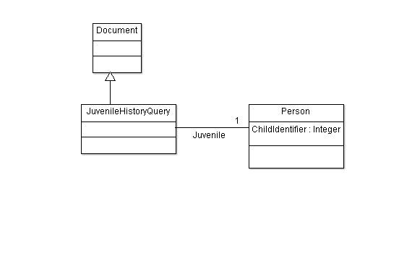

JuvenileCasePlanHistoryResponse

The 6 response messages each provide detailed information about the juvenile’s participation in a specific set of juvenile justice programs, including their case plans, hearings, intakes, offenses, placements and referrals.

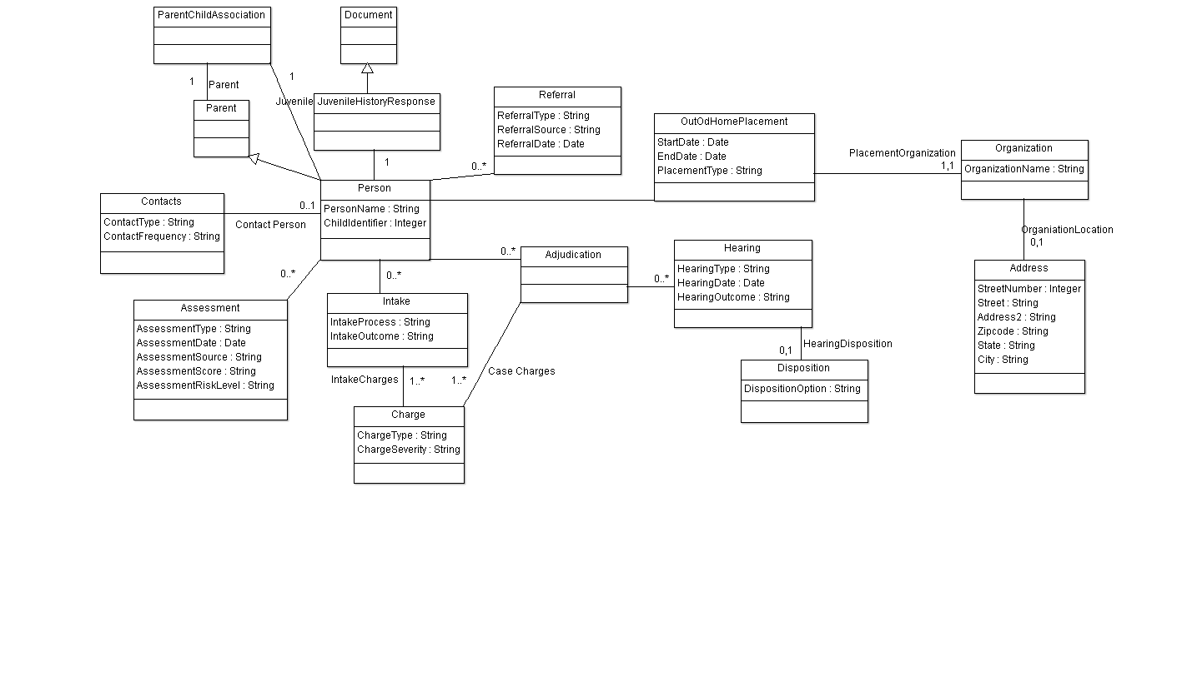Each response message provides a subset of the information shown in the above domain model. The contents of the JuvenileCasePlanHistoryReponse includes:

Name
Case Plan (yes/no)
Assessment (yes/no)

JuvenileHearingHistoryResponse

The contents of the JuvenileHearingHistoryReponse includes:

Hearing Type
Hearing Outcome

JuvenileIntakeHistoryResponse

The contents of the JuvenileIntakeHistoryReponse includes:

Intake Process
Screening (yes/no)
Assessment (yes/no)
Interview (yes/no)
Other
Intake Outcomes
Informal
Court diversion
Consent calendar
Hold in abeyance
Send warning letter
Formal Calendar
Transfer

JuvenileOffenseHistoryResponse

The contents of the JuvenileOffenseHistoryReponse includes:

Charge
PACC code
Date
Location
Local Charge
Description
Date
Location
Adjudication
Type
Not guilty/not responsible
Guilty/responsible
Dismissed
Date
Disposition (or Sentencing for designation cases)
Type
Warning
Probation
Residential Placement
County Jail
Adult Sentence
Date
Probation Violation
Yes/No
Date
Contempt of Court
Yes/No
Date

JuvenilePlacementHistoryResponse

The contents of the JuvenilePlacementHistoryReponse includes:

Placement Type
Custodial/Non-custodial Parent
Guardian
Relative/Friend
Foster Care (tie definition to payment)
Residential Care
Independent Living
Group home
Shelter Home
Detention
Jail
Placement Security (link to facility)
Secure
Non-secure
Placement History
Start Date
Day
Month
Year
End Date
Day
Month
Year
Person/Facility Name
Person/Facility Address

JuvenileReferralHistoryResponse

The contents of the JuvenileReferralHistoryReponse includes:

Referral Source
Police
Prosecutor
School
Court/Probation
Social Service Agency
Other
Referral Type
Complaint
Citation/Appearance Ticket
Petition
Community Referral
Referral History
Name
Organization
Instance/Count
Date

Logical Structure

The Juvenile History IEPD provides the structures and elements required for the IEPD in three primary schemas:

- Exchange Schema: Defines structures for each of the following messages exchanged by the Juvenile History Service including:
  - Query Message:
    - JuvenileHistoryQuery
  - Responses Messages:
    - JuvenileCasePlanHistoryResponse
    - JuvenileHearingHistoryResponse
    - JuvenileIntakeHistoryResponse
    - JuvenileOffenseHistoryResponse
    - JuvenilePlacementHistoryResponse
    - JuvenileReferralHistoryResponse

- Extension Schema: Contains Juvenile History-specific structures and elements used by the IEPD.

- NIEM 3.0 Subset Schema: Contains NIEM 3.0 structures and elements used by the IEPD.

A discussion of each of these components is included in the following sections.

Exchange Schema

The Juvenile History IEPD Exchange Schema provides structures to support the messaging requirements of the Juvenile History Service, including NIEM 3.0 definitions for the query message and the 6 response messages. Sample instances of each message are provided in the IEPD. The query message includes data elements to identify the query criteria. The response message contains the requested information and associated metadata.

Query Message (<local:JuvenileDemographicsQueryMessage>)

- Query Criteria (<local:JuvenileDemographicsQueryCriteria>): Contains the criteria used for performing the query.

The Query Message extends from the <nc:DocumentType>. As such, elements of the document type may be used by implementers to support the needs of their specific exchanges.

Response Message (<local:JuvenileDemographicsResponseMessage>)

- Query Criteria (<local:JuvenileDemographicsQueryCriteria>): Contains the criteria used for performing the query.

- Juvenile Information Availability (<nc:StatusType>): Indicates whether a particular type of information was available.

The Query Message extends from the <nc:DocumentType>. As such, elements of the document type may be used by implementers to support the needs of their specific exchanges.

The metadata in the response optionally includes nc:LastUpdatedDate. If nc:LastUpdatedDate is not included, the data is assumed to be real-time. If the data is not real-time, nc:LastUpdatedDate must be included in the response message.

Sample instances of the query and response messages are provided in the IEPD.

Extension Schema

The Juvenile History IEPD Extension Schema defines structures and elements that are required for the IEPD and not defined in NIEM 3.0. The extension schema conforms to the NIEM 3.0 Naming and Design Rules (NDR) available at niem.gov.

Additional discussion of the Juvenile Information Availability Code is included in the sections below.

Juvenile Information Availability Code (<local:JuvenileInformationAvailabilityCode)

The Juvenile Information Availability Code indicates the status of a particular type of information using one of three enumerated values:

- FOUND: Indicates that the responding system found information using the supplied query criteria.

- NOT FOUND: Indicates that the responding system found no information using the supplied query criteria.

- UNKNOWN: Indicates that the responding system was unable to perform the search. Can also indicate that the requesting system was unable to contact the responding system or did not receive a response from the responding system (see Information Availability Failure) below.

NIEM 3.0 Subset Schema

The Juvenile History IEPD NIEM 3.0 Subset Schema provides the structures and elements required for the IEPD that are defined in NIEM 3.0. The subset was generated using the NIEM 3.0 Subset Schema Generation Tool (SSGT) available at niem.gov.

Mapping

For information regarding the mapping of specific entities and data elements to NIEM components, please refer to the Juvenile History Mapping document included in this package.

Implementation Guidance

Implementers of this IEPD should consider the following guidance in their implementation.

Security and Privacy Considerations

Most states, including Michigan, require that personally identifiable information (PII) on juveniles be protected. Access to juvenile demographic information must be limited to authenticated and approved users. Implementers of this IEPD should consult guidance on securely implementing services, such as the Global Reference Architecture Reliable Secure Web Services Service Interaction Profile (RS WS SIP).

Appendix A—Glossary

DMC | Disproportionate Minority Contact
DOJ | United States Department of Justice
GRA | Global Reference Architecture
IEPD | Information Exchange Package Documentation
NDR | NIEM Naming and Design Rules
NIEM | National Information Exchange Model
OJJDP | DOJ Office of Juvenile Justice and Delinquency Prevention
RS WS SIP | GRA Reliable Secure SIP
SID | State Identifier
SIP | GRA Service Interaction Profile
SSGT | NIEM Subset Schema Generation Tool
UML | Unified Modeling Language

Appendix B—Document History

Date | Version | Editor | Change
9/18/2014 | 1.0.0 | James E. Cabral Jr. | Initial version

