I opened up the data set and scanned visually for anything obvious, unsurprisingly finding nothing. I also opened it up in Excel, sorted by the +/- column, and still didn’t see anything. I did run some summary stats, finding that there were 212 winners and 85 losers.

So then tonight I wrote up a script to pull out the attributes, as I had planned to. Here’s the rough code:

class CSVParser
path = 'winners_losers_with_attributes.csv'
lines = IO.readlines(path)
newLines = Array.new()
i = 0
lines.map do |line|
if(i==0)
description = "Second letter of first name"
newLines.insert(0,line.chomp + ',' + description)
else
name = line.split(",").first
firstname = name.split(" ").first
lastname = name.split(" ").last
value = firstname[1, 1]
puts value
newLines.insert(-1, line.chomp+','+value.to_s)
end
i = i + 1
end
File.open(path, 'w') do |file|
file.puts newLines
end

end

Obviously, that’s very rough, but it did what I needed it to do. I just modified the description and the logic in the else statement and that made it relatively easy to generate new attributes. The most difficult part was the simple fact of coding all the diverse ideas I had. “Count the number of vowels” sounds much easier to code than it actually is! But it wasn’t particularly hard either. I coded up maybe 10 attributes and then moved on to using Knime. Here’s some of the data:
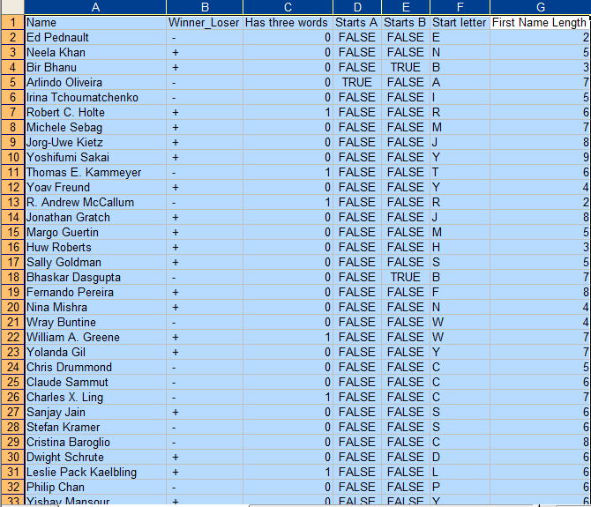

Knime was surprisingly easy – maybe because I had the benefit of hearing not to use Weka. I stuck with all the default options, connected the CSV reader module to my modified CSV file, connected it to the decision tree, told it to use the +/- column and ran it. At first I was confused that the depth was only one, but then I figured out the little + signs below the tree were expandable. It seemed to like splitting on the first character, but unsurprisingly it wasn’t very good.

Eventually I just used the answer I had already heard in class: what matters is whether the second character is a vowel. I probably wouldn’t have asked that question, but splitting on the second character was possible, so I did that instead and ran it through Knime again. Here’s the main and simple decision trees it produced:
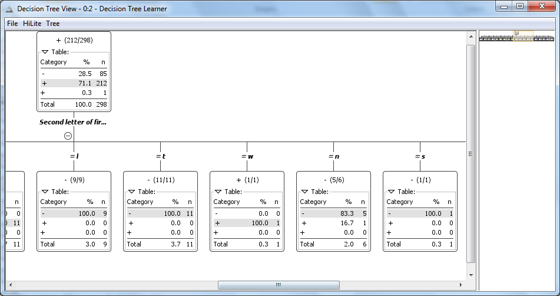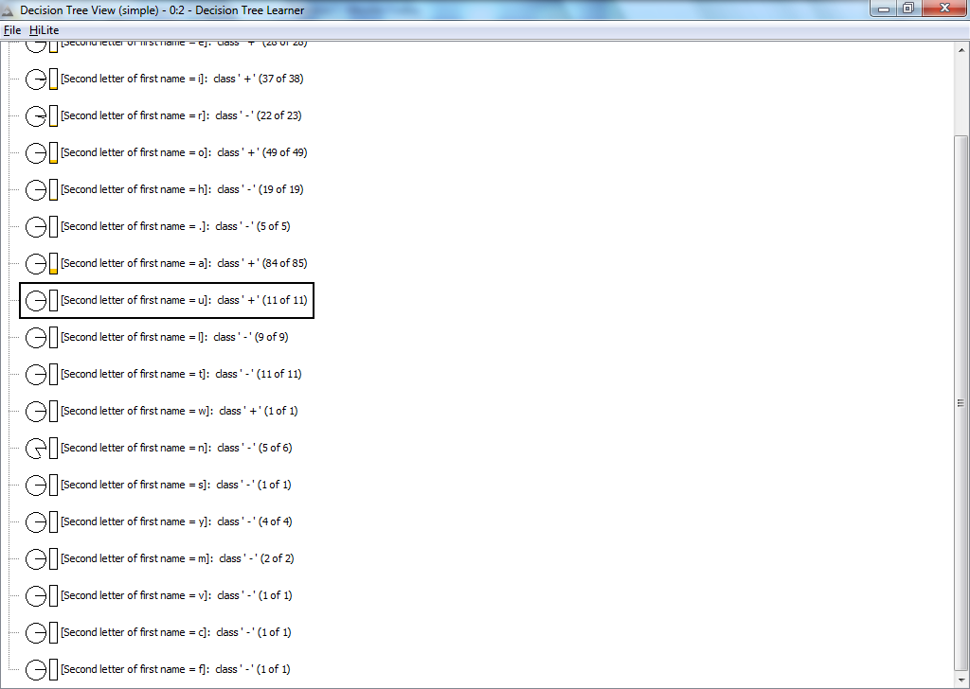
And those would have been enough for me. I didn’t find an accuracy percentage value (and yes, I did try connecting the output to the statistics module), but with only three values of noise, it is indeed clearly the answer. Kinda fun process actually and I’m looking forward to doing similar things soon!

