**PROJECT NAME – STUDENTS MANAGEMENT SYSTEM**

ABSTRACT

Student management systems serve academic institutions in a variety of ways, the most important of which is centralized data administration and accessibility. Administrators will be able to input, maintain, and access student data more simply. This will cub missing the data submitted by the students.

Documentation Diagrams:

Use Case Diagram, Class Diagram, Sequence Diagram, and Activity Diagram

Programming language used – Python and Mysql

Student Management System Modules

* **Student Information Management**: The data that are gathered form the student information must be secured in this system. These data were composed of the student basic information and academic status. This data after submission can be updated, deleted as the case may be.
* **Enrollment Management**: This is the process where the system takes care of the requirements provided by the student enrollees. They will require the birth cert of the enrollees for confirmation as well as their academic status that will serve as their basis if the student is new or continuing.

These modules must be present in creating the Student Management System to meet the needs in managing student information. Through this, the management and monitoring of students and school would be much easier for both school admin and teachers these modules for student management system were derived from the student management activities and processes.

UML Diagrams for Student Management System Project Report and Documentation.

1. **Student Information System Use Case Diagram**

 This discusses the meaning of the Student Information System project UML as well as its use case diagram using include and extend.  
  
A use case diagram is a visual representation of how a user might interact with a program. A use case diagram depicts the system’s numerous use cases and different sorts of users. The circles or ellipses are used to depict the use cases.  
  
By creating the use case of the Student Information System, you must determine first the possible features to identify the flow of the system. After that, you can now create the blueprint or core of the system function.

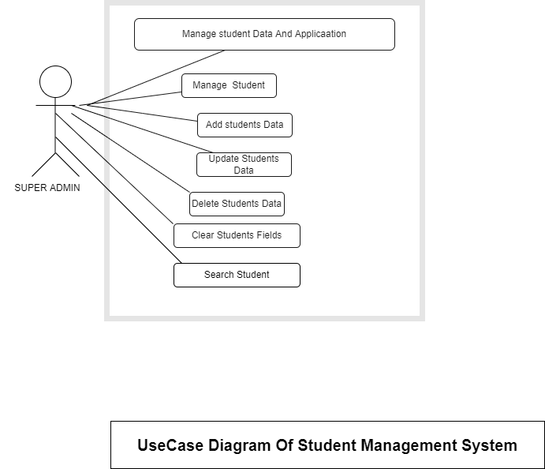

2.[**Student Management System Class Diagram**](https://itsourcecode.com/uml/student-course-registration-system-class-diagram-uml/)

STUDENT MANAGEMENT SYSTEM CLASS DIAGRAM is a designed diagram the shows the system’s relationships and classes. This UML Class Diagram is made to guide programmers along with the Student management system development. It contains the class attributes, methods as well as the relationships between classes. These mentioned contents makes sure that your Student management system development must inline with what should be its functions.

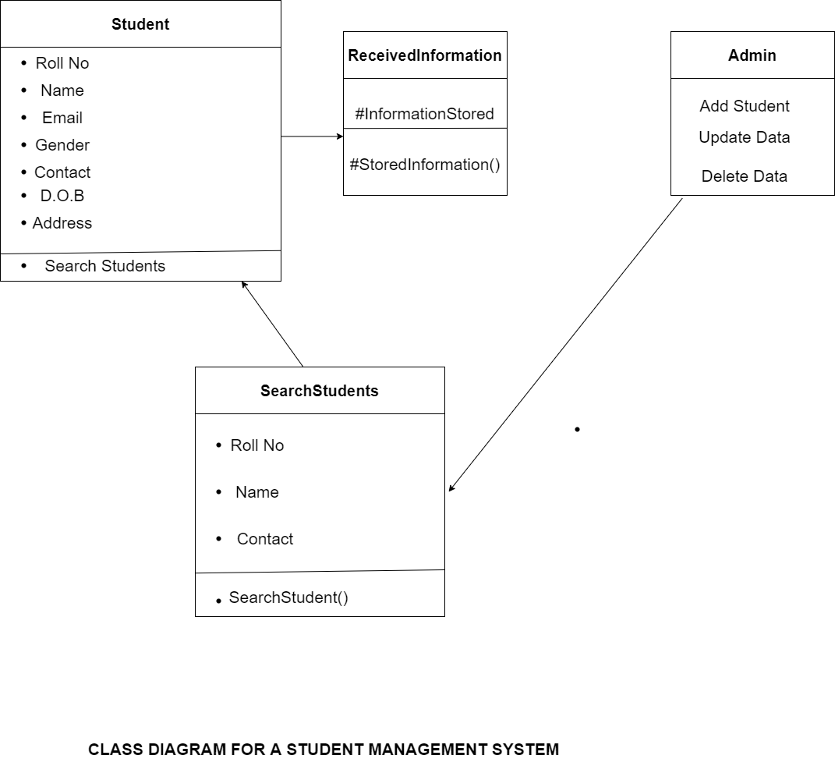

**3.** [**Student Management System Sequence Diagram**](https://itsourcecode.com/uml/student-management-system-sequence-diagram-uml/)

STUDENT MANAGEMENT SYSTEM SEQUENCE DIAGRAM illustrates the Student management activities using actors, objects and messages. This diagram gives you ideas and guides you on how should the Student Management System be built. These ideas were applied in UML sequence diagram to give efficiency on Student Management System development.

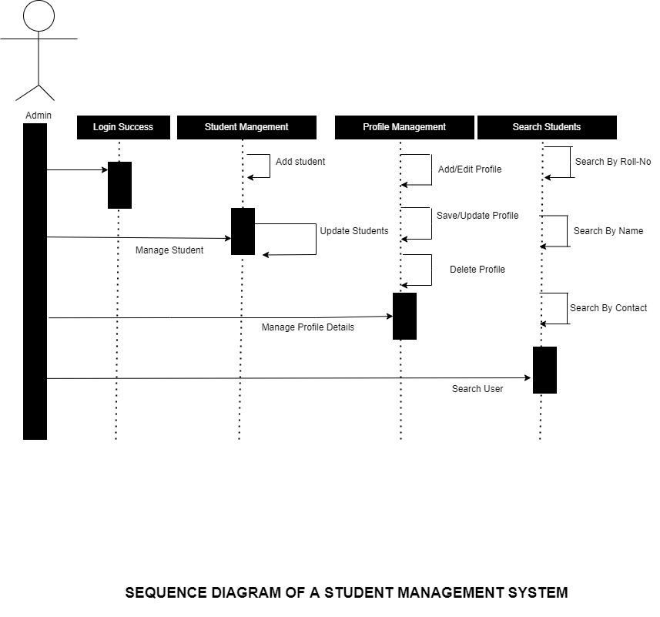

**4.**[**Student Management System Activity Diagram**](https://itsourcecode.com/uml/student-management-system-activity-diagram-uml/)

Student Management System Activity Diagram is built to give the proponents the right ideas on how to develop the said software. When designing this system activity diagram, you must know the flow of activities done in doing Student management. Why is that? it is because this will help you, your readers and users about how should the software behave once it is in use. It’s activity diagram is illustrated with the use of symbols like actors, swim lanes and arrows to understand the Student Management System core.

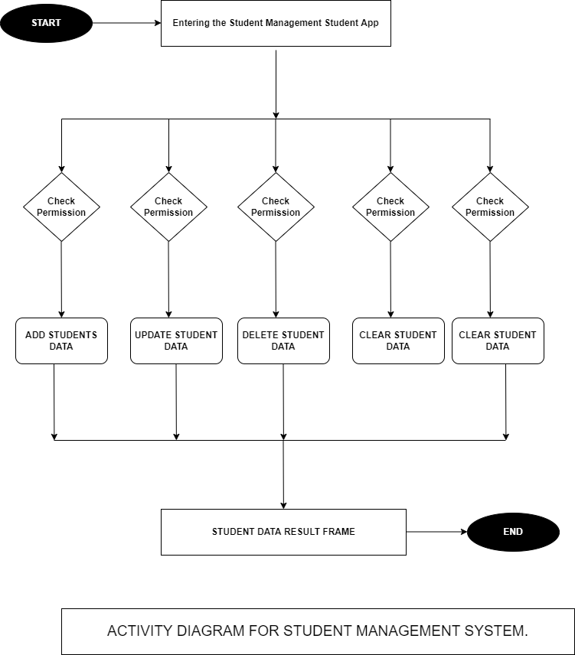

**THE APPLICATION FLOW**

The Application is divided into understand the following sessions

1. Accepting the Students Data
2. Update Students Data
3. Delete students Data
4. Clear Field
5. Search Student Data Using Roll No, Name or Contact
6. Show All Students Data
7. Logout

1.Accepting Students Data

The Data provided by the students are inserted into the Entry Fields provided on the Tkinter Application. Once all field has been properly provided the Admin can Click on the Add button to submit all the data to the Database. The inserted data will therefore appear on the right hand side of the screen.

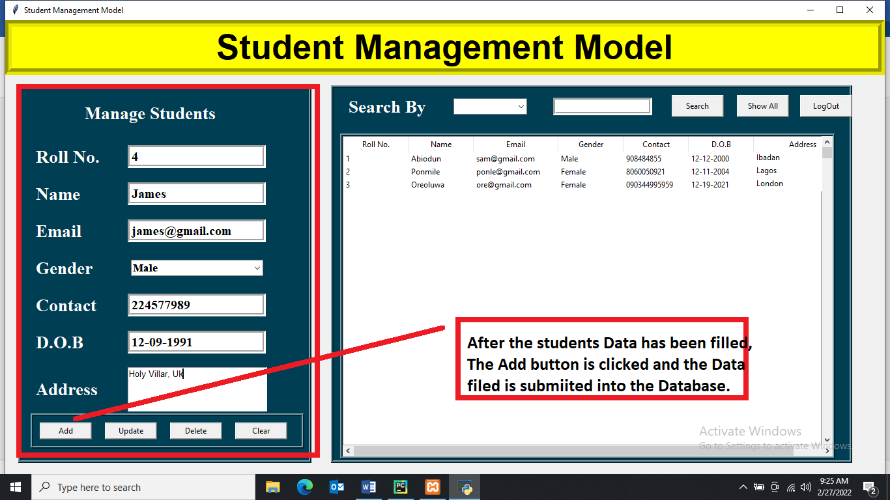

Fig 1.1

2.Update Students Data

After the student data has been submitted. In a situation where there is a need to correct or update the registered details about the student. The Admin can click on the student data. Make changes and click on the Update button. A confirmation message popped up on the screen as seen in fig 2.1. The changed data is updated properly as seen in fig 2.2

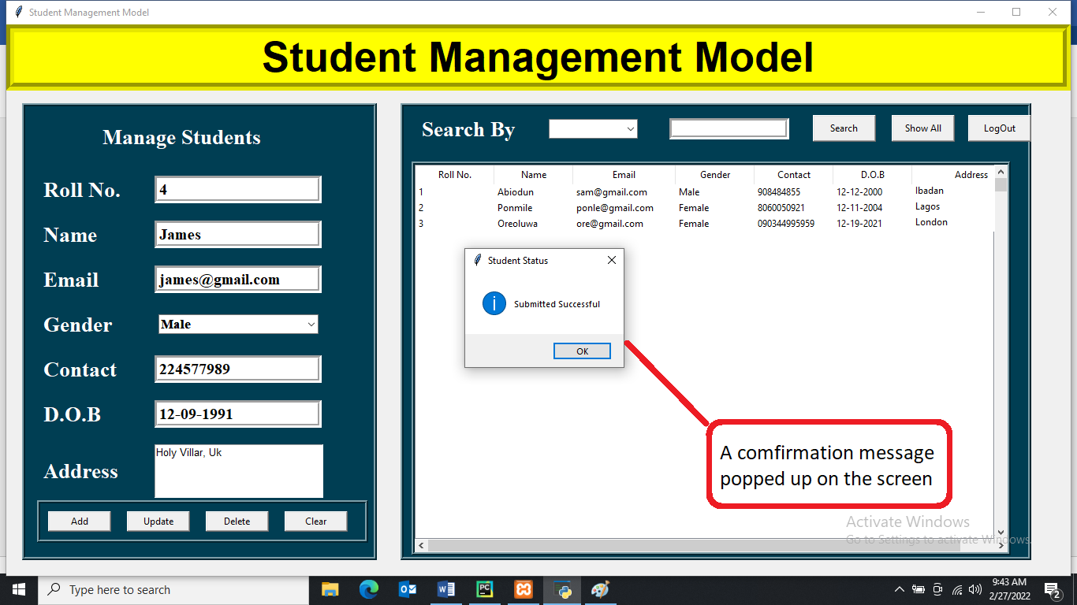

fig 2.1.

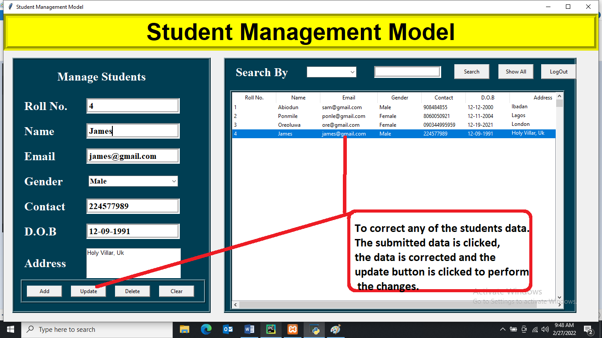

fig 2.2.

3.Delete students Data

The Admin has the opportunity to Delete any student data on the application. The data is clicked and the Delete button is clicked. The student data will be deleted from the database. fig 3.1.

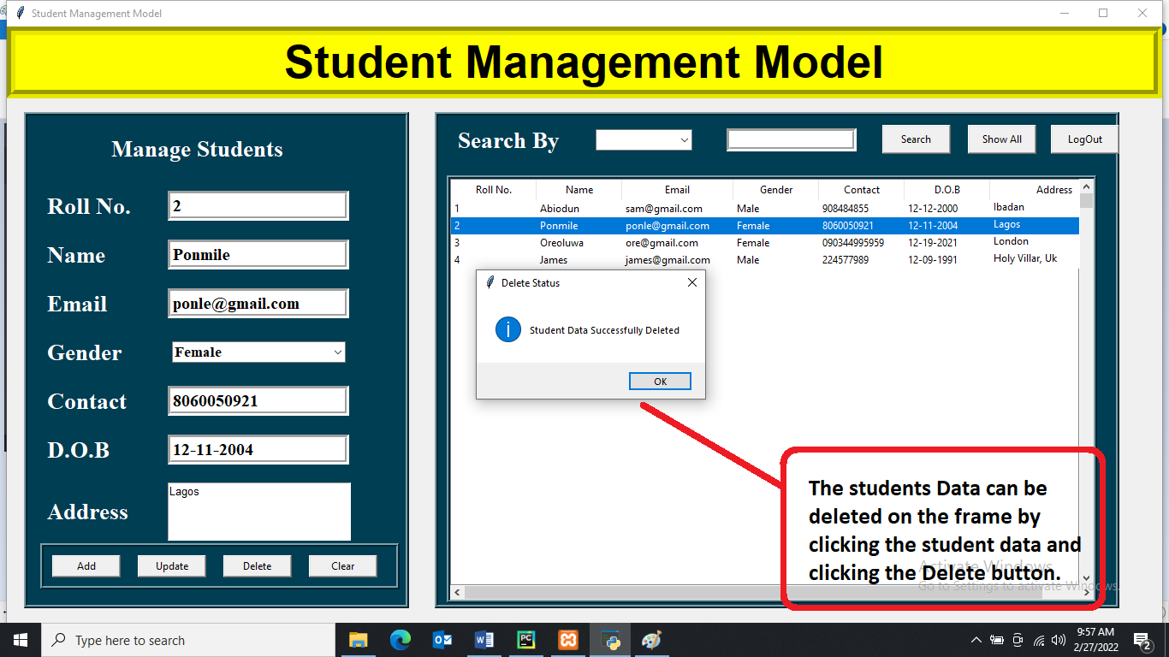

fig 3.1.

1. Clear Field

The filled Entry on the Application can be cleared due to errors after filling it as shown in the picture below.

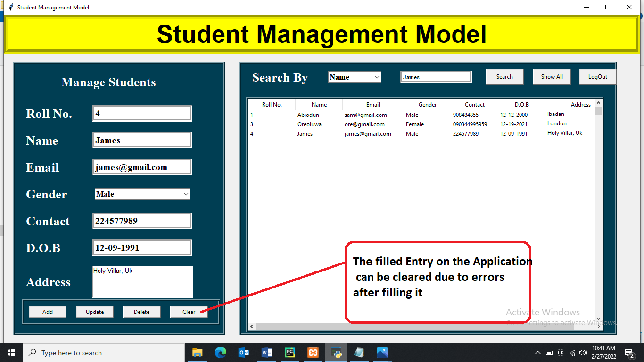

Fig 4.1

5.Search Student Data Using Roll No, Name or Contact

Every student on the application can be searched by the admin using their Roll No, Name or Contact filled during registration. The required option is picked and the entry box is filled with the right detail. The search button is clicked and the student appear.

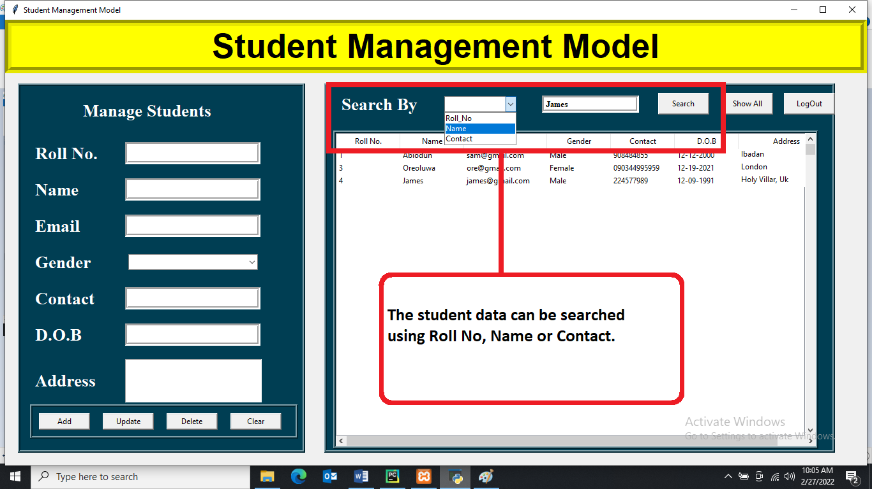

Fig 5.1

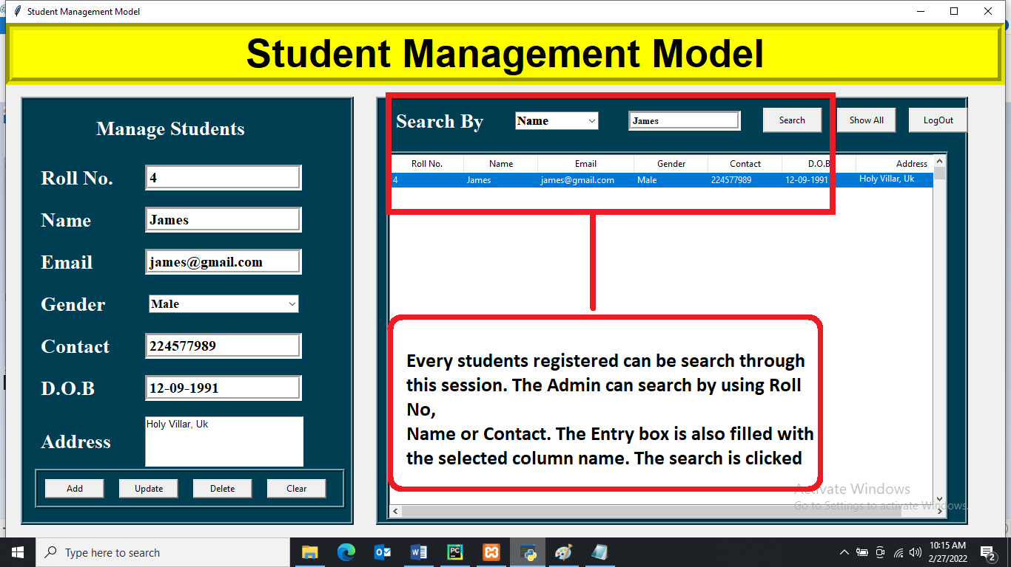

Fig 5.2

6.Show All students Data

After a particular student data has been searched. The show all button is used to show all the students that has been registered on the application.

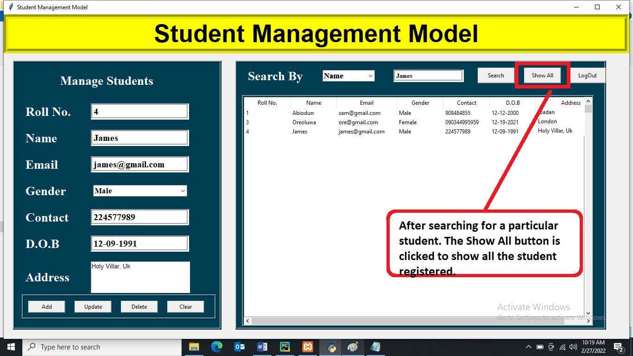

Fig 6.1

1. Logout

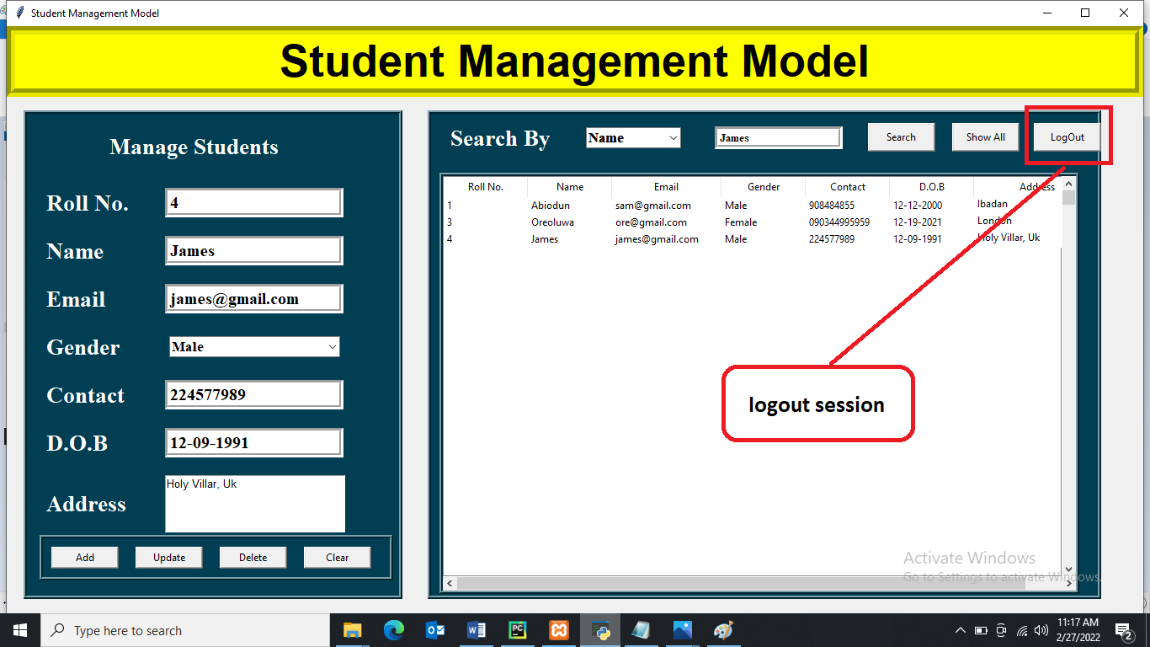

Fig 8.1