SAFe® Product Owner/Product Manager, Scrum Master Certified SMC™, Automation DevOps Engineer, analytical Senior Software Developer, expert in Java, C#,. Skilled in Digital Transformation, developing business plans, requirements specifications, user documentation, and architectural systems research.

Strong in RPA implementation (UiPath, Automation Anywhere, Blue Prism) design, analyst research and training coach of RPA teams, infrastructure, Data Science, and Artificial intelligence.

Forms I-140 $460

I-907 $2500

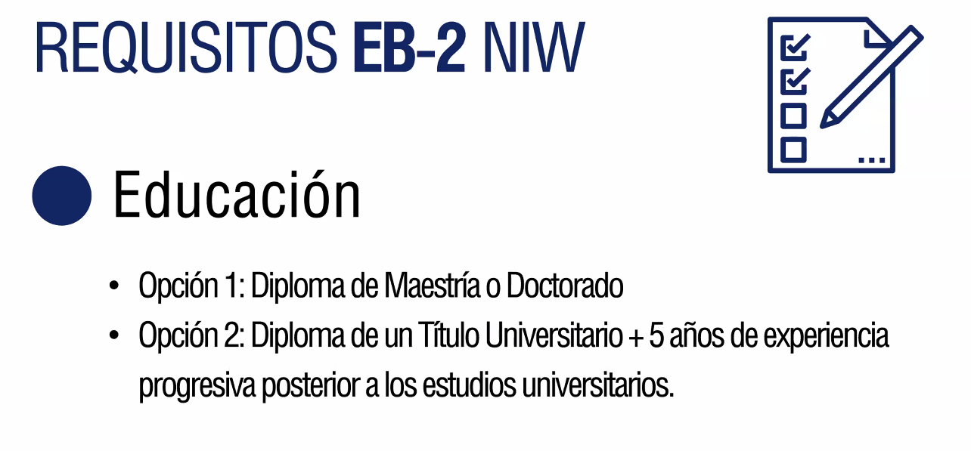

dfdfdf