Project: Example Take-Home Challenge: Relax Inc.

1. Used *takehome_user_engagement* file and identified users with 3 visits within any 7-day or less time period. Label them as Adopted Users.
2. Merged Adopted Users label with *takehome_users* file. *takehome_users* file has more than 3000 users that are not present in the user engagement file. These extra users were labeled as Non-adopted users as they did not have visit records so it is sensible to consider them as not adopted.
3. There are 13.35% adopted users among 12000 users.
4. User_id, creation_time, name, email, last_session_creation_time are not sensible predictors.
5. Crosstab shows that creation source appears to have some prediction power, with GUEST_INVITE and SIGNUP_GOOGLE_AUTH showing higher than average Adopted User fraction, and with PERSONAL_PROJECTS showing lower than average Adopted User fraction. See table below. Normalized column shows the adopted user fraction, and total_frequency column is the total number of users in that group (adopted and not adopted combined).

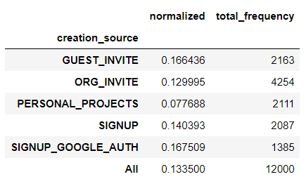

1. Opted_in_to_mailing_list and enabled_for_marketing_drip do not show significant impact.

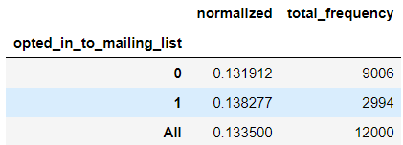 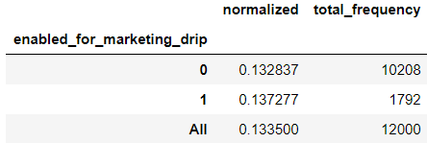

1. Org_id and invited_by_user_id both have many category levels with small sample size in every level, and therefore are not good predictors.
2. Org_id may have some prediction power. Suggest to find out if there is some sensible way to combine org_id into less number of groups and re-visit the data.