Requirement Analysis Report (RAR)
Student Support and Grievances System

Index
1. Introduction
1.1 Purpose
1.2 Scope
1.3 Objectives
2. Feasibility Study
2.1 Technical Feasibility
2.2 Economic Feasibility
2.3 Operational Feasibility
3. Stakeholder Analysis
4. Functional Requirements
5. Non-Functional Requirements
6. System Models
6.1 Use Case Diagram
6.2 Data Flow Diagram (DFD)
6.3 Entity-Relationship (ER) Diagram
7. Constraints & Assumptions
8. Future Enhancements
9. Conclusion

1. Introduction

1.1 Purpose
The purpose of the Student Grievances System is to provide a structured platform where students can submit, track, and resolve their grievances efficiently. It ensures transparency, accountability, and timely redressal of issues faced by students.

1.2 Scope
The system will be developed as a web-based and mobile-accessible application. It allows students to log complaints, faculty/administration to review them, and grievance committees to resolve them. Notifications and status updates will keep students informed throughout the process.

1.3 Objectives
• Provide a centralized grievance redressal platform.
• Improve transparency between students and administration.
• Reduce resolution time with an automated workflow.
• Maintain records for reporting and analytics.

2. Feasibility Study

2.1 Technical Feasibility
The proposed Student Grievance System is technically feasible as it can be developed using Python (Django/Flask), MySQL/PostgreSQL databases, and deployed on cloud servers. Django provides user authentication, database integration, form handling, and an admin panel for management.

2.2 Economic Feasibility
The system is economically feasible since it reduces paperwork, administrative costs, and staff workload. Open-source technologies minimize initial costs. Long-term benefits include improved efficiency, transparency, and student satisfaction.

2.3 Operational Feasibility
The system is easy to use for students, faculty, and admins. Training requirements are minimal. It provides reliable operations with role-based access for different users.

3. Stakeholder Analysis
1. Students – Register, login, submit grievances, track status, receive notifications.
2. Faculty/Staff – Respond to grievances assigned to them, ensure resolution.
3. Grievance Committee/Admin – Monitor, assign, and resolve complaints, generate reports.
4. System Administrator – Maintain system security, uptime, backups, and updates.

4. Functional Requirements
• User Registration & Login (Student/Admin/Faculty).
• Submit grievance (category, description, attachments).
• Track grievance status (Pending, In-progress, Resolved).
• Notifications via email/SMS/app.
• Admin dashboard for managing grievances.
• Reporting & analytics.

5. Non-Functional Requirements
• Performance – Quick response time (<2s).
• Security – Encrypted data, role-based access.
• Scalability – Support large number of users.
• Usability – User-friendly interface.
• Reliability – 24/7 availability.

6. System Models

6.1 Use Case Diagram

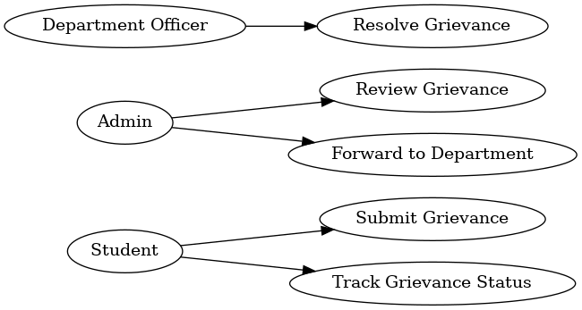

6.2 Data Flow Diagram (DFD)

6.2.1 Level 0 DFD
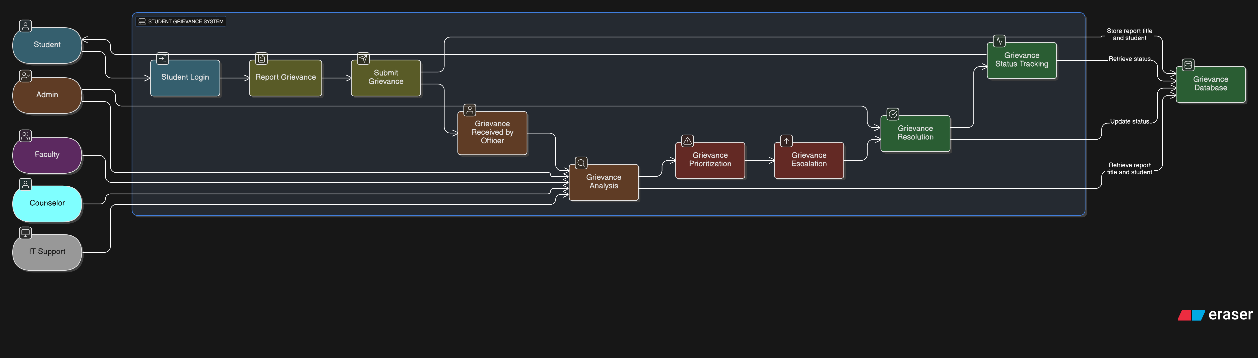
6.2.2 Level 1 DFD
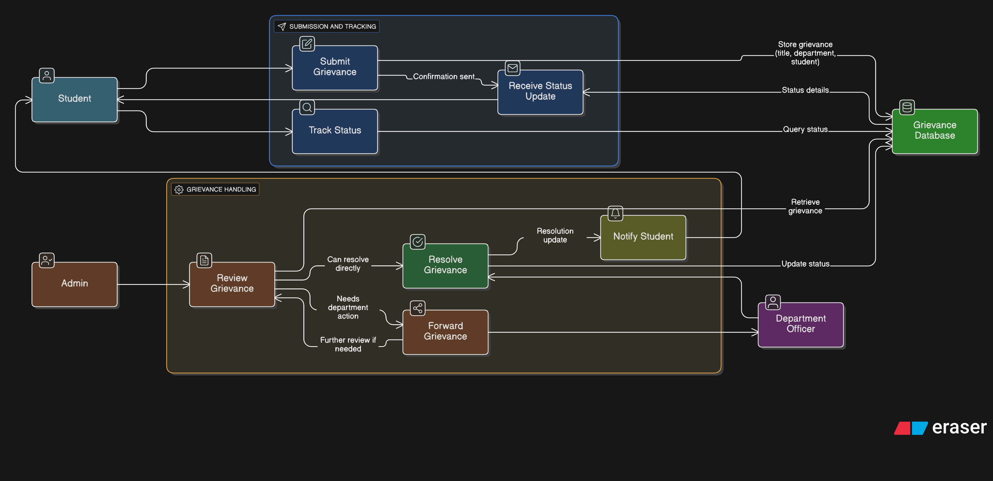

6.3 Entity-Relationship (ER) Diagram

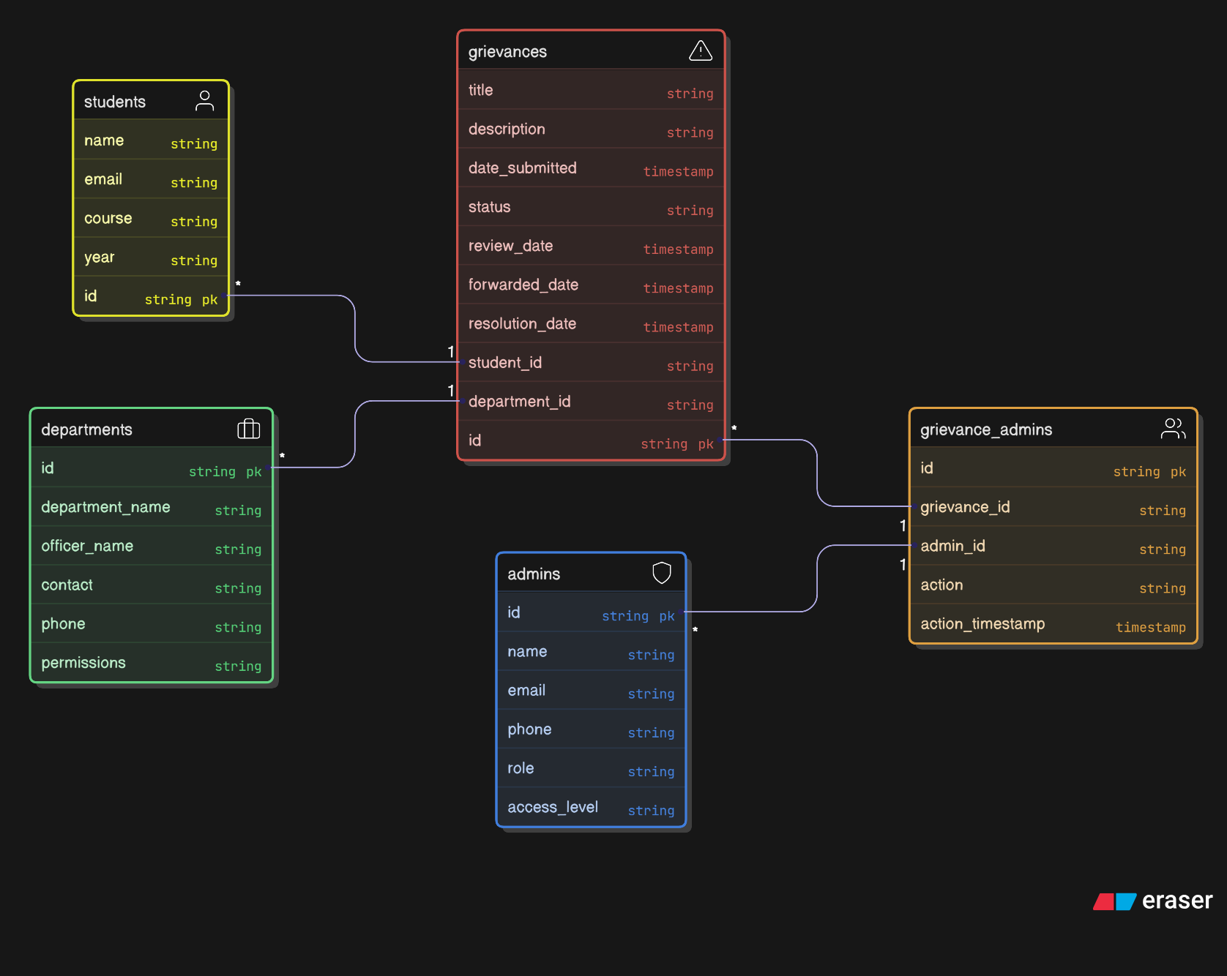

7. Constraints & Assumptions
• Internet access is required.
• System depends on timely action by grievance committee.
• Budget and resources are limited.
• Users are expected to provide honest grievances.

8. Future Enhancements
• AI-powered grievance categorization.
• Chatbot for quick query resolution.
• Integration with university ERP systems.
• Mobile app for easier access.

9. Conclusion
The Student Support and Grievances System enhances transparency, efficiency, and trust in grievance redressal. It ensures that students’ voices are heard and resolved promptly, improving student satisfaction and institutional reputation.

