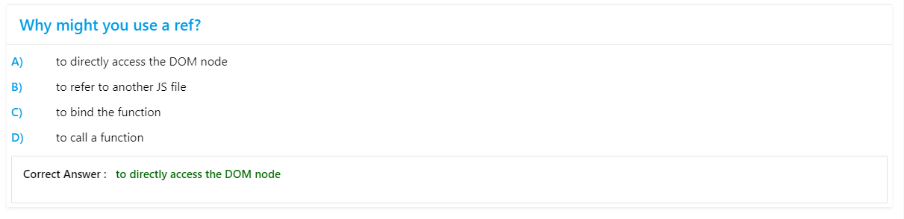  
  
  
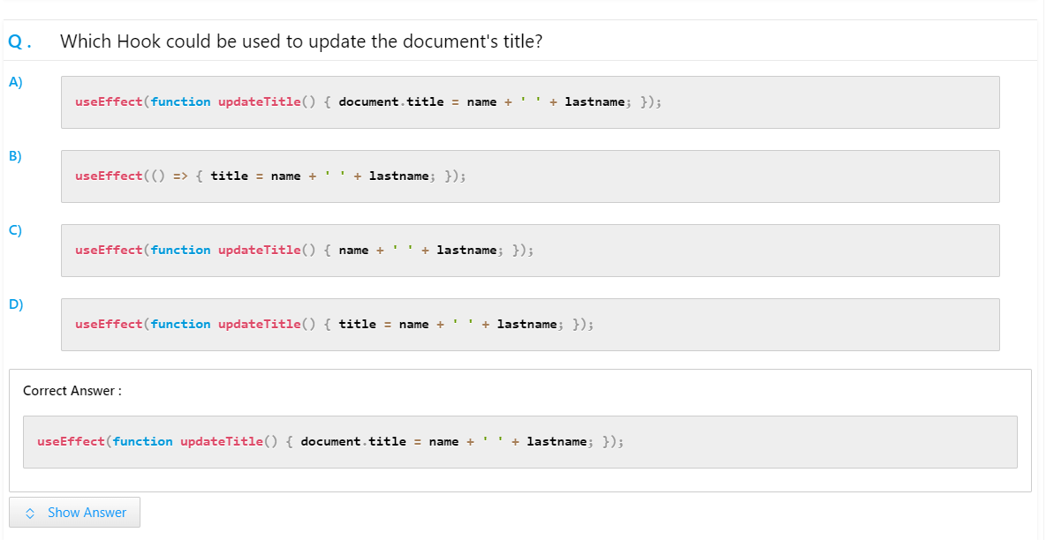  
  
  
  
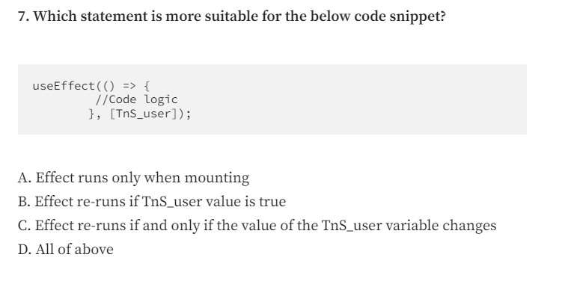  
  
  
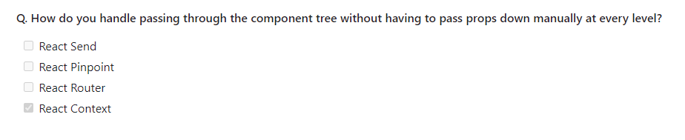  
  
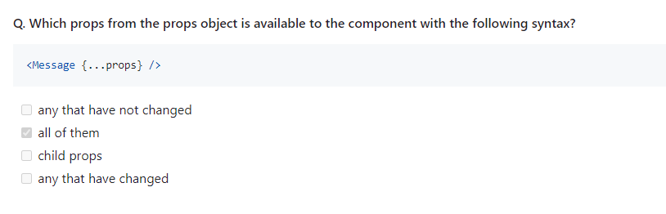  
  
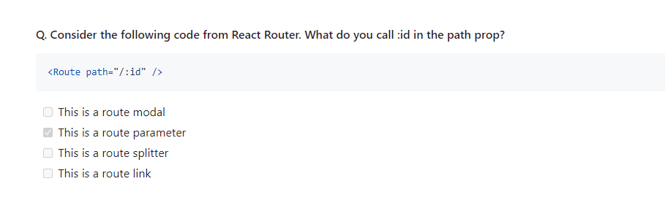  
  
  
  
  
  
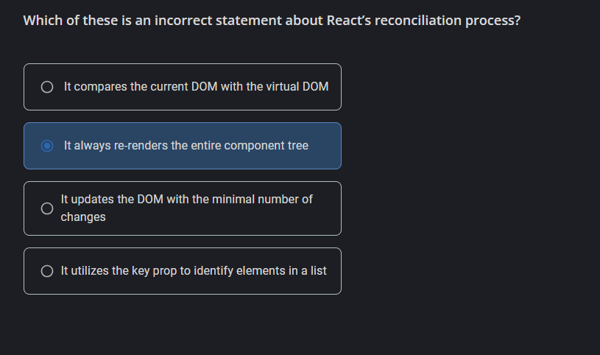  
  
  
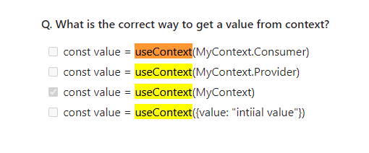  
  
  
  
  
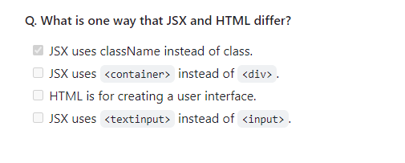  
  
  
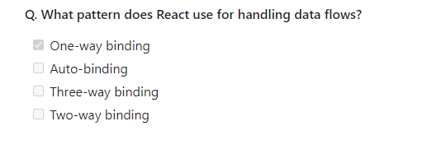  
  
  
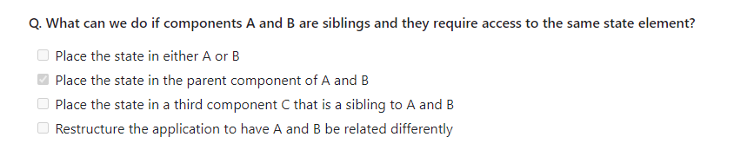  
  
  
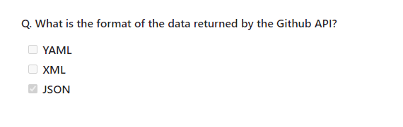  
  
  
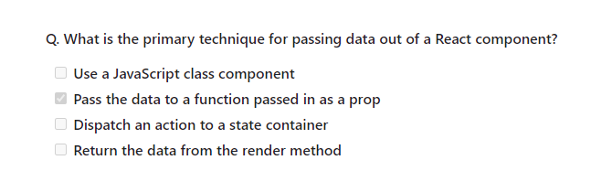  
  
  
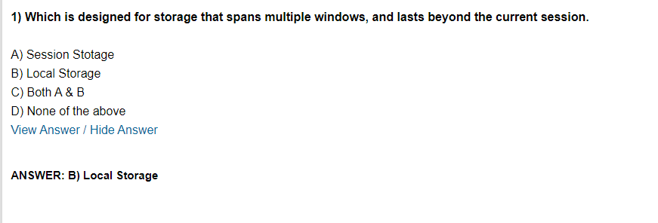  
  
  
  
How to store a value in localstorage its key value is is “item” – ans- (B)  
  
A) localStorage.getItem(“item” , “value”)  
B) localStorage.setItem(“item” , “value”)  
C) localStorage.getItem(“item” )  
D)None  
  
  
