------------------------------------------------------1----------------------------------------------------------------------

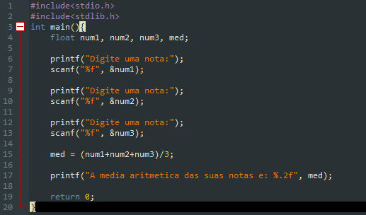

------------------------------------------------------2 ---------------------------------------------------------------------

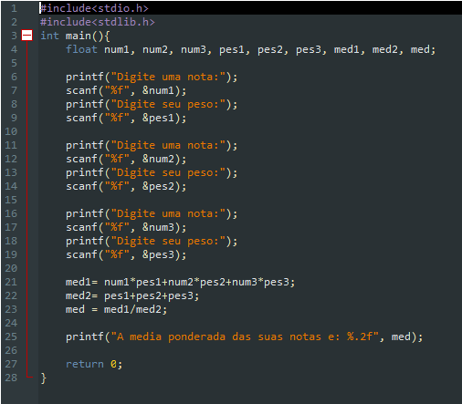

------------------------------------------------------3----------------------------------------------------------------------

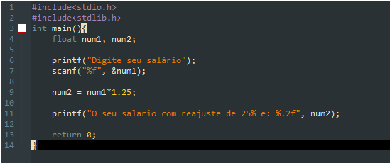

------------------------------------------------------4----------------------------------------------------------------------

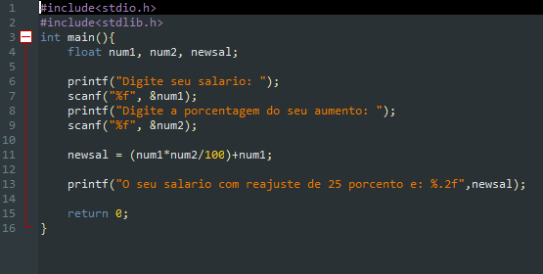

João Vitor Oliveira Araujo - **2020017537**