------------------------------------------------------------1----------------------------------------------------------------

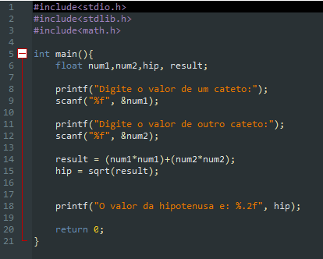

------------------------------------------------------------2----------------------------------------------------------------

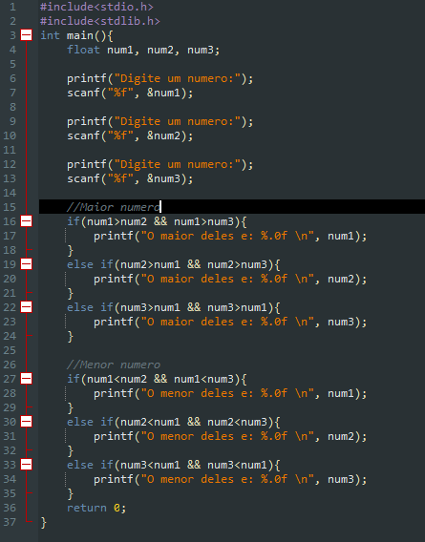

------------------------------------------------------------3----------------------------------------------------------------

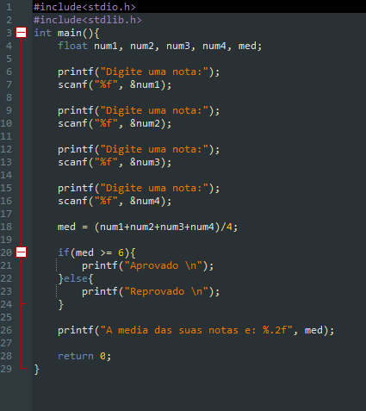

------------------------------------------------------------4----------------------------------------------------------------

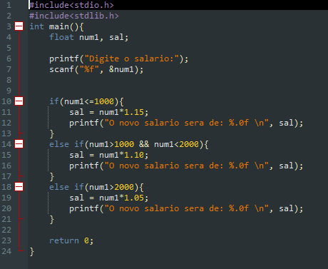

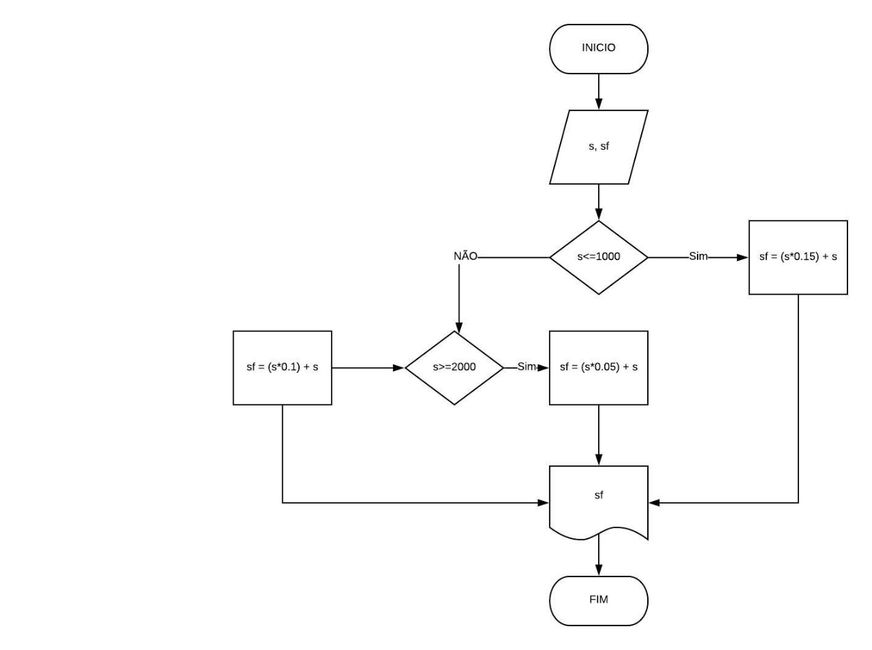------------------------------------------------------------5----------------------------------------------------------------

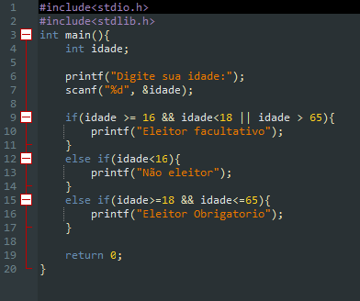

------------------------------------------------------------6----------------------------------------------------------------

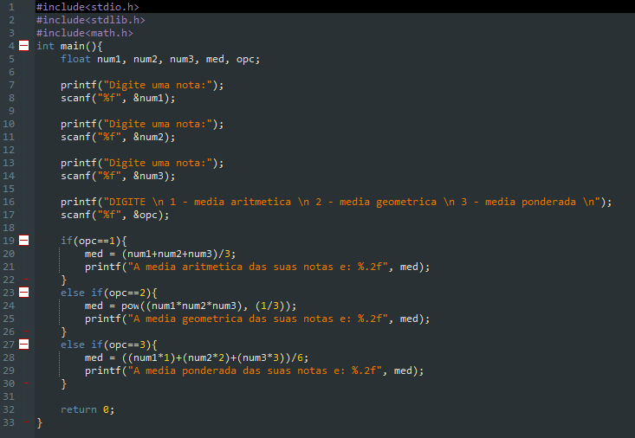

------------------------------------------------------------7----------------------------------------------------------------

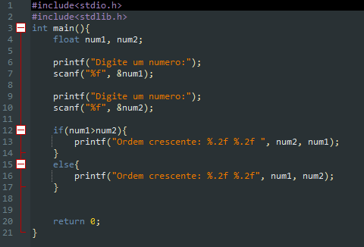

------------------------------------------------------------8----------------------------------------------------------------

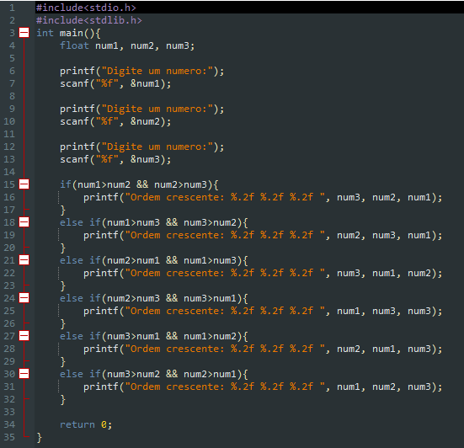

------------------------------------------------------------9----------------------------------------------------------------

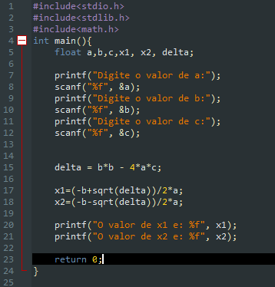

João Vitor Oliveira Araujo - **2020017537**