Technical introduction to Freshwater Fish Database (Version 1.0)

Cristián Correa

Summary
This document explains the components, structure and some of the functionality of a database of freshwater fish sampling and observations in Chile (hereafter DB). After reading this document the reader should be able to navigate the database, enter data, and query by content or geographical location. The current DB has two main components: a MS Access file and a ArcGIS file. The former stores all the non-geographic information and the latter all the geographical information. Both components are related by key codes and can be queried simultaneously. The DB is meant to facilitate data entry, editing and analyses, which does not mean it achieves any of these features! I invite the reader to be critical, report bugs and annoyances, and make suggestions. Also, solutions involving the use of freeware (in stead of cracks) are very welcome.

DB structure – MS Access
The MS Access file has all the information about the source of the info (i.e. bibliography), sampling sites, date of collection, species captured, etc. You can toggle between views (e.g. tables, queries, formularies) using the left hand menu-bar.

Formularies: To have a first look at the DB you can go to Formularies and open Bibliographic References. This is a nested formulary that has an upper level for References (e.g. Gajardo 1997...), followed by Sampling sites (e.g. quebrada del aji) and finally Species captured. Each level of the formulary has a different color (gray, green, or pink, respectively), and at the bottom of each level there are controls to navigate between entries. I designed this formulary in order to enter data in an easy way respecting relationships between tables and keeping tables singular (see below).
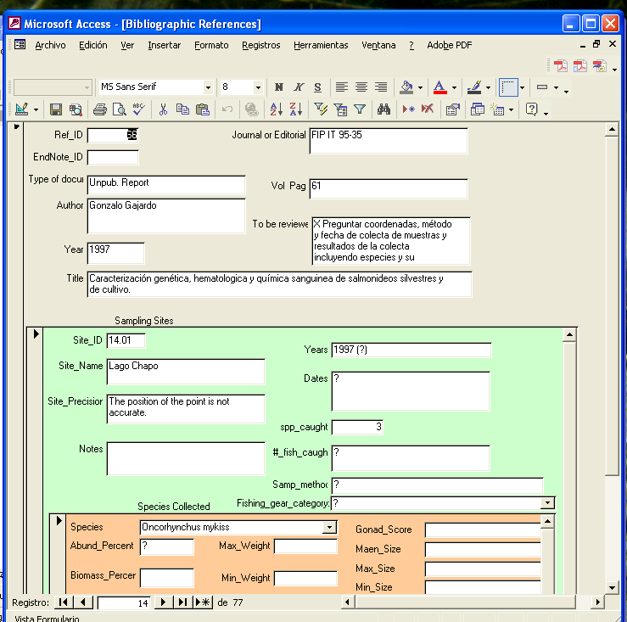

Tables: There are several tables storing the information. Each contains specific information such as Bibliographic References and Fish Sampling Sites by name (FishSamSites). Each table is singular, meaning that there are no repeated rows. Tables may be related with each other through ‘key fields’ and relationships can be visualized in the Relationship diagram (see below). This is advantageous because unlike in a simple Excel spreadsheet, an entry can be easily added or updated with no need to modify all the associated entries in related tables, checkups and queries are more efficient, more information is stored per unit of memory, errors in data editing are minimized, etc.

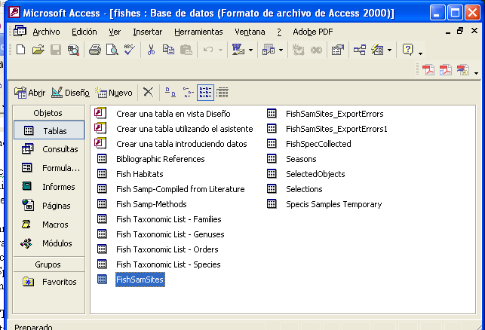

Relationship diagram: Go to Tools > Relationships or simply click the Relationship quick access button and you will find a diagram of the relationships among tables. This diagram not necessarily shows all the tables included in the DB but it does show all the relationships. A relationship is a virtual joint between two tables. For example, every paper entered in this DB, has the publishing information the Bibliographic References table, whereas the sampling sited reported are stored in a separate table called FishSamSites. These two tables are connected with a relationship so that it is possible to open a paper’s entry and then expand or navigate through all the related sampling sites (and fish associated to each site.). The relationship diagram is very important to understand the organization of the DB and easily visualize the content (columns) of tables.

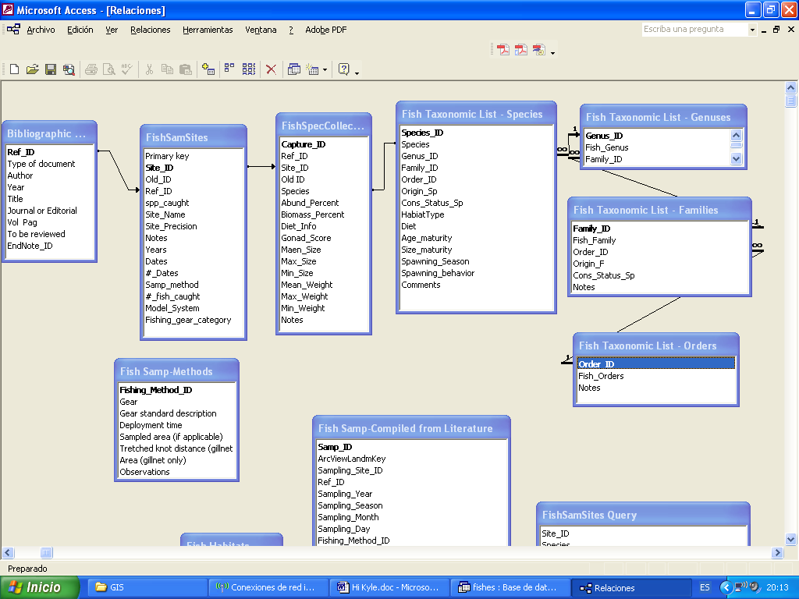

Queries: Queries are ‘virtual’ tables collecting information from the actual tables. Queries differ from tables in that they do not store information. They are useful to tailor the retrieval of information for particular purposes such as creating a data table for statistical analyses.

DB Structure – ArcGIS
The second main component of the DB is a geographic information system that stores and displays geographical information – a digital map with layers containing both referential information and position of sampling sites. This geographical information system (GIS) allows easy location of sites and advanced functionality to store, manage and analyze geographical information.

The main data layer in our DB is that corresponding to sampling sites. Is an ArcGIS point shapefile. The only information stored in this layer is latitude, longitude, and a key to relate with the MS Access DB (see interoperability below). There are many additional layers available which constitute a fairly precise and complete map of Chile including rivers, roads, villages, cities, height above sea level, etc. These layers comes from different sources including CONAMA, US National Geospatial-Intelligence Agency, LANDSAT imagery, SRTM digital elevation models, and features derived from the latter.

There is a universe of GIS tools and potential sources of geographical information which are described elsewhere. Here I will focus on the procedure to display and navigate the provided information as well as a detailed description to enter new data. I will be the moderator of any alteration of the master database to keep track of changes. New data could be provided in separate files which I can merge with the master DB. I will also take care of the management and processing of referential information facilitating the work of others who are not acquainted with GIS.

ArcMap: ESRI ArcGIS software is in fact a family of software. ArcMap is the ideal software to display, navigate and analyze geographical layers. It is possible to display several layers simultaneously, zoom in and navigate, change display settings, edit or add geographical information, etc.

ArcCatalog: This piece of software is useful to cut and paste layers, organize data, perform many geocoding operations, get and edit the metadata of layers, preview content, etc. I suggest to minimize the alteration of the original set of folders provided so that we can exchange projects and view (see below).

Google Earth Pro: This is a superb and intuitive digital map viewer which allows some basic data management. Almost anyone with little or no training can virtually fly the earth and find specific spots. We could try to exploit this easy developing the means to input sampling sites and/or displaying features of our database (but see issues about interoperability below). The free version of Google Earth is also excellent yet there is some useful extra functionality in the Pro version such ad directly importing ArcGIS shapefiles. This is also possible in the free version but using some middleware.

GRASS: Unix-based open source GIS (100% free, no crack needed). Experts in GRASS wanted!

Interoperability – Excel to/from Access
Queries and tables can be exported to excel and excel spreadsheets can be imported in tables as long as all the formatting correspond to that of the receiving table.

TO BE CONTINUED….

COMMENTS/EDITS OF THIS DOCUMENT ARE WELCOME! WE NEED TO PRODUCE A NICE MANUAL FOR ADDITIONAL USERS.

