Battery Monitor
Final Report

Automatio- ja systeemitekniikan projektityöt
AS-0.3200
Spring 2014

Otso Jousimaa
Aleksi Salonen
Johan Holmberg
25.5.2014

Table of Contents
Abbreviations 3
1 Introduction 4
2 Workflow 5
2.1 Study phase 5
2.2 Initial design 5
2.3 Producing the boards 5
2.4 Software development 5
2.5 Documentation 5
3 Project results 7
3.1 Hardware 7
3.1.1 LTC6803 7
3.1.2 Printed circuit board 7
3.1.3 Power supply 8
3.1.4 Hardware fault conditions 8
3.1.5 Passive balancing 9
3.1.6 Hardware configuration 10
3.2 Software 11
3.2.1 Software structure and interfaces 11
3.2.2 Software design 12
3.3 Interfaces 13
3.3.1 Monitor – Microcontroller 13
3.3.2 Monitor – Batteries 13
3.3.3 Microcontroller – PC 15
3.4 Implemented features and usage???????? 15
4 Time usage and schedule 16
5 Future work and improvement suggestions 18
5.1 PCB revision 2014-02-22 errata 18
References 19

Abbreviations
ADC - Analog to Digital Converter
BOM - Bill Of Materials
CS - SPI Chip Select
ESD - Electrostatic Discharge
KCL - Kirchoff's Current Law
LPP - Low-Pass Filtering
MBPS - Megabits Per Second
MCU - Microcontroller Unit
MISO - SPI Master In, Slave Out
MOSI - SPI Master Out, Slave In
NTC - Negative Temperature Coefficient
SCLK - SPI Clock
SMPS - Switch Mode Power Supply
SPI - Serial Peripheral Interface bus
TTL - Transistor-Transistor logic
USB - Universal Serial Bus

1 Introduction
The original project task was to create a battery balancer solution for the batteries in an electric car. The solution would consist of a separate battery balancer board, battery monitor board and a controller that would command the circuits. The battery balancer was designed and produced in another project during the Autumn of 2013. This project was concentrated on designing and producing the monitor part and integrating all the components into a working system.
Due to the fact that the balancer boards from the previous project were broken, the project scope was reduced to designing and producing the monitor board and controlling the monitor with a microcontroller. This document describes the final solution to the updated task. We also thought about making our own balancer board, but as there were no blueprints from the previous group, we deemed it to be way too time consuming. Also, the ordering process would've taken over 2 weeks, and there wouldn't have been time to write any software to use the balancer board.
The monitor board was designed using KiCad for schematic edition and layout. LTSpice 4 was used to simulate analog sections of board. There was enough components to fit on the board to motivate the use of a 4 layer board and KiCad capabilities to design multilayered boards. Also, as the boards were ordered from China instead of producing them on our own, we had no real reason not to use the 4 layer board.
Biggest risk in making the board was an unrecoverable mistake in hardware design. By the time mistake would be found, there would not be time left for creating and assembling new board. This risk was mitigated by designing board with functional blocks that have minimal interactions and soime free space in between. This way components could be added later on between testpoints and vias and signals could be injected to simulate proper behaviour of blocks. This separation of functinality and preparedness for later additions was a very good decision, since when the initial desigin failed we were able to isolate causes of errors and test fixes for them.
To make the task easier, we chose to use a Arduino Nano board with its ATmega328 microcontroller to run the necessary monitoring logic. The Arduino environment is easy to set up, which allowed us to put more focus on designing the monitor board and writing software for controlling the board.

2 Workflow

2.1 Study phase
Immediately at the beginning of the project we stumbled upon problems. We could not get the balancer board from the previous project to work. It took a while before we got to the root of the problem. Some pins of the main circuit on the board were short circuited. We were unable to fix the short circuited pins which lead to the updated project scope as mentioned in the introduction. Also, even if we could've removed the short circuits, the board probably wouldn't have worked. It's possible, that during the short circuit removal attempts the board overheated and broke some components. The other board was broken before we got it, as there were visible burn marks in some of it's components.
We also had to study on how to use KiCad. Luckily, Otso had prior experience and was willing to teach us about the software.

2.2 Initial design

2.3 Producing the boards
Because it is too difficult to produce your own 4 layered board, the monitor boards were ordered from China. The components on the board were soldered by hand. We also created a stripped version of the board as a single layer design and tried to solder it, but soon realized that the quality was not good enough for precision soldering.

2.4 Software development
The Arduino development environment was tested early on and some test programs were written to ensure that the Arduino with its ATmega328 was suited for the job.
Serious software development began in the beginning of April. This was already far behind schedule. Software development was rapid and quite straight forward, with a few major problems. One problem was that when adding code at some certain points, the Arduino would crash and reboot, or just stop communicating with any computer over the serial bus. The Arduino environment also had previously unknown restrictions which forced the team to modify the software architecture several times.

2.5 Documentation

3 Project results

3.1 Hardware

3.1.1 LTC6803
LTC6803 is a Multicell Battery Stack Monitor integrated circuit. It features 12 differential ADCs which can be used to measure voltages of individual batteries as well as 2 ADCs which can be used for measuring external voltages, for example NTC-resistors.
Communication between ICs in system is done through SPI-like current signaling bus. Current mode sigaling allows stacking of boards without level shifters in communication lines. Communication to MCU uses same bus, but communication must be isolated to avoid destroying attached control logic in case of some electrical fault in battery stack.
The circuit has also a watchdog timer and 2 GPIO pins which can be used to display status information or communicate with other digital devices in circuit. Leds were connected to these pins.

3.1.2 Printed circuit board
Circuit board was implemented using a 4-layer design which allows unbroken ground and power planes. Digital and analog sections of board are kept separate, and careful attention is paid to keep clearance distances in accordance of IPC 2221 [IPC 2221] .
Board design allows three separate functions: A bottom of stack board which communicates with the MCU and above boards, middle boards which pass data up- and downwards and top of stack.Having different roles on same PCB cuts down design time and cost.
All project files can be found at [GITHUB], PDF printouts should have accompanied this document. In case they were not, files are available at [OJOUSIMA.NET/AS03100/PDF] until 2015
Ten PCBs and parts for four asseblies were ordered. Two assemblies are complete with fixes, one with isolator. One assembly is complete, but not fixed. Fourth assembly went horribly wrong, twice. LTC6803-3 had to be extracted out of PCB using hot air, and it's potentially damaged. Since design is known to be defective, other components were not populated. In addition, two boards were destroyed while preparing for assembly, so only three bare PCBs remain intact. Our assembly process had yield of approximately ~ 50 % for PCBs and ~75 % for components. This is comparable to experiences of resaerch staff at laboratory.

3.1.3 Power supply
LTC6803 offers a possibility of using power supply completely isolated from batteries. In this case, ripple rejection resistors must be omitted and ferrite bead and polarity / overvoltage protection zener can be omitted.
Isolated PSU should be connected to V+ and DGND pins. Please note that this power connection does not have reverse polarity protection.
In battery powered mode PSU bypass circuit must be installed completely. Zener diode offers protection against ESD spikes and voltage transients as well as limited protection against overvoltage and reverse polarity. In case of overvoltage, power dissipated in zener will burn out the connection quickly and zener will fail, hopefully as a short.
In case of a reverse voltage, reverse voltage is clamped to forward voltage of zener. Bypass resistors limit the current to LTC6803 to under 10 mA as long as reverse voltage is clamped below 2 V, which is survivable. [LTC6803 datasheet p. 31]
To reject power supply ripple, bypassing is required. Since power supply and lowest battery measurement are isolated from each other in LTC6803-3, resistors can be added to both supply and ground lines. Differential bypassing suggested by LTC6803 datasheet (Figure 1) can be used.
This supply bypassing method also offers an easy way to measure current consumption of LTC-6803. A multimeter probing across resistor shows voltage across resistor, current can be calculated from equation I = U*R.

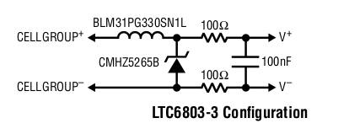Figure 1: voltage protection and filtering

3.1.4 Hardware fault conditions
Table 15 of LTC6803 datasheet [LTC6803 DATASHEET p.30] lists a number of fault conditions. Two first cases are mitigated by LPF circuit with protection zeners and internal clamps at LTC6803.
There is no redundant power supply in case of a power loss, if communication is lost battery charging / discharging should be driven into a safe state.
A break in battery stack would force reverse stack potential on communication link during discharge, high voltage series diodes protect monitor circuits and digital isolator protects controller circuit. During charge redundant current path can handle up to 10 A of current.
Two last cases are not accounted for. In case of a break within a stack, current carried by 0.5 mm trace between stacks. This trace can carry at most 2.5 A of a current according to IPC-2152 [IPC-2152]. If this trace burns out, voltage gets applied to discharge circuit and LPF resistors, leading to destruction of discharge circuit. Discharging voltage then is applied across the LPF resistors, 2 * 10 k ohms. Maximum survivable voltage is limited by power dissipation of resistors,
This is not a practical value in actual car battery stack, but it will do in laboratory testing.
Disconnect inside stack while charging can also lead to a catastrophic failure if voltage and current are not limited.

3.1.5 Passive balancing
LTC6803 has internal mosfets that can be used for modest passive balancing. Internal mosfets are connected directly into lower cell. LPF's series resistance would raise the voltage at ADC if current would be returned on LTC6803 side of filter. Figure 9 clarifies issue. Discharge current should be returned to input connector of battery rather than to ADC input pin to avoid rising voltage at lower ADC over spec.
This is done by using external transistor which can direct most of the current back to connector input.

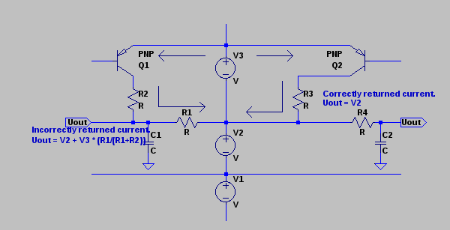Figure 2: Always, always, always consider KCL.
Datasheet of LTC6803 suggests using Si2351DS PMOS with a protection zener from gate to source. Using a PNP transistor avoids the need for a separate protection zener, since zener of LPF couples the voltage of lower cell to next cell in series, and this voltage gets coupled into base of transistor through emitter-base junction.
Voltage and current ratings should be comparable to Si2352DS: -20 Vce and 3 A of collector current. ZUMT718 is a decent match with Vce of -20 V, Ic of 1 A (3 A pulsed). It also has suitable package and it is readily available.
ZUMT718 has Hfe of at least 300 at collector current of 100 mA. The base resistor can have 100 * resistance of shunt resistor while still keeping transistor in saturated condition.
Since passive balancing can only turn excess charge into heat, heat management must be considered. Since external transistor is used to return bulk of current back to connectors, power dissipation at LTC6803 is negligible.
Most of the power is dissipated in shunt resistors. Since actual balancing is going to be implemented at a separate circuit, these resistors do not need to be scaled for useful powers. A 100 ohm 0805 resistor with power handling capacity of ¼ W can be to simplify the BOM, since PSU bypassing circuit already uses these.
Approximately 40 mA can be pulled from battery through this resistor. A LED is inserted in current path to show diagnostics information. This can be used for “battery full” indication. If a led is used, current must be limited to ~20 mA. This is conveniently achieved with 100 ohms shunt resistor together with forward drop of led.
Alternatively footprint of led could be replaced with another 0805 resistor for doubled power handling capacity. In that case 27 ohms would be a reasonable choice, as total series shunt resistance would be ~ 50 ohms leading to a current of ~ 80 mA when discharging a battery at 4.2 V (Typical lithium-ion cell at full charge). Power dissipated in a single resistor would be ~ 170 mW.
Every mosfet has an property of drain-source leakage current. Internal mosfets of LTC6803 are surely not an exception. While leakage current of a mosfet would not usually be a problem, any leakage is amplified by external PNP transistor.
LTC6803 has internal pull-up mosfets which connects the base of transistor to potential of upper cell. This will keep transistor strictly in cut off region, limiting leakage to it's own leakage current. Therefore, it is important to ensure in software that transistors are pulled up. External LEDs will light up if there is significant leakage current.
Lithium-ion batteries have ability of discharging at rather extreme currents, possibly causing fire or explosion. In case where PNP-transistor's base gets shorted to ground transistor will act as diode through emitter to base. Semiconductors have a habit of failing as short circuits unless internal connections of chip burn out.
This scenario is mitigated by laying base resistor before LPF's via to ground. In case of a short the resistors will limit the current through transistor and zener diodes will provide a path to ground for other cells. Resistors of LPF's will limit the current through these connections to survivable level.

3.1.6 Hardware configuration
Board has two jumpers, VMODE and TOS.
Case: Standalone circuit. TOS is connected to VREG. VMODE is connected to VREG.
Case: Multiple circuits, bottommost circuit. TOS is connected to V-. VMODE is connected to VREG.
Case: Multiple circuits, middle circuit. TOS is connected to V-. VMODE is connected to V-.
Case: Multiple circuits, topmost circuit. TOS is connected to VREG. VMODE is connected to V-.
Only bottommost circuit requires isolator and assorted capacitors and connector to MCU. Bottommost circuit does not need lower chain connector and topmost circuit does not need upper chain connector.
GPIO and Watchdog leds and resistors can be omitted if not used. If temperature sensing is not used, precision resistors and NTC connectors can be left out.

3.2 Software

3.2.1 Software structure and interfaces
The intended structure of the software is depicted in Figure 3 below.
Figure 3 Software components and interfaces

As seen in Figure 3 above, the software is split into several modules to keep the code structure clear. The Logic module consists of the main loop, which makes various checks and schedules the microcontrollers operation. The Serial I/O module is responsible for handling user input to the system. The SPI I/O module handles sending and receiving data to and from the SPI bus. The Database (DB) module is intended to store data from the monitor and balancer boards in meaningful structures for the Logic modules purposes. Lastly, the Self Test module checks incoming data from the SPI bus as well as the microcontrollers internal data and checks that the entire system operates properly. It raises error flags which the Logic module can use in case of invalid operation.
The software is configured from a laptop connected to the microcontroller over a serial port. In the case of the Arduino Nano board we used, this simply means installing the Arduino development environment and connecting the computer to the Arduino over USB. Using the Arduino Serial Monitor feature, the user can send commands to the microcontroller.
The microcontroller controls the monitor board over a SPI bus. This is done by writing to control registers in the monitors LTC6803 circuit. Data is read from the circuit by reading control or diagnostics registers on the LTC6803.
The balancer board has not been done yet and is therefore marked with red in Figure 3.

3.2.2 Software design
The software is designed to be modular so that it can be modified and improved later. The design is illustrated below in Figure 4.
Figure 4 Software design
Logic - main

========
Definitions &
Global data

main
balancerLogic
Microcontroller
SPI I/O

spi_io
Serial I/O

handleInput
pec
printData
Self Test

Database

db

3.3 Interfaces

3.3.1 Monitor – Microcontroller
According to LTC6803 datasheet , communication to MCU should be isolated to avoid destruction of controller in case of a battery stack connection failure. Since high-speed digital isolators need more current than integrated regulator of LTC6803 can source, a separate 5V source is required. [1]
Isolator needs 4 channels, 3 outputs from MCU side and 1 input to MCU side. Inbound signals are CS, SCLK and MOSI. Return channel carries MISO. At least 1MBPS data rate is required. Analog Devices offers isoPower -product line which has integrated isolated SMPS. Using such chip decreases overall complexity of design, as separate SMPS is not needed.
Based on these criteria, ADuM5401 [ADUM 5401 DATASHEET] is chosen as isolator. It has versions for 1 MBPS (A) and 25 MBPS (C) communication, A version is chosen to lower costs. SPI is clocked by master, so in case of data corruption speed of communication can be decreased.
SMPS of ADuM5401 operates without ferrite core to contain the stray magnetic field, which is why the chip is practically guaranteed to generate RF noise which would take highly specialised PCB layout to keep at EMC / FCC -compatible levels. If the product is to be commercialized, the layout has to be reviewed by an expert.
Test points are placed on isolated side to allow verifying data transmission across isolation boundary. In case of isolator design failure, these test points can be used to inject signals into target board.

3.3.2 Monitor – Batteries
All battery connectors have screw terminals. This allows a defined power connection sequence. Screw terminals are also resistant against vibration and shock, which is important consideration in an automotive environment.
The end goal is to integrate monitor board with balancer board, so connectors are 5.00 mm pitched with current carrying capacity of 10 A.
Every battery has their own connection. Batteries are connected in series on board, but this connection should not be used as only connection between batteries.
While batteries can be connected in any sequence without endangering the boards and even reverse voltage is survivable if source is current limited, it's recommended to connect batteries from bottom to top, negative terminal first.
Electrical connection to ADC has a RC low-pass filter shown in Figure 2 to reject noise coupling into measurement. A 7.5 V zener diode gives overvoltage and limited reverse polarity protection for the measurement cell.

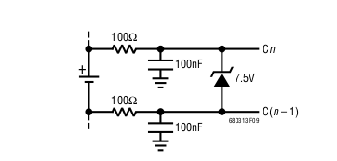Figure 5: LPF + protection zener

Series resistance of 100 ohms in parallel with 100 nF capacitancewould introduce an 1 mV DC measurement error to ADC. On the other hand, LPF offers 30 DB noise rejection and ESD protection with zener. Since 1 mV is smaller than LSB of ADC, this error is negligible. [LTC6803 DATASHEET p. 27]
On the other hand, ground connection of capacitor creates hazardous voltage differentials on board. In case where capacitor gets shorted grounded, up to 50 V (topmost cell, while charging) could be imposed on filtering resistor. This could be a catastrophic failure, as

While current of 0.5 A is not too much, if the resistor fails as short entire battery stack gets shorted.
As a mitigation measure LPF of 10k ohms and 3.3 uF is be used. 10 k series resistance limits current to 5 mA, and power dissipated is 250 mW. Capacitor that can handle at least 75 V (50% margin) is notably larger (at least 1206) and more expensive. DC error of such a circuit is smaller at 0.5 mV. [LTC6803 DATASHEET p. 27] Figure 6 shows the interface.

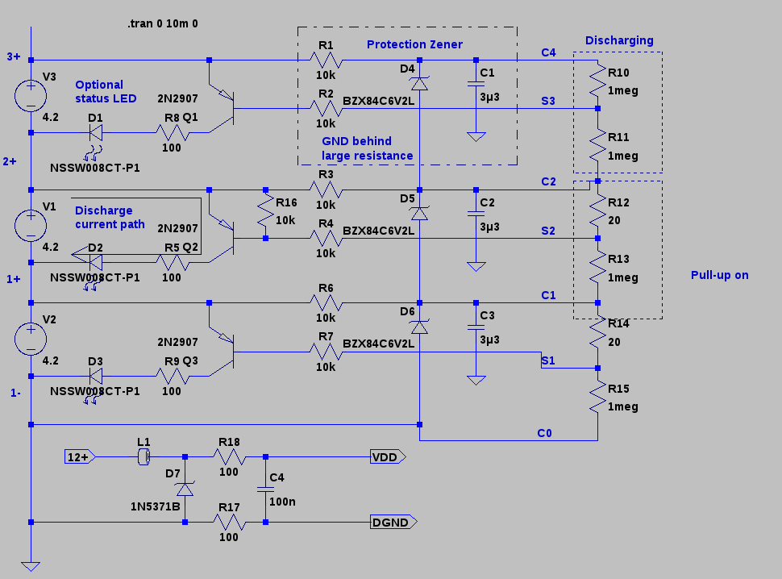Figure 6: Battery interface of circuit

3.3.3 Microcontroller – PC
The ATmega328 on the Arduino Nano communicates with a PC over a Serial Port with speed 9600bps.

3.4 Implemented features and usage????????

4 Time usage and schedule
The original schedule for the project can be seen below.

We were able to stick to the project schedule the first weeks, almost up until the intermediate report. Due to other courses, we fell significantly behind schedule after the intermediate report. The hardware part of the project progressed far more smoothly than the software. The software was developed mainly during the last 4 weeks of the project. Team member time usage per week can be seen below.

5 Future work and improvement suggestions

5.1 PCB revision 2014-02-22 errata
PCB had a few significant faults:
- SDO-line used for relaying data to MCU required pull-up resistor, which was omitted. Fix: 4k7 resistor can be connected between test points for 5V and SDO. This has been tested and verified.
- VREG should have an 1 uF bypass capacitor. Fix: Suitable capacitor can be added in isolator bypass footprint, even thought placement is far from optimal. This has been tested and verified.
- VREF should have 1uF bypass capacitor. Fix: Capacitor can be connected between VREF- and DGND vias near LTC6803. This has been tested and verified.
- External discharge transistors turn on seemingly at random. This might have something to do with internal pull-ups of LTC6803 behaving in an unexpected manner or some leakage current (maybe through zeners or capacitors?) getting amplified. Possible fixes: Either add external pull-up resistor (10 k) or remove discharge transistors to avoid bleeding batteries / reducing accuracy of ADC readings. Neither has been tested.
PCB also had some cosmetic faults, such as silkscreen texts being covered by components and MOSI / SCL lines have swapped labels near connector.
These mistakes have been incorporated in revised schematic available at [GITHUB].If another prototype seriers is made, these fixes should be included in PCB layout.

References

