AS-0.3200 Project work

Battery stack monitor board design documentation

Otso Jousimaa (otso.jousimaa@aalto.fi)
Table of Contents
AS-0.3200 Project work – Battery stack monitor board design documentation 1
Abbreviations 3
Introduction 4
Communication 5
Communication to MCU 5
Selection of isolator 5
Testing communication 5
Communication to between stacked monitors 5
Protection against faults 5
Protection against faults 6
Communication to balancer 6
Watchdog, GPIO 6
Battery interface 7
Connectors 7
Monitoring 7
Measuring temperature 7
Measuring voltage 7
Filtering and anti-aliasing 7
Open connection detection 8
Passive balancing 8
Current paths 8
Transistor selection 9
Power considerations 9
Minimizing leakage 9
Protection against short to LPF ground 10
In conclusion 10
Power supply 11
Isolated PSU 11
Battery powered mode 11
PSU Bypassing 11
Configuration 12
Software 12
Undervoltage and overvoltage limits 12
Jumpers 12
JMP 1 – Top Of Stack (TOS) 12
JMP 2 – Vmode 12
Jumper settings 12
Usage 13
Connections 13
Software instructions 13
Fault conditions 14
Results 15
PCB revision 2014-02-22 15
References 16

Abbreviations
ADC – analog to digital converter
BOM – bill of materials
CS - SPI Chip select
ESD – electrostatic discharge
KCL – Kirchhoff's current law
LPF – low-pass filter
MBPS - megabits per second.
MISO - SPI Master in, slave out
MOSI - SPI Master out, slave in
SCLK - SPI clock
SPI - Serial peripheral interface bus
TTL - Transistor-transistor logic

Introduction

Communication

Communication to MCU
According to LTC6803 datasheet , communication to MCU should be isolated to avoid destruction of controller in case of a battery stack connection failure. Since high-speed digital isolators need more current than integrated regulator of LTC6803 can source, a separate 5V source is required. [1]

Selection of isolator
Isolator needs 4 channels, 3 outputs from MCU side and 1 input to MCU side. Inbound signals are CS, SCLK and MOSI. Return channel carries MISO. At least 1MBPS data rate is required. Analog Devices offers isoPower -product line which has integrated isolated SMPS. Using such chip decreases overall complexity of design, as separate SMPS is not needed.
Based on these criteria, ADuM5401 [2] is chosen as isolator. It has versions for 1 MBPS (A) and 25 MBPS (C) communication, A version is chosen to lower costs. SPI is clocked by master, so in case of data corruption speed of communication can be decreased.
SMPS of ADuM5401 operates without ferrite core to contain the stray magnetic field, which is why the chip is practically guaranteed to generate RF noise which would take highly specialised PCB layout to keep at EMC / FCC -compatible levels. If the product is to be commercialized, the layout has to be reviewed by an expert.

Testing communication
Test points are placed on isolated side to allow verifying data transmission across isolation boundary. In case of isolator design failure, these test points can be used to inject signals into target board.

Communication to between stacked monitors
Communication between monitor boards is implemented by current mode signaling between stacked boards. While the hardware does support the communication, software control for chaining boards has not been tested.

Protection against faults
In case of connection breakage between battery stacks while charging, the charging current would go through internal paths of a LTC6803, leading to instant destruction of device. To protect against this, redundant current path is offered, as in illustration [1]. This redundant current path is implemented by connecting a wire with at least 10 A current carrying capacity between boards.
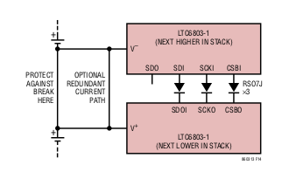Illustration 1: Redundant current path protects IC

This current path must carry whole charging current in case of a fault. Current design doesn't have any way to sense if redundant path is being used, method to sense connection integrity should be developed.

Protection against faults
If connection between battery stacks breaks while discharging, communication lines between boards see the full voltage of stack across them. To protect circuitry against this condition, high voltage diodes are inserted to communication path. In case of failure, these diodes limit current through communication lines to leakage current of diodes.
In general, LTC6803 should survive any electrical abuse as long as current into or out of pins is limited to 10 mA [1 p. 31].

Communication to balancer
This board is a step towards a complete, integrated balancing system. There are no plans to make permanent connection to balancing board. However, the test points of signals on battery side can be used to communicate to balancer board.
If current PCB design is used, a separate isolator is needed on balancer and communication from MCU must use SPI CHIP SELECT -signal to signify the receiver of communication.

Watchdog, GPIO
LTC6803 has a watchdog timer and two GPIO pins. These are open drain outputs, so they can only sink current. LEDs are attached to these outputs to get status information out of the board. Watchdog should light up if a valid command has not been received in 1 – 2.5 seconds since last valid command if board is not in stand-by mode.

Battery interface

Connectors
All battery connectors have screw terminals. This allows a defined power connection sequence. Screw terminals are also resistant against vibration and shock, which is important consideration in an automotive environment.
The end goal is to integrate monitor board with balancer board, so connectors are 5.00 mm pitched with current carrying capacity of 10 A.
Every battery has their own connection. Batteries are connected in series on board, but this connection should not be used as only connection between batteries.
While batteries can be connected in any sequence without endangering the boards and even reverse voltage is survivable if source is current limited, it's recommended to connect batteries from bottom to top, negative terminal first.

Monitoring

Measuring temperature
LTC6803 has two extra ADC inputs which are meant for temperature monitoring. Simple voltage divider from VREF to GND can be used. Since VREF can drive at maximum 100k ohm load, upper resistor is selected to be 200k ohms. This guarantees that load will not rise above maximum.
NTC-thermistors are connected between resistor and ground to form the voltage divider. Illustration [2] shows the temperature sensing connection.
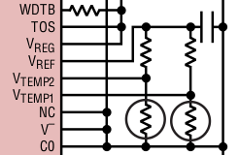Illustration 2: Temperature sensing

Measuring voltage
LTC6803-3 has 12-bit sigma-delta ADC. ADC outputs 12-bit code with an offset of 0x200 (512 decimal). Input voltage can be calculated as: [LTC6803 datasheet p. 14]
Passive discharging is turned off by default when cells are read. However, there exists a self-test mode where cell discharging switches are left on. [1 p. 14]

Filtering and anti-aliasing
Electrical connection to ADC has a RC low-pass filter shown in illustration [] to reject noise coupling into measurement. A 7.5 V zener diode gives overvoltage and limited reverse polarity protection for the measurement cell.
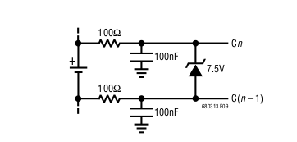Illustration 3: LPF + protection zener

Series resistance of 100 ohms in parallel with 100 nF capacitance introduces an 1 mV DC measurement error to ADC. On the other hand, LPF offers 30 DB noise rejection and ESD protection with zener. Since 1 mV is smaller than LSB of ADC, this error is negligible. [1 p. 27]
On the other hand, ground connection of capacitor creates hazardous voltage differentials on board. In case where capacitor gets shorted grounded, up to 50 V (topmost cell, while charging) could be imposed on filtering resistor. This could be a catastrophic failure, as

While current of 0.5 A is not too much, if the resistor fails as short entire battery stack gets shorted.
As a mitigation measure LPF of 10k ohms and 3.3 uF is be used. 10 k series resistance limits current to 5 mA, and power dissipated is 250 mW. Capacitor that can handle at least 75 V (50% margin) is notably larger (at least 1206) and more expensive. DC error of such a circuit is smaller at 0.5 mV. [1 p. 27]

Open connection detection
<todo>

Passive balancing

Current paths
LTC6803 has internal mosfets that can be used for modest passive balancing. Internal mosfets are connected directly into lower cell. LPF's series resistance would raise the voltage at ADC if current would be returned on LTC6803 side of filter. Illustration [4] clarifies issue. Discharge current should be returned to input connector of battery rather than to ADC input pin to avoid rising voltage at lower ADC over spec.
This is done by using external transistor which can direct most of the current back to connector input.

Transistor selection
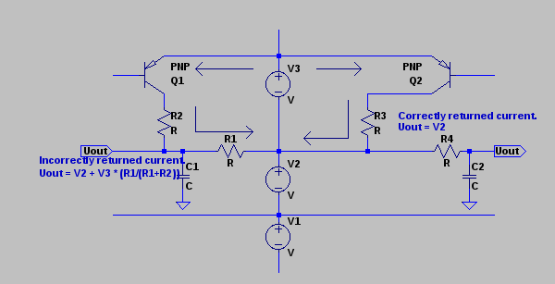Illustration 4: Always, always, always consider KCL.
Datasheet of LTC6803 suggests using Si2351DS PMOS with a protection zener from gate to source. Using a PNP transistor avoids the need for a separate protection zener, since zener of LPF couples the voltage of lower cell to next cell in series, and this voltage gets coupled into base of transistor through emitter-base junction.
Voltage and current ratings should be comparable to Si2352DS: -20 Vce and 3 A of collector current. ZUMT718 is a decent match with Vce of -20 V, Ic of 1 A (3 A pulsed). It also has suitable package and it is readily available.
ZUMT718 has Hfe of at least 300 at collector current of 100 mA. The base resistor can have 100 * resistance of shunt resistor while still keeping transistor in saturated condition.

Power considerations
Since passive balancing can only turn excess charge into heat, heat management must be considered. Since external transistor is used to return bulk of current back to connectors, power dissipation at LTC6803 is negligible.
Most of the power is dissipated in shunt resistors. Since actual balancing is going to be implemented at a separate circuit, these resistors do not need to be scaled for useful powers. A 100 ohm 0805 resistor with power handling capacity of ¼ W can be to simplify the BOM, since PSU bypassing circuit already uses these.
Approximately 40 mA can be pulled from battery through this resistor. A LED is inserted in current path to show diagnostics information. This can be used for “battery full” indication. If a led is used, current must be limited to ~20 mA. This is conveniently achieved with 100 ohms shunt resistor together with forward drop of led.
Alternatively footprint of led could be replaced with another 0805 resistor for doubled power handling capacity. In that case 27 ohms would be a reasonable choice, as total series shunt resistance would be ~ 50 ohms leading to a current of ~ 80 mA when discharging a battery at 4.2 V (Typical lithium-ion cell at full charge). Power dissipated in a single resistor would be ~ 170 mW.

Minimizing leakage
Every mosfet has an property of drain-source leakage current. Internal mosfets of LTC6803 are surely not an exception. While leakage current of a mosfet would not usually be a problem, any leakage is amplified by external PNP transistor.
LTC6803 has internal pull-up mosfets which connects the base of transistor to potential of upper cell. This will keep transistor strictly in cut off region, limiting leakage to it's own leakage current. Therefore, it is important to ensure in software that transistors are pulled up. External LEDs will light up if there is significant leakage current.

Protection against short to LPF ground
Lithium-ion batteries have ability of discharging at rather extreme currents, possibly causing fire or explosion. In case where PNP-transistor's base gets shorted to ground transistor will act as diode through emitter to base. Semiconductors have a habit of failing as short circuits unless internal connections of chip burn out.
This scenario is mitigated by laying base resistor before LPF's via to ground. In case of a short the resistors will limit the current through transistor and zener diodes will provide a path to ground for other cells. Resistors of LPF's will limit the current through these connections to approximately 7 mA, which is survivable.
While circuit itself might get destroyed in short, batteries themselves should survive this fault.

In conclusion
This section is summed up by Illustration [5]. LPF section without protection zener is shown. Passive discharge section shows the layout of LPF's ground via. Discharge current path is shown. Batteries are modelled as voltage sources and internal mosfets of LTC6803 are modelled as resistances.
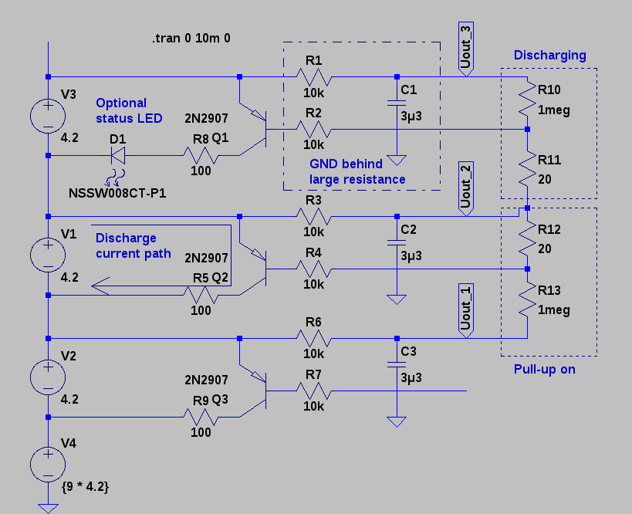Illustration 5: Battery interface of circuit

Power supply

Isolated PSU
LTC6803 offers a possibility of using power supply completely isolated from batteries. In this case, ripple rejection resistors must be omitted and ferrite bead and polarity / overvoltage protection zener can be omitted.
Isolated PSU should be connected to V+ and DGND pins. Please note that this power connection does not have reverse polarity protection.

Battery powered mode
In battery powered mode PSU bypass circuit must be installed completely. Zener diode offers protection against ESD spikes and voltage transients as well as limited protection against overvoltage and reverse polarity. In case of overvoltage, power dissipated in zener will burn out the connection quickly and zener will fail, hopefully as a short.
In case of a reverse voltage, reverse voltage is clamped to forward voltage of zener. Bypass resistors limit the current to LTC6803 to under 10 mA as long as reverse voltage is clamped below 2 V, which is survivable. [1 p. 31]

PSU Bypassing
To reject power supply ripple, bypassing is required. Since power supply and lowest battery measurement are isolated from each other in LTC6803-3, resistors can be added to both supply and ground lines. Differential bypassing suggested by LTC6803 datasheet (illustration [6]) can be used.
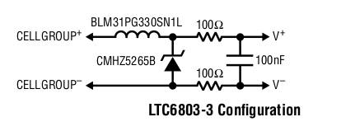Illustration 6: voltage protection and filtering

Configuration

Software

Undervoltage and overvoltage limits
<todo>

Jumpers

JMP 1 – Top Of Stack (TOS)
“TOS (Pin 35 on LTC6803-1/Pin 36 on LTC6803-3): Top of Stack Input. Tie TOS to VREG when the LTC6803-1 or LTC6803-3 is the top device in a daisy chain. Tie TOS to V– otherwise.
When TOS is tied to VREG, the LTC6803-1 or LTC6803-3 ignores the SDOI input and SCKO, CSBO are turned off. When TOS is tied to V–, the LTC6803-1 or LTC6803-3 expects data to be passed to and from the SDOI pin. ” [1].

JMP 2 – Vmode
“VMODE (Pin 40): Voltage Mode Input. When VMODE is tied to VREG, the SCKI, SDI, SDO and CSBI pins are configured as voltage inputs and outputs. This means these pins accept standard TTL logic levels. Connect VMODE to VREG when the LTC6803-1 or LTC6803-3 is the bottom device in a daisy chain.
When VMODE is connected to V–, the SCKI, SDI and CSBI pins are configured as current inputs and outputs, and SDO is unused. Connect VMODE to V– when the LTC6803-1 or LTC6803-3 is being driven by another LTC6803-1 or LTC6803-3 in a daisy chain. ” [1]

Jumper settings
Case: Standalone circuit. TOS is connected to VREG. VMODE is connected to VREG.
Case: Multiple circuits, bottommost circuit. TOS is connected to V-. VMODE is connected to VREG.
Case: Multiple circuits, middle circuit. TOS is connected to V-. VMODE is connected to V-.
Case: Multiple circuits, topmost circuit. TOS is connected to VREG. VMODE is connected to V-.

Usage

Connections
Connections to board should be made in following sequence:
- Set jumpers in accordance to role of board. See section “Configuration – jumpers” for details.
- Batteries, starting from negative terminal of first battery in stack, followed by + of 1st battery. Then terminals of second battery should be connected and so on. Connecting both terminals of batteries offers a redundant current path which gives a limited protection against open circuit between batteries, but this connection cannot carry more than a few amperes of current.
If less than 12 batteries are used, positive terminal of last battery in stack should be connected to terminal 12+ with a jumper from negative terminal of first omitted battery. Please note that LTC6803 requires at least 10 V of voltage to meet specified performance level.
- Redundant paths between stacks using tooth washers.
- Digital connections between boards in stack.
- Connection between isolator and MCU. MOSI / SCL lines have swapped labels near connector.

Software instructions
<TODO>

Fault conditions
Table 15 of LTC6803 [1 p.30] lists a number of fault conditions. Two first cases are mitigated by LPF circuit with protection zeners and internal clamps at LTC6803.
There is no redundant power supply in case of a power loss, if communication is lost battery charging / discharging should be driven into a safe state.
A break in battery stack would force reverse stack potential on communication link during discharge, high voltage series diodes protect monitor circuits and digital isolator protects controller circuit. During charge redundant current path can handle up to 10 A of current.
Two last cases are not accounted for. In case of a break within a stack, current carried by 0.5 mm trace between stacks. This trace can carry at most 2.5 A of a current according to IPC-2152. If this trace burns out, voltage gets applied to discharge circuit and LPF resistors, leading to destruction of discharge circuit. Discharging voltage then is applied across the LPF resistors, 2 * 10 k ohms. Maximum survivable voltage is limited by power dissipation of resistors,
This is not a practical value in actual car battery stack, but it will do in laboratory testing.
Disconnect inside stack while charging can also lead to a catastrophic failure if voltage and current are not limited.

Results

PCB revision 2014-02-22
PCB had a few significant faults:
- SDO-line used for relaying data to MCU required pull-up resistor, which was omitted. Fix: 4k7 resistor can be connected between test points for 5V and SDO. This has been tested and verified.
- VREG should have an 1 uF bypass capacitor. Fix: Suitable capacitor can be added in isolator bypass footprint, even thought placement is far from optimal. This has been tested and verified.
- VREF should have 1uF bypass capacitor. Fix: Capacitor can be connected between VREF- and DGND vias near LTC6803. This has been tested and verified.
- External discharge transistors turn on seemingly at random. This might have something to do with internal pull-ups of LTC6803 behaving in an unexpected manner or some leakage current (maybe through zeners or capacitors?) getting amplified. Possible fixes: Either add external pull-up resistor (10 k) or remove discharge transistors to avoid bleeding batteries / reducing accuracy of ADC readings. Neither has been tested.

PCB also had some cosmetic faults, such as silkscreen texts being covered by components and MOSI / SCL lines have swapped labels near connector.
PCB has been laid out so that same design can be used in three distinct roles: Bottom, middle, top. Roles are assigned by jumpers and some components can be omitted in some roles for cost savings. For example isolator is needed only by bottommost board and top board does not need connector or protection diodes to upper board in stack.
The board can accurately measure (within 10 mV) voltage of connected batteries. Batteries can be reliably discharged, but internal pull-ups cannot keep discharging off in all cases.

Production files of PCB
Entire project was coordinated as a github repository. Any revision of any relevant file can be fetched from [3].

Cost of product
<TODO>

Simulations
Passive discharging and filtering were simulated with LTSpice 4. Simulation was used as a design aid and to verify functionality of subcircuits. Ironically passive discharging was also the only part of project to fail. Some further simulation revealed that if internal pull-ups of LTC6803 turn off for some reason, passive discharge will engage.
Simulation also verified that proposed fix of adding external pull-up resistors with value of 10 k ohms should keep discharging strictly off unless discharging is actively driven.

Schematic revision 2014-05-22
Mistakes found in first round of prototyping have been fixed in schematic. Schematic fixes do not effect silkscreen of PCB. If a next iteration of prototype is developed, PCB should be redesigned to match the schematic.

References
[1] LTC6803-1 and -3 - Multicell Battery Stack Monitor. Datasheet. Available at http://cds.linear.com/docs/en/datasheet/680313fa.pdf. Retrieved on 22.5.2014.
[2] Quad-Channel, 2.5 kV Isolators with Integrated DC-to-DC Converter. Datasheet. Available at http://www.analog.com/static/imported-files/data_sheets/ADuM5401_5402_5403_5404.pdf Retrieved on 22.5.2014.
[3] ojousima/as-03200. Github repository. Available at: https://github.com/ojousima/as-03200.

Attachments

