DEPARTMENT OF COMPUTER SCIENCE

THE UNIVERSITY OF YORK

_____________________

SEPR - Assessment 2

USER MANUAL

Evil Geese

_____________________

Contents

**1. Story** **1**

**2. Getting Started** **1**

2.1 Title Screen 1

**3. How To Play** **2**

3.1 Navigating World 2

3.1.1 Movement 2

3.1.2 Interaction With The World 2

3.1.3 Transitioning Between Location 2

3.2 Main Menu 3

3.3 Battle 3

3.4 Character Roster 4

3.5 Minigame 4

3.5.1 Menu Navigation 4

3.5.2 Navigation 4

**4. World Map** **3 4**

_____________________

January 2018

# 1. Story

The story begins with our three students, who have been thrown into a disastrous situation and now faced with the biggest adventure of their lives. The Vice Chancellor now a breeder of darkness has put out a bounty for these students, and has turned the university into a place of unhappiness. Our three Students have the fate of the University in their hands, with the help of friends and allies that you meet. You’ll shall step out into this threatening situation and must defeat the Vice Chancellor to bring about peace to the University of York once again.

# 2. Getting Started

## 2.1 Title Screen

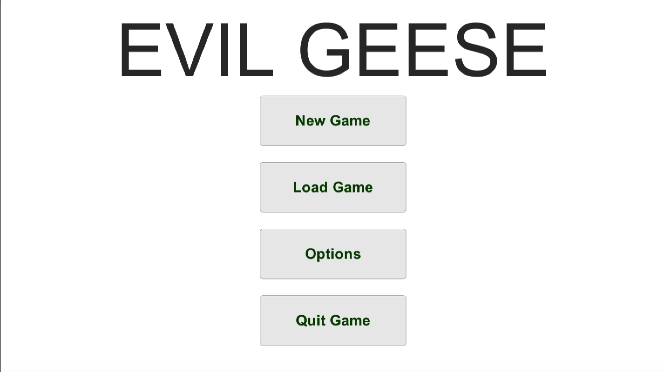

Upon starting the game, you will reach the title screen. This is where you are able to start a ‘New Game’ from clicking on the save game button. Continue playing from a save file by clicking the ‘Load Game’ button. Access the settings by clicking on the ‘Options’ icon. You can exit the game by clicking the ‘Quit Game’ button.

# 3. How To Play

## 3.1 Navigating World

#### 3.1.1 Movement

Your character is able to move in 4 directions, ‘Up, Down, Left, Right’ using either the arrow keys or the keys ‘W, S, A, D’

#### 3.1.2 Interaction With The World

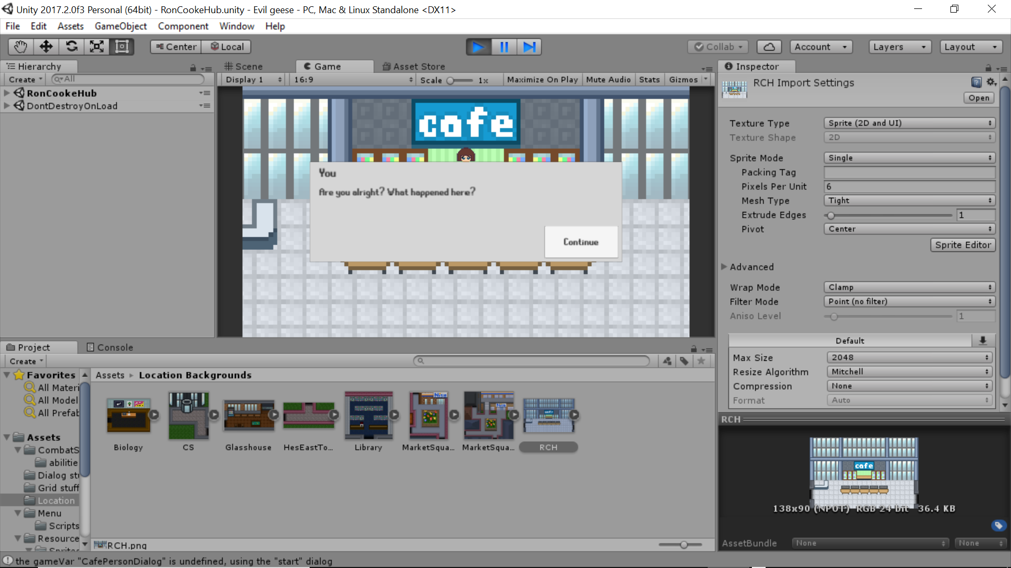

Your character is able to interact with the world by pressing the ‘Spacebar’.You will have encounters with people who will help guide you and you will have to face enemies during your adventure.

#### 3.1.3 Transitioning Between Location

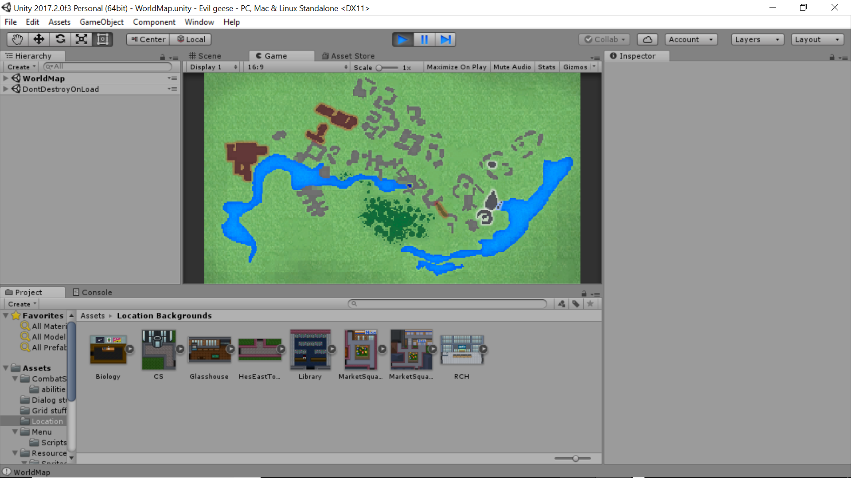

To travel to another location, you have to go through one of the exits present in the existing location. This will bring up the world map where you will use your mouse to click and choose your desired location. Locations which are available to you have a white border surrounding them. Locations which are restricted will have a red border surrounding them until later in the game they may become available to you.

## 3.2 Main Menu

To access the main menu,you need to to press the escape key. Here you will be to save the game by selecting the ‘Save’ icon.There are six save slots to choose from. Load another Save file by selecting the ‘Load’ button. By pressing the ‘Quit’ button you will be able to return to the title screen.

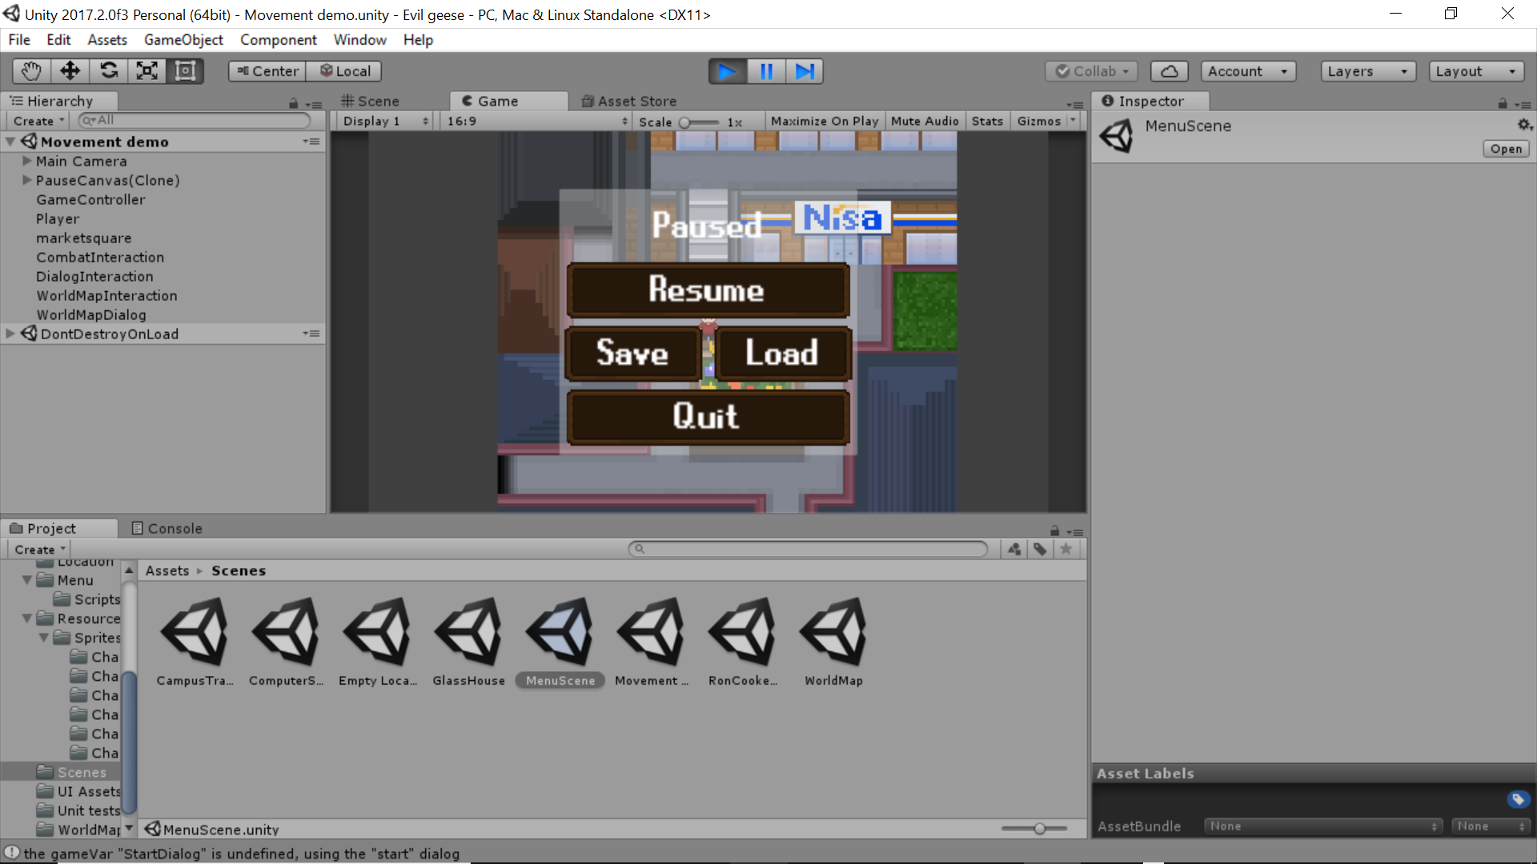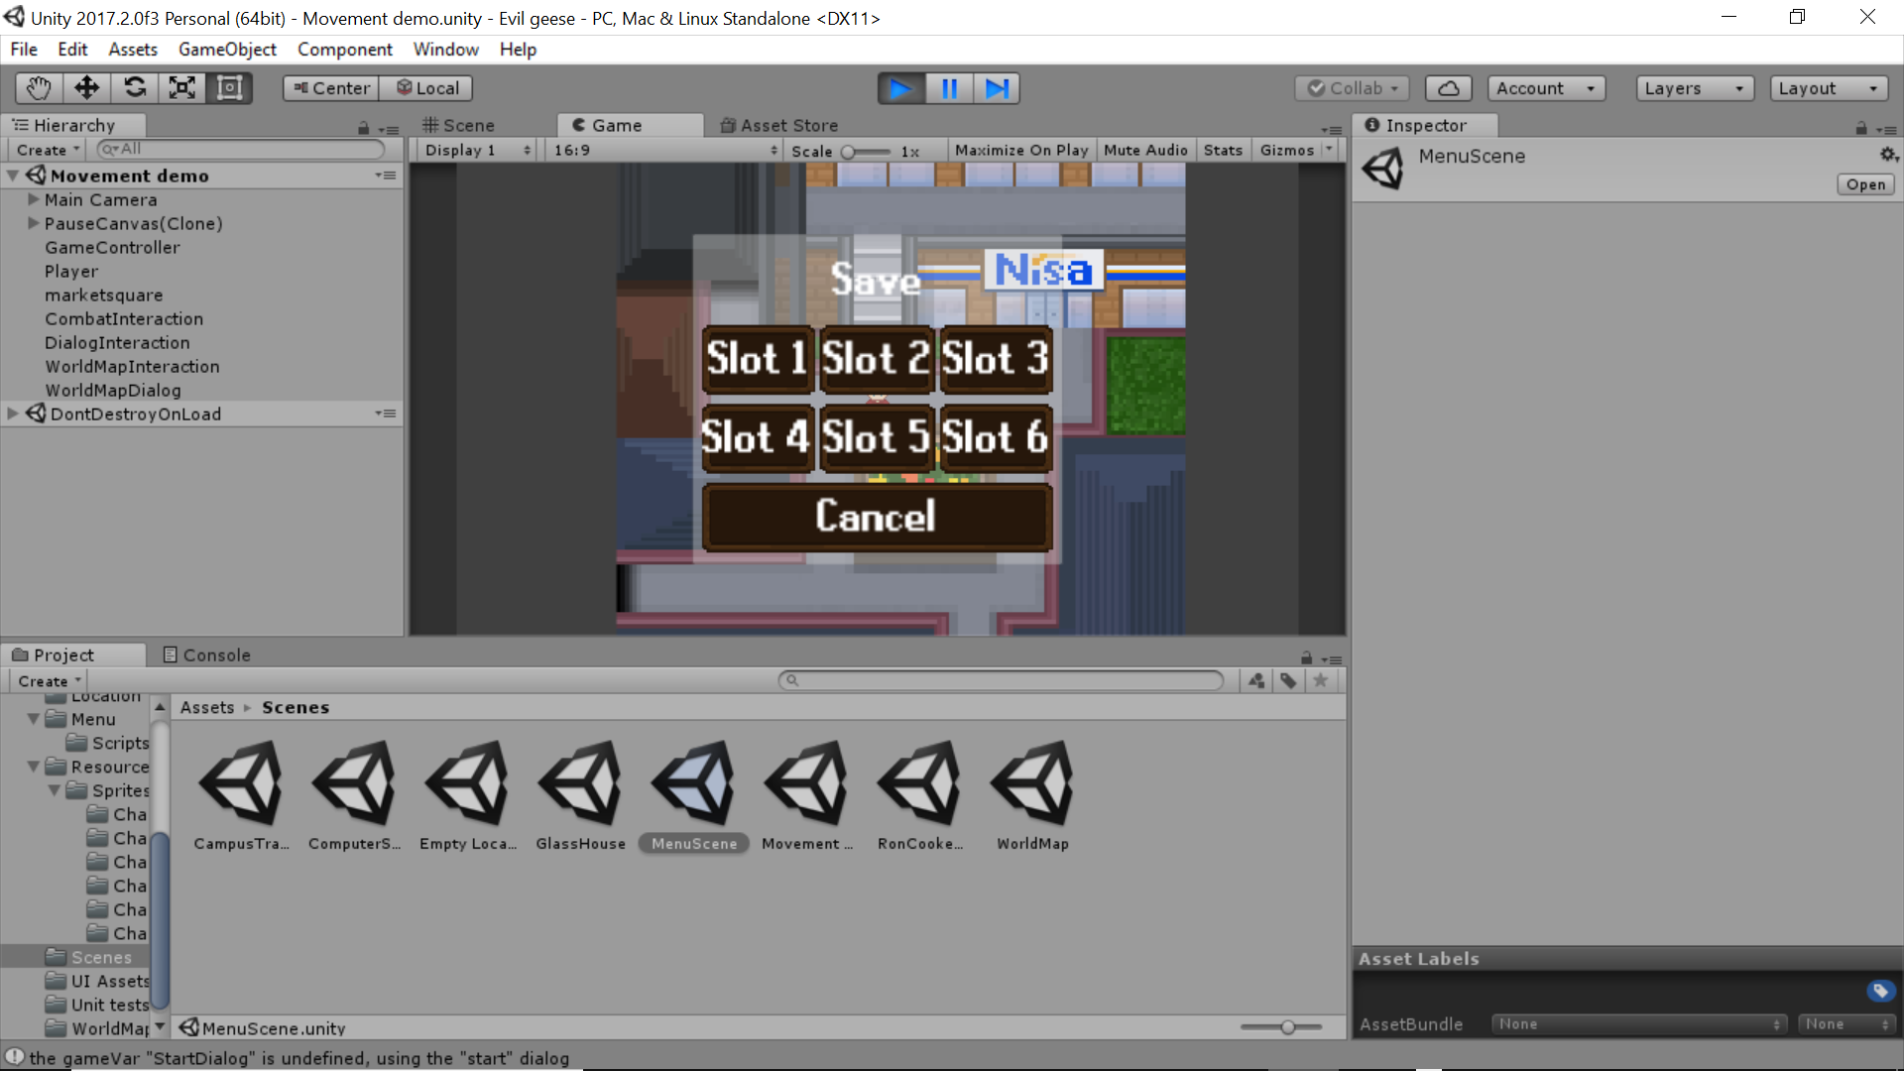

## 3.3 Battle

A battle with enemies is initiated, after interaction with them. This will take you to a battle scene where only 3 characters from your party will be in combat.

The battle system used is turn based. So every character in your party will have a chance to attack, including the enemy.

You will have the option to use a basic attack or use an ability which will cost you some energy decreasing the blue bar.

You will also have the option to use items to aid you during battle.

The red bar is your health bar, this will decrease after taking damage from the enemy. If this becomes 0 then you will lose a party member during battle. So the main objective is to defeat all of the enemies - try not to die!

## 3.4 Character Roster

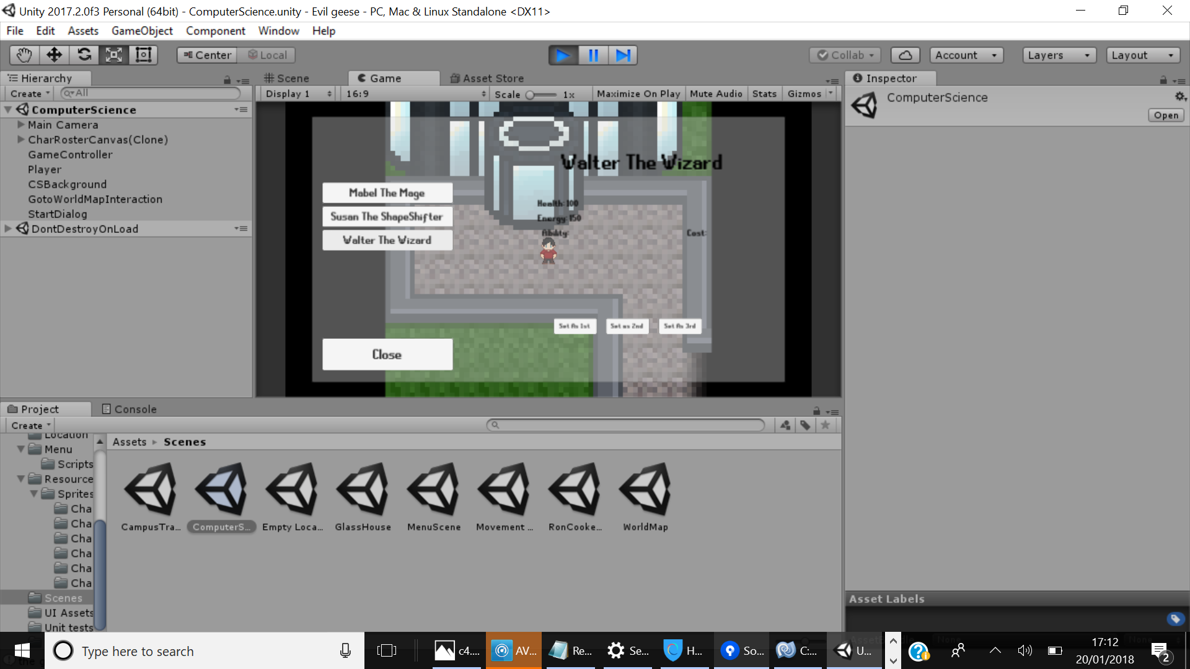

To bring up the character roster you will have to press the keyboard key ‘R’, here you will be able to see who is in your party and make changes as to who will be engaging in battle. Your party will grow as you progress through the story.

## 3.5 Mini-Game

### 3.5.1 Menu Navigation

The menu system within the mini-game works exactly the same as that of the core game’s menu system, allowing you to navigate through it with ease.

### 3.5.2 Navigation

The character can be controlled with the left and right arrow keys to move in each corresponding direction. Just don't hit the geese!

# 4. World Map

# 