**OJPITRE.AI | ENGINEER**

**](https://ca.linkedin.com/in/ojpitre)[](https://instagram.com/ojpitre)[](https://twitch.tv/ojpitre)[](https://open.spotify.com/user/ojpitre)[](https://www.reddit.com/user/ojpitre)[](https://discord.com/users/150370210086387713)[](https://ojpitre.ai)[Icon
](mailto:ojpitre@ojpitre.ai)

**ABOUT**

[**Jean-Olivier Pitre**](https://ojpitre.ai) |**🤖 Engineer** specialized in *building* **Artificial Intelligence** solutions using **Microsoft Azure** technologies.

|🌎 <https://ojpitre.ai> | ✉️ [ojpitre@ojpitre.ai](mailto:ojpitre@ojpitre.ai) | 📌 Montréal, Québec, Canada

**EXPERIENCE**

**[](https://stm.info)**

[**Société de Transport de Montréal**](https://stm.info) **| Data Engineer | 2008+**

Pioneered artificial intelligence & cloud computing practices for the Montreal Metro.

Improved the metro ridership experience by providing data-driven insights to clients, management & engineering.

[](https://nbc.ca/)

[**National Bank of Canada**](https://nbc.ca) **| Programmer-Analyst | 2003 - 2007**

Designed KPI dashboards for the Canadian headquarters’ IT support department.

Reduced the number of incidents & improved server uptimes by providing operation insights to systems engineer.

**EDUCATION**

[](https://www.mcgill.ca/continuingstudies/program/professional-development-certificate-data-science-and-machine-learning)[](https://www.concordia.ca/academics/undergraduate/computer-engineering.html)

[**McGill University**](https://www.mcgill.ca/continuingstudies/program/professional-development-certificate-data-science-and-machine-learning) **| 2018 – 2020** [**Concordia University**](https://www.concordia.ca/academics/undergraduate/computer-engineering.html) **| 1999-2003**

Professional Development Certificate Baccalaureate

Data Science & Machine Learning Computer Engineering

**LICENSES**

](https://www.oiq.qc.ca/)

[**Ordre des Ingénieurs du Québec**](https://www.oiq.qc.ca/) **| 2011+**

**ENG**: Professional Engineer

**License**: #141204

**CERTIFICATIONS**

](https://www.credly.com/users/ojpitre/badges)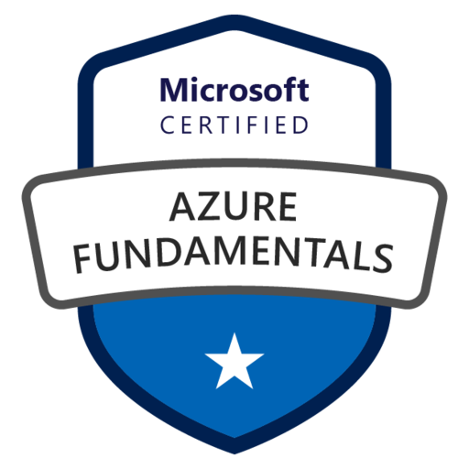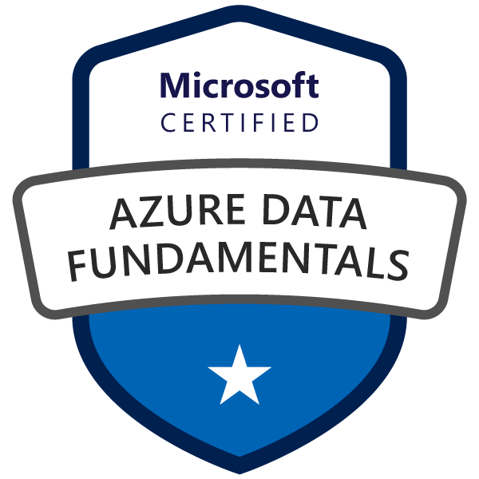

[**Microsoft Certified Associate**](https://www.credly.com/users/ojpitre/badges) **| 2023+**

Azure Network Engineer

Azure Data Fundamentals

Azure Fundamentals

**SKILLS**

](https://mvp.microsoft.com/)[**Azure**](https://www.credly.com/users/ojpitre/badges) **|** [**Microsoft**](https://www.credly.com/users/ojpitre/badges) **| 2023+**

**DevOps:** Azure DevOps, Azure Pipelines, GitHub, PowerShell, Bash, Bicep, Git, Docker, Windows, Linux

**DataOps I:** Azure Data Factory, Azure Synapse, Azure Event Grid, Azure Event Hubs, Azure IoT, Azure Stream Analytics

**DataOps II:** Azure Storage, Delta Lake, Azure SQL, Azure Cosmos DB, Azure Batch, Azure Functions, Python, Spark, Power BI

**MLOps:** Azure Machine Learning, Azure Cognitive Services, Azure Kubernetes Service, MLFlow, TensorFlow

**Network:** Azure Virtual Network, Azure Private Endpoints, Azure Private DNS, Azure Network Security Groups

**Security:** Azure Active Directory, Azure Key Vault, Azure Firewall, Microsoft Defender, Microsoft Sentinel

**Admin:** Azure Monitor, Azure Log Analytics, Azure Application Insights, Azure Data Explorer, Kusto

**Dev:** Azure Static Web Apps, C#, .NET, Blazor